

**BOCNY Trade Finance Verification**

**User Specification Requirement**

|  |  |
| --- | --- |
| Serial number of demand: |  |
| Current version: | X.Y.Z |
| Sponsor department: |  |
| Compiled by: | (Name of compiler required*)* |
| Audited by: |  |
| Signed and issued by: | *(Member of the General Manager’s Office of business units/departments)* |
| Date of signature: | 2018/07/18 |

© Bank of China All Rights Reserved















**Log Sheet of Document Change**

|  |  |  |  |  |
| --- | --- | --- | --- | --- |
| **Date** | **Document Version No.** | **Revision marks** | **Revision note** | **Author** |
| March 28, 2018 | V1.0.0 | A | Added | IBM China hands to IBM US |
| April 13, 2018 | V1.0.2 | M | Modified | Received from Bank of China |
| May 18, 2018 | V1.0.3 | M | Modified | Revised by IBM per BRD Review Sessions |
| July 18, 2018 | V1.0.4 | M | Modified | Revised by TSD business team |

**Revision marks: A** – Added; **M** – Modified; **D** – Deleted

Contents

BOCNY Trade Finance Verification 1

User Specification Requirement 1

Chapter 1. Overview 9

1.1. Background 9

1.1.1. The system will follow the logic to answer the Transaction Risk Mitigation Check List questions, and part of the questions semi-auto and manual answer will be required. 10

1.1.2. Availability of BoC resources within 21 working hours of request by development team of feedback for each Sprint within 24 hours of Sprint delivery. 11

1.1.3. Project timeline, especially when it will have impacts to Business Team’s resource allocation, must be pre-approved by the Business Team 11

1.1.4. Development will follow an iterative methodology. Bank of China will support this methodology by supporting environments, conducting system integrating testing, and reviewing/identifying defects for Sprint outputs including GUI and system functionality. 11

1.1.5. Bank of China New York will be required to ensure the availability of the key participants at the kick-off meeting and provide development team project participants appropriate workspace, computers, network and internet access. As for developers, this should include physical space and internet resources for at least 30 persons. 11

1.1.6. The completed system may require local and/or foreign regulatory approval before Go-Live event. 11

1.1.7. Information such as price and or company data may be limited online, and manual search may be necessary. 11

1.1.8. The development team software has not yet reached its end-of-support date. 11

1.1.9. This service outlined in this SOW do not include the provision of any hardware equipment, software program, hardware equipment maintenance or warranty, software program maintenance or warranty, user (exits) modifications, data handling/conversion, performance tuning, or product exploitation. 11

1.1.10. Bank of China New York and the development team are expected to have appropriate resources available during this timeframe to provide necessary actions and responses for completing project. 11

1.1.11. Help the development team obtain an understanding of the business problem, the data, and the current process/practice, and provide business requirements. In reverse, help TSD team to solve the business problem, provide professional opinion, understand system function and manipulation. 11

1.1.12. Provide the necessary operating environment for all equipment delivered, in accordance with the equipment manufacturer’s specifications. 11

1.1.13. This solution assumes Bank of China will use Fircosoft for all OFAC checks and due diligence, replacing Bridger Insights. All subject to changes during the development of the FircoSoft project, which is expected concluded in September 2018. 12

1.1.14. The proposed solution will not have a management reporting functionality in this phase. 12

1.1.15. The BoC Trade Finance AML system will adopt the GLS developed look and feel, similar to the AML Intelligence Solution. 12

1.1.16. Utilization of architectural components listed in the Technical Solution Document will be used, and development team retains the right to change an architectural component due to functionality or environment requirements. 12

1.1.17. BoC will provide the Excel files which will be maintained in the UI interface in the future. Previously, “Jack” was to provide this information. 12

1.1.18. BoC will provide access to an information source where Trade Finance customer information can be retrieved. 12

1.1.19. The system is being built for U.S. branches. 12

1.1.20. This newly-built Trade Finance tool will require use of and access to paid API’s. 12

1.1.21. Test preparation and execution for system and user acceptance testing. 12

1.1.22. A decrease in development and testing resources by 50% after Sprint 9, as planned by the development team. 12

1.1.23. Requirement stability and sign-off prior to the beginning of development. 12

1.1.24. Bank of China support and owning of Regulatory Compliance Validation and Post-Go Live Monitoring. 12

1.1.25. Acquisition and installation of architectural components in Bank of China’s environment. 12

1.1.26. Configuration of space in Bank of China’s source code management repository. 12

1.1.27. Provision of deployment automation and DevOps environment. 12

1.1.28. Provision of System Testing and UAT Servers (web, application, and database). 12

1.1.29. Provision of Bank of China Java script library and visual design standards. 12

1.1.30. A development and testing environment are necessary for the migration of code builds to Bank of China during Sprints. 13

1.1.31. Approval, acquisition and installation of recommended architectural components. 13

1.1.32. TSD is responsible for submitting business requirements but not technical requirements in this BRD. 13

1.1.33. The Trade Finance AML System (TF AML) should be reviewed by an independent party before being putting into production. This compliance focused review, should be conducted by the LCD or a consultant firm agreed upon by the LCD, is to confirm the limitations, the architecture, the accuracy rates, the efficiency of the System. More importantly the review is to test the evidences returned by the TF AML and logic behind those evidences are sufficient to answer Transaction Risk Mitigation Check List 35 questions, either manually, semi-automatically or automatically. The reason for such a review is because although all answers or results from the TF AML are supposed to be reviewed and judged manually, when employing an automated system, sooner or later, human will inevitably rely on the system, and hence a level of comfort must be obtained from the system before implementation. 13

1.3. Brief introduction to feasibility 13

1.4. Basic definition 14

Chapter 2. Business Operation Flow 15

2.1. Business operation flow brief 15

2.2. Business flowchart 25

2.3.Business operation flow Description 26

Chapter 3. Functional Description 35

3.1. Functional classification 35

3.2. Functional description 37

3.2.1 Login Page 38

~~1..1.~~ ~~AS-IS~~ 38

1..2. Enhancement 40

3.2.1.1. Brief introduction to function 40

3.2.1.2. Detailed description 42

3.2.1.3. Interface requirements 45

3.2.2 Home Page 47

~~1..1. AS-IS~~ 48

1..2. Enhancement 48

3.2.2.1. Brief introduction to function 50

3.2.2.2. Detailed description 51

3.2.2.3. Interface requirements 52

3.2.3 Operations Analyst: Case List Page 54

1..1. AS-IS 54

1..2. Enhancement 55

3.2.3.1. Brief introduction to function 55

3.2.3.2. Detailed description 56

3.2.3.3. Interface requirements 61

3.2.4 Admin 63

1..1. AS-IS 63

1..2. Enhancement 64

3.2.4.1. Brief introduction to function 64

3.2.4.2. Detailed description 64

3.2.4.3. Interface requirements 68

3.2.5 Operations Analyst: Create Case Page 70

1..1. AS-IS 70

1..2. Enhancement 72

3.2.5.1. Brief introduction to function 73

3.2.5.2. Detailed description 74

3.2.5.3. Interface requirements 75

3.2.6 Operations Analyst: Case Verification Page 78

1..1. AS-IS 78

1..2. Enhancement 81

3.2.6.1. Brief introduction to function 84

3.2.6.2. Detailed description 86

3.2.6.3. Interface requirements 96

3.2.7 Operations Analyst: Case Questions Check Page 123

1..1. AS-IS 124

3.2.7.1. Brief introduction to function 125

3.2.7.2. Detailed description 125

3.2.7.3. Interface requirements 129

3.2.8 Operations Analyst: Evidence Management Page 130

1..1. AS-IS 130

1..2. Enhancement 134

3.2.8.1. Brief introduction to function 135

3.2.8.2. Detailed description 136

3.2.8.3. Interface requirements 140

3.2.9 Operations Analyst: Details 141

3.2.9.1. Brief introduction to function 141

3.2.9.2. Detailed description 143

3.2.9.3. Interface requirements 152

3.2.10 All Forms 153

3.2.10.1. Brief introduction to function 153

3.2.10.2. Detailed description 154

3.2.10.3. Interface requirements 164

3.2.11 Operations Manager 170

3.2.11.1. Brief introduction to function 170

3.2.11.2. Detailed description 170

3.2.11.3. Interface requirements 176

3.2.12 Compliance Supervisor 180

3.2.12.1. Brief introduction to function 180

3.2.12.2. Detailed description 180

3.2.12.3. Interface requirements 186

3.2.13 Compliance Analyst 190

3.2.13.1. Brief introduction to function 190

3.2.13.2. Detailed description 191

3.2.13.3. Interface requirements 197

3.2.14 BSA Officer 198

3.2.14.1. Brief introduction to function 198

3.2.14.2. Detailed description 199

3.2.14.3. Interface requirements 201

3.2.15 LCD Department 203

3.2.15.1. Brief introduction to function 203

3.2.15.2. Detailed description 203

3.2.15.3. Interface requirements 206

3.2.16 35Q logic 208

1..1. AS-IS 208

3.2.15.1. Brief introduction to function 227

3.2.15.1. Detailed description 227

3.2.17 Future Development 250

1..2. Enhanced Due Diligence 250

3.2.18 Case Process Enhancement 252

~~3.2.18.1.~~ ~~Case List for Review Page~~ 252

~~3.2.18.2.~~ ~~Case Review Page~~ 256

~~3.2.18.3. Case Assignment Page~~ 260

~~3.2.18.4.~~ ~~Case Sign-Off Page~~ 261

~~3.2.18.5.~~ ~~Case Return Page~~ 262

~~4.2.18.6.~~ ~~Case Refer to Next Page~~ 263

~~4.2.18.7.~~ ~~Upload Evidence Button~~ 265

~~4.2.18.8.~~ ~~Operations Analyst: Special Approval Form Page~~ 265

~~4.2.18.9.~~ ~~Compliance Analyst: Supplementary Notes Page~~ 266

~~4.2.18.10.~~ ~~Compliance Analyst: TSD Case Review Check List Form Page~~ 268

~~4.2.18.11.~~ ~~Compliance Supervisor: TSD Case Review Check List Form Page~~ 269

~~4.2.18.12.~~ ~~BSA Officer: TSD Case Review Check List Form Page~~ 270

~~4.2.18.13.~~ ~~BSA Officer: Unusual /Suspicious Activities Form Page~~ 271

~~4.2.18.14.~~ ~~LCD Officer: Review & Feedback Page~~ 272

~~4.2.18.15.~~ ~~Administrator: Exception Process Page~~ 275

3.2.19 Operations Analyst: Case Summary Report Page 276

1..1. AS-IS 276

1..2. Enhancement 278

3.3. Requirements for customer information 279

3.4. Requirements for channel 279

3.5. Requirements related to the core system 279

3.5.1 Technical Enhancement 279

3.5.1.1. Workflow Control 279

3.5.1.2. Add Audit Trail 279

3.5.1.3. File Management 280

3.5.2 Interface Requirements 280

3.5.2.1. Hardware 280

3.5.2.2. Access 281

3.6. Requirements for report and accounting 281

Form 1: Service & Insurance (#6) 281

Form 2: Metal (#7) 284

Form 3: Oil & Petro (#8) 286

Form 4: Shipping & Ship Building (#9) 288

3.7. Regulatory requirements 289

3.8. Requirements for data downloading 289

1..1. AS-IS 289

1..2. Enhancement 290

3.9. Relevant computing methods and calculation formulas *If there are special or complicated computing methods or calculation formulas in terms of transaction processing, please describe in details, and the background knowledge of computing methods or calculation formulas shall also be explained in details.* 294

Chapter 4. Other Requirements 295

4.1. Post evaluation 295

4.1.1 Post evaluation 295

4.1.2 Post evaluation data acquisition 295

4.2. Data quality requirements 295

4.3. Business indicators 295

4.4. Security indicator (for branch) 299

4.5. Suggestions on development mode 299

4.6. Requirements for time and resources 299

4.7 Other requirements _Non-Functional Requirements 300

4.7.1 Availability 300

4.7.2 Maintanance, Back-up and Recovery 300

4.7.3 Capacity Planning 300

4.7.4 Data Retention 301

4.7.5 Disaster Recovery 301

4.7.6 Reliability and Stability 302

4.7.7 Regulatory Compliance 302

4.7.8 Security Requirements 302

4.7.9 System Management Requirements 303

4.7.10 User Management Requirements 304

4.7.11 Coding Standards 305

4.7.12 Monitoring 305

References 305

4.8. Business Workflow Forms 306

4.8.1. #1 Transaction Risk Mitigation Check List 306

4.8.2. #2 Special Approval Form 310

4.8.3. #3 Compliance Section Supplementary Notes 311

4.8.4. #4 TSD Case Review Check List 312

4.8.5. #5 Referral Form of Unusual /Suspicious Activities (offline) 315

4.8.6. #10 Case-by-case transaction worksheet (online for inward collection & offline for export L/C collection) 316

4.9. Transaction Documents Fields 319

4.10. File Management Structure Design 320

4.11. New Function & Enhancement List 321

4.13. Trade Finance User Requirements Specifications 327

Chapter 1. Overview

1.1. Background

* *Introduction*

This document is one of the formal deliverables of the Bank of China’s New York Branch on the "Trade Finance AML Intelligence Screening Project ". It describes the requirement of the TSD department of the New York Branch for trade financing business transactions in accordance with regulatory and internal control regulations and analyze how to use the IT application and business intelligence technology to support the information verification and compliance inspection business, and detailed function specifications are also included.

This document will be the baseline of the future design, development, test and acceptance after confirmed by TSD department of Bank of China New York branch.

The readers of this document include:

* Business personnel, Manager of TSD department of Bank of China New York branch
* BA, SA of the project team
* Application system operations and maintenance support personnel of BOC IT department
* Operations management personnel of Information Center of America
* *Background:*

Bank of China U.S. Branches Trade Services Department (“BOC TSD”) mitigates AML risks by performing extensive due diligence checks on transactions, including OFAC check, Negative news check, Price check, Vessel movement check, Company information check, etc. After manually performing these checks, TSD operations unit will fill out Transaction Risk Mitigation Check List for every transaction. With large transaction volume and timing requirement, there is a strong need for TSD to have a tool to reduce manual work to standardize and improve efficiency of transaction monitoring.

Trade Finance AML Intelligence Screening Project is setup for trade finance business. In phase 1 release 1, there is only TSD Operations Unit in the system. In phase 1 release 2, the work flow is extended from the Operations Analyst to the TSD compliance unit and LCD department. It also includes necessary enhancements to support the daily transaction compliance check, anti-money laundering monitoring, and analysis work of the business staff of the New York Branch’s TSD. BOC TSD will benefit from standardizing operations procedures and processing business with higher quality and efficiency.

* *Project Assumptions*

### The system will follow the logic to answer the Transaction Risk Mitigation Check List questions, and part of the questions semi-auto and manual answer will be required.

### Availability of BoC resources within 21 working hours of request by development team of feedback for each Sprint within 24 hours of Sprint delivery.

### Project timeline, especially when it will have impacts to Business Team’s resource allocation, must be pre-approved by the Business Team

### Development will follow an iterative methodology. Bank of China will support this methodology by supporting environments, conducting system integrating testing, and reviewing/identifying defects for Sprint outputs including GUI and system functionality.

### Bank of China New York will be required to ensure the availability of the key participants at the kick-off meeting and provide development team project participants appropriate workspace, computers, network and internet access. As for developers, this should include physical space and internet resources for at least 30 persons.

### The completed system may require local and/or foreign regulatory approval before Go-Live event.

### Information such as price and or company data may be limited online, and manual search may be necessary.

### The development team software has not yet reached its end-of-support date.

### This service outlined in this SOW do not include the provision of any hardware equipment, software program, hardware equipment maintenance or warranty, software program maintenance or warranty, user (exits) modifications, data handling/conversion, performance tuning, or product exploitation.

### Bank of China New York and the development team are expected to have appropriate resources available during this timeframe to provide necessary actions and responses for completing project.

### Help the development team obtain an understanding of the business problem, the data, and the current process/practice, and provide business requirements. In reverse, help TSD team to solve the business problem, provide professional opinion, understand system function and manipulation.

### Provide the necessary operating environment for all equipment delivered, in accordance with the equipment manufacturer’s specifications.

### This solution assumes Bank of China will use Fircosoft for all OFAC checks and due diligence, replacing Bridger Insights. All subject to changes during the development of the FircoSoft project, which is expected concluded in September 2018.

### The proposed solution will not have a management reporting functionality in this phase.

### The BoC Trade Finance AML system will adopt the GLS developed look and feel, similar to the AML Intelligence Solution.

### Utilization of architectural components listed in the Technical Solution Document will be used, and development team retains the right to change an architectural component due to functionality or environment requirements.

### BoC will provide the Excel files which will be maintained in the UI interface in the future. Previously, “Jack” was to provide this information.

### BoC will provide access to an information source where Trade Finance customer information can be retrieved.

### The system is being built for U.S. branches.

### This newly-built Trade Finance tool will require use of and access to paid API’s.

### Test preparation and execution for system and user acceptance testing.

### A decrease in development and testing resources by 50% after Sprint 9, as planned by the development team.

### Requirement stability and sign-off prior to the beginning of development.

### Bank of China support and owning of Regulatory Compliance Validation and Post-Go Live Monitoring.

### Acquisition and installation of architectural components in Bank of China’s environment.

### Configuration of space in Bank of China’s source code management repository.

### Provision of deployment automation and DevOps environment.

### Provision of System Testing and UAT Servers (web, application, and database).

### Provision of Bank of China Java script library and visual design standards.

### A development and testing environment are necessary for the migration of code builds to Bank of China during Sprints.

### Approval, acquisition and installation of recommended architectural components.

### TSD is responsible for submitting business requirements but not technical requirements in this BRD.

### The Trade Finance AML System (TF AML) should be reviewed by an independent party before being putting into production. This compliance focused review, should be conducted by the LCD or a consultant firm agreed upon by the LCD, is to confirm the limitations, the architecture, the accuracy rates, the efficiency of the System. More importantly the review is to test the evidences returned by the TF AML and logic behind those evidences are sufficient to answer Transaction Risk Mitigation Check List 35 questions, either manually, semi-automatically or automatically. The reason for such a review is because although all answers or results from the TF AML are supposed to be reviewed and judged manually, when employing an automated system, sooner or later, human will inevitably rely on the system, and hence a level of comfort must be obtained from the system before implementation.

**1.2. Requirement Brief**

*BoC and development team will work together to jointly define the success criteria. Below are typical examples that development team has utilized as success criteria with other clients.*

* Increase efficiency by X%, in terms of time saved in processing of each transaction, by automating Trade Finance and reducing manual effort
* Maintain digital copies of Trade Finance documents in a central repository for easy access
* Meet regulatory requirements by documenting Trade Finance analysis online and providing an audit trail of activities and approvals
* Maintain Trade Finance activities online to provide management with an understanding of work effort and case status

1.3. Brief introduction to feasibility

* *project feasibility analysis including, but not limited to: market conditions and trends, the achievement of similar products in the industry, the impact of national policies, operational status quo / questions / suggestions for improvement and business value, user usage, risks, strategic conformity market demand trends, enhance the customer experience, the regulatory requirements.*

1.4. Basic definition

* *Define and explain special terms (jargons) or abbreviations, serial numbers and codes related to the demand.*

|  |  |
| --- | --- |
| 术语 | 定义或说明 |
| TFS | 单单相符核查系统 |
| CASE | 国际贸易中客户需要提交相关单证以申请相关金融服务 |
| OA | Operations Analyst缩写 |
| OM | Operations Manager缩写 |
| CS | Compliance Supervisor缩写 |
| CA | Compliance Analyst缩写 |
| BSA | BSA Officer缩写 |
| LCD | LCD DEPARTMENT缩写 |

# Chapter 2. Business Operation Flow

2.1. Business operation flow brief

* + *Flow Status Control*

| **Step** | **动作** | **当前状态** | **操作** | **接下去状态** | **授权的角色** |
| --- | --- | --- | --- | --- | --- |
| 1A | 创建Case | Pending Operations Analyst Review（界面不会出现此状态） | 列表页点击 Add New Case | Under Operations Analyst Review | Operations Analyst |
| 1B | 修改Case | Under Operations Analyst Review | 详情页点击Modify the case | Under Operations Analyst Review | Operations Analyst |
| 2 | **Input(录入PDF)** | Under Operations Analyst Review | 列表页或详情页点击Input | Under Operations Analyst Review | Operations Analyst |
| 3 | **Check (请求API&回答35个问题&整理证据)** | Under Operations Analyst Review | 列表页或详情页点击Check | Under Operations Analyst Review | Operations Analyst |
| 4A | 不进行后续步骤，直接把INPUT发给OM审查 | Under Operations Analyst Review | 详情页点击Send to Manager | Pending Operations Manager Review | Operations Analyst |
| 4B | 创建1#Summary | Under Operations Analyst Review | 详情页点击1#Summary | Under Operations Analyst Review | Operations Analyst |
| 4C | 创建2#SAF（确定是否需要） | Under Operations Analyst Review | 详情页点击2# SAF | Under Operations Analyst Review | Operations Analyst |
| 4D | 发送CASE给到OM | Under Operations Analyst Review | 详情页点击Send to Manager | Pending Operations Manager Review | Operations Analyst |
| 5A\7A | **Recheck处理被OM打回的CASE** | Pending Operations Analyst Modify | 列表页点击Recheck | Under Operations Analyst Modify | Operations Analyst |
| 5B | 把Recheck完后的case发给OM | Under Operations Analyst Modify | 详情页点击Send to Manager | Pending Operations Manager Review | Operations Analyst |
| 6A | OM审核CASE（Operations Manager review the case ） | Pending Operations Manager Review | 详情页点击Check或整条，进入详情页(Open case to review) | Under Operations Manager Review | Operations Manager |
| 7A | 确定是否需要修改（Identify if modification needed） | Under Operations Manager Review | 表单中回复，并在详情页点击Return to OA (Comments & returns to Operations Analyst ) | Pending Operations Analyst Modify | Operations Manager |
| 7B | 确定是否需要修改（Identify if modification needed） | Under Operations Manager Review | 详情页点击Approve (Sign-off with approval) | Close Approval | Operations Manager |
| 7C | 确定是否需要修改(Identify if modification needed) | Under Operations Manager Review | 详情页点击Refer to CS（ Refer to Compliance unit to review） | Pending Compliance Supervisor Assign | Operations Manager |
| 6B\5B | OM审核打回OA，OA再次发过来的CASE | Pending Operations Manager Review | 列表页点击Check | Under Operations Manager Review | Operations Manager |
| 8A | 列表页第一次看到该CASE | Pending Compliance Supervisor Assign | 列表页点击进详情页或列表页点击Assign(状态 很短) | Under Compliance Supervisor Assign | Compliance Supervisor |
| 8B | 将CASE分配给CA(Assign to Compliance Analyst) | Under Compliance Supervisor Assign | 列表页或详情页，点击Assign，确认分配后（Assign to Compliance Analyst） | Pending Compliance Analyst Review | Compliance Supervisor |
| 9 | CA审核CASE (Compliance Analyst review case) | Pending Compliance Analyst Review | 列表页点击Check或整条，进入详情页（Open case to review） | Under Compliance Analyst Review | Compliance Analyst |
| 10 | 确认是否有危险信号（Identify if no Red flag & not in watch list） | Under Compliance Analyst Review | 详情页点击Refer to CS (Refer to Compliance Supervisor for review) | Pending Compliance Supervisor Review | Compliance Analyst |
| 11 | 合规主管审核 | Pending Compliance Supervisor Review | 列表页点击Check或整条，进入详情页 | Under Compliance Supervisor Review | Compliance Supervisor |
| 12 | 合规主管签字并发给LCD(Compliance Supervisor sign & refer to LCD) | Under Compliance Supervisor Review | 详情页点击Refer to LCD (Compliance Supervisor sign & refer to LCD) | Pending LCD Feedback | Compliance Supervisor |
| 13A | LCD审核（LCD review） | Pending LCD Feedback | 列表页点击Check或整条，进入详情页（LCD open case to review） | Under LCD Feedback | LCD |
| 13B | LCD反馈后发送给CA (LCD feedback and refer to Compliance Analyst) | Under LCD Feedback | 详情页点击Refer to CA (LCD feedback and refer to Compliance Analyst) | Pending Compliance Analyst Review | LCD |
| 14A | CA审核 | Pending Compliance Analyst Review | 列表页点击Check或整条，进入详情页 | Under Compliance Analyst Review | Compliance Analyst |
| 14B | 发给CS复核（Refer to Compliance Supervisor ）review | Under Compliance Analyst Review | CA填写#3，，详情页点击Refer to CS （Refer to Compliance Supervisor review） | Pending Compliance Supervisor Review | Compliance Analyst |
| 15 | CS复核  Compliance Supervisor opens case to review | Pending Compliance Supervisor Review | 列表页点击Check或整条，进入详情页  （Open case to review） | Under Compliance Supervisor Review | Compliance Supervisor |
| 16A | 确认CASE是否有效(Identify if it is a productive case and make a decision ) | Under Compliance Supervisor Review | 详情页点击Approve (Sign-off with approval) | Close Approval | Compliance Supervisor |
| 16B | 确认CASE是否有效(Identify if it is a productive case and make a decision ) | Under Compliance Supervisor Review | 详情页点击（Return to CA） Return to Compliance Analyst for #4 preparing | Pending Compliance Analyst Review | Compliance Supervisor |
| 17 | 审核CASE | Pending Compliance Analyst Review | 列表页点击Check或整条，进入详情页 | Under Compliance Analyst Review | Compliance Analyst |
| 18/ 16B/20 | 创建#4并发给CS (Input #4 & refer to Compliance Supervisor) | Under Compliance Analyst Review | 详情页点击Refer to CS | Pending Compliance Supervisor Review | Compliance Analyst |
| 19 | CS复审 | Pending Compliance Supervisor Review | 列表页点击Check或整条，进入详情页 | Under Compliance Supervisor Review | Compliance Supervisor |
| 20 | 复核表四并发送给BSA (Input #4 & refer to BSA Officer) | Under Compliance Supervisor Review | 详情页点击Refer to BSA | Pending BSA Officer Review | Compliance Supervisor |
| 21 | BSA复核 | Pending BSA Officer Review | 列表页点击Check或整条，进入详情页 | Under BSA Officer Review | BSA Officer |
| 22 | 回复 #4 | Under BSA Officer Review | 详情页进入#4填写完成 | Under BSA Officer Review | BSA Officer |
| 23A | 确认是否需要进一步操作（Identify if further action required） | Under BSA Officer Review | 详情页点击Approve (Sign-off with approval) | Close Approval | BSA Officer |
| 24B | 确认是否需要进一步操作（Identify if further action required） | Under BSA Officer Review | Sign-off with reject | Close Reject | BSA Officer |
| 25C | 确认是否需要升级Identify if need to escalate | Under BSA Officer Review | Identify if need to escalate | Under BSA Officer Review | BSA Officer |
| 26D | 确认是否需要进一步操作Identify if further action required | Under BSA Officer Review | 详情页点击Return to CS  （Return to Compliance Supervisor assign） | Pending Compliance Supervisor Assign | BSA Officer |
| 27 | 确认是否需要升级（Identify if need to escalate） | Under BSA Officer Review | 完成表5并点击refer to LCD (Complete #5 and refer to LCD for review offline) | Pending LCD SAR Process | BSA Officer |
| 28 | LCD open to review | Pending LCD SAR Process | LCD open case to review | Under LCD SAR Process | LCD |
| 29 | Input SAR Log #点击SAR按钮 | Under LCD SAR Process | SAR弹窗点击Submit后  LCD Input SAR Log # | Close with SAR Control LOG# | LCD |
| 30A | Compliance Supervisor assign case（要升级处理的CS重新分配让CA补充资料） | Pending Compliance Supervisor Assign | 点击进详情页或点击Assign按钮 | Under Compliance Supervisor Assign | Compliance Supervisor |
| 30B | Compliance Supervisor assign case（要升级处理的CS重新分配让CA补充资料） | Under Compliance Supervisor Assign | 完成分配Compliance Supervisor assign case | Pending Compliance Analyst Review | Compliance Supervisor |
| 31A | Compliance Analyst open case for further action（CA继续处理回走前面流程 9往下） | Pending Compliance Analyst Review | 点击列表Check进入详情页Open case to review | Under Compliance Analyst Review | Compliance Analyst |
| 31B | Compliance Analyst open case for further action（CA继续处理回走前面流程 9往下） | Under Compliance Analyst Review | upload additional Info as evidence | Pending Compliance Supervisor Review | Compliance Analyst |

除以上状态外，还有2个异常状态

1）案件删除——只有OA有权删除他自己创建的案例。点击删除，需要填写删除原因。删除后，不会显示在列表里，只是在后台数据库中记录。状态为Deleted。Case不再继续流转

2） 案例取消——只有OA有权取消案例，点击取消，会出现弹窗要求填写取消原因。取消后，会显示在列表>> History List里，状态 为”cancelled”。 Case不再继续流转

| **Step** | **Action** | **Current Status** | **Action Taken** | **Next Status** | **Authorized Roles** |
| --- | --- | --- | --- | --- | --- |
| 1 | Create a new case， modify a case | Pending Operations Analyst review | Submit for Operations Manager review | Pending Operations Manager review | Operations Analyst |
| 2 | Operations Manager review the case | Pending Operations manager review | Open case to review | Under Operations Manager review | Operations Manager |
| 2A | Identify if modification needed | Under Operations Manager review | Comments & returns to Operations Analyst | Pending Operations Analyst modify | Operations Manager |
| 2B | Identify if modification needed | Under Operations Manager review | Sign-off with approval | Close Approval | Operations Manager |
| 2C | Identify if modification needed | Under Operations Manager review | Refer to Compliance unit to review | Pending Compliance Supervisor assign | Operations Manager |
| 3 | Assign to Compliance Analyst | Pending Compliance Supervisor assign | Assign to Compliance Analyst | Pending Compliance Analyst review | Compliance Supervisor |
| 4 | Compliance Analyst review case | Pending Compliance Analyst review | Open case to review | Under Compliance Analyst review | Compliance Analyst |
| 5 | Identify if no Red flag & not in watch list | Under Compliance Analyst review | Refer to Compliance Supervisor for review | Under Compliance Supervisor review | Compliance Analyst |
| 6 | Compliance Supervisor sign & refer to LCD | Under Compliance Supervisor review | Compliance Supervisor sign & refer to LCD | Pending LCD feedback | Compliance Supervisor |
| 7 | LCD review | Pending LCD feedback | LCD open case to review | Under LCD review | LCD |
| 8 | LCD feedback and refer to Compliance Analyst | Under LCD review | LCD feedback and refer to Compliance Analyst | Pending Compliance Analyst review | LCD |
| 9 | Refer to Compliance Supervisor review | Pending Compliance Analyst review | Refer to Compliance Supervisor review | Pending Compliance Supervisor review | Compliance Analyst |
| 10 | Compliance Supervisor opens case to review | Pending Compliance Supervisor review | Open case to review | Under Compliance Supervisor review | Compliance Analyst |
| 10A | Identify if it is a productive case and make a decision | Under Compliance Supervisor review | Sign-off with approval | Close Approval | Compliance Analyst |
| 10B | Identify if it is a productive case and make a decision | Under Compliance Supervisor review | Return to Compliance Analyst for #4 preparing | Pending Compliance Analyst review | Compliance Supervisor |
| 11 17D | Input #4 & refer to Compliance Supervisor | Pending Compliance Analyst review | Open case to review | Under Compliance Analyst review | Compliance Analyst |
| 12 | Refer to Compliance Supervisor | Under Compliance Analyst review | Refer to Compliance Supervisor | Pending Compliance Supervisor review | Compliance Analyst |
| 13 | Input #4 & refer to BSA Officer | Pending Compliance Supervisor review | Open case to review | Under Compliance Supervisor review | Compliance Supervisor |
| 13 | Refer to BSA Officer | Under Compliance Supervisor review | Open case to review | Pending BSA Officer Review | BSA Officer |
| 14 | Complete #4 | Pending BSA Officer Review | Open case to review | Under BSA Officer review | BSA Officer |
| 15A | Identify if further action required | Under BSA Officer review | Sign-off with approval | Close Approval | BSA Officer |
| 15B | Identify if further action required | Under BSA Officer review | Sign-off with reject | Close Reject | BSA Officer |
| 15C | Identify if need to escalate | Under BSA Officer review | Identify if need to escalate | Under BSA Officer review | BSA Officer |
| 15D | Identify if further action required | Under BSA Officer review | Return to Compliance Supervisor assign | Pending Compliance Supervisor assign | BSA Officer |
| 16C | Identify if need to escalate | Under BSA Officer review | Complete #5 and refer to LCD for review offline | Pending LCD feedback | BSA Officer |
| 17C | LCD open to review | Pending LCD feedback | LCD open case to review | Under LCD SAR process | LCD |
| 18C | Input SAR Log # | Under LCD SAR process | LCD Input SAR Log # | Close with SAR control LOG# | LCD |
| 16D | Compliance Supervisor assign case | Pending Compliance Supervisor assign | Compliance Supervisor assign case | Pending Compliance Analyst review | Compliance Supervisor |
| 17D | Compliance Analyst open case for further action | Pending Compliance Analyst review | Open case to review & upload additional Info as evidence | Under Compliance Analyst review | Compliance Analyst |

There are two exception statuses during case handling

1. Case Delete – If case needs to be deleted, current action handler should refer to the Operations Analyst (default original Operations Analyst) to delete directly, the Operations Analyst must add comments before delete. The case list should not be included this record. The record in DB will be marked as "deleted”. This will be tracked in the audit trail.
2. Case cancel – If case need to be cancelled, the current action handler should refer to the Operations Analyst (default original Operations Analyst) to cancel directly, the Operations Analyst must add comments before cancel. The case list could be included this record with status is "Cancelled". The record in DB is marked as "cancelled”. This operation will be tracked in the audit trail.

2.2. Business flowchart



2.3.Business operation flow Description



* Process Description:

1. Customer submits physical transaction documents to the TSD Operations unit for handling and review.
2. TSD Operations Analyst will upload PDF files/scan directly to save as PDF files and creates a new transactional case in the system.
3. After case created, the Operations Analyst will name the documents type and manually input data. System will be based on the document type and classified in the respective document type’s folder

以上3.2.5

1. If the Operations Analyst needs to add/remove/delete/~~replace~~ documents during process or after case completed (provided that it will not affect the evidence result), he/she can take the appropriate actions and the relevant documents will be saved into an appropriate subfolder under the followings scenarios:
   * 1. The uploaded documents can be added to the designated position in the case
     2. ~~After replacement, previous documents will be moved or saved into subfolder.~~
     3. If deleted documents , pop up confirmation for permanent delete or move and save into subfolder.
     4. Remove existing documents , move and save to the subfolder.
     5. Previous documents can be dragged back from subfolder to the existing documents in designated position.
     6. Can direct upload documents into appropriate subfolders.
     7. Structure of subfolders inside the transactional case.

1. Export L/C (for export only)

2. Due Diligence checklist 尽职调查

3. Old documents

4. Customer correspondence/info

5. Issuing bank correspondence

6. Payment

7. Others

以上3.2.6

1. If not required to add/remove/delete/replace documents to revise the case, the Operations Analyst can go into the checking process
   * 1. The tool will call API’s to retrieve evidence.
     2. The tool will interface with the T24 database system to retrieve evidence. After the completion of evidence collection from external websites, the system will process logic check by answering questions based on pre-defined 35 investigation questions and T24 data.
     3. The tool will interface with the Data Mart database system to answer the 35 questions.
     4. The tool will ultimately interact with Accuity Fircosoft. Fircosoft searches for and obtains relevant evidence for AML checks, OFAC checks (including negative news, price, vessel movement, Beneficial Ownership, and company information) supporting the business transaction from the designated external website based on manually entered transaction document data (refer to Appendix 7.2.Transaction Documents Fields: “T24-Firco Interface Porcessing New Adding Fields 20180710.docx” for a list of parties require OFAC checks).

以上3.2.7

1. When Operations Analyst confirm all the answers, the system will generate a ‘Transaction Risk Mitigation Checklist’ for review and determine whether red flags exist or not. The casewill be submitted to Operations Manager for verification and approval.
2. Operations Analyst check the Transaction Risk Mitigation Check List Summary Report to determine whether red flags exist or not.
   * 1. If no Red Flags and neither National Defense Authorization Act (NDAA), Comprehensive Iran Sanctions, Accountability, & Divestment Act of 2010 (CISADA) nor Non-Customer Case-by-Case, the case will be sent, with all relevant documents, to the Operations Manager for sign off and approval.
     2. If non red flagged transaction but involves one of the four identified EDD-required products or services and/or requires Case-by-Case form, the Operations Analyst will complete the appropriate form (Future Development) together with the relevant documents to the operations Managers for sign off but escalate to TSD compliance for approval
     3. -
     4. If one or more red flags are detected but not involve National Defense Authorization Act (NDAA), Comprehensive Iran Sanctions, Accountability, & Divestment Act of 2010 (CISADA)), and/or Non-Customer Case-by-Case, the case will be sent, with all relevant documents, to the Operations Manager for sign off and further escalate for TSD compliance for approval.
     5. If red flag transaction and/or involve one of the four identified EDD products or services or Non-customer case. The operation Analyst will complete the appropriate EDD (#6-9) and/or Case by Case form (#10) together with the relevant documents submitted to Operations Manager to sign off and further escalate to TSD compliance for approval.

以上3.2.9

1. Operations Manager opens the case to review/verify the accuracy and completeness of the case.
2. If the Operations Manager discover error occur and determines additional information is required, the case will be returned to the Operations Analyst with comments, in order to re-run the API and logic checking, or upload additional evidence and re-generate the transaction Migration check list and resubmit to Operations Manager for verification and/or approval (follow the workflow procedure).
3. Instead of returning the case to the Operation Analyst,the Operations Manager may choose to upload additional evidence, if required.The Transaction Risk Mitigation Report will be refreshed and update evidence.
4. The Operations Manager verifies the case includes the relevant case documents (i.e. Transaction Risk Mitigation Check List, and/or any relevant forms including but not limited to: special approval forms, and/or EDD form, and/or Case-by-Case forms).
5. If case does not have red flag(s) or EDD forms or Case-by-case form, Operations Manager signs off and approves the case.
6. If the case does not have red flag(s), but includes EDD or Case-by-Case forms, the Operations Manager signs off non red flag(s) and escalates to TSD Compliance Supervisor for review/approval.
7. If the case does have red flag(s), the Operations Manager signs off red flag(s) and escalates to TSD Compliance for review/approval.
8. If case does have red flag(s), but includes EDD or Case-by-Case forms, Operations Manager signs off red flag and escalates all documents accompany with appropriate form to TSD Compliance for review/approval.
9. Operations Manager submits the case to Compliance Supervisor.

以上3.2.11

* + 1. Compliance Manager receives case for review.

1. Compliance Supervisor assigns case to a Compliance Analyst for review.

以上3.2.12

1. Compliance Analyst receives the case and conducts a review, firstly he/she checks case-related data and Operations Analyst's investigation report to determine whether it needs to be escalated to the LCD immediately. If the case needs to be reported immediately, the Compliance Analyst confirm the contents of the Special Approval Form prepared by Operations Analyst, signs off on the Special Approval Form, and returns the Case to Compliance Supervisor.

以上3.2.13

1. Compliance Supervisor re-reviews the case, signs off, and approves. The case is then transferred to the LCD for processing.

以上3.2.12

1. LCD Officer logs in to the system and checks the Case and Special Approval Form application form reported from the TSD Compliance unit, then LCD OFAC team performs an OFAC check on the transaction offline (which belongs to an LCD internal process and is not supported by this system).
2. LCD Officer provides feedback and OFAC inspection results (hit or miss) for the transaction case and returns the case to the Compliance Analyst.

以上3.2.15

1. The Compliance Analyst will continue to perform follow up review processes. After Compliance Analyst completes various types of audits for the case, the Analyst completes a Supplementary Report (Supplementary Notes, Form #3) to explain the results of the analysis of the Case.
   * 1. Finally, the Analyst signs-off and submits the Case to the Compliance Supervisor for review.
2. Compliance Supervisor reviews the Case submitted by Compliance Analyst, reviews the relevant data and attached reports of the Case, and confirms whether the Supplementary Notes and analysis in Form #3 supports the case being “Productive”.
   * 1. If the case is “Non-Productive”, the Compliance Supervisor signs-off on the case.
     2. If the case is “Productive”, the Compliance Supervisor will send the case to Compliance Analyst.
     3. The Compliance Analyst will then complete the TSD Case Review Check List online (Form #4) and sends case off to Compliance Supervisor.
3. The Compliance Supervisor will provide further input on the Case Review Check List (Form #4) and submit the case to the BSA Officer for processing.
4. BSA Officer receives the Case submitted by the Compliance Supervisor and conducts a review, he/she reviews the relevant data and reports of the Case, and “TSD Case Review Check List” and fills in his/her own review comments (approval, rejection, or further investigation).
   * 1. If the BSA Officer believes no further investigation is required (e.g. existing data/evidence/reports can support the decision), sign-off will be applied based on the “TSD Case Review Check List” form. (Approve or Reject)
     2. If the BSA Officer determines further due diligence is needed, the case is returned to the Compliance Supervisor.
     3. The Compliance Supervisor will then assign the case to a Compliance Analyst.
5. The Compliance Analyst completes further verification, uploads the required additional evidence, updates Form #4 for the case as described in steps 17c and 17d.
6. If the case is considered exception and rejected, the case will be reported to LCD.
7. The BSA Officer will need to complete, report, and sign off on an Unusual/Suspicious Activities Form (#5) to submit to the LCD Unit offline.
8. When receiving the Unusual/Suspicious Activities application form submitted by the Compliance Unit, the LCD SAR Team performs SAR inspections and other related processes offline which is an LCD internal process and not supported by the system. Finally, the LCD will record the SAR inspection results of the case in the system.

* + *Business Scenario*

The Trade Finance Screening module enables intelligent verification of related transactions in multiple financial and trade business scenarios, which include the following categories:

1. New LC Import issuance/amendment
2. New LC Import drawing
3. New LC Export documents/Transfer/AOP
4. New Inward Collections Documents
5. New Outward Collections Documents
6. Funded/Unfunded Risk Participation
7. Forfeiting
8. Factoring/Supply Chain Financing
9. Short Term Financing Transaction

以上为创建CASE时TYPE下拉框的字段

*Business Roles*

There are five work roles within whole TSD team and one LCD work role during Trade Finance Screening processing:

在整个TSD团队中有五个工作角色，在贸易融资审查过程中有一个LCD工作角色

|  |  |  |  |
| --- | --- | --- | --- |
| **Dept.** | **Unit** | **Roles** | **Permission Operations and Functions** |
| TSD  Dept. | Operation  Unit | Operations Analyst | * Create Case * Upload Transaction Business Documents * Edit and input transaction document data * Case verification * Complete case Transaction Risk Mitigation Check List (35 Questions) * Generate Transaction Risk Mitigation Report * Initialize EDD form or Case by Case form if required. * Initialize special approval form if needed |
| Operations Manager | * Review Operations Analyst’s Transaction Risk Mitigation Check List. * Returns case to Operations Analyst if needed. * Or manually upload evidences * Signs-off non red flag on case if no unusual activity * Signs-off on case if no unusual activity, and escalate to TSD compliance approval if EDD form / Case by Case form required * In the event of unusual activity, including red flags, if any, accompany with EDD , Case by Case form , sign off red flag on case and escalate to Compliance Unit for review & disposition. |
| Compliance  Unit | Compliance Supervisor | * Assigns case to Compliance Analyst for review or additional action(s). * Reviews and submits to Compliance Analyst for immediate escalation to LCD. * Review Compliance Analyst report and Transaction Risk Mitigation Check List.。 * Signoff non-productive case. * Fill out Case Review Check List. * Raise productive case to BSA Officer for decision. |
| Compliance Analyst | * Review and check case report from operations unit. * Raise case to LCD team for special approval if needed. * Generate case Supplementary Notes. * Initialize Case Review Check List if necessary. * Execute additional due diligence and upload additional evidence if necessary. * Upload Evidence manually. |
| Compliance BSA Officer | * Review case and confirm Case Review Check List. * Return case to Compliance Analyst for additional due diligence process. * Sign-off transaction case (approve or reject). * Complete case unusual/suspicious activity form and refer to LCD for SAR recommendations. * Upload Evidence manually. |
| LCD  Dept. | LCD Team | LCD | * Reviews case information requiring LCD review (includes immediately escalation by Compliance Analyst and escalation by BSA Officer) * Provide comments and feedback on LCD process result to TSD in this system. |



# Chapter 3. Functional Description

3.1. Functional classification

（Operations Analyst ，Operations Manager ，Compliance Supervisor ，Compliance Analyst ，BSA Officer ，LCD Department ）+Admin

|  |  |  |  |  |  |
| --- | --- | --- | --- | --- | --- |
| **No#** | **角色** | **需求分类** | **需求名称** | **优先级** | **需求详细描述** |
| 1 | OA角色 | 首页 Home Page | 账号信息 | 低 | 1.基本信息修改 2.密码修改 |
| 2 | 列表 Case List Page | TO DO List | 高 | 1.筛选 支持分行、状态、日期、金额、搜索框（Case ID, Clint ID, Reference NO.or Boc Reference NO.)搜索 2.列表 展示条数可设置 3.批选&删除&取消 CASE操作 |
|  | Pending List | 高 | 1. 筛选，通上 2. 列表通上 |
| 3 | Histroy List | 高 | 1. 筛选，通上 2. 列表通上 |
| 4 | 新建案例 Create Case Page | 新建案例 | 高 | 1.基本信息填写（客户名与ID自动映射；Reference NO.唯一性识别） 2. PDF上传（一次可选多份文件） |
| 5 | 录入单证（Case Verification Page) | 左侧PDF相关编辑功能 | 中 | 1. 翻页、跳页 2. 插入、删除页面； 3. 返回（返回上一步；返回初始） 4. 增加PDF子文件夹；删除PDF子文件夹（可还原）；暂存文件夹（可添到正式） 5. PDF页数调整 6. 放大、缩小、旋转、还原 |
| 6 | 右侧下拉框 | 高 | 1.调取发票、提单等单证模板录入相关内容；录入映射关系处理 2.提单等单证与发票关联关系的绑定 3.切换已录入的单证，查看&修改 4. EDD表单模板 5. 删除&修改绑定关系 6. PDF关联识别&确认 |
| 7 | 保存 Save | 中 | 1. 中途未保存退出提醒 2. PDF操作自动保存 3. 手动保存 |
| 8 | 提交 Submit | 高 | 1. 将相关字段给到第三方请求API数据 2. 相关字段，内部比对出相关结果 3. 给到数据有问题(第三方账号密码）返回说明 |
| 9 | 不可编辑页 | 中 | 发送完成后，页面变为不可编辑页面 |
| 10 | 表单模板 | 高 | 部份表单允许多可，可增减 |
| 11 | 35个问题页面（Case Questions Check Pase) | Check按钮 | 高 | 判断CASE&input信息是否发生了变更，变更了的话，需要重新请求API接口 |
| 12 | 左侧PDF | 高 | 1. 展示 2. 放大、缩小、还原、翻页基本功能 |
| 13 | 右侧35个问题 | 高 | 1. API获取相关字段，根据相应规则，显示相应答案；可更改 2. 手动回答35个问题 3. 填写COMMENTS字段 |
| 14 | 右侧证据管理 | 高 | 1. API调证据 2. 程序生成证据 3. 手动上传证据 4. 删除证据 |
| 15 | Save&Submit | 高 | 点击Submit,35个问题回答NO的标红；证据显示NO FOUND的标红 |
| 16 | Export to PDF | 低 | 生成PDF |
| 17 | 不可编辑页 | 中 | 发送完成后，页面变为不可编辑页面 |
| 18 | 证据管理页 Evidence Management Page | 通右侧证据管理 | 中 | 显示CASE的全部证据 |
| 19 | 详情页 Details | 基本信息 | 中 | 1. 状态通状态表 2. 来源于创建CASE字段 |
| 20 | 日志 | 中 | 点击Submit的所有操作日志。日志用权限配置吧，默认只能看到他自己的 |
| 21 | Documens Verification | 中 | 1.Input录入的单证会显示在这里 标题, 验证结果, 核心信息 2.可以删除&编辑 |
| 22 | Checking & Evidence | 中 | 证据的验证结果 |
| 23 | 准备表单 | 高 | 1. 根据情况创建表单 2.1#，2#，10# 根据是否红色预警&相关情况会出现这三张表入口 3. 新增后有一个全部表单查看页面，加进EDD表单。在Send to manager前可修改 4. 进入流转的表单有一个workflow detail查看流转情况 |
| 24 | send to manager | 高 | 把CASE发给上一层，CASE进入不可编辑状态 |
| 25 | 文件管理页 | 中 | 对所有文件进行管理，可按类下载，各角色均有 |
| 26 | Admin | Admin | 相关列表管理 | 中 | 1. 列表导入导出功能 2. 编辑功能 a.List of sanctions countries;b.Common Tax Havens; c.Company name suffix list; d.Top 10 Exports; e.Top 10 Exports。主要是35个问题调取时可用 |
| 27 | 第三方账号设置 | 中 | 用于给API接口向第三方请求的第三方账号 |
| 28 | 单位配置 | 中 | INput录入的一些单位选择字段 |
| 29 | case列表 | 中 | 看到所有CASE的信息 |
| 30 | OM | 列表页 | TO DO List&Pending List & History List | 高 | OA发给他的CASE显示在这里 |
| 31 | 详情页 Details | 基本信息 | 高 | 状态、客户信息 通OA 日志，默认权限，能看他自己的和OA的操作日志 |
| 32 | Confirms Case | 高 | 1.OA创建的表单会在这个区块显示，后面的角色都有这个区块，但会根据权限不同，创建&允许显示浏览&审阅对应的表单 2.需要审阅的会有对是否审阅状态的显示 |
| 33 | Documens Verification | 中 | 1. 单证结果比对页面 2. Input不可编辑页 |
| 34 | Checking & Evidence | 高 | 1. 证据管理 可编辑 2. Check页看权限是否允许编辑 |
| 35 | CS | 列表页 | TO DO List&Pending List & History List | 高 | 1. OM发过case来时首次看到对应CASE 2. ASSIGN分配CASE给CA |
| 36 | 详情页 Details | 详情页 Details | 高 | 没有Documens Verification这块，其它模块通OM 自有的流转按钮 |
| 37 | CA | 列表页 | TO DO List&Pending List & History List | 高 | 1. CS分配过来时首次看到对应CASE |
| 38 | 详情页 Details | 详情页 Details | 高 | 1.模块通CS 2.根据情况创建#3,#4 |
| 39 | BSA | 列表页 | TO DO List&Pending List & History List | 高 | 1. CS带着#4发过来时首次看到对应CASE |
| 40 | 详情页 Details | 详情页 Details | 高 | 1.模块通CS 2.根据情况创建#5 3.导出所有表的报告 |
| 41 | LCD | 列表页 | TO DO List&Pending List & History List | 高 | 1. CS发过来时首次看到对应CASE |
| 42 | 详情页 Details | 详情页 Details | 高 | 1.模块通CS 2.OFAC验证结果备注 3.SAR验证结果备注 |
| 43 | Admin | 账号系统 | 创建银行、角色 | 中 | 原有账号系统管理 1. 创建角色、银行配置 |
| 44 | 角色权限配置 | 中 | 1. #1~#5，#10 表单浏览回复权限配置（要注意一些角色固有的会影响到流程跑通的权限会置灰不给配置） 2. check编辑权限配置  3. Log日志浏览权限配置 |
| 45 | 所有角色 | 登录 | 用户正常登录 | 中 | 1.登录 2.初始密码设置 |

需求项的分级标准目前定义如下：需求的等级按照优先级、重要性和迫切程度的综合考虑来划分，共分3级：

1级：高，一般来说是用户需求中优先级较高且是基础功能的部分；

2级：中，一般来说是用户需求中优先级中等且与其他功能有一定关联的部分；

3级：低，一般来说是用户需求中优先级较低且相对比较独立的部分。

可以将高、中、低级细分为等级别，进行进一步细分。

3.2. Functional description

**Note: All screens below are representative of the functionality that will be built, and the final screen may differ in color, shape, icon or size, but will provide the same functionality as described.**

3.2.1 Login Page

### ~~AS-IS~~

~~Current system login interface is shown as next:~~

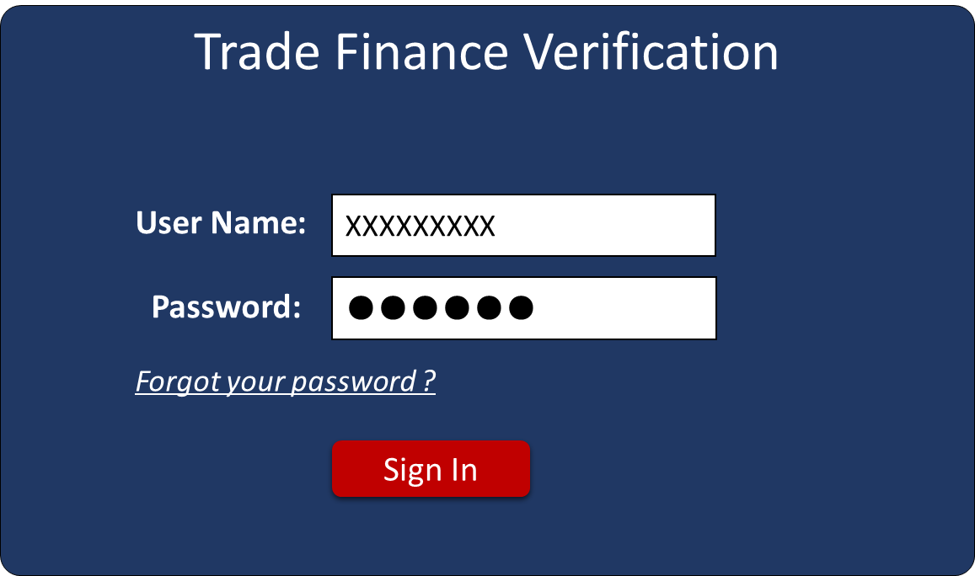

* **~~Normal Login~~**

~~In the login page of trade finance system, enter the following information:~~

~~Step 1：Enter User ID.~~

~~Step 2：Enter password, the password is case sensitive~~

~~Step 3：Click “Sign in”, the system will log into the main interface.~~

* **~~Password forgotten~~**

~~If password forget，you can get new password with follow steps as below：~~

~~Step 1：Click “Forget your password”, shown as next~~

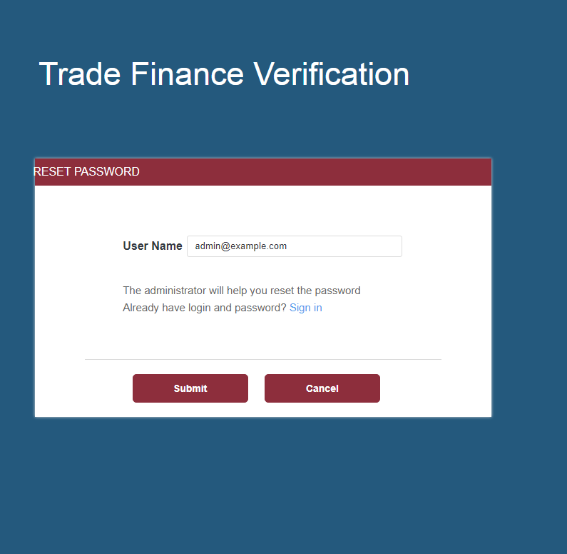

~~Step 2：Input your correct Email address and then click “Submit”，Click Sign in or Cancel if you have your password.~~

~~Step 3：the system server will send out email containing a link to reset your password.~~

~~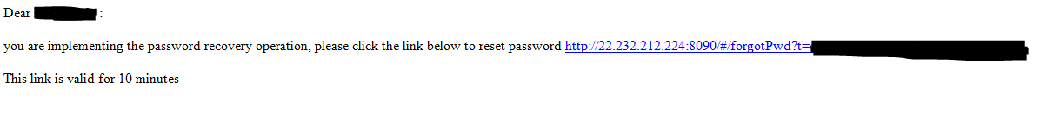~~

~~Step 4：Click on the link and follow the instruction to change your password.~~

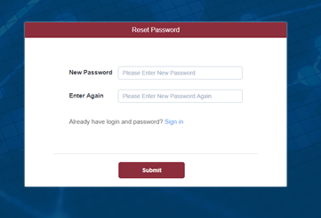

### Enhancement

* ~~Password wordings should be improved：Delete wording "Already have login and password?"~~
* User could Change Branch with a drop-down option for Company selection when user logins in system. Only 3 branches included in this phase: New York Branch, Chicago branch, and Los Angeles branch. NYB user will handle NYB and Chicago branch business data，LAB user will handle LA branch business data. No user id should be created in Chicago branch.
* User could also switch difference branches without logout. Click “Change Branch” and select company.
* The activities of user login/logout should be tracking, ~~refer to Chapter 4.15.2~~

3.2.1.1. Brief introduction to function

该模块主要是对账号创建、登录流程功能进行的的说明



3.2.1.2. Detailed description

* **创建账号**（原有账号管理系统）

使用统一的账号管理分配系统由管理员创建账号。

程序配置好TFS的账号系统

Step 1：创建角色

程序配置：参照3.5. Business Roles进行角色创建，共6个业务角色；另外再另创建一个Admin角色。进行管理员相关操作

Step 2: 银行配置

这一阶段只有3家分支机构:纽约分行、芝加哥分行和洛杉矶分行（New York Branch, Chicago branch, and Los Angeles branch）。钮约分行用户将处理钮约分行业务和芝加哥分行业务数据,洛杉矶分行用户仅处理洛杉矶分行业务。在芝加哥分行中不应该创建用户id。

**系统配置好只能在纽约分行&芝加哥分行下创建账号。并且钮约分行下的账号可以进行支行切换。TFS系统中有个branch下拉选择（不需要退出账号即可切换）**

Step3: 创建账号

人工创建，由相关管理人员在账号系统中创建账号。系统会自动把初始密码发送到用户邮箱，用户登录后自行修改密码。

Step4: 登录登出日志

用户登录退出要有日志可追踪。（原有）

相同账号不能同时登录不同PC设备

* **账号权限配置**（原有账号管理系统）

|  |  |  |
| --- | --- | --- |
| *一级菜单* | *二级菜单* | *功能菜单* |
| *Case Management* | *To Do List* | *编辑Input (关联）*  *编辑Input(非关联）*  *浏览INPUT* |
| *编辑Check(35个问题）*  *编辑Check(comments)*  *编辑Check(Evidence)* |
| *回复 #1*  *回复 #2*  *回复 #3*  *回复 #4*  *回复 #5*  *回复 #6~#9*  *回复 #10*  *浏览 #1*  *浏览 #2*  *浏览 #3*  *浏览 #4*  *浏览 #5*  *浏览 #6~#9*  *浏览 #10* |
| *上传文件*  *下载文件*  *浏览文件* |
| *浏览日志* |
| *Pending List* | *浏览INPUT* |
| *浏览 #1*  *浏览 #2*  *浏览 #3*  *浏览 #4*  *浏览 #5*  *浏览 #6~#9*  *浏览 #10* |
| *上传文件*  *下载文件*  *浏览文件* |
| *浏览日志* |
| *Pending List* | *浏览INPUT* |
| *浏览 #1*  *浏览 #2*  *浏览 #3*  *浏览 #4*  *浏览 #5*  *浏览 #6~#9*  *浏览 #10* |
| *上传文件*  *下载文件*  *浏览文件* |
| *浏览日志* |
| *Admin Management* | *List of sanctions countries* | *编辑*  *删除*  *新增* |
| *Common Tax Havens* | *编辑*  *删除*  *新增* |
| *Company name suffix list* | *编辑*  *删除*  *新增* |
| *Top 10 Exports* | *编辑*  *删除*  *新增* |
| *Customer list* | *编辑*  *删除*  *新增* |
| *List of third-party websites* | *编辑*  *删除*  *新增* |
| *Unit Configuration* | *编辑*  *删除*  *新增* |

* **正常登录流程**

Step 1: 输入账号密码

输入用户账号，用户账号区分大小写

输入密码，密码区分大小写

Step2: 初始密码修改

1. 点击登录，账号密码匹配正确则弹出初始密码修改框
2. 设置新密码

密码规则，至少8个字符，包含以下四种字符中的任意3种（数字、大写字母、小写字母、键盘上的符号）

密码符合规则，点击Confirm提示密码修改成功，文案:【Modified password successfully,please log in with the new password.】

C．点击Cancel&X, 关闭弹窗，未完成修改设置

Step3: 输入新密码，完成登录

* **异常登录流程**

Step 1: 账号异常

1. 账号不存在：提示文案：【Not this user】
2. 账号为空，登录按钮置灰不可点击

Step 2: 密码异常

1. 密码不匹配，提示文案：【Password error, you have 2 try login times】

B．这里会有一个密码错误次数的限制，在账号管理系统中设置，所以在提示不匹配时，会告诉还能尝试几次。当把次数尝试完，将无法登录系统。提示文案：【The number of consecutive login failures exceeds the upper limit】这时需要账号管理系统重新授权，重设密码

C．密码为空，登录按钮置灰不可点击

* **异常重设密码流程**

Step 1: 新设密码过短

新设密码少于8个字符，点击提示文案：“Your password is too short”

Step 2: 新设密码格式不对

点击提示文案：【Your password must contain any three of “lowercase letters”,”uppercase letters”,”numbers”,”special characters”.】

Step3: 再次输入的密码与第一次输入的不匹配

点击提示文案：【两次输入密码不一致，请核对后重新输入】

Step4: 表单输入值为空，Confirm不可点击

* **Remember Me**

Step 1: 勾选了，系统记住密码。但是系统只会记10天，如果10天没有操作的话，账号可以依然记住，但是密码需要重新输入

Step 2: 在账号输入框更改了登录账号，密码清空

Step 3: 记的是最近一次登录成功的账号密码

* **Forgot Password?**

Step1 线下联系管理员，让管理员进行重置

Step2 注册邮箱收到重置密码，走正常登录流程>>设置新密码

3.2.1.3. Interface requirements

|  |  |  |  |
| --- | --- | --- | --- |
| *Name of element* | *Required/optional* | *Type* | *Remarks* |
| **Password** | *Required* | *8~20-digit characters* | password must contain any three of “lowercase letters”,”uppercase letters”,”numbers”,”special characters” |

* 账号创建

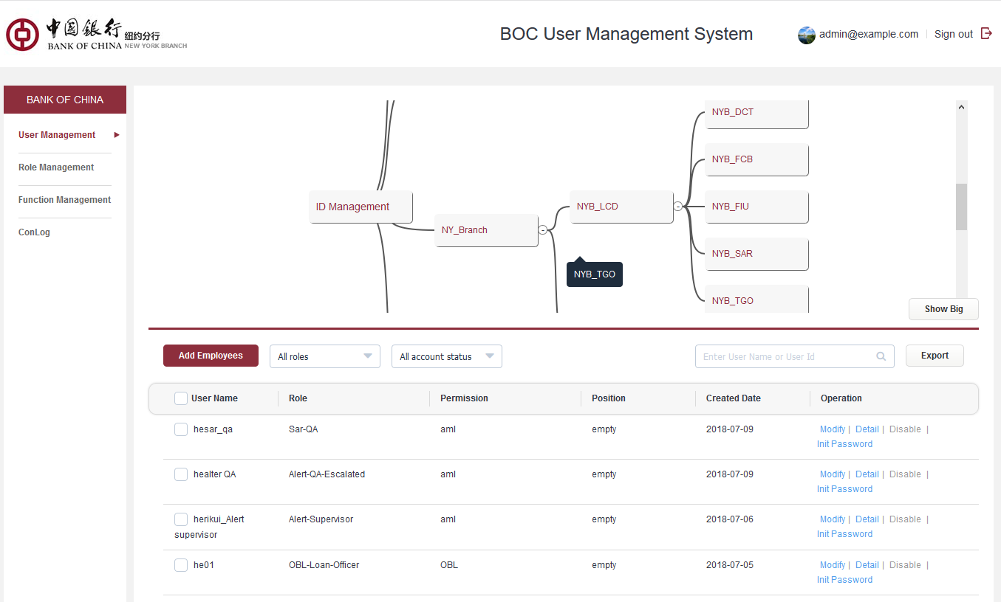

* **登录登出日志**

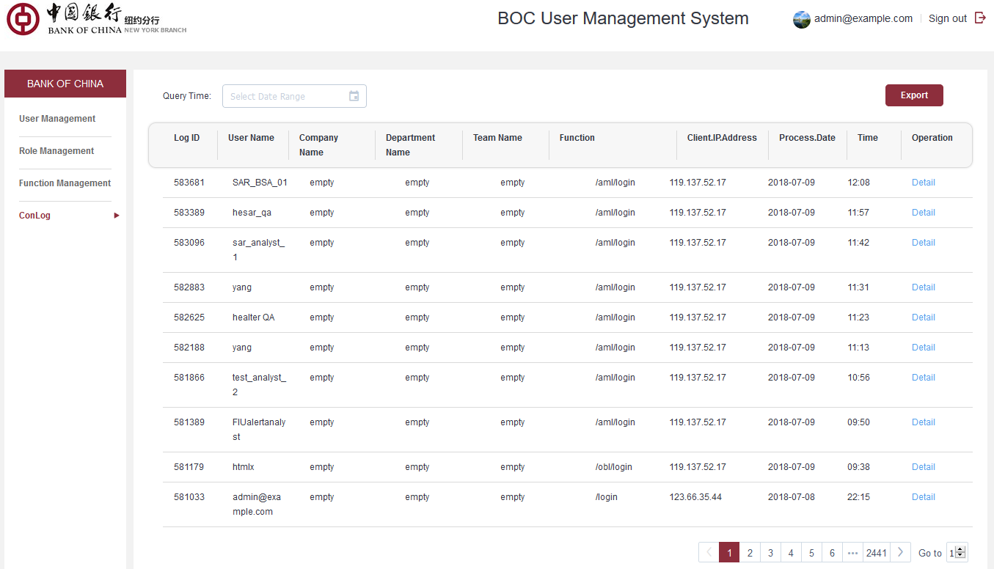

* **权限配置**

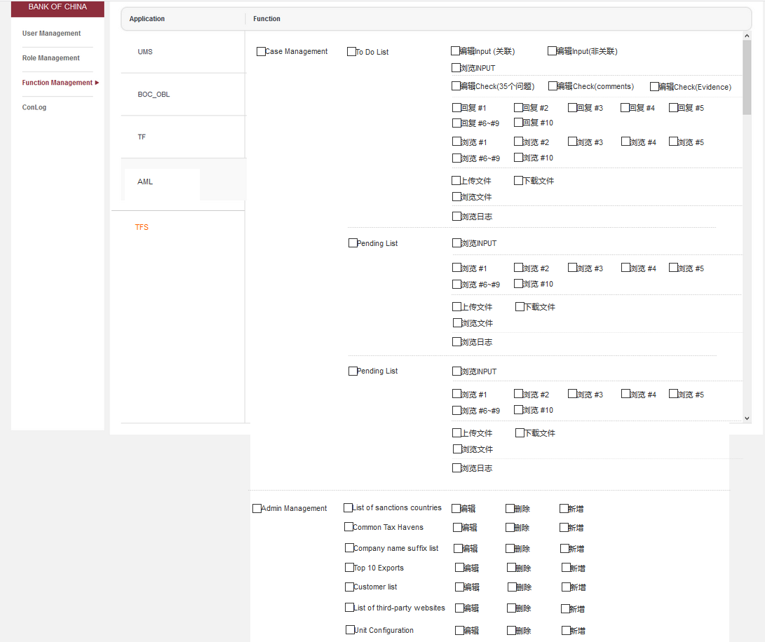

* **登录界面**

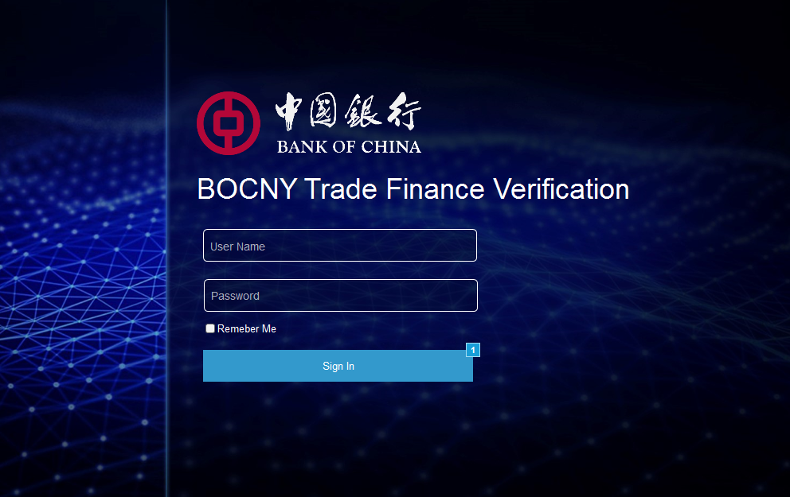

* **初始密码修改**

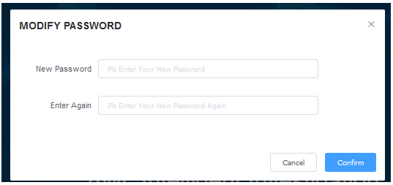

## **Home Page**

### ~~1..1. AS-IS~~

~~The As-Is system only provides support for the operations function of Operations Analyst, and does not involve other roles. When Operations Analyst logs into this system, it will directly enter his/her own Case List working screen.~~

~~At the title area of the Case List working screen, some of the main function links are provided (as follows):~~



~~includes:~~

1. ~~LOGO: Back to case list page when it is clicked.~~
2. ~~ID Configuration：account and password configure for external web resources.~~
3. ~~User ID: shown current login user’s email address.~~
4. ~~Sign out：If user wants to sign out the system, he/she could click the “Sign out” button shown in upper right. Then he/she will sign out the system.~~

### 1..2. Enhancement

* Add a user main working screen (Home Page).
* ~~The main working screen provides functional component management, while the user selects different functional components, and enters the operations interface of each component (displayed in Working Area)~~
* Add a “Change Branch” new function to Home Page, user can switch to other branches authorized to operate at any time. authorized branch at any time.

#### New Home Page

~~The new main working screen is provided as shown in the following figure:~~

~~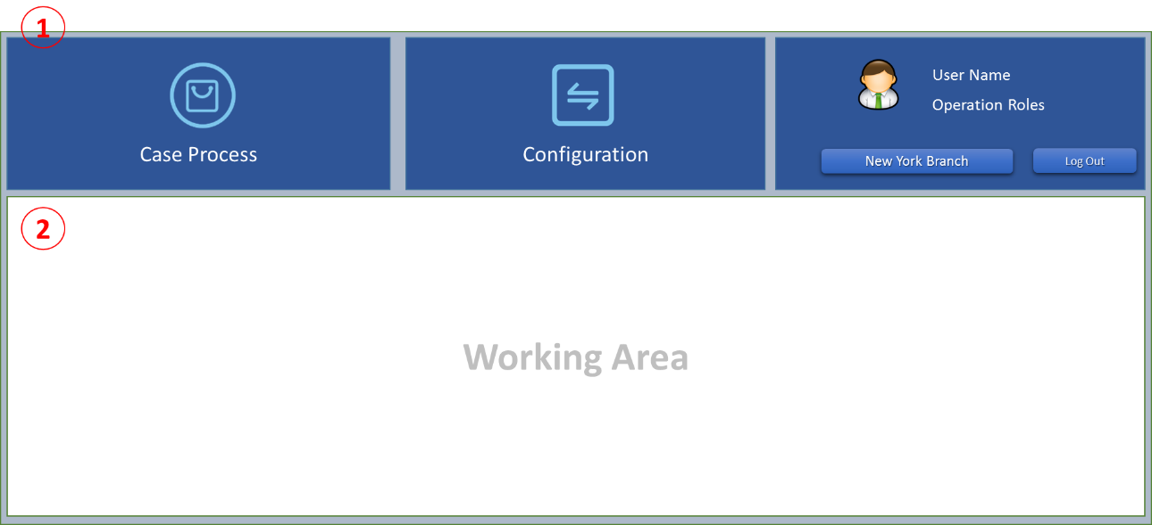~~

*~~Page description:~~*

* ~~This screen is divided into two areas: one is functional components area, and the other is working area.~~

~~The functional component area provides the user with access to the different operating function of the system, profile information of the currently login user, and related operations links. The work area is set to a blank page as default.~~

* When the user login successfully, it will go to this web page.
* ~~Items Description of functional component area~~

| ~~Item~~ | ~~Description~~ |
| --- | --- |
| ~~Case Process~~ | ~~Operations entry for handling case related operations. Includes case creation and case verify, case check, case review for operations unit, case review for compliance unit, and case feedback for LCD.~~  ~~Click to enter the user’s Case list screen, and:~~   * ~~Workflow management interface operations entry~~ * ~~Manual intervention of re-assign in case process flow~~ |
| ~~Configuration~~ | ~~An operations entry that includes the following function:~~   * ~~Static data import from Excel file~~ * ~~Static data maintenance~~ * ~~Extranet ID & Password configuration~~ |
| ~~User Profile~~ | * ~~Display current logon user information, such as user id, user name, working role, current business branch~~ * ~~Link of Sign-out/Logout.~~ |

* ~~Note: each functional component is shown in a blue background, while the current selected functional component is indicated as a green background.  
  After the user selects a component in the functional component area, the system will display the entry page for the component in the work area.~~

#### Change Branch

* Each TSD role of New York branch can handle business cases in both New York branch and Chicago branch. The Los Angeles branch only needs to handle the business cases for their own.
* The user management and authorization management functions are implemented by "user management module UMS". When the user ID is created for the system under UMS, the user should be assigned at least one branch to handle the Trade Finance AML Intelligence Screening business.
* When the user login successfully, the user can click the Change Branch at any time on the Home Page of the system. After switching successfully, the data and functions matched by the newly selected branches can be seen.
* ~~When the user wants to process cases for other branches, there are two switching modes. One is that the user exits the system first, then login again, and when he logs in, he chooses the other branch. The other is, after he has successfully logged in, switch to the designated branch in the Home Page of the system.~~
* ~~The following screen will pop up when the user clicks the link of [Branch Name] in the title area of the Home Page screen.~~

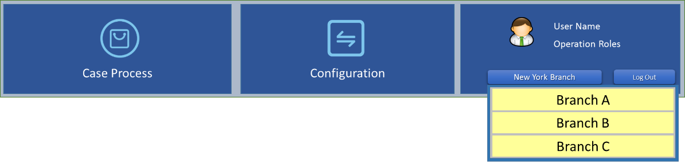

* The content of the drop-down list is the list of branches that the user has authorized to handle in the UMS system. The user selects a branch to switch, the user does not need to logout from the system at the time of switching, the work UI returns to Home Page, and the user can access and operate the data of the newly-switched branch.

3.2.2.1. Brief introduction to function

登录后，进入的默认页面，目前与与各角色的CASE列表页共为一个页面

3.2.2.2. Detailed description

* **通用导航栏**

首页LOGO不可点击，其它页LOGO点击跳转到首页

* **账号信息**

显示字段，默认头像ICON，是固定不可改的，设计根据需要去留

昵称，默认显示Use Name，有真实姓名则显示真实姓名

下方，显示当前角色。创建该账号时归的角色

点击图示区域，进入基本信息页

可以查看和修改一些基本信息

密码Password, NAME, Cell Phone、Telephone Number、Gender可供修改，其它字段不可修改，调取账号系统创建账号时填写的字段

点击Update Setting完成修改

* 密码修改规则

1. 旧密码输入正确，否则提示，【旧密码输入错误】
2. 新密码不能与旧密码相同，否则提示【旧密码不能与新密码相同】
3. 2次输入的新密码要匹配，否则提示【前后输入的密码要一致】
4. 表单为空，提交按钮置灰不可点击

* 退出登录

点击退出，退出当前页至登录界面

3.2.2.3. Interface requirements

* 基本信息可修改字段规则

|  |  |  |  |
| --- | --- | --- | --- |
| ***字段名称***  *Name of element* | ***是否必填***  *Required/optional* | ***字段类型和长度****Type* | ***备注***  *Remarks* |
| gender | *optional* | int |  |
| Name | *optional* | *60-digit characters* |  |
| Cell Number | *optional* | *20-digit number* |  |
| Telephone Number | *optional* | *20-digit number* |  |

* 首页

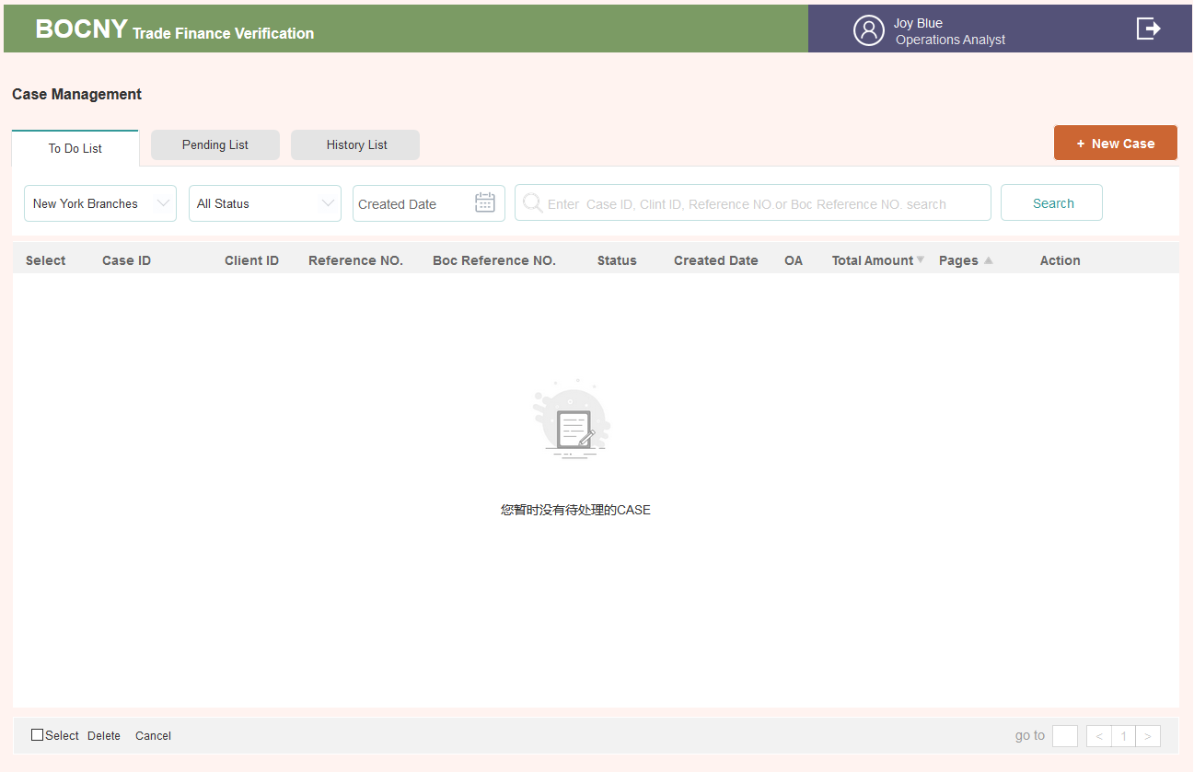

* 账号信息

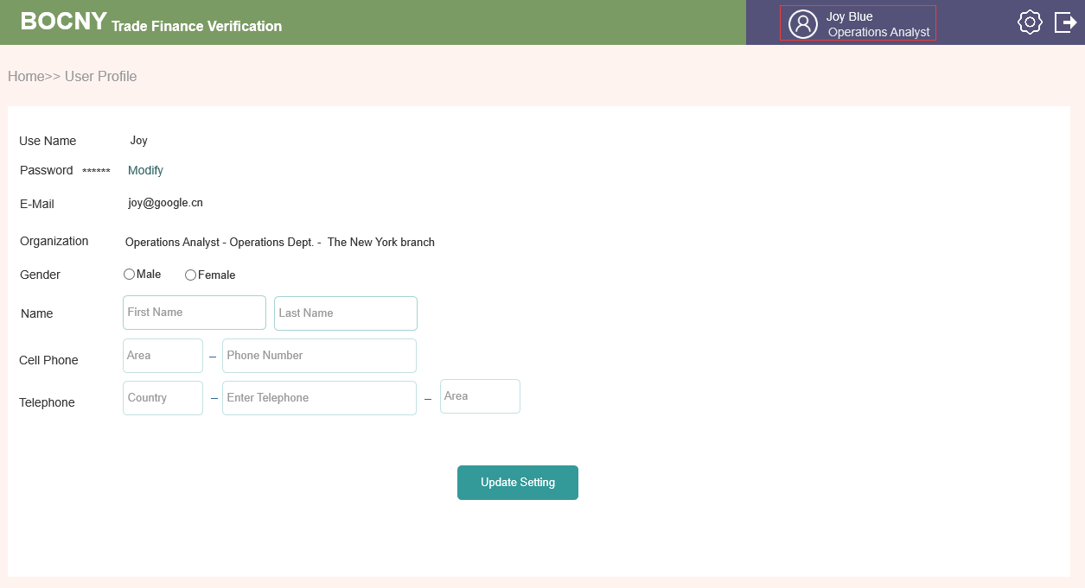

* 修改密码页

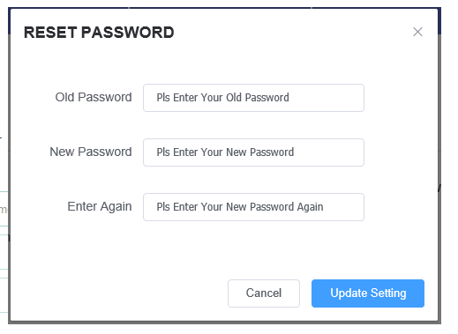

## **Operations Analyst: Case List Page**

### 1..1. AS-IS

~~Currently，User work area Part for Operations Analyst only is shown as below：~~

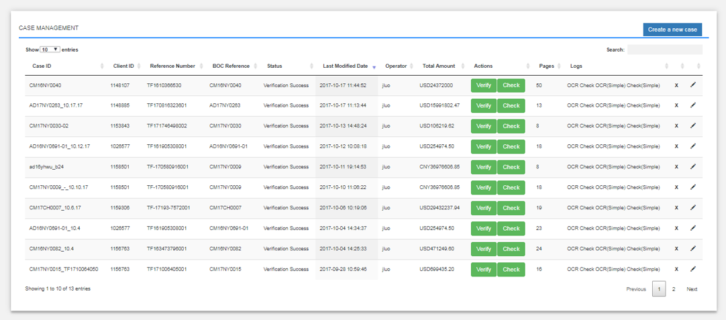

* 1. Show Entities: select how many entities you want to preview by each page. 4 options （10,25,50,100）for selection.
  2. Create a new case (Operations Analyst Only): case generation button.
  3. ~~Title items for transaction: Cases can be ranked by the item in each column. The case management page will summarize the following items for each case. Components in tables is shown as below~~

|  |  |
| --- | --- |
| ITEM | DESCRIPTION |
| Case ID |  |
| Client ID |  |
| Reference No |  |
| BOC Reference No |  |
| Status | Verification Success and Verification Failed. |
| Last Modified Date |  |
| Operations Analyst | Operations Analyst who created the case |
| Total Amount | Total amount for this case |
| Action | Upload of documents |
| Pages: | page amount of the uploaded PDF |

### 1..2. Enhancement

* N/A

3.2.3.1. Brief introduction to function

OA角色的工作台



3.2.3.2. Detailed description

列表状态

分为待处理, 处理中，已结束CASE列表（To Do List & Pending List & History List）

需要当前角色处理的CASE就放在了To Do List列表,

进入其它角色处理的CASE就放到Pending List里，可以方便当前角色追踪CASE是处在谁的处理下了

处理完了的CASE就放到了已结束History List列表里面。这个列表的搜索&列表标题字段，通Pending List

* **To Do List**

1. **状态**

这里有3种状态的CASE，1）点击+New Case创建成功后, 按钮为 Input; 2) Input里点击Submit,列表按钮变为Check; 详情页，Send to Manager后消失放入Pending List里 3) 被OM打回，按钮为Modify。详见状态列表1A~5B(含)；

1. **筛选**

* 筛选规则

所有搜索条件为关联搜索关系

比如选择了New York Branch, 那么状态则是在这个分行下面的

* 筛选字段

|  |  |
| --- | --- |
| ITEM | DESCRIPTION |
| branches | 钮约分行的用户看到的列表才有该字段，默认为New York Branch ,可以切换为Chicago branch。数据来于钮约分行用户创建CASE时选择的Branch |
| Action Status | 默认为全部 All Status , 下拉为Under OA Review，Under OA Modify等状态 |
| Created Date | 按创建日期进行搜索 |
|  |  |
| CASE 金额 | 货币格式 |
| 搜索框 | 允许按Case ID, Clint ID, Reference NO.or Boc Reference NO.搜索 |

1. **列表**

* 列表字段，见下表

|  |  |
| --- | --- |
| ITEM | DESCRIPTION |
| Select | 复选框，用于做批量操作 |
| Case ID | 来源于创建CASE时填写 |
| Client ID | 同上 |
| Reference NO. | 同上 |
| BOC Reference NO. | 同上 |
| Action Status | Under OA Review，Under OA Modify。考虑到列表显示字段有限，所以角色在列表显示时用缩写。但详情页要 完整显示 |
| Created Date | 创建日期，列表页显示到日，详情页需显示到时 正倒序 |
| Opertor | Operations Analyst who created the case |
| Total Amount | Total amount for this case，正倒序，来源于创建CASE时填写 |
| Pages | 上传时PDF总页数，会随着INPUT页面的增减而变化。正倒序 |
| Action | Input, Check, Details, Modify |

若CASE发生了修改，CASE字段也会相应的变化

* 排序规则

默认最新创建的展示在前

Created Date& Total amount &Pages3个字段可以按正倒序排列，三角指向顺应变化

* 翻页说明

一页显示数据可自由调整,默认为25条

可跳转翻页，有几页，下面的页数就显示几页，第一页时往前不可点击，最后一页时，往后不可点击，置灰

1. **删除&取消CASE**

* 只有OA角色才有该权限，并且只能删除他们自己创建的CASE，只有在OA可编辑状态方可做这二个操作
* 全选，选中select左边的框，则勾选当页全部CASE，可以进行批量操作，也可以单个选中进行操作
* 删除和取消CASE都需要填写原因，原因字符小于1000
* 删除

删除后，该CASE会在系统的数据库里记录删除原因。前端无处可见该CASE

* 取消CASE

取消case后，该CASE会在History List 里可见，可查询到所有记录，只是不再进入处理流

* **Pending List**

1. **状态**

* 状态列表6（含）以后扣除History List的状态会放在Pending List里详见状态表

1. **筛选**

通TO DO LIST

只不过，这里的状态是暂时不用处理的状态

时间，则是显示最近更新的时间。变化到当前所显示的状态的时间

1. **列表**

列表字段，见下表

|  |  |
| --- | --- |
| ITEM | DESCRIPTION |
| Select | 复选框，用于做批量操作 |
| Case ID | 来源于创建CASE时填写 |
| Client ID | 同上 |
| Reference NO. | 同上 |
| BOC Reference NO. | 同上 |
| Status | 状态列表6（含）以后的状态+取消的状态 |
| Modifled Date | 最近修改日期，列表页显示到日，详情页需显示到时 正倒序 |
| Opertor | Operations Analyst who created the case |
| Total Amount | Total amount for this case，正倒序，来源于创建CASE时填写 |
| Pages | 正倒序。上传时PDF总页数，会随着INPUT页面的增减而变化。 |
| **Action** | Details |

注意，日期与TO DO LIST是不同的，这里显示的是最近修改日期。

操作下的按钮，这里就是一个Details点进 详情页去看

3.2.3.3. Interface requirements

* **To Do List**

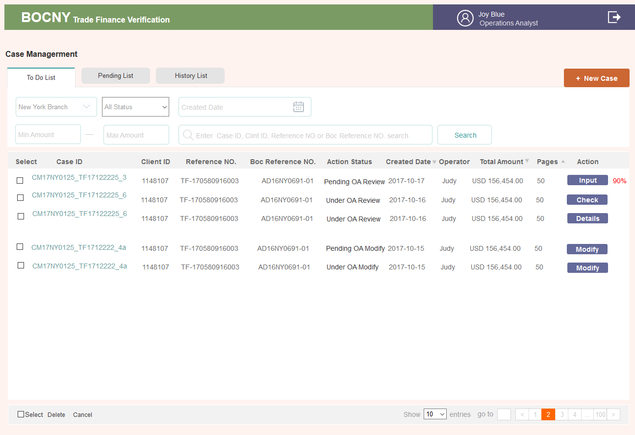

* **Pending List**

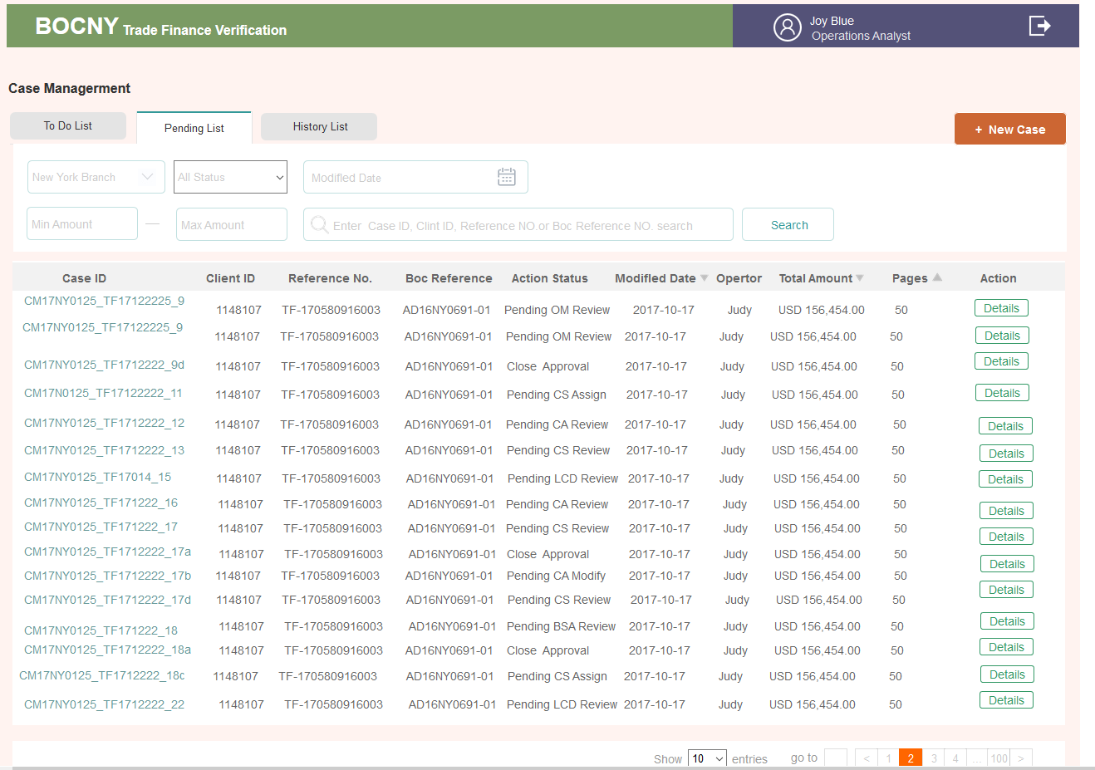

## **Operations Analyst: Create Case Page**

### 1..1. AS-IS

Creation of a case is handled by Operations Analyst, which is based for trade finance transaction risk mitigation review and related documents categorize.

* A case is created by an Operations Analyst and each case can be identified by the analyst’s User ID.
* Only PDF documents can be uploaded.

After ID configuration, the Operations Analyst can click the “Create a new case” button to create the new case. ~~The system will pop up a window.~~

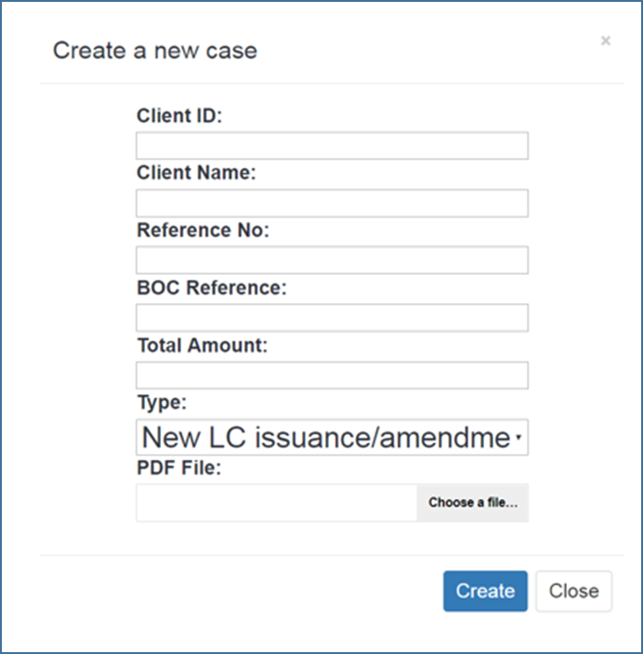

~~In the popup window, enter the following information:~~

~~Input component：~~

|  |  |  |
| --- | --- | --- |
| Field | Valid Data type |  |
| Case ID | Not need input | Need to show in page.  String, create automatically based on the name of upload PDF file ，input mandatory |
| Client ID | Arabic number  # auto-match hint with client name if the system has the client record | String，input manually, input mandatory ,appear selection which Operations Analyst could select one based on input characters |
| Client Name | Letter | String，selected automatically based on input client ID. Appear with client ID input in pairs |
| Reference No | Arabic number starting with TF | String，input manually, input mandatory, |
| BOC Reference | Letter/Arabic number | String，input manually, input mandatory, unique index code |
| Total Amount | Currency abbreviation in three letters and Arabic number | Input “USD” and case amount input mandatory, |
| Type | Select from the drop-down menu | 1. New LC Import issuance/amendment  2. New LC Import drawing  3. New LC Export documents/Transfer/AOP  4. New Inward Collections Documents  5. New Outward Collections Documents  6. Funded/Unfunded Risk Participation  7. Forfeiting  8. Factoring/Supply Chain Financing  9. Short Term Financing Transaction |

Subfolder Archiving:

The Operations Analyst may obtain documents from a client that may be an early draft of on invoice, B/L or another document. In these cases, the clients will present the final version of the document after discussion with the Bank. In this scenario, the bank will edit the electronic document to remove the early draft and replace it with the final document.

To accomplish the remove, edit and add functionality, the Operations Analyst, the system must be flexible and permit the creation of folders and sub-folders. Specifically, Operations Analyst must be able to:

* Insert one or more document pages to batch of documents
* Replace a document with another document
* ~~Create a subfolder to hold the original page(s) that were removed~~
* Rename subfolder as required
* ~~Advance or Reverse specific pages in a document so that the page location in a batch of document changes~~
* Move documents from the Sub-folder to the original documents.

For example:

1. Add invoice before B/L No. 5

2. replace B/L no. 1 by B/L no. 6 and move B/L no. 1 to subfolder (rename as bad B/L)

3. remove B/L No. 7 to subfolder (rename: pending )

4. drag B/L no. 7 from pending subfolder to original documents, position before B/L no. 4

5. direct upload customer instruction to subfolder (rename as customer instruction)

### 1..2. Enhancement

* Price input should include two sections:
  + Currency – Default value is USD. The currency list should start with: USD, CNY, EUR, JPY, GBP, KRW, CHF.
  + The ISO 4217 list of currency codes will be utilized in the system.
  + All amounts should be verified and include separators for “Thousands”. For example, if I manually input 250000, it should be adjusted as 250,000.00 automatically.
* For cases with the same reference number, Reference number will be unique code, system could block out and alert users once case create.

3.2.4.1. Brief introduction to function

只有OA有权创建案件， OA为降低贸易融资交易风险进行单证审核。并将案件归到相应的贸易融资业务类型中



3.2.4.2. Detailed description

OA角色点击首页列表右上角按钮+ New Case，会弹出创建CASE的页面

* **Upload Documents**

1. 上传PDF文档，会显示上传的一个进度情况。上传完成，打勾
2. 目前定的是能支持多选 上传，最多可以上传100份PDF，每份PDF 30M以内

电脑桌面或相关文件夹中，按住CTRL可以选中上传多份文档,

1. PDF名字，取上传时PDF的名字,如果发现名字重复，需要出提示弹窗，“已存在同名称的PDF文件，请确认或修改名称后上传“
2. 允许删除
3. 允许拖动调整位置，提交后，会按他们的位置顺序一页页PDF排序下来

* **提交（Submit）**

1. 只有表单必填项都填写了，并且文件至少上传了一份时，Submit提交这个按钮和提交并保存两个按钮才是可以点击的，否则都是置灰不可点击的。CC
2. 生成CASE时，系统会按照一定的编码规则，生成CASE ID. ID生成规则：TF+年月日+6位序列号

3. Submit(提交)是跳转到列表页。列表页新增一条CASE

4. Submit&Continue(提交并保存)，是一个新的添加NEW CASE的页面，方面CASE的连续导入工作。

5. Modify the Case 在 发送给OA(send to manager)前，这个页面是可以修改的。详情页点击右上角的Modify the Case进入。只有Submit按钮。点击Submit时出是否确认修改的提示弹窗。点击确认修改才会更新掉原有的内容。

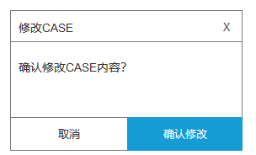

1. 新增了CASE，即可点击整个条目进入详情页，内容字段见详情页说明

7. 系统将基于文档类型，并在相应的文档类型 的文件夹中进行分类（数据库建表要求）

3.2.4.3. Interface requirements

* **基本字段说明**

字母，区分大小写，表单识别空格

|  |  |  |  |
| --- | --- | --- | --- |
| ***字段名称***  *Name of element* | ***是否必填***  *Required/optional* | ***字段类型和长度****Type* | ***备注***  *Remarks* |
| Client ID* | *Required* | *30-digit characters* | 数字、字母、下划线  手动输入 |
| Client Name | *Required* | *60-digit characters* | 数字、字母、横杆  如果是系统中原有客户，输入ID后会匹配自动把这客户的名字调取出来 |
| Reference No. | *Required* | *30-digit characters* | 具有唯一性，系统需要识别，若发现之前已输入过Reference No.点击下一个表单时识别：“Reference NO.已存在，请核对后重新输入” |
| BOC Relevance | *Required* | *30-digit characters* | 数字、字母、横杆 |
| 币种 | *Required* | *Dropdown menu* | Admin管理，默认权重最高的币种 |
| Total Amount | *Required* | *15-digit value* | 不管填没填会自动小数点后2位 |
| Branch | *Required* | *Dropdown menu* | 这一阶段只有3家分支机构:纽约分行、芝加哥分行和洛杉矶分行（New York Branch, Chicago branch, and Los Angeles branch）。钮约分行用户可处理钮约分行业务和芝加哥分行业务数据,可以下拉选择。  洛杉矶分行用户仅处理洛杉矶分行业务。无下拉框，直接写固定 的Los Angeles branch |
| Type | *Required* | *Dropdown menu* | 1. New LC Import issuance/amendment  2. New LC Import drawing  3. New LC Export documents/Transfer/AOP  4. New Inward Collections Documents  5. New Outward Collections Documents  6. Funded/Unfunded Risk Participation  7. Forfeiting  8. Factoring/Supply Chain Financing  9. Short Term Financing Transaction |

* 创建CASE界面

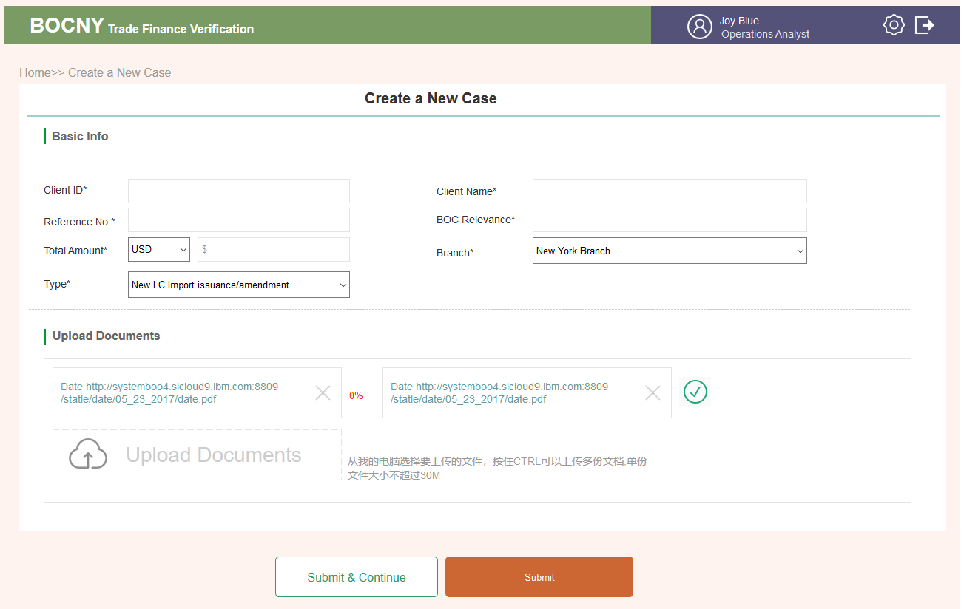

## **Operations Analyst: Case Verification Page**

### 1..1. AS-IS

Case verification is where Operations Analyst input and verify the relevant information for each transaction case. After the Operations Analyst click the ~~“Verify”~~ button, the system will enter ~~the case verification page.~~

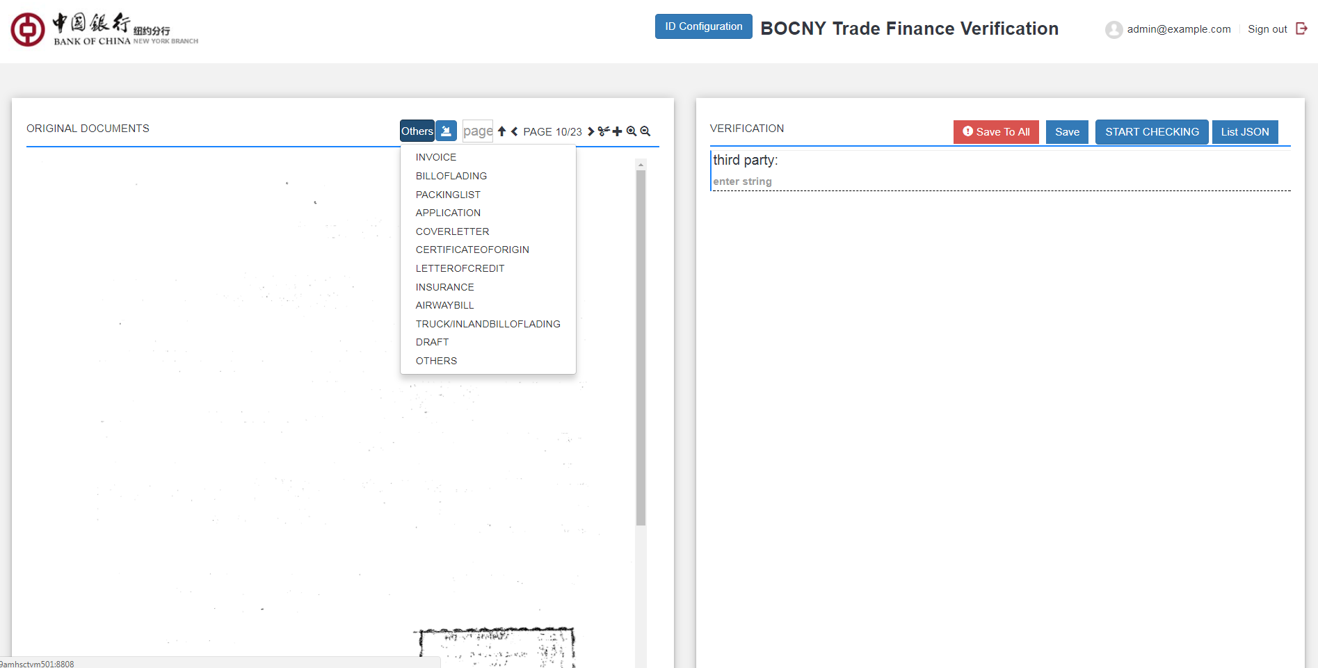

~~On the left-hand side of window, the system will show the original documents for preview. The system can automatically recognize two document types on each page. These two documents are the Invoice and Bill of Lading respectively. If the document type recognized by the system is incorrect, the Operations Analyst could also use the selection bar to change the document types.~~

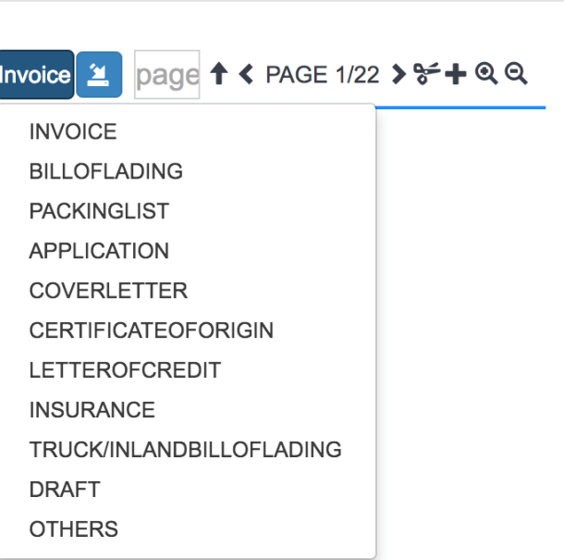

Other functions are listed in Quick reference

|  |  |  |
| --- | --- | --- |
| Button | Action | Reference |
| “<” and “>” buttons | “<” and “>” buttons will guide the Operations Analyst to switch to the previous and next page. |  |
| “ $↑$” | The Operations Analyst could also directly input the page number in “page” domain, then click “ $↑$”, the system will automatically jump to the according page. |  |
| ../Desktop/Screen%20Shot%202017-09-27%20at%206.45.50%20PM.p | The Operations Analyst could delete a page by clicking ../Desktop/Screen%20Shot%202017-09-27%20at%206.45.50%20PM.p button. System will prompt a window to ask whether the Operations Analyst confirms to delete the current page. If click “OK”, then the current page will be deleted. |  |
| ../Desktop/Screen%20Shot%202017-09-27%20at%206.50.37%20PM.p | If the current page is deleted by mistake, the Operations Analyst could click ../Desktop/Screen%20Shot%202017-09-27%20at%206.50.37%20PM.p to revoke the action or restore the detailed page. System will have two options. “PREVIOUS RECORD” allows Operations Analyst to recover to the latest record before deletion. “ORIGINAL RECORD” allows Operations Analyst to restore the document to its original state as initial upload. | ../Desktop/Screen%20Shot%202017-09-27%20at%206.14.11%20PM.p |
| “+” | To add extra PDF pages in the current case, the Operations Analyst could click “+” button on any page of document. Then a popup window will ask the Operations Analyst to upload the PDF file and the insert position before or after the current page. After click “Upload” button, the system return to case management page. The Operations Analyst could click “Verify” button to reenter the case with new added pages. |  |
| ../Desktop/Screen%20Shot%202017-09-27%20at%206.58.16%20PM.p | The ../Desktop/Screen%20Shot%202017-09-27%20at%206.58.16%20PM.pbuttons on the left-hand side of window allows Operations Analyst to zoom in/out the current page. On each document page, Operations Analyst can move the PDF by dragging the mouse. | ../Desktop/Screen%20Shot%202017-09-27%20at%206.58.16%20PM.p |
| ~~Save~~ | ~~save all field value in current page~~  ~~After the Operations Analyst finish entering and refining all the entity values, he/she could click “Save” button to save the entered value. A format reminder will be prompted if there is incorrect format. Without correcting the incorrect entity value format then clicking the “Save” button will trigger the following popup window The Operations Analyst must correct the incorrect format to save the current page.~~ | ../Desktop/Screen%20Shot%202017-09-27%20at%206.12.39%20PM.p |
| ~~Save to all~~ | ~~save all field value across same type of document~~  ~~If “Save To All” button is clicked, then the entity values across all the same document type will be saved as the current page value. A format reminder will be prompted if there is incorrect format. Without correcting the incorrect entity value format then clicking the “Save To All” buttons will trigger the following popup window. The Operations Analyst must correct the incorrect format on the current page.~~ | ../Desktop/Screen%20Shot%202017-09-27%20at%206.12.39%20PM.p |
|  | Rotate button, current page will be rotated 90 degrees once click, it could be saved after adjustment. |  |
| ~~START CHECKING~~ | ~~It should trigger the API process, and it will provide answers/evidence for auto/semi-automatically questions~~ |  |
| ../Desktop/Screen%20Shot%202017-10-23%20at%204.16.51%20PM.p | ~~Add/delete same set~~ |  |

~~The transaction documents fields please ref to Appendix 7.2~~

### 1..2. Enhancement

* ~~When 'shipment date' is blank an alert should be generated. The shipment date is necessary for a Lloyds search.~~
* ~~Operations Analyst should be able to select the document type from the document type drop-down list.~~
* ~~When a new page is added, the system will default the newly added page into the “Others” category.~~
* ~~New API to the new Lloyds website.~~
* ~~Adjust Verify Page: split PDF edit function (add page, delete page, change page sequence, rotate page, Operations Analyst can zoom-in or zoom-out or rotate for view) from original page and add new page for these edit functions; keep PDF view function (Operations Analyst can zoom-in, zoom-out, page up, page down, page restore) in original page.~~

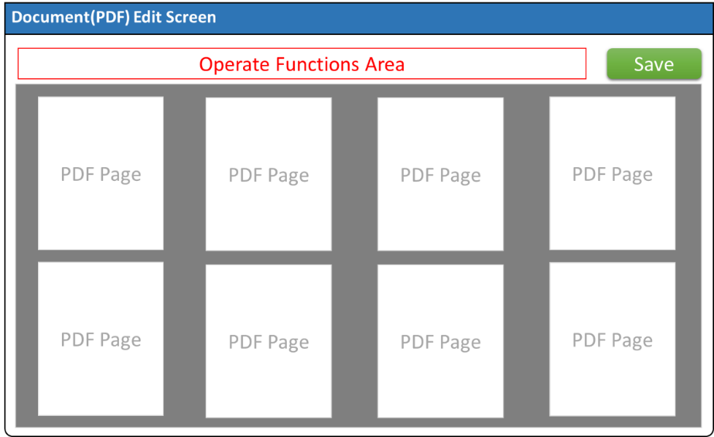

~~As is:~~

1. ~~Operations Analyst click “verify” button on case list page, switch to case verification screen(A)~~
2. ~~On screen (A) left side, Operations Analyst can edit PDF pages and identify documents page type.  
   On screen (A) Right side, Operations Analyst can input data refer to left side PDF page.~~
3. ~~After data input finished, click “Start Checking” button on the top of right site, and return to case list screen.~~

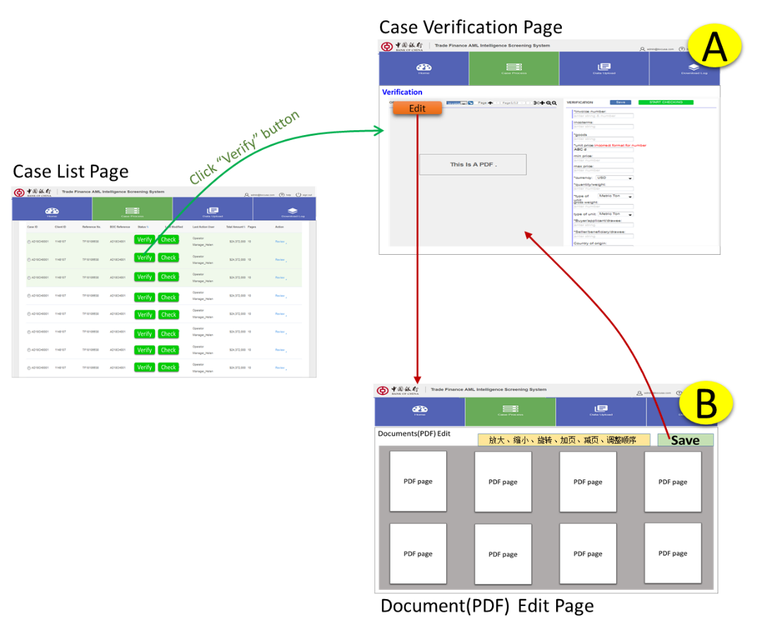

~~To be：~~

~~Split screen (A) to two screens. (Left side separate to screen B). Screen (B) focuses on PDF modifications. Screen (A) focuses on Data input and left side keeping PDF view function. Switch to screen-B from screen-A if needs~~

1. ~~Operations Analyst click “verify” button on case list page, switch to case verification screen(A)~~
2. ~~Add a “Edit” button on screen(A) left side, then skip to new screen(B)~~
3. ~~On screen (B), Operations Analyst can edit and click “Save” return to screen (A). The updated PDF file should be shown on the left side of screen(A).~~
4. ~~Input data on the right side of screen (A).~~

*~~Page description:~~*

* ~~In AS-IS Case Verify screen, an “Edit PDF” button is added to the left PDF file display area. When Operations Analyst wants to modify the content of PDF file, click this button to jump to Document Edit Page.~~
* ~~This page is divided into two areas: 1. Function control area, 2. PDF page display area.~~
* ~~The function control area includes basic operations buttons: enlarge, reduce, rotate, add pages, delete pages, browse pages and move pages.~~

~~The PDF page operations area will display multiple pages one by one in thumbnail mode.~~

* ~~When Operations Analyst finishes editing the PDF file, clicking the "Save" button will return to the Verify page and the contents of the updated PDF file will be displayed on the left side of the Case Verify page.~~
* ~~The left side of the Verify page only retains the functions of browsing page, enlarge page and reduce page, and the operations of the page classification and identification.~~

3.2.5.1. Brief introduction to function

案例录入是OA把CASE表单进行结构化，以便系统进行识别的地方



3.2.5.2. Detailed description

OA角色列表页&详情页 点击Input 进入

* + - * **左侧PDF**

1. **数据来源**

1）在Create a New Case 时上传了的PDF，会全部显示在这里。如果有传了EDD文档，也会显示在这里。会把PDF打散成一页一页的，在这里翻页显示

2）上传后，会在程序底层进行一个初始编号，该编号不会随着增删位置移动发生变化，比如100页，当删掉了98页，就是没有98页了，其它还是他们的编页

但是界面上的翻页还是会变化的，以当前实际页码翻页

1. **功能菜单**

|  |  |
| --- | --- |
| Button | Action |
|  | 1. 页数，有几页PDF就会显示几页，可以左上角翻页，或滚动条翻页。第一页往前置灰不可点，最后一页，往后置灰不可点  2. 双击数字，可以修改里面的数字，必须在页数范围内，否则输入不了。点击回车，进行跳页 |
|  | 点击，插入一张PDF，相当于是上传PDF的功能，插入到当前页的后面  出小弹层，”成功插入10张PDF” 1000ms后消失  页面停留在新插入的PDF的第一页  插入的PDF需要记录在加入的文件包中，见下说明 |
|  | 点击，删除当前页,  出一个小弹层  文案：” Permanent delete or move and save into subfolder？”  确认是要完全删除，还是说要暂存在回收站里 |
|  | 点击这个ICON，有两个操作可选，返回上一步，或回到第一步。基于点击右上角Submit前的操作。  左边PDF的操作每一个边操作边就自动保存（暂存）  **此处只是对左侧PDF的返回，对右边表单填写等相关操作不进行关联控制** |
|  | A.这是一个子文件包，点击小加号，可以增加子文件  B. 增加的子文件放到子文件包中  子文件夹页  A. 可进入子文件夹中添加文件，或删除子文件夹文件  B. 有翻页功能，点击 返回 |
|  | 1. 前面  点击删除的页面，会出现在旧文件夹里，用户可以点击进去，找回误删的页面   C.  点击还原当前页面，回收站页数减少。提示弹层，文案：【文件已移动到PDF】。1000ms后消失。插入到PDF的当前所在页前一页，返回即可看到最后插入的这一页  D. 可以点击加号，把一些要暂存，但是又不想放到PDF主文件夹里的文件插入到这里面，点击  时，把该页插入到PDF里。插入到PDF的当前所在页前一页，返回即可看到最后插入的这一页 |
|  | 1）鼠标移入PDF框，会出现该ICON所在弹层  2）单击键头指的是往前移或者往后移一个位置  （即当前是第10页，点击向下键头，则该第10页变到第11页，第11页变到第10页），  注意第一页不能往上、向上置灰，最后一页不能往下，往下置灰  3）如果点击小三角的话，会出一个弹窗，可以进行跳页，比如当前是在第15页 ，点击向上右的小三角，可以填写小于15的数字，进行跳页，将当前页插入到指定页数上  4）跳页还涉及绑定票据类型问题，如到第10页，把其插入到第5页，而原关联关系，1到5页为发票，6到8页为提单。插入的这个第10页会自动归到发票中，则1到6为发票，7到9为提单 |
|  | 1）鼠标移入PDF框，会出现该ICON所在弹层  2）从右往左，分别表示  放大、缩小、还原（把放大放小的还原到默认大小）、  旋转（把该页PDF旋转方向） |
| 滚动条 | 也是鼠标移入才会出现，进行下拉翻页 |

* + - * **右侧下拉框**

1. 概说

这里有2种录入方式，一种是关联录入，一种是不关联录入，

1）关联录入方式会将各种单证与发票绑定，个别不与发票绑定，则选择不绑定发票

用户看到左侧创建CASE时上传的PDF会去识别这张PDF是属于哪种单证（提单、发票之类的），同时看这张单证是属于哪张发票下面的。（可以理解成淘宝买了一个订单获得一张发票表示该订单，该发票下面会附着快递单、提贷单等单证）

2）不关联录入，就是直接选择单证模板，不进行关联操作

不关联录入的单单相符比对为全部单证比对，比如里面有3张发票，5张运输单（可能海陆空单）；4张装箱单

则所有发票的产品&数量 &单位字段，与所有运输单里加起来的总和进行比对

1. 字段

|  |  |  |
| --- | --- | --- |
| 一级类目 | 二级类目 | 三级样板 |
| NO INVOICE | BILLOFLADING | BILLOFLADING 1  BILLOFLADING 3  BILLOFLADING 7 |
| PACKINGLIST |  |
| APPLICATION |  |
| COVERLETTER |  |
| CERTIFICATEOFORIGIN |  |
| L/C ISSUANCE |  |
| INSURANCE |  |
| AIRWAYBILL |  |
| TRUCKIN LAND BILL |  |
| OF LADING |  |
| DRAFT |  |
| OTHERS |  |
| INVOICE 1 | 同上 | 同上 |
| EDD FORM | COMMODITIES SECTORS | OIL & PETROLEUM |
| INSURANCE SECTORS |  |
| OIL & PETROLEUM |  |
| SHIPPING &SHIPBUILDING SECTORS |  |

1. **关联录入层级关系**

这里分为三个层级，一般来说，一张发票会关联一系列的提单、装箱单等。当然也有些票据不关联发票。

1）**第一层级**为关联关系确认（不关联发票、关联发票、EDD类）

2）**第二层级**为关联确认关系下的对应表单

除发票外的所有票据类型（后期可能会根据创建CASE时选的那个 TYPE类型进行对应票据调取）

点击对应类型，则调出对应的空表单（如提单）

**3）第三层级**为已填过的表单，点击SAVE或SUBMIT会进入到第三层级

同一类型的表单，可能会有多张，所以会进行一个标号

**4) 在左边选择PDF时，会去识别左边PDF翻了几页，点击调取空表单时，把这个识别到的页数同时显示在右上角，头尾可增删。**

**如果发生了跳页，**如到第10页，把其插入到第5页，而原关联关系，1到5页为发票，6到8页为提单。插入的这个第10页会自动归到发票中，则1到6为发票，7到9为提单

**点击save&submit提交后，再次点开这个表单，左边的PDF会自动翻到第一页**

**4. NO INVOICE**(不关联发票)

1）表示左侧的这个PDF单证类型，不与任何发票关联

2）移入，调出第二层级--对应的单证类型，无点击效果

3）第二层级，这里会有一些映射关系。

1）点击右上角映射设置，弹出映射字段勾选框，保存后，当再碰到相同的单证，如提单2时，会按照该页（如提单1）设置的字段自动映射字段，就不用再次录入了。

2）如果碰到新的（如提单3）重新设置了，则会清空提单1的设置，到录提单4时就按提单3设置的情况进行录入了。

如果在提单3将所有的映射字段清空了，并点击保存时，提单4不再继续映射。（提单3点击映射设置时，默认的是把提单1设置的映射字段映射过来的

4） 第三层级。当第二层级在表单中填写了相应内容，点击SAVE（保存）或者SUBMIT（提交）时，第三层级产生了相应的内容，点击可以选中切换。

5） 第三层级，点击这个图标，可以拖动单证，比如这个单证是属于INVOICE1下面的，可以把他拖到INVOICE2或者NO INVOICE下面

1. **INVOICE**

第一层级

1. 如果要跟发票关联，需要先添加发票

点击+ADD INVOICE, 在第1层目录会多出来一个INVOICE，按顺序编号

鼠标移入，显示二层目录，让用户选择与该发票关联的其它单证

点击的话，则直接调出该发票。

1. 删除
2. 如果删除的话，则重新编号。
3. 删除只会把该张发票删除，他下面关联的其它表单会自动放入NO INVOICE里面
4. 删除时，会出现提示弹窗，详见原型。
5. 注意，系统里不可逆的删除，都要有一个提示弹窗，让用户再确认一遍
6. 发票字段备注

当该发票已录入了内容（比如INVOICE1）

鼠标移入，左侧还会出现一些备注，让用户知道现在这个发票的一些基本内容，便于选择跟该发票关联的单证

字段为

发票号（Invoice Number）、买家(Invoice Buyer / Applicant / Drawee)、卖家(Invoice Seller / Beneficiary / Drawer)、总金额(所有商品 单价*数量相加的总和)、前三款产品标题

1. 第二第三层级规则，通NO INVOICE不再赘述

* **SAVE&SUBMIT**

1. **中途退出**

当用户在该页面做了任何操作，包括左侧的增删PDF等操作时，未经保存即退出该页面时。会出现提示弹窗

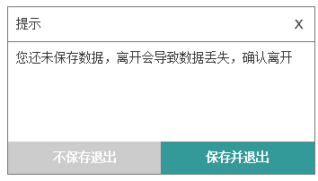

**2.SAVE**

1) 是为了用户在操作中避免数据流失（如断电等），过程中的及时保存。不会出现页面跳转

2) 点击保存后，左侧PDF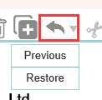这个控件，理论上是置灰的

3）下拉框第三层级会有该表单

4）详情页Documents Verification会把添加了内容的表单放于其间

5）没有任何操作，SAVE&Submit置灰，

**3.Submit**

1）点击submit跳转到详情页

2）Submit按钮启动了下一个步骤。列表页按钮变为Check

3) 详情页置灰的Evidence Management&Check按钮变为可点击

4）点击Submit时就可以先把相关字段去请求API接口，能出结果的就先出结果。暂时出不了结果的，显示待验证

结果分为2种，一种是单单相符验证结果。一种是与第三方验证出的结果，除了其它项，所有项的验证说明都在35个问题里

程序将~~第三方账号、~~CASE信息、INPUT的内容传输给到第三方, 第三方账号在ADMIN端创建时，即已先传输给到API接口了

程序API对接输入

从第三方 T24&graphen返回相应的信息

A．35个问题可回答的答案YES&NO&N/A；有COMMENT的传回COMMETNT显示

B．每个问题有证据的，对应的证据字段（形成EXCEL）或链接或其它形式文档或NO FOUND；ALERT之类的字段

~~C. 如果传过去的第三方账号信息字段有误，会返回一个弹窗~~

~~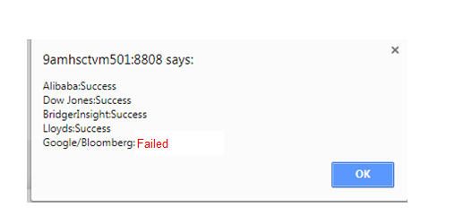~~

~~部份账号Failed不影响其它信息的获取~~

~~D. input页面有误的字段信息，在TFS平台会进行红色标识~~

~~3. 上图结果可能在点击SUBMIT或者点击Check时返回~~

* 发送给OM后，该页面不再允许编辑

1. 点进的input页面，不再允许编辑

2. 左侧保留翻页滚动条，放大缩小还原功能；

垃圾箱&添加的页功能（不能编辑）其它角色无此二页

3. 右侧表单内中不再允许编辑增删（增删多选控件消失

4. 下拉框只是点击调出相应页面，点击调出空页面、增加发票、移动归类功能消失）

5. Save&Submit按钮消失

* **表单**

1. 能否增加字段，表示该字段是可以有多个的，所以在原型上有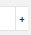用于增减
2. 多个字段合并单元格的，表示是成串增减的，比如商品描述那一系列字段
3.  与35个问题关联，见3.2.16 35个问题说明

3.2.5.3. Interface requirements

* **表单字段规则**

1. INVOICE（发票）

|  |  |  |  |  |
| --- | --- | --- | --- | --- |
| ***字段名称***  *Name of element* | ***是否必填***  *Required/optional* | ***字段类型和长度****Type* | ***能否增加***  *Can Add* | ***备注***  *Remarks* |
| *Invoice Number* | *Required* | *50-digit*  *number/letter/-//* | *N* | *Any arabic number and String combination, including -, /, ., i.e. 16TAC-123AA* |
| *Goods Description* | *Required* | *Max255Text* | *Y* |  |
| *Unit Price* | *Required* | *15-digit value* | *小数点后2位，价格格式。没有填写小数字后2位，到下一表单，自动补齐* |
| *Currency* | *Required* | *Dropdown menu* | *Admin后台管理，权重最高的为默认单位* |
| *Quantity / Weight* | *Required* | *15-digit number* | *数字、允许小数点后2位*  *标题2个下拉选某一个名称* |
| *Type of Unit* | *Required* | *Dropdown menu* | *Admin后台管理，权重最高的为默认单位* |
| *Gross Weight* | *optional* | *15-digit number* | *数字、允许小数点后2位* |
| *Type of Unit* | *optional* | *Dropdown menu* | *Admin后台管理，权重最高的为默认单位* |
| *Country of Origin* | *optional* | *Dropdown menu* | *国家插件（含全称&简写），表单搜索，下拉形式。填写了一个，后面增加的自动填充该字段，以最近的国家默认填充* |
| *Invoice Buyer /*  *Applicant /*  *Drawee* | *Required* | *60-digit characters* | *N* | *Invoice Buyer 3个标题字段，下拉选某一个名称* |
| *Invoice Seller /*  *Beneficiary /*  *Drawer* | *Required* | *60-digit characters* | *N* | *Invoice Seller 3个标题字段，下拉选某一个名称* |
| *Assignee Name* | *optional* | *60-digit characters* | *Y* |  |
| *Transferee Name* | *optional* | *60-digit characters* | *Y* |  |
| *Manufacturer / Supplier(下拉选某一个名称)* | *optional* | *Max255Text* | *Y* |  |
| *Invoice Third Party* | *optional* | *Max255Text* | *Y* |  |

1. BILLOFLADING（提单）

|  |  |  |  |  |
| --- | --- | --- | --- | --- |
| ***字段名称***  *Name of element* | ***是否必填***  *Required/optional* | ***字段类型和长度****Type* | ***能否增加***  *Can Add* | ***备注***  *Remarks* |
| B/L NO. | *Required* | *50-digit*  *number/letter/-//* | N | *Any arabic number and String combination, including -, /, ., i.e. 16TAC-123AA* |
| Port of Loading | *optional* | *Max255Text* | Y |  |
| BL P/L Ccountry | *optional* | *Dropdown menu* | 国家插件 |
| Port of Discharge | *optional* | *Max255Text* | Y |  |
| BL P/D Country | *optional* | *Dropdown menu* | 国家插件，表单搜索，下拉形式 |
| Transshipment Country | *optional* | *Dropdown menu* | Y | 国家插件，表单搜索，下拉形式 |
| Goods Description | *Required* | *Max255Text* | Y |  |
| Gross Weight | *Required* | *15-digit value* | 数字、允许小数点后2位 |
| Type of Unit | *Required* | *Dropdown menu* | Admin后台管理 |
| Quantity / Weight  (下拉选某一个名称) | *optional* | *15-digit value* | 数字、允许小数点后2位 |
| Type of Unit | *optional* | *Dropdown menu* | Admin后台管理 |
| BL Shipper | *Required* | *60-digit characters* | Y |  |
| BL Consignee | *optional* | *60-digit characters* | Y |  |
| Notify Party | *optional* | *100-digit characters* | Y |  |
| Vessel Name / IMO NO. | *Required* | *100-digit characters/50-digit*  *number* | Y | （船号/船名）Arabic number /String |
| Shipment Date | *Required* | Datetime | *Display in the format of yyyy-mm-dd;* 时间插件 |
| Transshipment Vessel | *optional* | *100-digit characters* | Y |  |
| Transshipment Date | *optional* | Datetime | *Display in the format of yyyy-mm-dd;* 时间插件 |
| Forwarding Agent | *Required* | *100-digit characters* | Y |  |
| Destination Agent | *Required* | *100-digit characters* | Y |  |
| Carrier/Master | *Required* | *100-digit characters* | Y | *Carrier 2个标题字段下拉选某一个名称* |
| Shipping Agent | *optional* | *100-digit characters* | Y |  |
| BL Third Party | *optional* | *100-digit characters* | Y |  |

1. PACKINGLIST(装箱单)

|  |  |  |  |  |
| --- | --- | --- | --- | --- |
| ***字段名称***  *Name of element* | ***是否必填***  *Required/optional* | ***字段类型和长度****Type* | ***能否增加***  *Can Add* | ***备注***  *Remarks* |
| Goods Description | *optional* | *Max255Text* | Y |  |
| Gross Weight | *optional* | *15-digit value* | 数字、允许小数点后2位 |
| Type of Unit | *optional* | *Dropdown menu* | *Admin后台管理，权重最高的为默认单位* |
| Net Weight | *optional* | *15-digit value* | 数字、允许小数点后2位 |
| Type of Unit | *optional* | *Dropdown menu* | *Admin后台管理，权重最高的为默认单位* |
| PL Third Party | *optional* | *100-digit characters* | Y |  |

1. APPLICATION (申请表)

|  |  |  |  |  |
| --- | --- | --- | --- | --- |
| ***字段名称***  *Name of element* | ***是否必填***  *Required/optional* | ***字段类型和长度****Type* | ***能否增加***  *Can Add* | ***备注***  *Remarks* |
| Application Buyer/Applicant/Drawee | *Required* | *100-digit characters* | N | Application Buyer *3个标题字段，下拉选某一个名称* |
| Application Seller/Beneficiary/Drawer | *Required* | *100-digit characters* | N | Application Seller *3个标题字段，下拉选某一个名称* |
| Transferee Bank | *optional* | *100-digit characters* | Y |  |
| High Risk Country | *optional* | *Dropdown menu* | *Admin后台管理* |
| Bank of China | *optional* | *100-digit characters* |  |
| Second Beneficiary | *optional* | *100-digit characters* |  |
| Assignee | *optional* | *100-digit characters* | Y |  |
| Assignee Bank | *optional* | *100-digit characters* |  |
| High Risk Country | *optional* | *Dropdown menu* | Admin后台管理 |
| Bank of China | *optional* | *100-digit characters* | 无，识别空格、大小写 |
| Shipment Date in Application | *optional* | Datetime | Y | 日期插件  mm-dd-yyyy |
| Application Date | *Required* | Datetime | N | 日期插件 |
| Application Third party | *optional* | *100-digit characters* | Y | 无，识别空格、大小写 |

1. COVERLETTER (说明信)

|  |  |  |  |  |
| --- | --- | --- | --- | --- |
| ***字段名称***  *Name of element* | ***是否必填***  *Required/optional* | ***字段类型和长度****Type* | ***能否增加***  *Can Add* | ***备注***  *Remarks* |
| Correspondent Bank | *optional* | *100-digit characters* | Y |  |
| High Risk Country | *optional* | *Dropdown menu* | Admin后台管理 |
| Bank of China | *optional* | *100-digit characters* |  |
| CL Third Party | *optional* | *100-digit characters* | Y |  |

1. CERTIFICATE OF ORIGIN 原产地证明书

|  |  |  |  |  |
| --- | --- | --- | --- | --- |
| ***字段名称***  *Name of element* | ***是否必填***  *Required/optional* | ***字段类型和长度****Type* | ***能否增加***  *Can Add* | ***备注***  *Remarks* |
| Origin | *Required* | *Dropdown menu* | Y | Country full name or Abbreviation 国家插件 |
| Certificate Third  Party | *optional* | *100-digit characters* | Y |  |

1. L/C ISSUANCE 信用证

|  |  |  |  |  |
| --- | --- | --- | --- | --- |
| ***字段名称***  *Name of element* | ***是否必填***  *Required/optional* | ***字段类型和长度****Type* | ***能否增加***  *Can Add* | ***备注***  *Remarks* |
| *Advising Bank* | *optional* | *100-digit characters* | *Y* | *BANK OF CHINA* |
| *High Risk Country* | *optional* | *Dropdown menu* | *Admin管理* |
| *Bank of China* | *optional* | *100-digit characters* |  |
| *LC Transshipment Country* | *optional* | *Dropdown menu* | *Y* | *国家插件* |
| *Port*  *Of Loading/Departure Place/From* | *optional* | *100-digit characters* | *Y* | *标题字段3个下拉选一个* |
| *LC P/L country* | *optional* | *Dropdown menu* | *国家插件* |
| *Port of Discharge/Arrvial Place/To* | *optional* | *100-digit characters r* | *Y* | *标题字段3个下拉选一个* |
| *LC P/D Country* | *optional* | *Dropdown menu* | *国家插件* |
| *Goods Description* | *optional* | *Max255Text* | *Y* |  |
| *Unit Price* | *optional* | *15-digit value* | *小数点后2位，价格格式。没有填写小数字后2位，到下一表单，自动补齐* |
| *Currency* | *optional* | *Dropdown menu* | *Admin后台管理，权重最高的为默认单位* |
| *Type of Unit* | *optional* | *Dropdown menu* | *Admin后台管理* |
| *Applicant* | *optional* | *100-digit characters* | *N* |  |
| *Beneficiary* | *optional* | *100-digit characters* | *N* |  |
| *End User* | *optional* | *100-digit characters* | *Y* |  |
| *LC Third Party* | *optional* | *100-digit characters* | *Y* |  |

1. INSURANCE 保险单

|  |  |  |  |  |
| --- | --- | --- | --- | --- |
| ***字段名称***  *Name of element* | ***是否必填***  *Required/optional* | ***字段类型和长度****Type* | ***能否增加***  *Can Add* | ***备注***  *Remarks* |
| Insurance Company | *Required* | *Max255Text* | Y |  |
| Insurance Issuing Agent | *Required* | *100-digit characters* | Y |  |
| Insurance Third Party | *optional* | *100-digit characters* | Y |  |

1. AIRWAYBILL 空运单

|  |  |  |  |  |
| --- | --- | --- | --- | --- |
| ***字段名称***  *Name of element* | ***是否必填***  *Required/optional* | ***字段类型和长度****Type* | ***能否增加***  *Can Add* | ***备注***  *Remarks* |
| AWB NO. | *Required* | *50-digit*  *number/letter/-//* | N | *Any arabic number and String combination, including -, /, ., i.e. 16TAC-123AA* |
| Shipment Date | *Required* | Datetime | N | *Display in the format of yyyy-mm-dd;* 时间插件 |
| Departure Airport | *optional* | *Max255Text* | Y |  |
| Departure Airport Country | *optional* | *Dropdown menu* | 国家插件 |
| Arrival Airport | *optional* | *Max255Text* | Y |  |
| Arrival Airport Country | *optional* | *Dropdown menu* | 国家插件，表单搜索，下拉形式 |
| Transshipment Country | *optional* | *Dropdown menu* | Y | 国家插件，表单搜索，下拉形式 |
| Goods Description | *Required* | *Max255Text* | Y |  |
| Gross Weight | *Required* | *15-digit value* | 数字、允许小数点后2位 |
| Type of Unit | *Required* | *Dropdown menu* | Admin后台管理 |
| Quantity / Weight | *optional* | *15-digit value* | 数字、允许小数点后2位(下拉选某一个名称) |
| Type of Unit | *optional* | *Dropdown menu* | Admin后台管理 |
| Airwaybill Shipper | *Required* | *60-digit characters* | Y |  |
| Airwaybill Consignee/Receiver | *Required* | *60-digit characters* | Y | 标题字段下拉选某一个名称 |
| Airwaybill Notify Party | *optional* | *100-digit characters* | Y |  |
| Transshipment Airport | *optional* | *Max255Text* | Y | （ |
| Transshipment Date | *optional* | Datetime | *Display in the format of yyyy-mm-dd;* 时间插件 |
| Forwarding Agent | *Required* | *100-digit characters* | Y |  |
| Destination Agent | *Required* | *100-digit characters* | Y |  |
| Carrier | *Required* | *100-digit characters* | Y |  |
| Carrier Agent | *optional* | *100-digit characters* | Y |  |
| AIRWAY Third party | *optional* | *100-digit characters* | Y |  |

1. TRUCKIN LAND BILL OF LADING 货车运输提单

|  |  |  |  |  |
| --- | --- | --- | --- | --- |
| ***字段名称***  *Name of element* | ***是否必填***  *Required/optional* | ***字段类型和长度****Type* | ***能否增加***  *Can Add* | ***备注***  *Remarks* |
| TRUCK BL  NUMBER | *Required* | *50-digit*  *number/letter/-//* | N | *Any arabic number and String combination, including -, /, ., i.e. 16TAC-123AA* |
| Shipment Date | *Required* | Datetime | N | *Display in the format of yyyy-mm-dd;* 时间插件 |
| Departure Place | *optional* | *Max255Text* | Y |  |
| Departure Country | *optional* | *Dropdown menu* | 国家插件 |
| Arrival Place | *optional* | *Max255Text* | Y |  |
| Arrival Country | *optional* | *Dropdown menu* | 国家插件，表单搜索，下拉形式 |
| Transshipment Country | *optional* | *Dropdown menu* | Y | 国家插件，表单搜索，下拉形式 |
| Goods Description | *Required* | *Max255Text* | Y |  |
| Gross Weight | *Required* | *15-digit value* | 数字、允许小数点后2位 |
| Type of Unit | *Required* | *Dropdown menu* | Admin后台管理 |
| Quantity/Weight | *optional* | *15-digit value* | 数字、允许小数点后2位(下拉选某一个名称) |
| Type of Unit | *optional* | *Dropdown menu* | Admin后台管理 |
| TRUCK/BL Shipper | *Required* | *60-digit characters* | Y |  |
| TRUCK/BL Receiver/Consignee | *Required* | *60-digit characters* | Y | 标题字段下拉选某一个名称 |
| Truck Notify Party | *optional* | *100-digit characters* | Y |  |
| Transshipment Place | *optional* | *Max255Text* | Y |  |
| Transshipment Date | *optional* | Datetime | *Display in the format of yyyy-mm-dd;* 时间插件 |
| Forwarding Agent | *Required* | *100-digit characters* | Y |  |
| Destination Agent | *Required* | *100-digit characters* | Y |  |
| Truck Company Name | *Required* | *100-digit characters* | Y |  |
| Truck Third Party | *optional* | *100-digit characters* | Y |  |

1. DRAFT 汇票

|  |  |  |  |  |
| --- | --- | --- | --- | --- |
| ***字段名称***  *Name of element* | ***是否必填***  *Required/optional* | ***字段类型和长度****Type* | ***能否增加***  *Can Add* | ***备注***  *Remarks* |
| Issuing Bank / Confirming Bank | *optional* | *100-digit characters* | Y |  |
| High Risk Country | *optional* | *Dropdown menu* | Admin管理 |
| Bank of China | *optional* | *100-digit characters* |  |
| Draft Third Party | *optional* | *100-digit characters* | Y |  |

1. OTHERS 其它

|  |  |  |  |  |
| --- | --- | --- | --- | --- |
| ***字段名称***  *Name of element* | ***是否必填***  *Required/optional* | ***字段类型和长度****Type* | ***能否增加***  *Can Add* | ***备注***  *Remarks* |
| Third party | *optional* | *100-digit characters* | Y |  |
| End User | *optional* | *100-digit characters* | Y |  |

* 说明：能否增加列，合并的单元格，表示那几个字段是关联成串出现的，如果要增加也是成串增加
* 可以通过鼠标上移，左右移切换光标到对应的表单
* 商品类（Good Description）的 有一个"LME" Check, 这里的勾选 是与35个问题关联的
* 可编辑INPUT页面

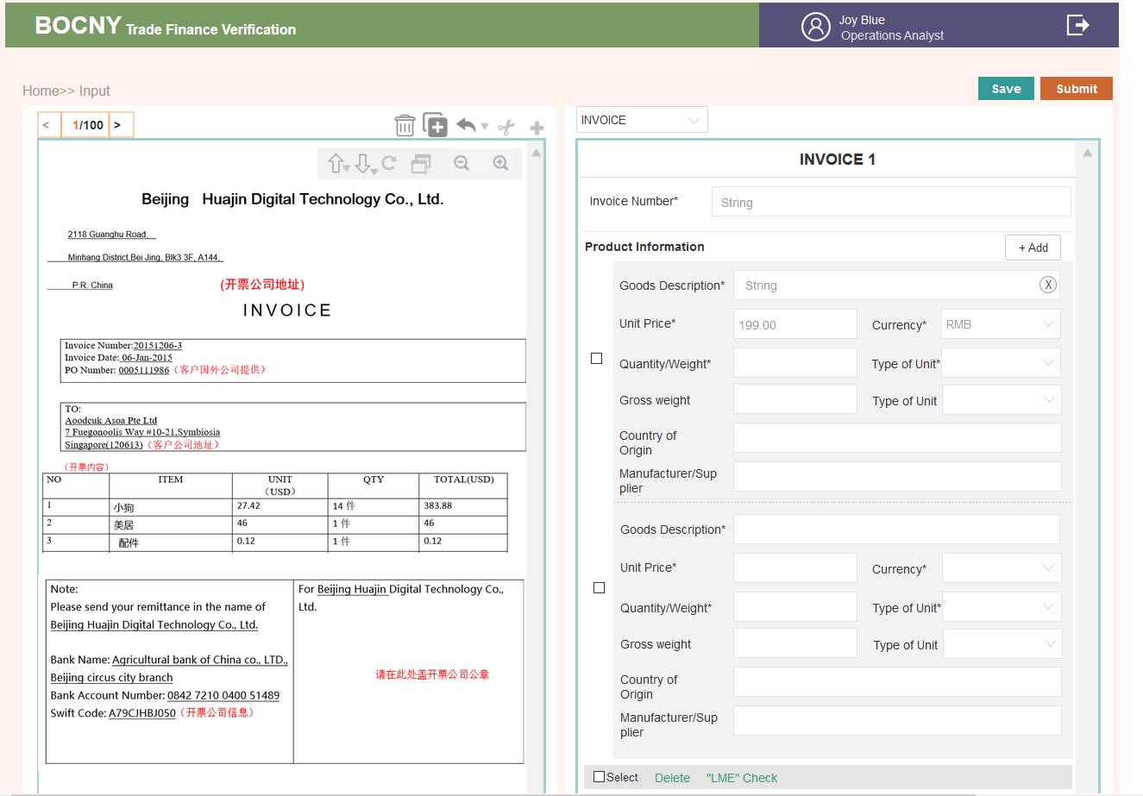

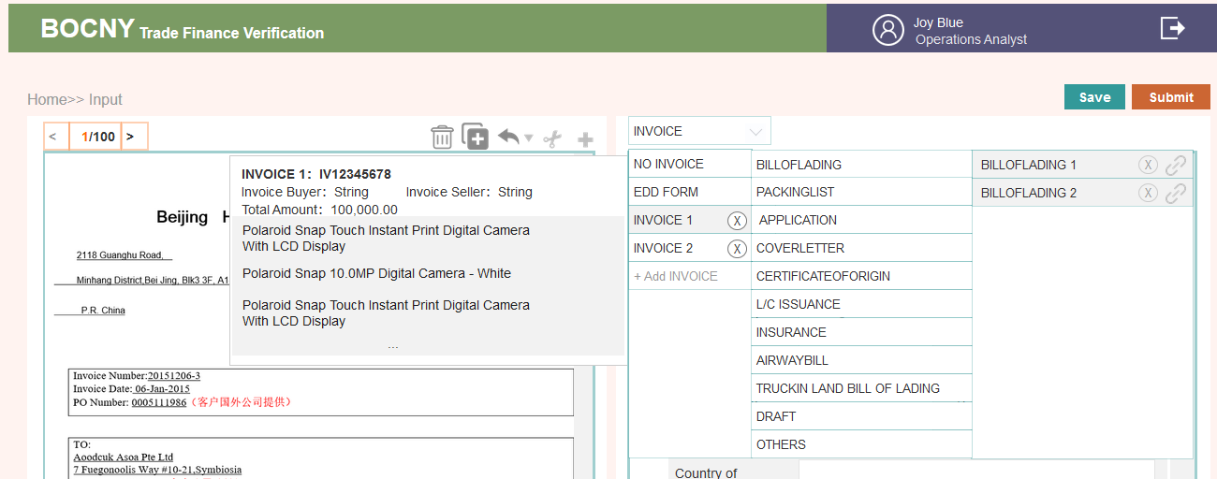

* 不可编辑INPUT页面

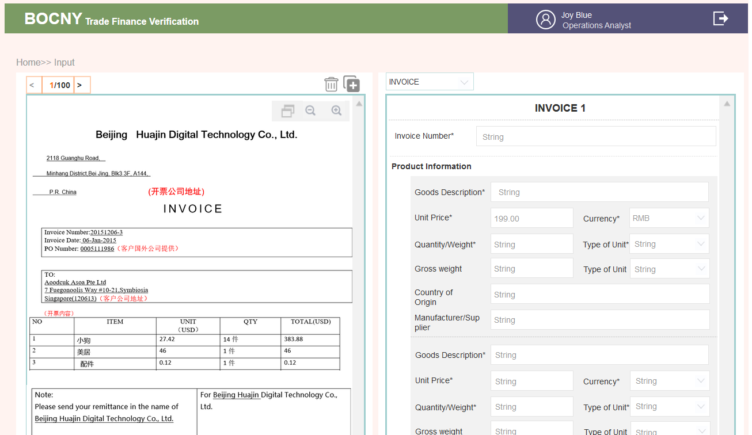

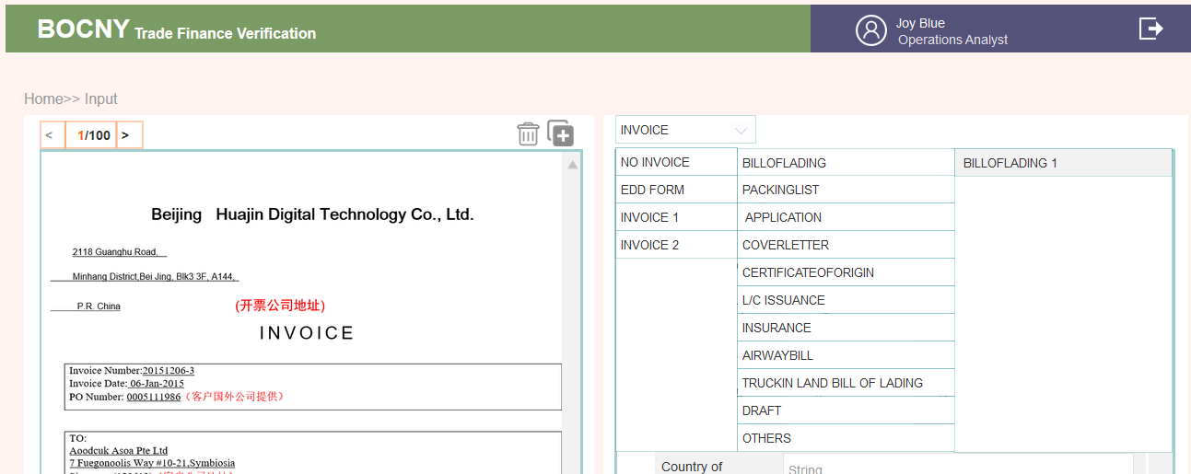

* 垃圾箱页面

可编辑

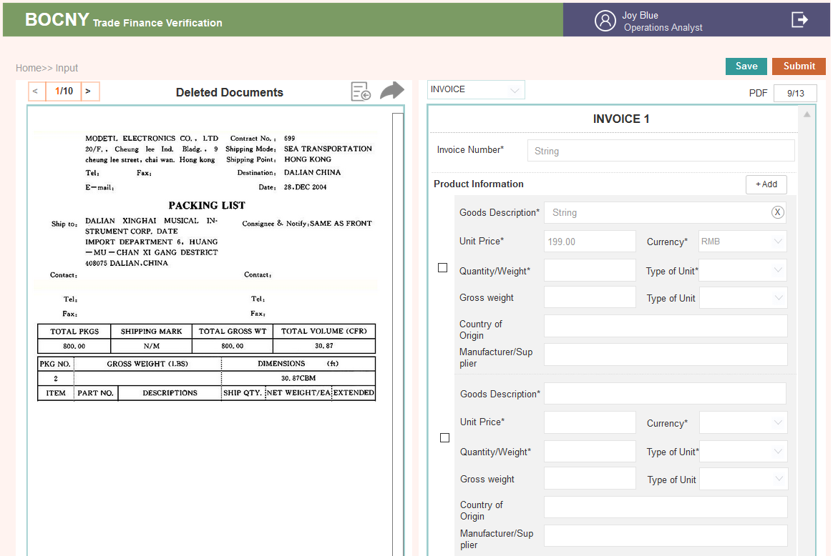

不可编辑

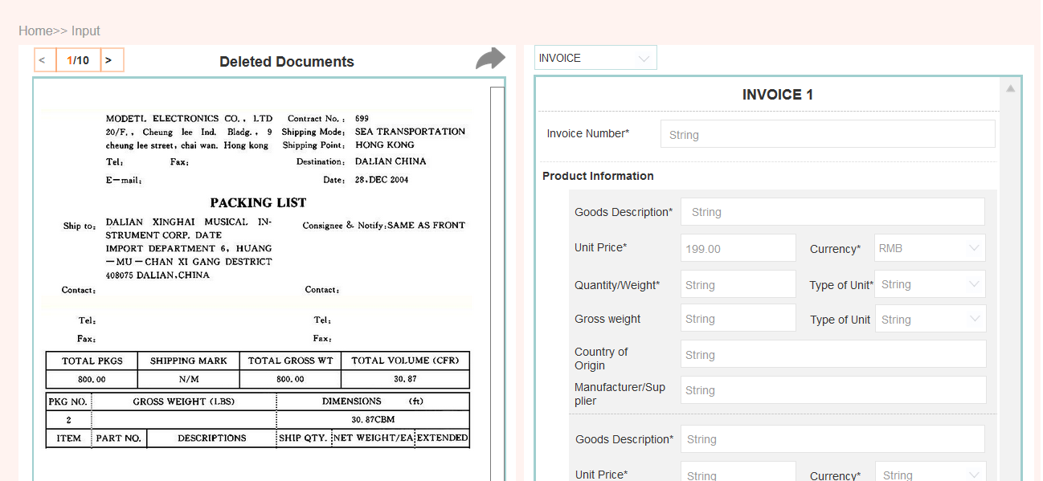

* **表单排版样式**

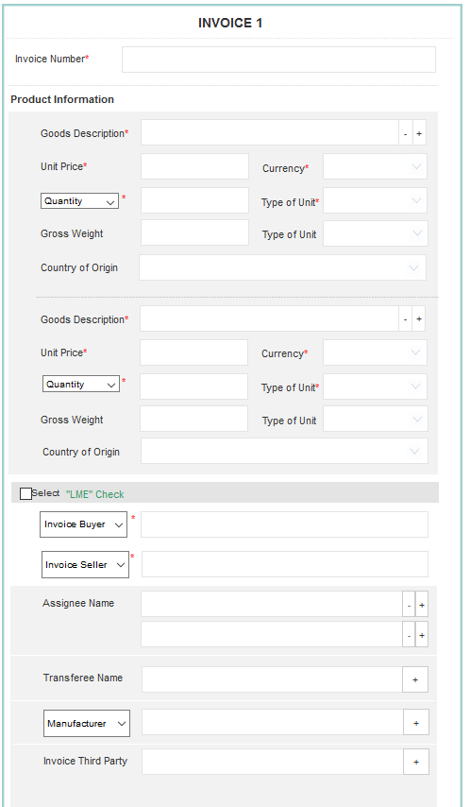

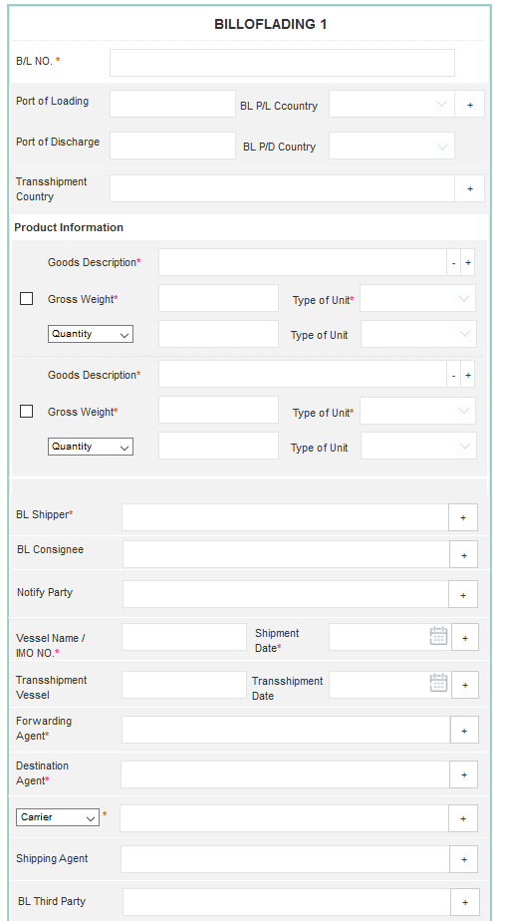

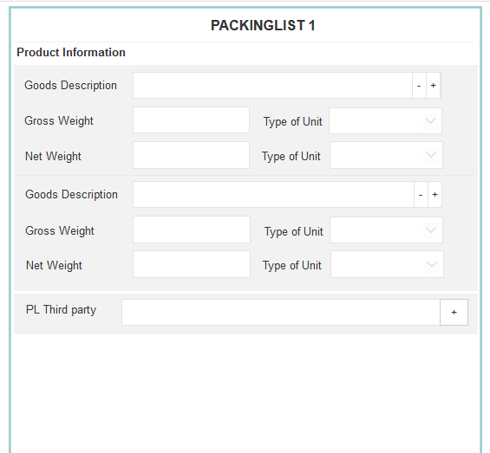

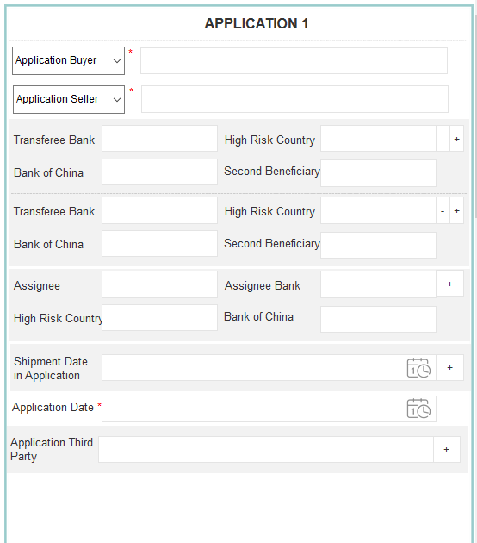

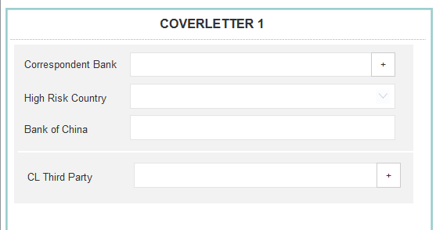

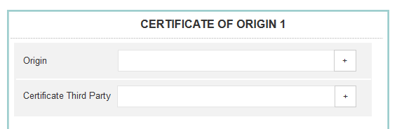

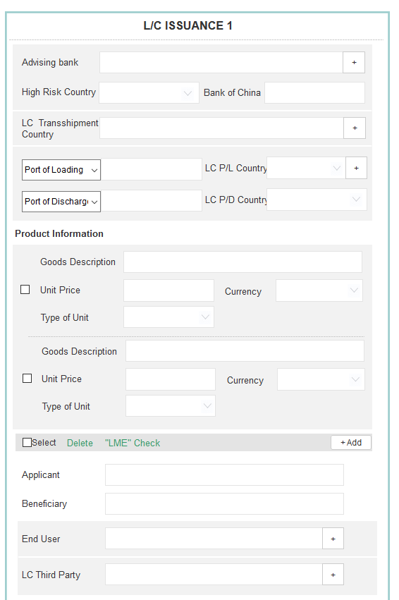

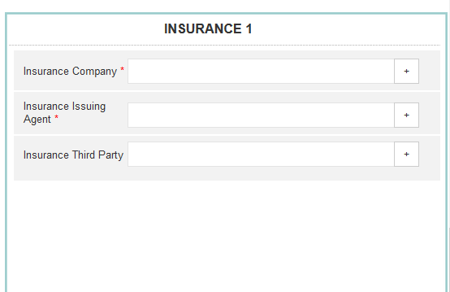

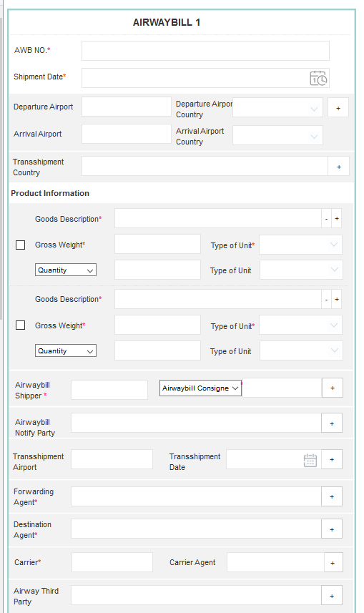

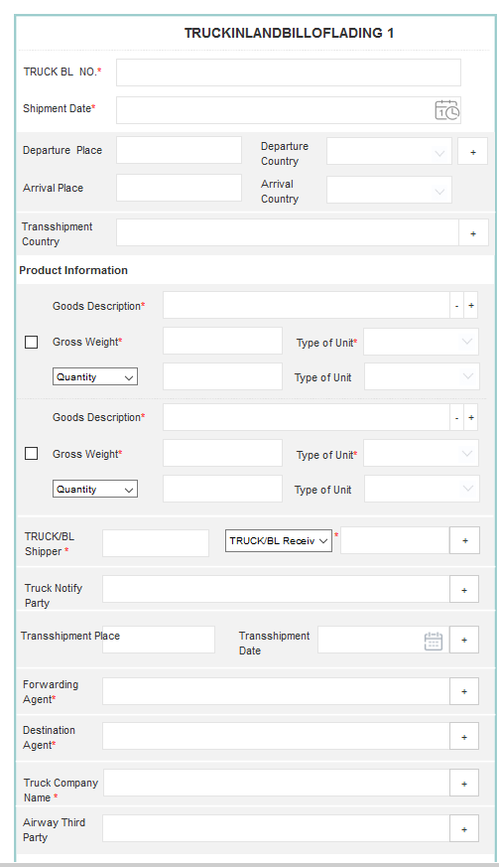

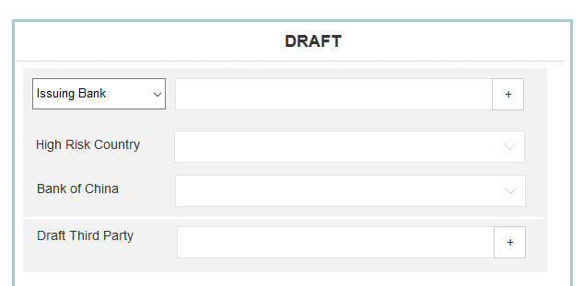

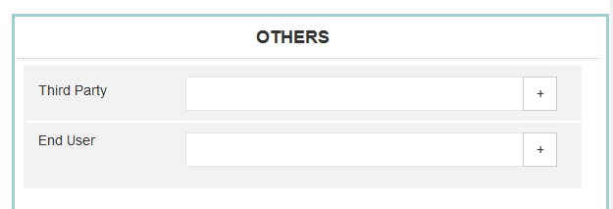

## **Operations Analyst: Case Questions Check Page**

### 1..1. AS-IS

Case verification is to generate the answers to the 35 questions.

On the left-hand side of the interface, it will still show the preview of the case. On the right-hand side of the interface, system will display all 35 questions page by page. For questions that have the automatic logic check, system will answer the question automatically and display relevant evidence if the question has designed to display evidence. For semi-automatic questions, system will only display evidence for operations to answer the question accordingly.

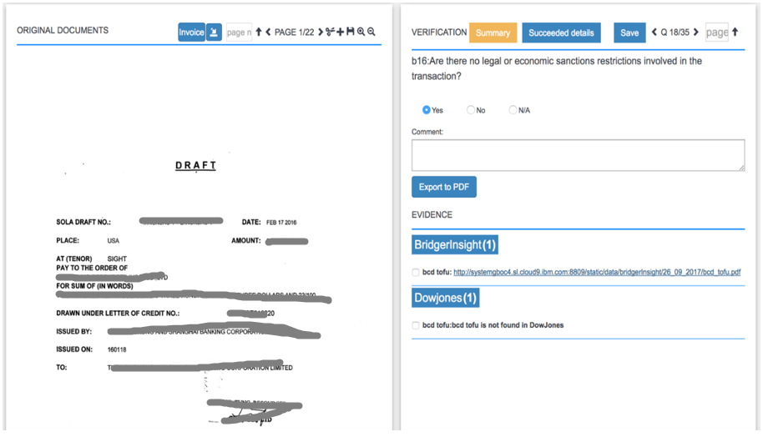

As shown in picture question “a1” is listed on the upper right-hand side, this question will be answered by the system automatically. There are 23 questions which could be answered by the system automatically/semi-automatically. For any incorrect answers, the Operations Analyst could also modify the answer manually. For the other 12 manually answered questions, the system will be answered manually by Operations Analysts. (Note that the logic of all 35 questions is as reference in the appendix.)

~~After all the entity fields in all pages have been filled in, the Operations Analyst can click “START CHECKING” button to start the checking process. Then the system will automatically return to the [ page and the case status under “Status” column will change to “Verification Running”. Once verification running completed, the case status will change to “Verification Success”, then “Check” button will be shown under “Actions” column, the Operations Analyst can click on the “Actions” button to check the results of the case.~~

3.2.6.1. Brief introduction to function



3.2.6.2. Detailed description

* 在列表页&详情页点击Check

1. ‘如果数据没有发生变化，则之前SUBMTIT提交时出的结果就直接 跳转显示了
2. 如果发生了数据变化，在点击SUBMIT或INPUT时，需要把变化再请求API接口一次（INPUT的SUBMIT按钮也会导致再请求）

* 左侧PDF

1. 匹配对应

通INPUT页面，是INPUT时调整完后点击save&submit后最终的PDF，注意INPUT页修改后，这里要及时调整以确保两边数据匹配对应

1. 功能控件

这个页的PDF，不再能修改。仅保留了左上角切换，右侧滚动条滚动进行翻页；

放大、缩小、还原PDF功能

* 右侧35个问题

1. 翻页

系统将逐页显示所有35个问题，左上角可以进行问题翻页。到底置灰

点击文案，有35个问题下拉框，可快速切换到对应问题

1. 问题标题

见附表

1. 问题答案

graphen返回答案

8个自动回答；15个半自动回答，可能有结果返回；12个人工自己回答。答案分为三种，是、不是、不知道。（YES\NO\N/A）

1. COMMENT, 1000字符以内，每个问题下面都附一个COMMENT供他们进行备注说明。

答案为N/A的，系统会调取出一些COMMENT文案，给自动展示在COMMETNT表单里吧，要改能改。详见附表

1. 系统调取的问题答案是或不是，可以手工修改

|  |  |  |
| --- | --- | --- |
| Answer method回答方法 | Num 数量 | Question SeqNo问题编号 |
| Automatic自动 | 8 | a1, b3, b5, b6, b8, b9, b17, b20 |
| Semi-Automatic半自动 | 15 | a2, b1, b2, b4, b7, b11, b15, b16, b18, b21, b22, b23, b24, b25, b29 |
| Manually answered by Operations手动 | 12 | b10, b12, b13, b14, b19, b26, b27, b28, b30, c1, c2, d1 |

* 右侧证据

1. 切换35个问题时，对应的证据也会跟着切换。这个页面问题与证据是一一对应关系的。有的问题有附证据，有的问题则没有附证据
2. 用户可以自行增加或删除证据
3. 设计上注意把系统自动获取的证据与用户自行增加的证据做个区分

细节说明见下文证据模块

* Save& Submit

1. Save是把当前填写的内容做的修改进行保存
2. Submit会出一个结果

35个问题，回答NO的，会出现标红，

证据，要求找到相关证据，却没有找到的，会出现标红

1. 35个问题没答完，Submit按钮置灰不可点击

* ~~Export to PDF~~

~~点击这个控件，生成的是1#那张表格样式的PDF~~

~~系统需要识别，只有回答完35个问题才能生成该PDF，否则会有提示~~

~~弹窗告知要回答完35个问题才会生成PDF（我弹窗写的是并点击SUBMIT）程序上识别到35个问题回答了，就让他导出PDF ~~~

* INPUT页进行了修改重新点击Submit页

1. 如果INPUT页进行了修改，然后SUBMIT再次请求第三方API，会导致这里的内容发生变化。
2. 35个问题，YES&NO，自动获取的直接覆盖
3. Comment:人工填写的不进行覆盖
4. Evidence, 人工上传的不进行覆盖。系统上传的，全部替换成新的

* 发送给OM后，该页面不再允许编辑

1. 点进的Check页面，不再允许编辑

2. 右侧 COMMENT可填写框变为纯显示框。是否的答案回答显示最终答案

3. +New Evidence按钮、垃圾桶、复选框、Edit消失

4. Save& Submit按钮消失

5. 导出PDF依然可操作

3.2.6.3. Interface requirements

* 可编辑Check页面

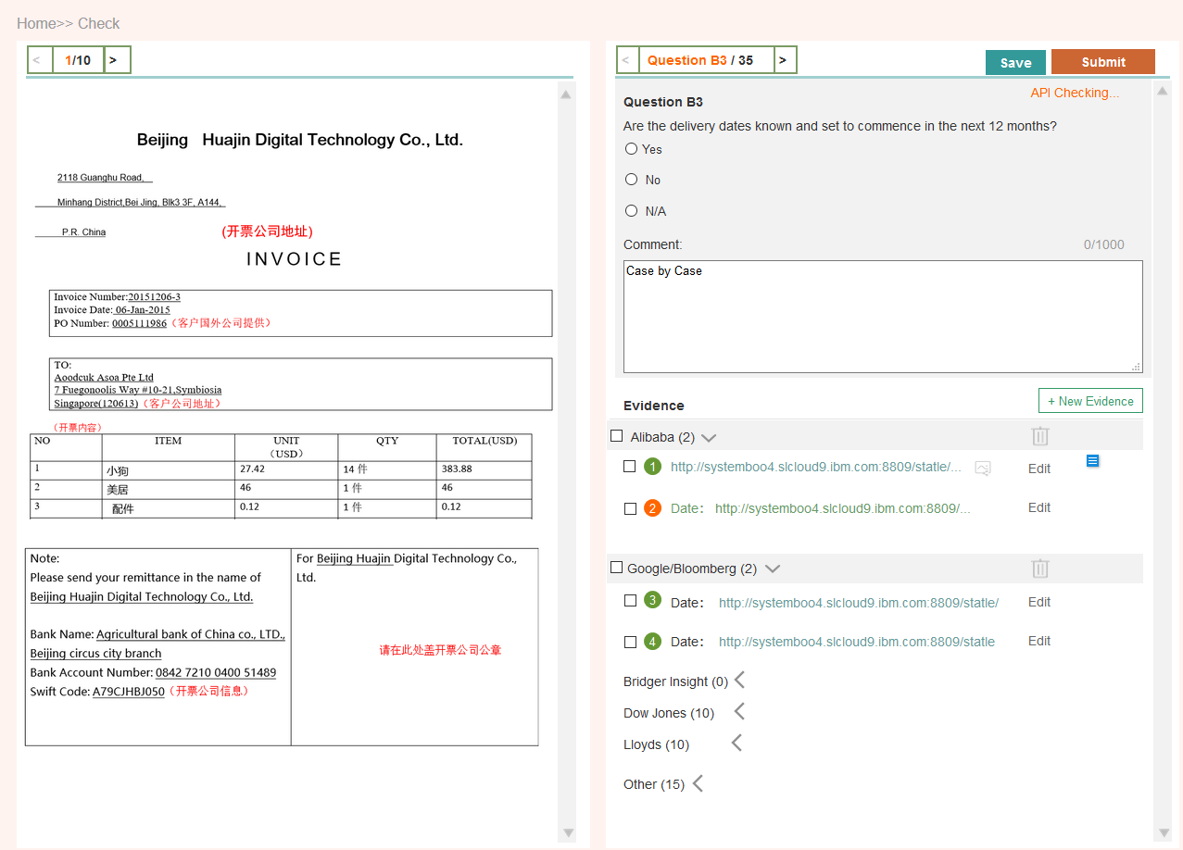

* 不可编辑Check页面

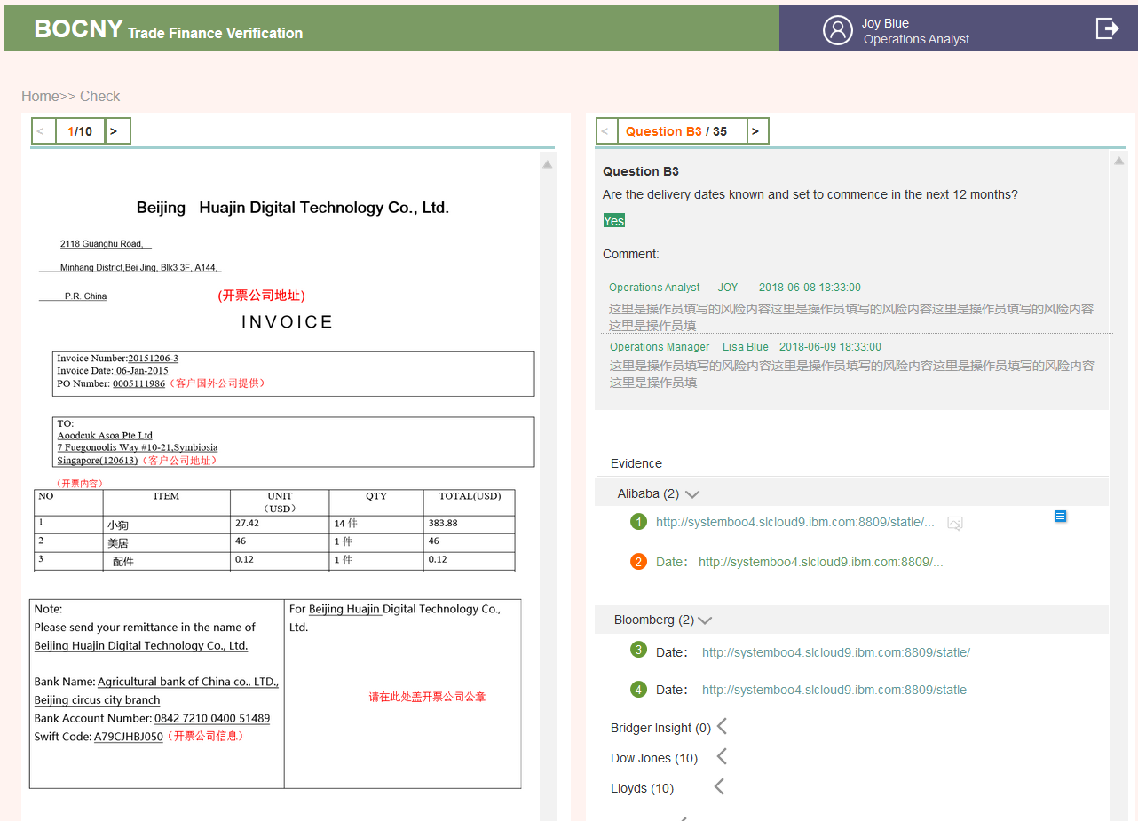

## **Operations Analyst: Evidence Management Page**

### 1..1. AS-IS

In the “EVIDENCE” field, if there is any evidence available, the evidence will be shown and divided into different vendor categories including “Bridger Insight”, “Dow Jones”, “Alibaba”, “Bloomberg”, “Lloyds” and Logic result from T24 DB based on each question’s logic and requirement. The evidence will be shown as the query name followed by the PDF link. The evidence and evidence PDF for each domain is listed as follows:

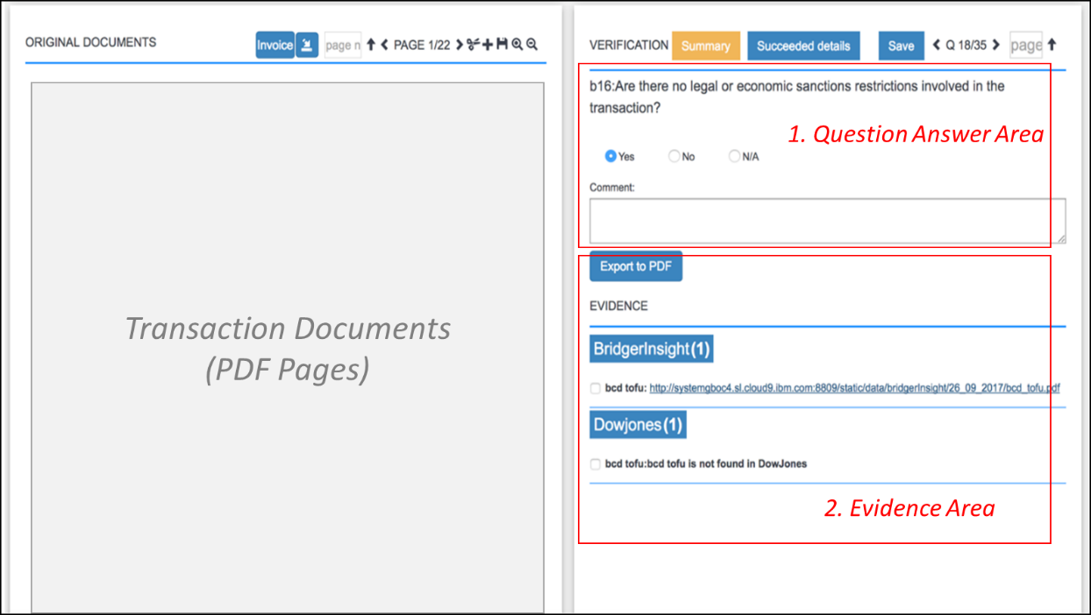

~~When the user clicks the “Evidence management” button, a popup window for evidence management will appear. All original evidence can be downloaded and exported when the user clicks the “Download” button.~~

~~If the user wants to upload subfolder evidence, Operations Analyst could use “upload folder” shown to upload the zip folder.~~

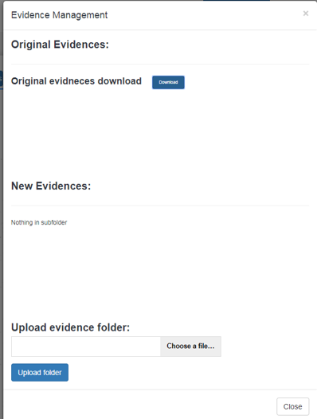 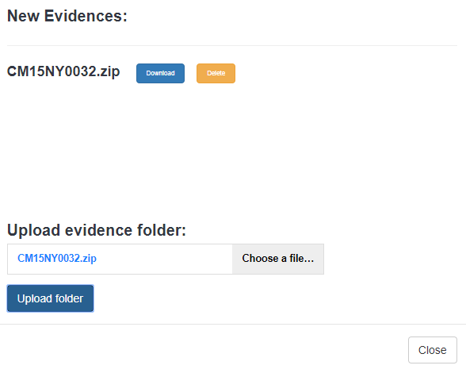

If the query is not found in certain domain, then the system will list the query name, followed by “XXX is not found in XXX”. (e.g., XYZ is not found in Bloomberg.) When the evidence is incorrect, the Operations Analyst could delete the PDF evidence by clicking “X”. If “ $↑$” button is clicked, the Operations Analyst could upload the answer evidence to the system using “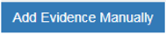” shown in the “Upload New Evidence” popup window, enter the following information to upload additional evidence:

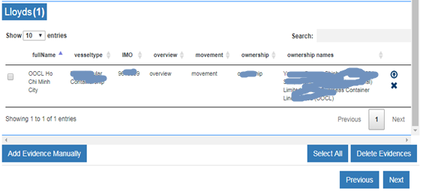

1. Choose an evidence file from the computer to upload.
2. Input Evidence Name
3. Type: select from the drop-down bar including “Alibaba”, “Bridger Insight”, “Dow Jones”, “Lloyds”, “Bloomberg”.
4. ~~Any comments added (imposed onto the artifact) to an uploaded document must be displayed on the document.~~

~~After click “Upload” button, the manual evidence will upload to the current question.~~

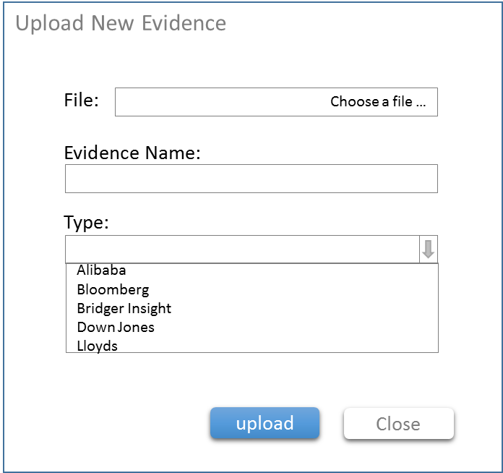

~~Operations Analyst could click “” to select/unselect all evidence， and batch delete the evidence with“”.~~

For Bridge Insight evidence，the system obtains the result from Bridge Insight via API. The Operations Analyst is required to input comments if the Bridge Insight RATIONALE OVER 80%. The Operations Analyst could select theevidence, and it will trigger and pop out a window to add comments.

Once the Operations Analyst complete comments input and save, the highlighted comments will appear in left PDF，and a PDF could be created which is including original Bridge insight result and inserted comments. The PDF name should be original name+ identified stamp. The system must allow a PDF file to be upload as evidence manually.

Lloyd’s evidence must be displayed as a table , and the Operations Analyst could click for details with PDF in pop-up window:

Store digital sample for transaction

|  |  |
| --- | --- |
| A2-Anticipated Activity.xlsx |  |
| A2-T24 results |  |
| B1-Invoice&Industry Description |  |
| B2-T24 results |  |
| B2-Transaction amount |  |
| B4-Goods information |  |
| B4-T24 result: Country Name |  |
| B5-Product tolerance max and min |  |
| B6-T24 results |  |
| B6 Invoice Number |  |
| B7 Invoice & Lading Quantity check |  |
| B9 Transaction Amount |  |
| B11 Invoice & Lading Quantity check |  |
| B16 Country List |  |
| B16 Sanction Countries | Two fields:  1. Country Name  2. Abbreviation (two characters) |
| B20 Country List |  |
| B21 Tax Heavens | 1. field：Country Name/Region Name |

### 1..2. Enhancement

1. Evidence management-not organize and categorize

1) Name standard of file which download is Reference No. (e.g. TFxxxxxxxxxx.zip)

2) There are 6 sub-folders under this zip file. (5 API evidence + 1 logic)

1. Evidence file should have naming standard which can contain ownership, movement and vessel information.
2. All evidence should be internally linked: once an evidence is deleted under certain question, the same evidence will automatically disappear under other questions at the same time.
3. If BI rationale is over 80%, Operations Analyst should input comments, otherwise system should alert.
4. Establish database for commodity and unit price，establish database for invoice no.
5. If Dow Jones RATIONALE OVER 80% (manually judge). Operations Analyst could select an evidence, and it will trigger and pop out a window for comment input. Once Operations Analyst complete comments input and save, the highlighted comments will appear in left PDF. The input comment will be added at the end of the PDF. And a PDF could be created which is including original DJ result and input comments. The PDF name should be original name+ identified stamp. The PDF file could upload as evidence via manually.
6. Operations Analyst could select an evidence in Bloomberg/Google, and it will trigger and pop out a window for comment input. Once Operations Analyst complete comments input and save, the highlighted comments will appear in left PDF. The input comment will be added at the end of the PDF. And a PDF could be created which is including original result and input comments. The PDF name should be original name+ identified stamp. The PDF file could upload as evidence via manually.

3.2.7.1. Brief introduction to function

点击更多，可以查看该CASE的所有相关证据

从API接口获得的相关证据和手动上传的证据，将会在这里显示出来。



3.2.7.2. Detailed description

**API方式获取证据**

* 来源

1. API接口获取。按照35个问题规则从T24（银行内部系统）请求或从Graphen（银行合作的做AI的公司，35个）获取

* 内容展示形式

1. 标题

EXCEL标题见证据样本，后加.xlsx后缀；

链接的则显示链接

1. 总共有五个渠道+一个其它，从哪个渠道获得的证据就放在哪个渠道下，没有对应渠道的就放到其它类下

“Alibaba”, “Bridger Insight”, “Dow Jones”, “Lloyds”, “Bloomberg”,“others”

1. 证据管理页，显示的是某个CASE的所有证据列表
2. 各类可以展开收起显示

* 未查询到相关证据或证据异常

1. 如果特定的字段未找到相关内容，则系统会列出（例：XYZ is not found in Bloomberg.）这条证据前序号会标红
2. 如果一个问题下的某条证据标红了，则在详情页，这个问题对应的证据是标红的。
3. 用户可以手动删除这条标红证据。如果没有了标红证据，则详情页证据的红色标识消失。
4. 如果一个问题下Bloomberg的证据数量占比超过了80%，在35个问题下的COMMENT框下面会有一个ALERT提醒 文案：”Alert: The BI rationale is over 80%, Please input comments.”

* 搜索

1. 提供按证据名称搜索
2. 搜索结果显示来源和相关的这条证据标题&comment等内容
3. 如果没有结果，则显示：“没有搜索到相关证据，请更换搜索条件搜索“

* 全选&删除

1. 在send to manager前OA可以删除证据，删除为物理删除
2. 勾选了底部的选择框，则所有证据展开，并选中状态

用户可以点击删除去删除

1. 也可以勾选每个类别左侧的选择框，此时只是选中该类的所有证据

点击垃圾桶或底部Delete按钮进行删除操作

1. 如果没有勾选任何证据，垃圾箱和Delete置灰不可点击
2. 如果勾选了证据，点击删除，出现一个弹窗，文案：“确定删除你选中的5个证据。”点击确认，则删除该条证据
3. 注意证据的连动关系，在一个地方进行了删除&编辑操作，在其它位置也会相应的变化。其它能看到证据页面的角色所看到的页面也要相应的变化

* 下载

1. 点击下载可以将所有证据打包下载下来
2. 压缩包标题为上传CASE时填写的Reference No.加.zip

(e.g. TFxxxxxxxxxx.zip)

1. 在这个压缩包里包含了6个文件夹（5个渠道+1个others）

* 权限

见3.2.1.2权限配置表

**手动上传证据**

* 点击+ New Evidence 可以在桌面上选择证据，选定后，跳转到证据上传页面

在证据上传页面会显示上传进度，完成，打勾。

* 标题默认获取桌面文件的标题，可供修改。

标题在300字符以内

* 有一个COMMETNS说明字段，非必填，1000字符以内。如果填写了，就显示在证据的下方
* 如果是在check页，在哪个问题下面点击的增加证据，就默认调取这个问题的序号，如果在证据管理页，则证据序号为空
* Type即上文所说的六个类供选
* 在submit前，在当前页，可以继续添加或删除已添加的
* 证据未上传完，或表单字段为空，SUBMIT按钮置灰，无法上传。

**发送给OM后，证据不再允许编辑**

除PDF打包下载功能，其它新增、删除、复选控件消失

* Store digital sample for transaction 证据样本见35个问题说明



3.2.7.3. Interface requirements

* 可编辑证据页面

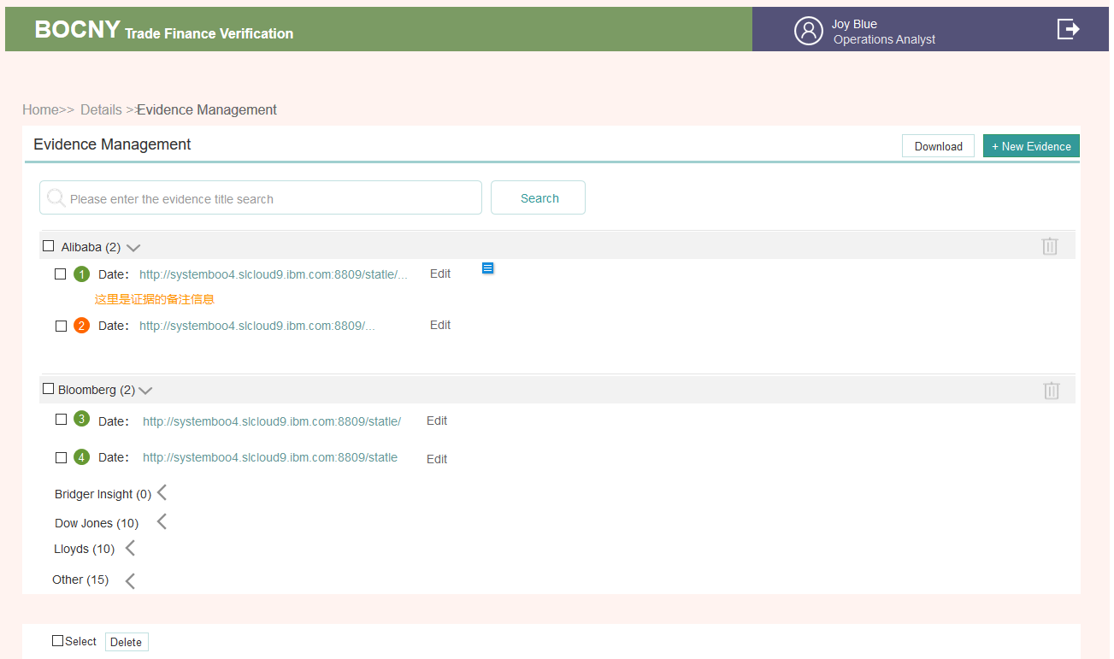

* 不可编辑证据页面

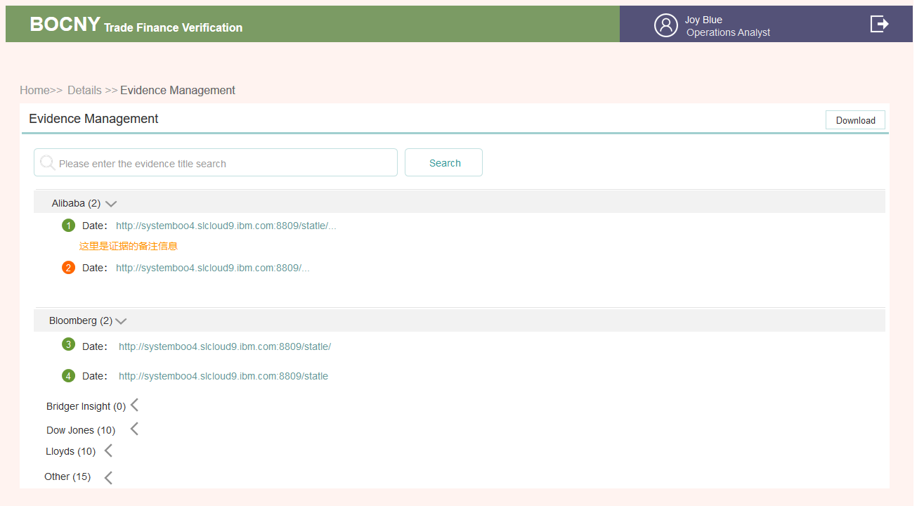

* 手动上传证据页面

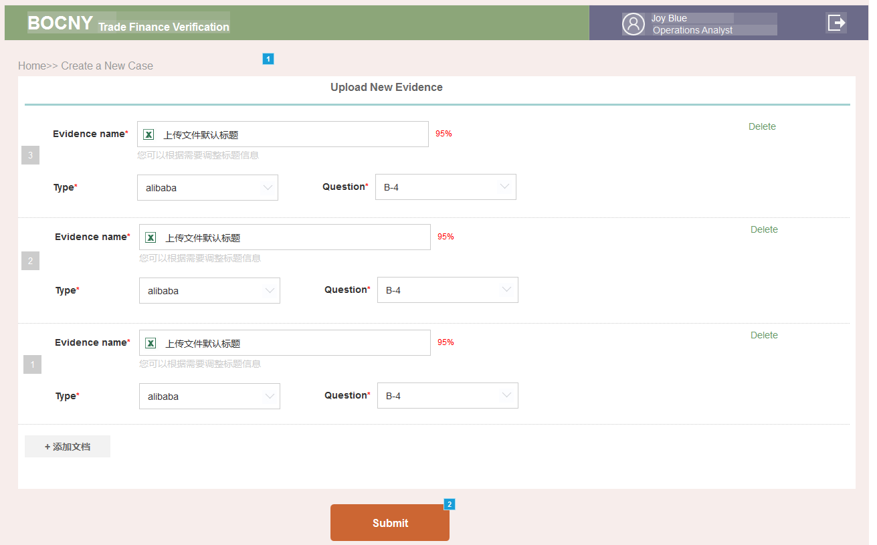

3.2.8 Operations Analyst: Details

3.2.8.1. Brief introduction to function

这里主要分为三大块内容。用户基本信息；INPUT录入的表单；35个问题和证据。及相应的操作按钮。在不同状态时，内容按钮会有一定的变化



3.2.8.2. Detailed description

* 页面字段

|  |  |  |  |
| --- | --- | --- | --- |
| # | ITEM | 来源 | 内容 |
| 1 | 状态 | 根据状态表确定 | * Pending Operations Analyst Review * Under Operations Analyst modify |
| 2 | 客户基本信息 | 来源于创建CASE时字段 | * Case ID * Total Amount * Pages * Clint Name * Reference No. * Boc Reference * Clint ID * Created Date * Modifled Date * Operator |
| 3 | 右上角按钮 | 会根据用户的操作进度而变化 | * Send to Manager * 1#TRM * 2# SAF * 6# EDD Form * 10# Case by Case * FILE Management * Modify the Case |
| 4 | Documens Verification | 在INPUT页面，录入了表单，点击SAVE&SUBMIT时方出现该块的内容 | * 单证类型 * 所属归类 * API验证成功&失败 * 单证核心字段摘要 |
| 5 | Documens Verification 操作控件 | 有内容了才会出现Edit  超过两行了才会出现Unfold | * Input * Edit * Unfold |
|  | Checking&Evidence  >>Commetns | 回答NO&N/A的COMMENTS会出现在这里 | * 撰写人 * 角色 * 撰写时间 * 问题编号 * Commets内容 |
|  | 35个问题结果&证据 | 回答NO的Question和找不到相应字段的Evidence 会标识感叹号 | * 问题编号 * 问题或证据是否有危险标识 |
|  | Checking & Evidence右上方操作控件 | 根据状态变化 | * Evidence Management * Check |

* ~~当前状态~~

~~根据状态表定，点击可以看到日志，包含各个状态节点；处理人&处理时间。只记录状态 变化的节点加一个取消的状态点~~

* 基本信息

1. 创建完CASE后，如果有内容填写错误的，可以点击Modify the case进行修改，所有字段可调整

2. 在Send to Manager前都允许其修改，修改后，详情页的客户信息字段要相应变化

3. 被打回时可以修改，修改后，自己详情页&OM详情页客户信息字段要相应变化

如果被打回时填写了相关原因，会在这里基本信息下方显示。只显示最新的一条COMMENTS，历史的点击 see more查看

为保证一致性，所有进入另一个角色 的操作都有一个可以填写COMMENTS 字段。非必填项。同时都会选择角色的账号。

每一个SUBMIT会进行日志记录

* Documens Verification

1. 出现情况 ：Input填写了单证（点击SAVE或Submit后）会在详情页Documens Verification下面显示。没填写完或者没点击submint提交，验证状态为Verification Pending。点击了SUBMIT后才会进行单单相符验证。优先比对发票，其次比对提单，再次对比装箱单

2. 排序：最新添加的展示在前，超过2行，有展开收起控件

3. 字段：显示单证类型&序号；单证所属归类；单证验证情况；单证的核心字段，挑几个显示

4. 有2种展示方式，

1）一个是打包展示

A. 按单证与发票的关联关系展示。右上角为标题

所有单证会有一个标题 格式为：caseID+Doc Type+编号。DOC TYPE按01往下排，编号也是按01往下排

B. 显示该包里的文件总数，通过验证数和验证失败数

C. 如果没有与发票关联的放在NO INVOICE包里，NO INVOICE的不进行验证

D. 点击进入该文件包中查看该文件包下所有文件。发票包下的，可以看到验证了哪些字段，哪些出现了异常

2）另一种是平铺展示方式

鼠标移入，会出现个下拉小标识，点击出一个删除&移动操作。删除会弹出弹窗，让用户确认是否删除

移动，则可以从发票1中移动到发票2包中

6. 搜索，点击搜索，会自动切换到平铺展示方式，筛选出某一类单证，如提单

* Checking & Evidence

在Check页点击SUBMIT后，这里会根据情况出结果

* 有红标的Comments才会出现在这里
* 只有NO的才出红标
* 点击Check跳转到Check页，点击Evidence Management跳转到证据管理页
* 准备表单

根据情况准备相应的表单，表单说明，下文另说

* 准备好后，点击Send to Manager发送给OM
* 会弹出确认弹框，把他所在支行的OM角色列出来供其选择确认是发给谁
* 选过一次后，下次会默认选 中上一次选择的OM角色账号,

如果被打回，也会默认显示该OA的账号

* 可以填写一些要说明的COMMENTS，1000字符以内，非必填项
* 流程进入下一个人时，会对下一个人发一封邮件进行通知。所有都是
* 文件管理

1. 在check 后会出现文件管理入口，有什么文件显示什么文件

2. 可以将对应的文件按文件归类打包打出，

~~也可以选择对应的文件进行打印~~

|  |  |  |
| --- | --- | --- |
| 文件一级包 名称 | 文件2级包 | 文件来源 |
| Evidence | Company Info | Bloomberg API |
| OFAC | T24 |
| Dow Jones | 35个问题Dow Jones渠道数据来源 |
| Google Strings | 35个问题Google渠道数据来源 |
| Price | Alibaba |
| Lloyds | 35个问题Lloyds渠道数据来源 |
| Logic | 35个问题，所有证据EXCEL表格 |
| Form |  | 所有表格里的1#, 2#, 10#, EDD Forms（哪张就显示哪张名称） |
| Transaction documents | 有绑定发票的就发票类（invoice&no invoice）2级包，然后与该发票下的所有单证3级包的 | INPUT页左侧上传的PDF文件，下载下来可以是一张张的PDF， 注意是最终调整的结果 |
| SubFolders | Export L/C (for export only) | INPUT页PDF子文件包 |
| Due Diligence checklist | 手动上传 |
| Old Documents | 删除PDF存放进的文件包， |
| Customer Correspondence/Info | 手动上传 |
| Issuing bank correspondnece | 手动上传 |
| Payment | 手动上传 |
| Others | 手动上传 |
| Compliance |  | 所有表格里的 #3, #4, #5 |

1. SubFolders 右侧有个上传的按钮，可以把文件上传到对应的文件包中

2. 下载，点击下载，会把选中的文件按上述打成一个包下载下来，整包名称为

FILE Management_ Case ID

附表：各动作下，控件变化情况

| **Step** | **动作** | **位置** | **类型** | **内容** |
| --- | --- | --- | --- | --- |
| 1A | 创建Case点击Submit | To Do List列表 | 按钮 | Input |
| Details>>客户信息 | 状态 | Under Operations Analyst Review |
| 内容 | 客户基本信息 |
| 按钮 | * Modify the case * Send to Manager(置灰) |
| Details>> Documens Verification | 内容 | 空 |
| 按钮 | Input |
| Details>> Checking & Evidence>> Comments | 内容 | 空 |
| Details>> Checking & Evidence>>警告标识 | 内容 | 空 |
| 按钮 | * Evidence Management（置灰） * Check（置灰） |
| 1B | 修改Case | 同上 | 同上 | 同上（客户信息修改，则发生改变，其它信息不变） |
| 2 | Input(录入PDF)点击Submit | To Do List列表 | 按钮 | Check |
| Details>>客户信息 | 状态 | 同上 |
| 内容 | 同上 |
| 按钮 | 同上 |
| Details>> Documens Verification | 内容 | 有(save时就有了)  超过2行有展开收起 |
| 按钮 | * 删除（删除录入的单证） * 移动 (把单证移动到某张发票中与其关联) * Input（默认跳转到INPUT页第一张PDF） |
| Details>> Checking & Evidence>> Comments | 内容 | 同上 |
| ~~按钮~~ | ~~同上~~ |
| Details>> Checking & Evidence>>警告标识 | 内容 | 同上 |
| 按钮 | * Evidence Management * Check |
| 3 | Check (请求API&回答35个问题&整理证据)后点击Submit | To Do List列表 | 按钮 | Details |
| Details>>客户信息 | 状态 | 同上 |
| 内容 | 同上 |
| 按钮 | * Send to Manager（选择具体的人；选填备注信息） * 1#TRM * 2#SAF * 6# EDD Form（这个需要填写完后才会有编号，没有选择填写时是不知道#6~9具体是哪张表的） * 10#Case by Case Form * FILE Management * Modify the case |
| Details>> Documens Verification | 内容 | 出验证结果~~成功&失败~~  ~~超过2行有展开收起~~ |
| 按钮 | * Edit * Input（点击Check时返回数据这个页面就会把异常的标色标出来了） |
| Details>> Checking & Evidence>> Comments | 内容 | * 有红标的Comments就会出现在这里 * 只有NO的才出红标（如果人工在对应类项下加了证据，则NO的红标消失。） |
| ~~按钮~~ | ~~可以点击，跳转到Input页面~~ |
| Details>> Checking & Evidence>>警告标识 | 内容 | 有 |
| 按钮 | * Evidence Management * Check |
| 4A | 不进行后续步骤，直接把INPUT发给OM审查 | Details>> Checking & Evidence>> Comments | 通4D | 通4D |
| 4B | 创建1#Summary | Details | 通3 | 通3 |
| 4C | 创建2#SAF（确定是否需要） | Details | 通3 | 通3 |
| 4D | 发送CASE给到OM后 | Pending List**列表** | 按钮 | Details |
| Details>>客户信息 | 状态 | Pending Operations Manager review |
| 内容 | 有 |
| 按钮 | * All Forms~~（如果填写了1#，2#，EDD，case by case任一表。~~ * ~~在后续中其它角色添加了3#、4#、5#不需要OA处理的话，他是看不到后面的表的，到时做成可配置? 这里则有该按钮）~~ * FILE Management |
| Details>> Documens Verification | 内容 | 有  ~~超过2行有展开收起~~ |
| 按钮 | * Details【原型：input(发OM后) 】   1. 点进的input页面，不再允许编辑  2. 左侧保留翻页滚动条，放大缩小还原功能；  3. 右侧表单内中不再允许编辑增删（增删多选控件消失  4. 下拉框只是点击调出相应页面，点击调出空页面、增加发票、移动归类功能消失）  5. Save&Submit按钮消失 |
| Details>> Checking & Evidence>> Comments | 内容 | 前置有内容则有，无内容则无 |
| Details>> Checking & Evidence>>警告标识 | 内容 | 通前置原有内容 |
| 按钮 | * Check【原型：Check(发OM后) 】   1. 点进的Check页面，不再允许编辑  2. 右侧 COMMENT可填写框变为纯显示框。是否的答案回答显示最终答案  3. +New Evidence按钮、垃圾桶、复选框、Edit消失  4. Save& Submit按钮消失   * Evidence Management   除PDF打包下载功能，其它新增、删除、复选控件消失 |
| 5A\7A | **Modify**处理被OM打回的**CASE** | 状态 | 状态 | Under Operations Analyst Modify |
| 通3 | 通3 | * 操作控件，变到发送OM前状态 * 内容上OM可能进行了处理（增添证据），要同步显示 * OM一般会在ALL Forms那里填写回复意见，会同步过来。ALL Forms那里可以接去回复 * 所有控件多了个ALL Forms控件 |
| 5B | 把Recheck完后的case发给OM | 状态 | 状态 | Pending Operations Manager review |
| 通4D | 通4D | 注意内容调整后的变化同步 |

3.2.8.3. Interface requirements

* 部份内容为空样式

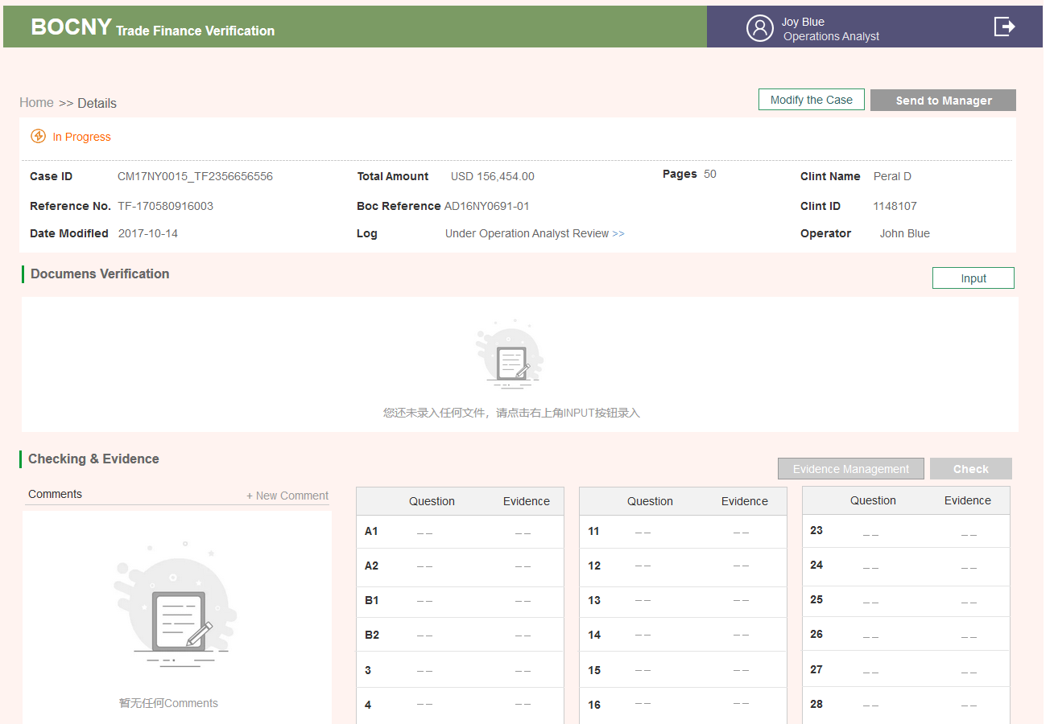

* 有内容样式

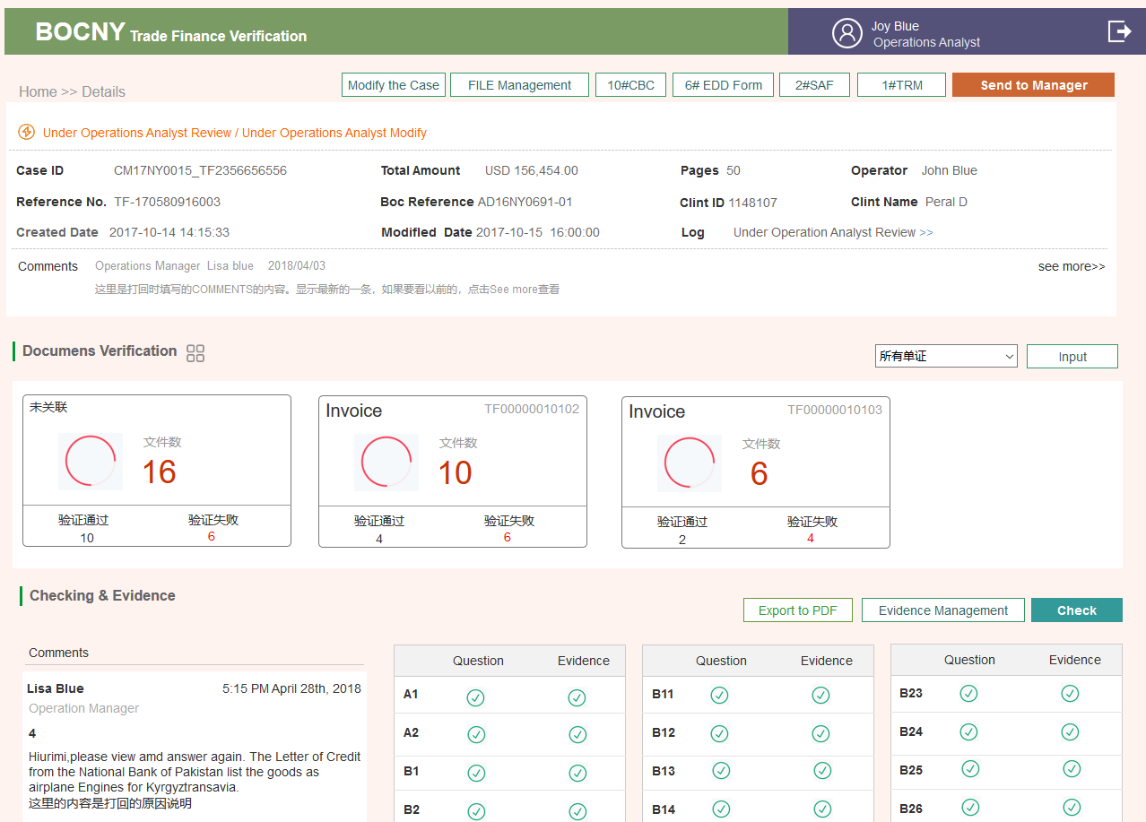

~~任一表~~

3.2.9 All Forms

3.2.9.1. Brief introduction to function

目前有6张表格+1张EDD表格；有2种样式；

一种是新建&修改的样式（单张）；

一种是复核查看，回复意见的样式（~~一旦成功submit了一张表单~~，在Send to Managerment后即会出现All Forms按钮，可以点进去查看&下载，随着表单的增多，添加标签，切换查看）

只有新建表单者可以修改表单

不同的角色会根据他们的权限或可新建，或可复核回复，或仅可浏览

3.2.9.2. Detailed description

* 表单处理权限 默认

|  |  |  |  |  |  |  |  |
| --- | --- | --- | --- | --- | --- | --- | --- |
|  | EDD | #1 | #2 | #3 | #4 | #5 | #10 |
| OA | 创建&  打回后修改回复 | 创建&  打回后修改回复 | 创建（标识红标）&  打回后修改回复； | 不可浏览 | 不可浏览 | 不可浏览 | 创建 |
| OM | 回复；打回后再发来回复 | 回复；打回后再发来回复 | 回复（标识红标）；打回后再发来回复； | 不可浏览 | 不可浏览 | 不可浏览 | 回复 |
| CA | 回复 | 浏览 | 回复 | 创建&打回后修改 | 创建&打回后修改 | 不可浏览 | 回复 |
| CS | 回复 | 浏览 | 回复 | 回复；打回后再发来回复 | 回复 | 不可浏览 | 回复+填些内容 |
| BSA | 浏览 | 浏览 | 浏览 | 浏览 | 回复 | 创建 | 浏览 |
| LCD | 浏览 | 浏览 | 回复 | 浏览 | 浏览 | 浏览 | 浏览 |

以上为默认权限，允许在角色管理那里去调整浏览&回复权限

* 创建字段

详见下文各表单字段说明

* 导出PDF

1. 创建后点击Submit即会出现Export to PDF  ~~All Forms~~按钮，~~该页面~~可以点击导出PDF
2. PDF格式见3.6对应的表单
3. 签名人按对应角色取对应处理人姓名；

时间取对应角色点击Submit的时间

1. 签名栏中间，姓名之类上面是调取COMMET字段的，有填，则有

* 回复字段

1. 进度条

* 在回复&浏览的页面底部回复框上可见
* 状态：小方块有三种颜色，待处理的；正常处理完的；被打回的
* 小方块下显示的是对应的状态&处理人。文案可以跟状态表对应
* 时间的话是对应角色点击Submit后的时间。
* 切换，可以看到每个角色的回复（有的含处理结论，有的只是comments内容）

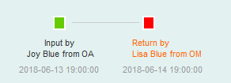

1. Processing opinion

* 这一行显示的是当前处理人
* 如果有处理结论字段的，会显示处理结论

1. Comments

如果没有填写的话，则框内字段为空。但是依然是占了一个状态 环节

1. Workflow Detail

列表形式展示，理论上跟那个小方块应该是对应的

* **#6~#9 Enhanced Due Diligence（EDD表）**

在OA角色的详情页出现，点击EDD Form调出相关页面，

1. 上传EDD客户表；2. 选择EDD 类型；3. 程序根据选择的EDD类型调出对应的EDD模板。

TSD REFERENCE 100字符内

其它表单自适应，1000字符以内

包含四个行业的调查表

* + Shipping
  + Service & Insurance
  + Metals
  + Oil & Gas
* **~~#1 Case Summary Report Page~~**
* **#1 Transaction Risk Mitigation Check List**

所有CASE都有该表单

1. 基本信息字段，来源于创建CASE时

Client ID

Client Name

Reference NO.

BOC Relevance

Total Amount

Type

不允许在该页面修改，若要修改，只能去修改CASE，改完后，这里数据会相应变化

1. 35个问题

* 这里包含了，35个问题的序号&标题&答案&系统生成的Coments&人工填写的Commets这几个字段
* 允许进行编辑，但编辑是跳转到Check页面进行编辑，编辑后，注意这里的信息&Details页面最下方红标那块的信息会发生相应变化。点击SAVE或Submit均可产生变化

1. Comments

每个问题的COMMENTS会附在问题下面，有则显示

1. OA

之后再填写一个总结性的备注，即针对于整个CASE的风险评估总结。1000字符以内Max length is 1000 bytes

* OA角色

1. 创建（标识&Comment必填）否则Submit置灰不可点击
2. 打回后修改（所有可编辑字段）（标识&Comment必填）否则Submit置灰不可点击

* OM角色

A. 进行批复意见，编辑每个问题，及每个问题下的commets

B. 填写总的回复意见（非必填）

打回后，继续进行批复意见

填写回复意见（非必填）

* 其它角色

权限可配置

* **#2 Special Approval Form**

1. 表单字段

|  |  |  |  |
| --- | --- | --- | --- |
| ***字段名称***  *Name of element* | ***是否必填***  *Required/optional* | ***字段类型和长度****Type* | ***备注***  *Remarks* |
| Approval of | *Required* | *Dropdown menu* | * 单选； * 如果选择了其它，需要进行说明100字符以内 |
| Party to be approved | *optional* | 80字符以内 |  |
| Our Ref. No | *Required* | 30字符以内 | 默认获取创建CASE时填的BOC REFERENCE字段 |
| Amount | *Required* | 20字符以内 | 默认获取创建CASE时填的Total Amount字段（货币单位+金额。金额小数点后2位） |
| Import/Export | *Required* | *Dropdown menu* | 单选下拉 |
| From to | *Required* |  | 地址 |
| Description of Goods | *Required* | 每行显示一个，一行不超过255字符。最多不超过200行 | 从INPUT的发票里面调取不重复的的商品标题 |
| BOC branch | *optional* | *80字符以内* | 创建CASE时填写，默认调取，允许修改 |
| Red&no red | *Required* | *单选* | 系统可以判断默认勾选 |
| Comments | *optional* | *1000字符内* |  |

Our Ref. No；Amount；Description of Goods；BOC branch 这四个字段系统调取，允许修改

1. Submit

点击创建成功，跳转回详情页

1. 角色权限

* OA角色

创建&修改

1. 创建成功后，可以导出为PDF

* **#3 Supplementary Notes Page**

1. 只有CA有权创建#3

对于Non-Productive Case ，Productive Case，CS也有权判断(保留CA的判断)，所以这个表单CA&CS是有处理结论字段的

CS在回复框commets那进行Non-Productive Case ，Productive Case的判断

1. 出现时间点，被LCD打回时

详见CA角色说明

1. 表单字段

|  |  |  |  |
| --- | --- | --- | --- |
| ***字段名称***  *Name of element* | ***是否必填***  *Required/optional* | ***字段类型和长度****Type* | ***备注***  *Remarks* |
| Clint Name | *Required* | *创建CASE处调取* |  |
| Reference No. | *Required* | 创建CASE处调取 |  |
| Transaction Risk Mitigation Check List | *Required* | 程序判断 | 35个问题都回答了就打勾，一般来说没有回答是到不了这步的 |
| Types of Red Flags Identified* | *Required* | *多选框* | * Bridger Insight * High Risk Country * Miscellaneous * Negative News * Price Check |
| Red Flag Analysis | *Required* | 自适应文本框 |  |
| Transaction Disposition | *Required* | 单选框 | Non-Productive Case  Productive Case |
| Comments | *optional* | *1000字符以内* |  |

* **# 4 TSD Case Review Check List**

1. 只有CA有权创建#4，详见上表角色权限
2. 出现时间点，被CS打回时

详见CA角色说明

1. 表单字段

* CA角色

|  |  |  |  |
| --- | --- | --- | --- |
| ***字段名称***  *Name of element* | ***是否必填***  *Required/optional* | ***字段类型和长度****Type* | ***备注***  *Remarks* |
| TSD Transaction Number | *Required* | *调取* | 来自创建CASE时BOC reference & Reference No |
| Client Name | *Required* | 调取 | 创建CASE时获取 |
| Address | *optional* | 100字符以内 |  |
| Source of Referral | *optional* | *多选框* | * Operations Section identified Red Flag * Discrepancy Compliance Section identified Red Flag * Discrepancy Legal Compliance Department * Other (e.g., 314(b) referral, internal audit referral) Describe   其它项可手动填写100字符以内 |
| Describe Red Flag/Discrepancy | *optional* | 1000字符以内 |  |
| Comments | *optional* | *1000字符以内* |  |

* CS角色

|  |  |  |  |
| --- | --- | --- | --- |
| ***字段名称***  *Name of element* | ***是否必填***  *Required/optional* | ***字段类型和长度****Type* | ***备注***  *Remarks* |
| **Further Action(s) Required** | *Required* | *多选* | * Potential OFAC Match-Escalate to LCD * Dow Jones Negative News Match – Escalate to LCD * Follow up vessel movement or transshipment * Additional due diligence on price verification * Seek additional information from account officer * Additional due diligence on transaction details * Resolution of Red Flags (Describe): Other |
| **Assigned to** |  |  | 不在界面显示，导出PDF时需要程序自行填入，根据CS分配给了哪个CA及分配时间来判断填入 |
| **Referral Conclusion** | *Required* | 单选 | * Transaction Activity Deemed Reasonable (No Further Action At This Time) * No Unusual Activity During the Period the Investigation Covered * Transaction Activity Deemed Inexplicable and Possibly Suspicious |
| Comments | *optional* | *1000字符以内* |  |

为确保一致性，这2个选择项都放在了COMMETS栏那

这个表单CS&BSA角色有Processing result字段

* BSA角色

|  |  |  |  |
| --- | --- | --- | --- |
| ***字段名称***  *Name of element* | ***是否必填***  *Required/optional* | ***字段类型和长度****Type* | ***备注***  *Remarks* |
| **Approval of Case Disposition** | *Required* | *单选* | * Waive Case – Continue Process Transaction * Further Investigate – Special Due Diligence Report * Reject Transaction |
| Comments | *optional* | *1000字符以内* |  |

这里要注意，BSA选择了Reject会导致这个CASE的状态发生了变化，详见状态表

24B Close Reject

* **#5 Referral Form of Unusual /Suspicious Activities (offline)**

1. 当在表四中选择了Reject项提交后，会出现#5（如果做了修改，#5的入口消失）
2. BSA有权创建#5
3. 表单字段

|  |  |  |  |
| --- | --- | --- | --- |
| ***字段名称***  *Name of element* | ***是否必填***  *Required/optional* | ***字段类型和长度****Type* | ***备注***  *Remarks* |
| **Clint Name** | *Required* | *调取* | * 来源于CASE |
| Account NO. (if any) | *optional* | *30字符以内* |  |
| Related Accounts (if any) | *optional* | *30字符以内* |  |
| Has This Activity Been Reported Before | *Required* | *255字符以内* |  |
| Dollar Amount of Activity | *Required* | *货币* | 小数点后2位 |
| Date(s) of the Activity | *Required* | *时间插件* |  |
| Unusual Brief | *Required* | *复选* | 其它类有表框填写，100字符以内 |
| Comments | *optional* |  | 表格这里的字段 PLEASE PROVIDE A BRIEF DESCRIPTION  OF UNUSUAL ACTIVITIES: |

当表五填完submit后，BSA角色那出现导出按钮，把所有这些表单导出打印，他们会有一个线下流程，详见3.2.14 BSA

* **#10 Referral Form of Unusual /Suspicious Activities (offline)**

1. 这个表是在创建CASE时发现添加的是新客户时才会出现

3. 表单字段

|  |  |  |  |
| --- | --- | --- | --- |
| ***字段名称***  *Name of element* | ***是否必填***  *Required/optional* | ***字段类型和长度****Type* | ***备注***  *Remarks* |
| Date | *Required* | *时间插件* | 默认调取填表当日 |
| Our Ref. No | *Required* | 30字符以内 | 默认调取创建CASE时填的BOC REFERENCE字段 |
| Type of Transaction | *optional* | 单选 |  |
| Correspondent Bank ID | *Required* | 30字符以内数字、字母、斜杆、横杆、下划线 |  |
| Name | *Required* |  |  |
| Counterparty's I.D | *Required* | 30字符以内 | 数字，字母 识别空格 |
| Account with our bank | *Required* | 单选 | 是&否 |
| Counterparty's Name | *Required* | *100字符以内* |  |
| Contact person | *Required* | *60字符以内* |  |
| Contact phone | *Required* | 30字符以内 |  |
| Amount | *Required* | 货币格式 |  |
| Customer's Tax I.D. | *Required* | 30字符以内 | 数字、字母 |
| Customer's US Bank | *Required* | *60字符以内* |  |
| A/C No. | *Required* | 30字符以内 | 数字、字母 |
| Comments | *optional* | 1000字符以内 |  |

3.2.9.3. Interface requirements

* #1 Transaction Risk Mitigation Check List

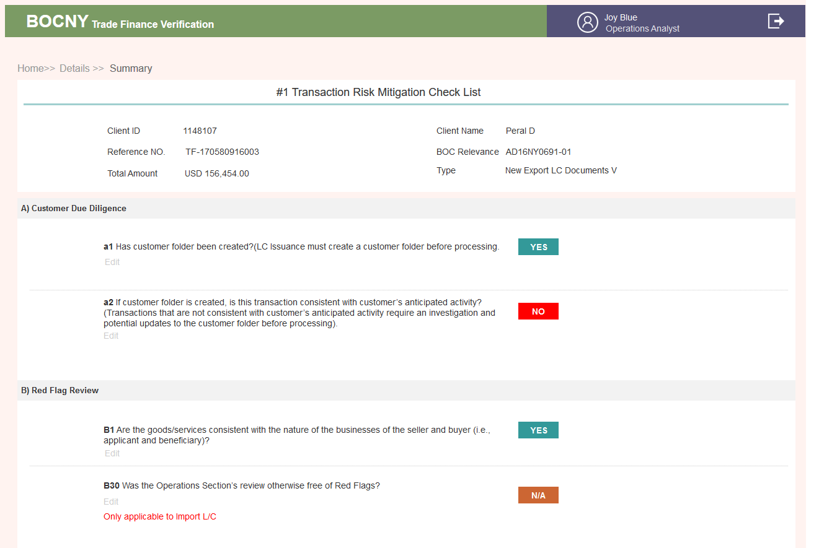

* #2 Special Approval Form

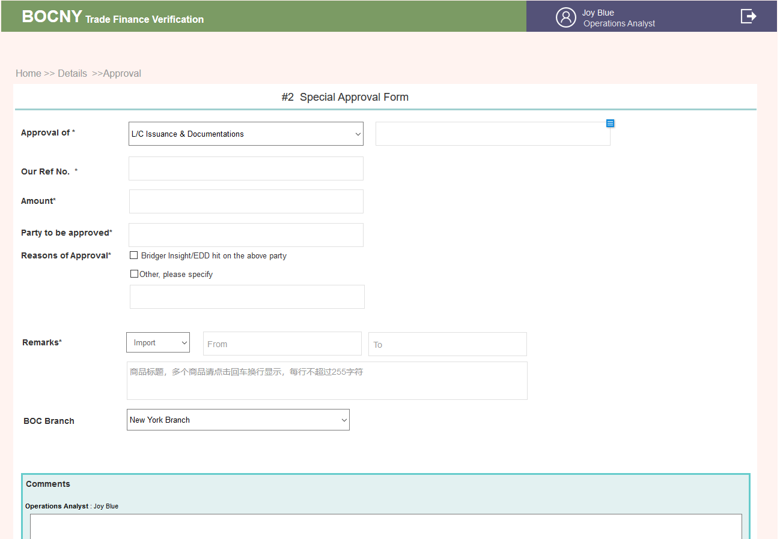

* #3 Compliance Section Supplementary Notes

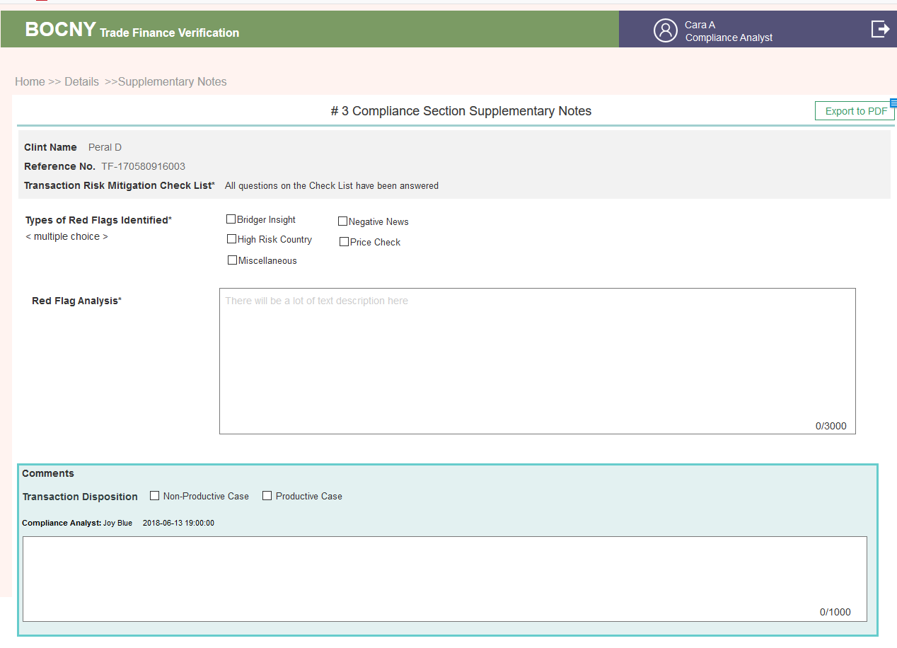

* #4 TSD Case Review Check List

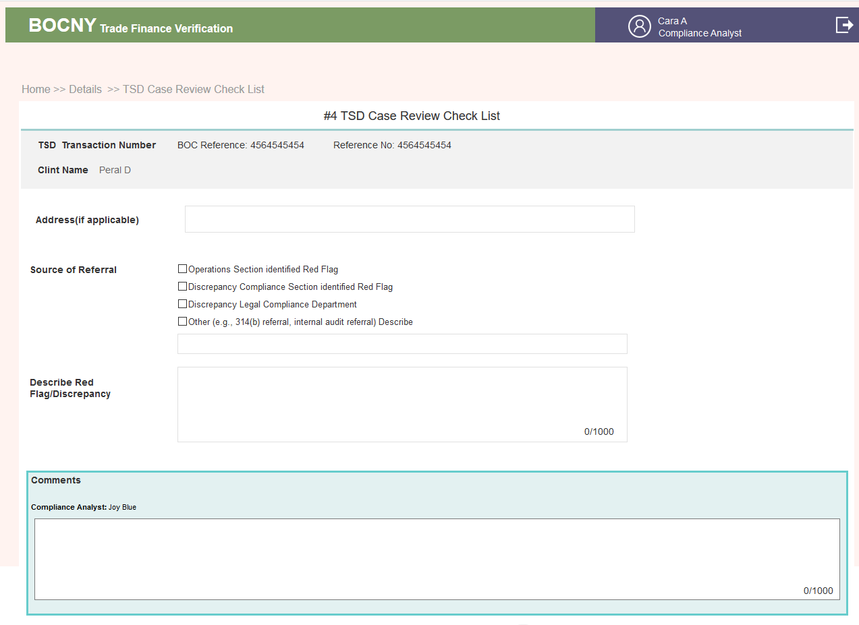

* #5  Referral Form of Unusual

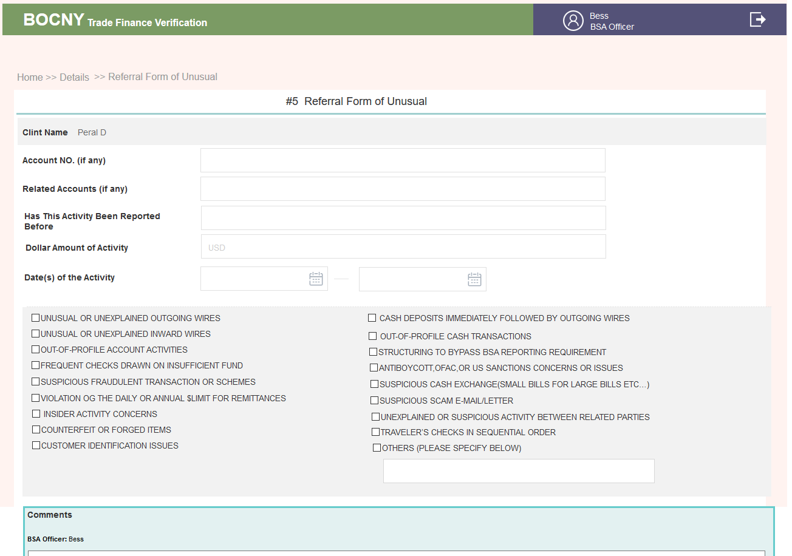

#10

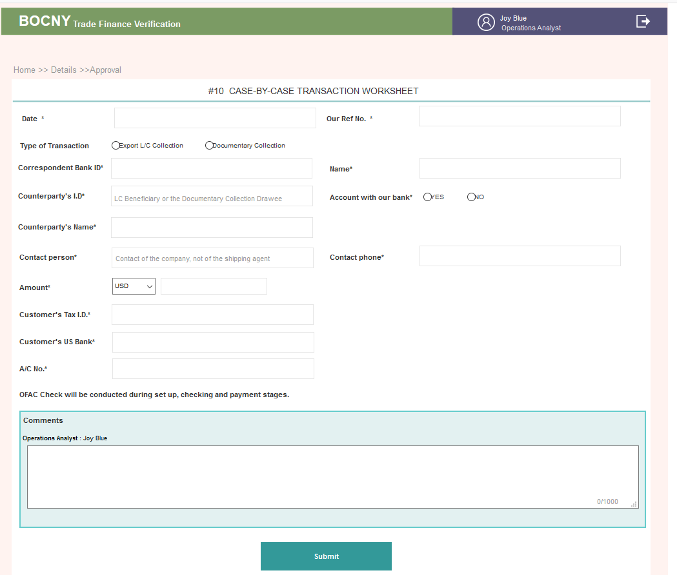

* All Forms

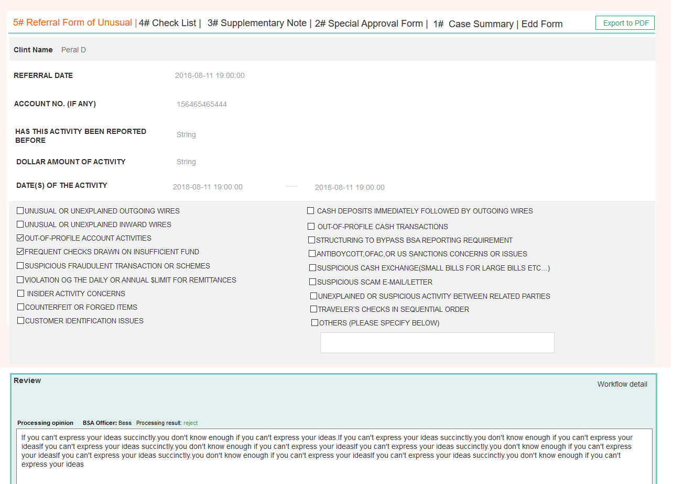

## **3.2.10** **Admin**

### ~~1..1. AS-IS~~

~~ID configuration is login integration with Lloyd’s and Dow Jones. BOC Trade Finance system utilizes a cognitive solution and provides a semi-auto platform for case review and verification. The system will automatically use Operations Analyst’s user account to log into several external resources to gather relevant meta-data, and answer the logic questions in the verification procedure. Before cases are created, Operations Analyst needs to finish the ID Configuration step. In the ID configuration login page, the Operations Analyst needs to enter his/her user account information on “Lloyd’s” and “Dow Jones” as well as his/her Bank of China ID (Email).~~

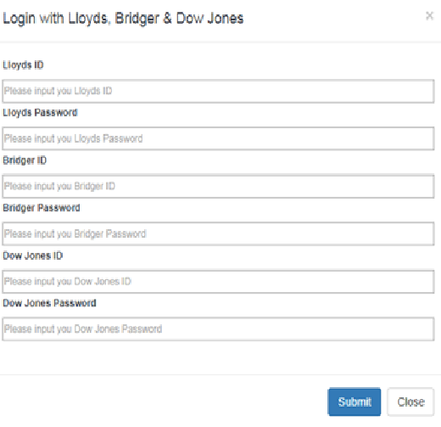

~~Component in this page：~~

|  |  |  |  |
| --- | --- | --- | --- |
| ~~#~~ | ~~ITEM~~ | ~~NAME~~ | ~~COMMENTS~~ |
| ~~1~~ | ~~Login ID (Dow Jones)~~ | ~~User ID~~ | ~~Mandatory input~~ |
| ~~2~~ | ~~Password (Dow Jones)~~ | ~~User PWD~~ | ~~Mandatory input，Context with secret cover “****”~~ |
| ~~3~~ | ~~Login ID (Lloyd’s)~~ | ~~User ID~~ | ~~Mandatory input，~~ |
| ~~4~~ | ~~Password (Lloyd’s)~~ | ~~User PWD~~ | ~~Mandatory input，Context with secret cover “****”~~ |

~~Input authorized ID & password of Lloyd’s & Dow Jones， Click “Submit”, you will get the related authorized access synchronously.~~

~~After the Operations Analyst clicks the “Submit” button, the system will automatically verify whether the account information is valid in each external resource. The system will display a popup window to notify if the system successfully login to each external resource. If information in a domain is invalid, the popup window will show “Failed” after the related domain’s name. Then the Operations Analyst could click “ID Configuration” again to reenter the account information. If the ID configuration cannot login to any of the external resource, relevant meta-data won’t be able to extract from the resource in the checking stage.~~

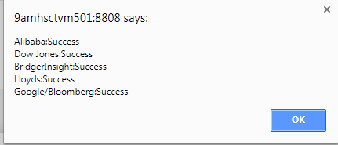

### 1..2. Enhancement

* IF ANY ID CONFIGURATION FAILED, IT SHOULD BE BIG ALERT TO DRAW OUR ATTENTION.

3.2.10.1. Brief introduction to function

主要是对平台要用到的一些通用数据的管理

3.2.10.2. Detailed description

* **List of sanctions countries**

1. 搜索，可以使用国家全名或简写搜索

按风险等级搜索

搜索右侧放一个总览，表示各风险级别国家数量。具体看视觉设计

1. 新增

1）新增方式 可以使用导入或者单个增加的方式添加

2）添加的置于前，一页最多显示25个（可调，所有列表用那个可调的通用翻页插件），

页码有几页显示几页，只有一页，可以不要页码

3）新增字段规则

A. 国家找下，有没有含有简写的国家插件给到，让用户搜索下拉去选

B. 如果国家已存在，会把这国家的相应字段调出来

并提示，该国家已存在，那么再次提交，就是相当于编辑功能，会把之前的覆盖掉

|  |  |  |  |
| --- | --- | --- | --- |
| ***字段名称***  *Name of element* | ***是否必填***  *Required/optional* | ***字段类型和长度****Type* | ***备注***  *Remarks* |
| Country | *Required* | *Dropdown menu* | 找下看有无国家插件，最好含缩写的，这样选中国家插件就可以直接把缩写调出来 |
| ISO Alpha-2 | *optional* | *2-digit value* | 2个字母的缩写 |
| ISO Alpha-3 | *optional* | *3-digit value* | 3个字母的缩写 |
| ISO Numeric | *optional* | *6-digit value* | 数字 |
| Risk Score | *Required* | *6-digit value* | *允许小数点后2位* |
| Risk Rank | *Required* | *6-digit value* | 数字 |
| Risk Rating | *Required* | *Dropdown menu* | 1. High  2. Medium  3. Low  4. HIGH(based on BOC-USA's past experience)  5. MEDIUM(based on BOC-USA's past experience) |

3. 应用Input单证里有涉及到制裁国家的下拉框，从这里进行管理High Risk Country字段&35个问题 B16

4全选、删除 。删除为物理删除

5. 编辑，

单个编辑，所有字段可编辑

6. 导入

1）如果再次导入的有相同国家名的，会把之前的国家名覆盖掉

列表显示Modify Date 为最近更新时间，到日即可（以下全部显示的都是这个最近更新时间）

2） 如果导入的必填项没填写的，则异常的没法导入，提示文案

成功导入100条数据，失败4条（15，19，20，25） 把失败的条目按EXCEL左侧序号提示出来

以下有导入的列表通用该规则

* **Common Tax Havens**

1. 应用 35个问题B21

2. 可导入或单个新增，可全选删除

新增字段规则

|  |  |  |  |
| --- | --- | --- | --- |
| ***字段名称***  *Name of element* | ***是否必填***  *Required/optional* | ***字段类型和长度****Type* | ***备注***  *Remarks* |
| Country /Region Name | *Required* | *Dropdown menu* | 找下看有无国家插件，最好含缩写的，这样选中国家插件就可以直接把缩写调出来 |
| Source | *optional* | *链接300字符以内* | 主要是数据的来源，列表不显示了，点击编辑时可见吧 |

3. 搜索

按国家名称或缩写搜索

* **Company name suffix list**

1. 应用 35个问题里要用公司名称搜索的，要把后缀去掉搜索B16 B21

2. 搜索 按各种变体都可搜到

3. 缩写是不带点的，后缀带了点，全名就是完整名称

变体的话他可以多个添加，到时候只要能匹配上，都会把这些文案去掉，然后给到第三方去访问

4. 新增至少要填了一个表单才能够点击确认添加

* **Top 10 Exports**

1. 应用 35个问题B4

2. 搜索 允许输入国家名称或缩写搜索

3. 新增字段规则

|  |  |  |  |
| --- | --- | --- | --- |
| ***字段名称***  *Name of element* | ***是否必填***  *Required/optional* | ***字段类型和长度****Type* | ***备注***  *Remarks* |
| Country Name | *Required* | *Dropdown menu* | 找下看有无国家插件，最好含缩写的，这样选中国家插件就可以直接把缩写调出来 |
| Abbreviation | *optional* |  |  |
| Link | *optional* | *链接格式300字符以内* |  |

* **Customer list of branches**

**1. 应用 35个问题A1 A2 B1**

**2. 字段**

|  |  |  |  |
| --- | --- | --- | --- |
| ***字段名称***  *Name of element* | ***是否必填***  *Required/optional* | ***字段类型和长度****Type* | ***备注***  *Remarks* |
| Customer Name | *Required* | *80-digit value* |  |
| Customer ID | *Required* | *30-digit value* |  |
| Industry/Sector | *Required* | *80-digit value* |  |
| Expected Annual Transaction Volumn | *Required* | *225-digit text* |  |

* **List of third-party websites**

第三方网站账号&密码设置。在请求第三方API获取证据时，需要把这块的数据传过去。

如果密码错误会显示文案，“Alibaba 账号验证失败，请核对后重新输入” 点击修改后去重新修改。

如果验证成功，文案显示“Alibaba 账号验证成功”

|  |  |  |  |
| --- | --- | --- | --- |
| ***字段名称***  *Name of element* | ***是否必填***  *Required/optional* | ***字段类型和长度****Type* | ***备注***  *Remarks* |
| Source | *Required* | *80-digit value* |  |
| API接口地址 | *optional* | *300-digit value* |  |
| 网站URL | *optional* | *300-digit value* |  |
| Account | *Required* | *30-digit text* |  |
| Password | *Required* | *30-digit text* | 暗码 |

* 单位配置

在Input 页面，单证涉及到单位的，让在ADMIN这里设置好，然后在填写时，下拉选择

详见单证字段说明，来源于ADMIN的字段

目前有3个字段

Quantity ，Weight ，币种

下拉选不同类型，调对应字段填写

* 所有CASE

这里可以看到所有的CASE

CASE相关的DETAILS所有内容都可以在这里看到，只是这里没有业务流的操作权限

* CASE BY CASE

如果哪个CASE有填写了CASE BY CASE表单则会出现在这里

右上角显示总共填了多少张CASE BY CASE表单，数字会随着时间范围的筛选变化

点击Details可以查看该CASE BY CASE表单的内容

3.2.10.3. Interface requirements

* **List of sanctions countries**

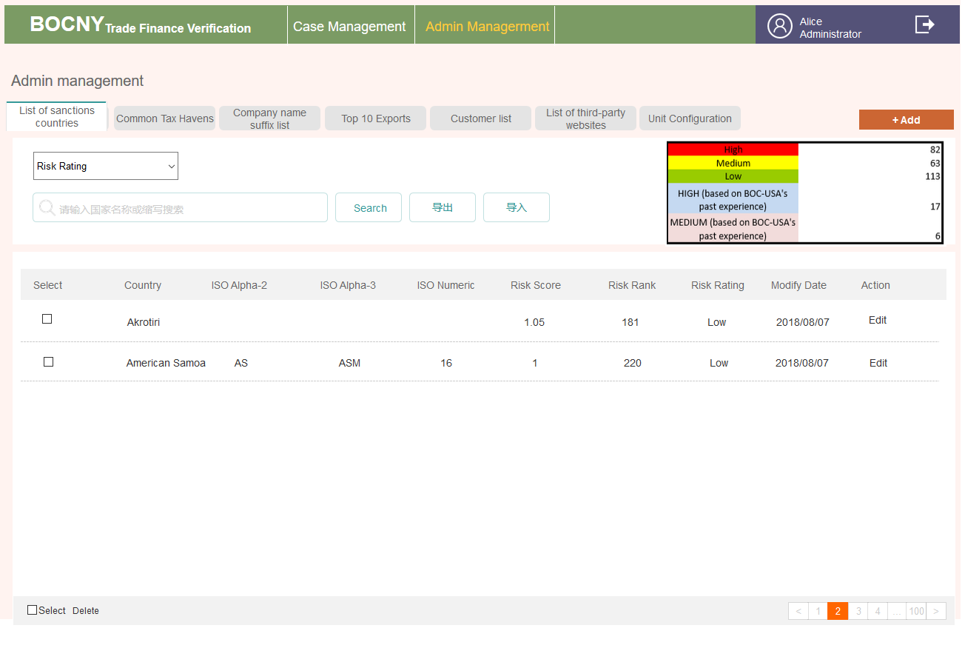

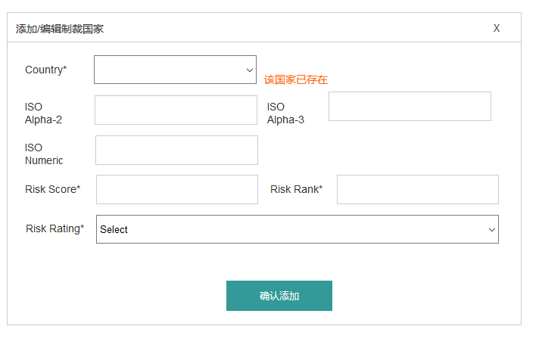

* **Common Tax Havens**

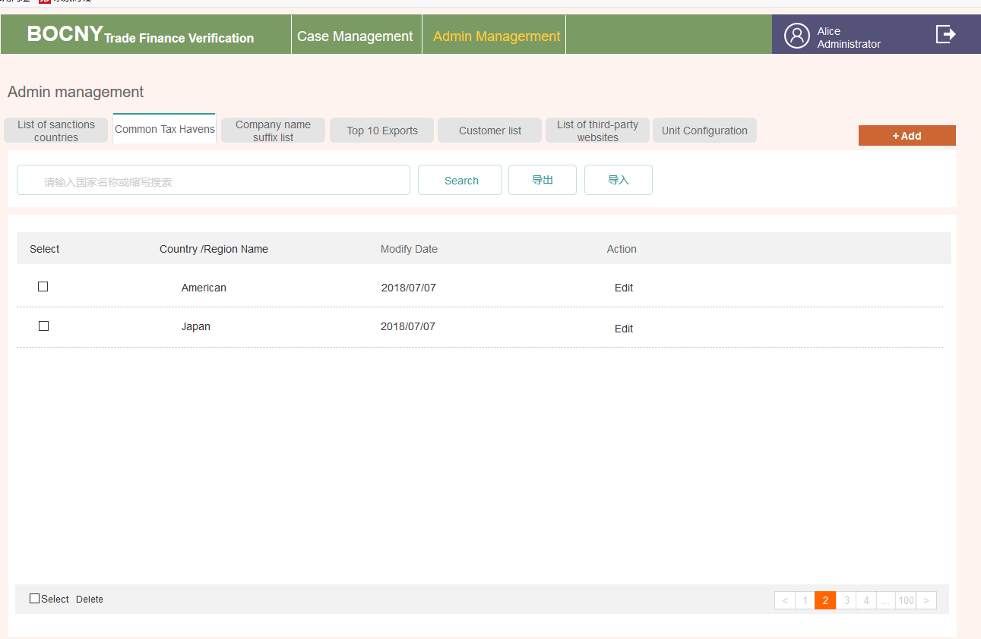

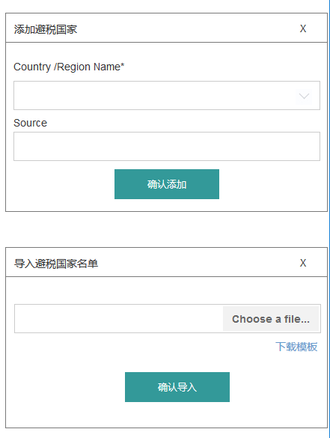

* **Company name suffix list**

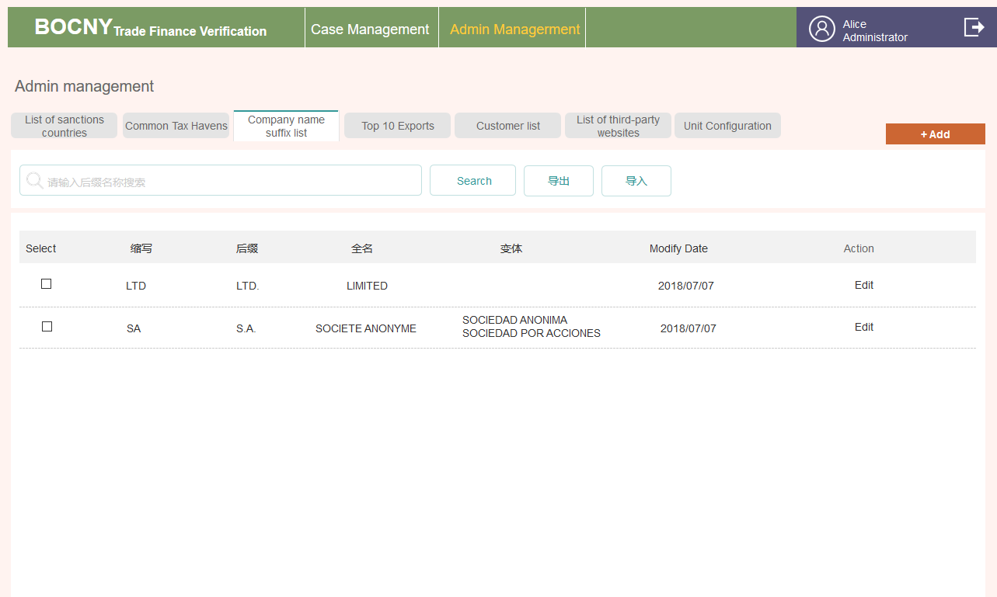

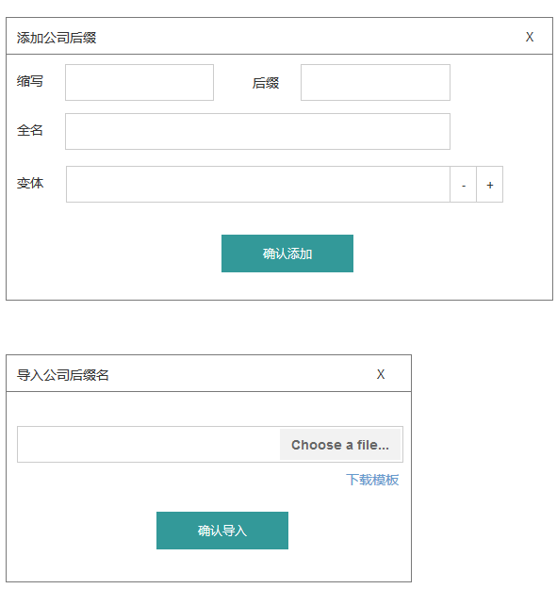

* **Top 10 Exports**

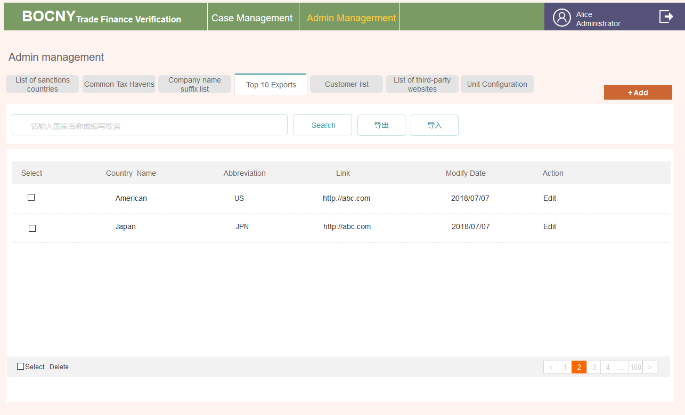

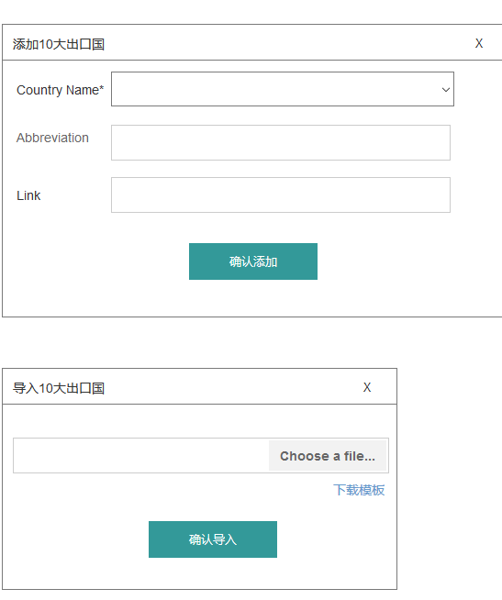

* **Customer list of branches**

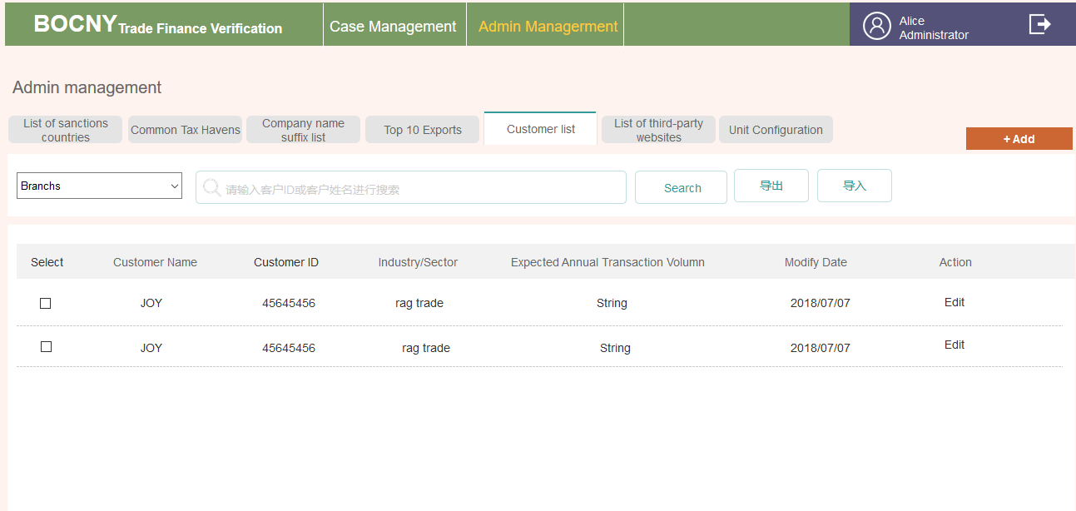

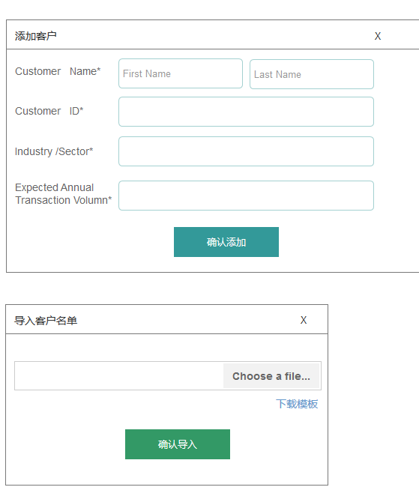

* **List of third-party websites**

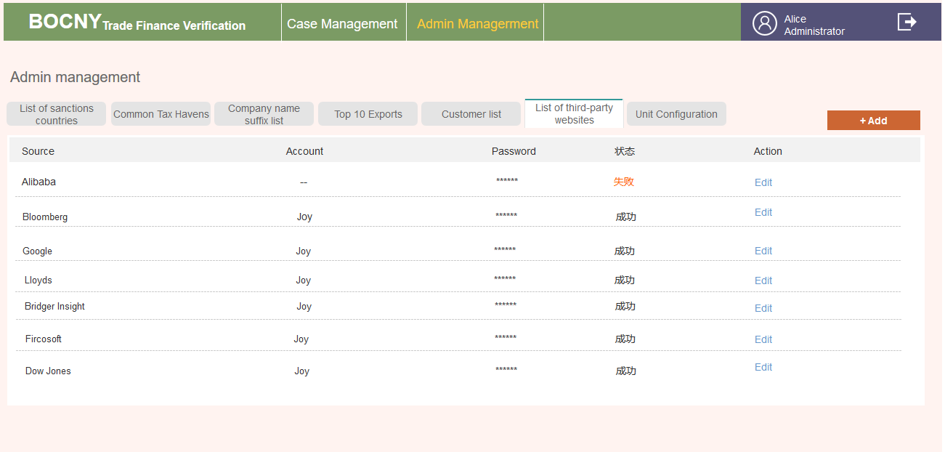

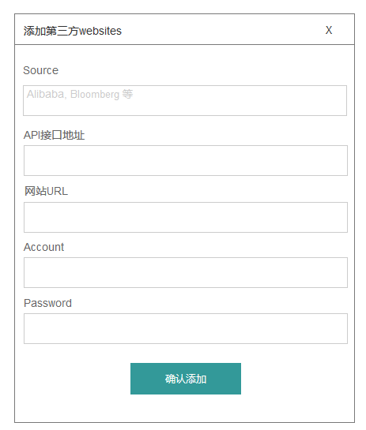

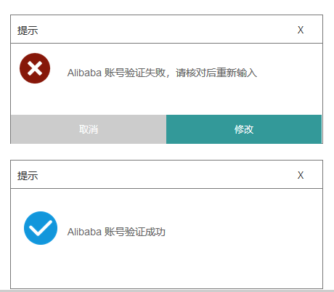

* Unit Configuration

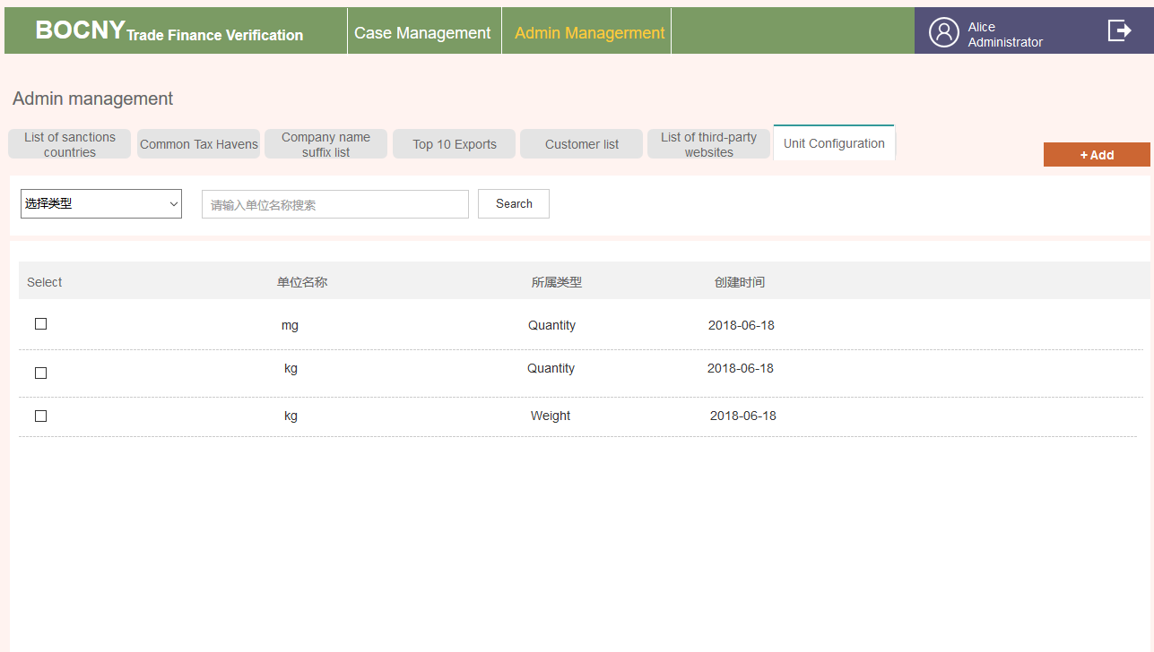

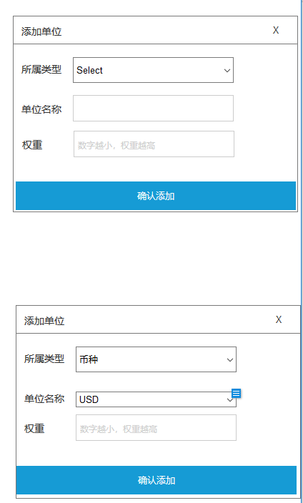

* Case list

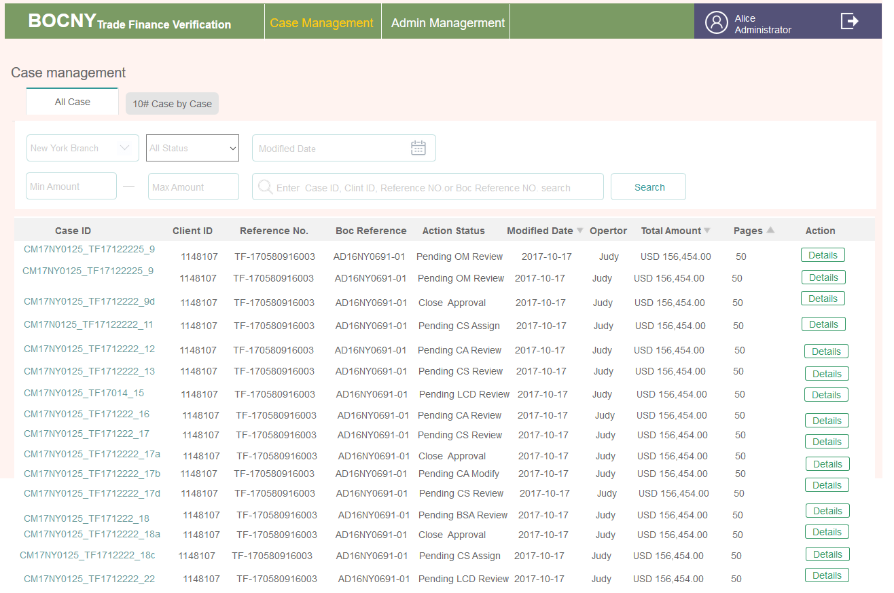

* 10# Case by Case

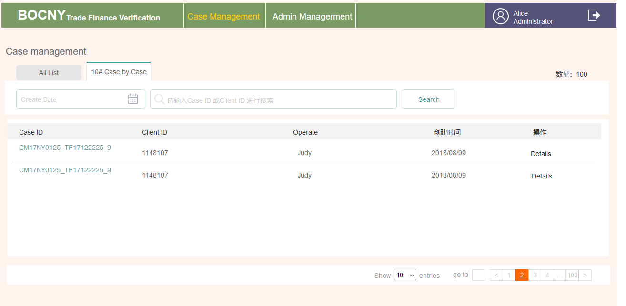

3.2.11 Operations Manager

3.2.11.1. Brief introduction to function



3.2.11.2. Detailed description

* 列表

|  |  |  |
| --- | --- | --- |
| ***列表标签****t* | ***对应状态*** | ***备注*** |
| *TO DO LIST* | ***6A~ 6B*** | *有二种情形的会出现在OM角色的待处理项中*   * *一个是OA第一次发过来的CASE（注意这时OM第一次看到这个CASE）* * *另一个是打回给OA，OA修改后又再次发过来的CASE* * *点击Check进入详情页* |
| Pending List | *8（含）以后的状态&5A&5B，扣除History List状态* | *操作按钮为Details点击进入详情页* |
| *History* List |  |  |

时间字段，为最近更新时间

打回，点击打回操作时，会出一个弹窗，可以填写打回原因，该字段展示在该OA的详情页基本信息字段下方

其它字段规则通OA，不再赘述

* 各状态控件变化

| **Step** | **动作** | **位置** | **类型** | **内容** |
| --- | --- | --- | --- | --- |
| 6A | OA第一次发过来的CASE | To Do List列表 | 按钮 | Check |
| Details>>客户信息 | 状态 | Under Operations Manager Review |
| 内容 | 客户基本信息 |
| 按钮 | ~~无~~ File Management |
| Details>>Confirms Case | 内容 | * 如果OA有填了EDD&1#&2#发过来的话，则在这里会显示（表单页点击了Submit状态会变为已审阅，注意，表单没有全变成已审阅，下按钮项，除ALL FORMS外其它往下走的按钮虽可见，但是置灰不可点击） * 之后会随着后面角色的填写不断增加 |
| 按钮 | * All Forms ~~（有发表过来才有这个按钮，当前最多3张表，均有回复提交功能）~~ * Return to OA * Refer to CS * Approve |
| Details>> Documens Verification | 内容 | 有(通OA该模块，看有无配编辑权限，无，则只是浏览)  ~~（指向对应的INPUT对应单证页）~~ |
| 按钮 | Details (通OA，有编辑权限则为INPUT，没编辑权限则为Details)  ~~（注意与内容指向不同，下文另述）~~ |
| Details>> Checking & Evidence>> Comments | 内容 | OA那有，在这则有 |
| Details>> Checking & Evidence>>警告标识 | 内容 | 有 |
| 按钮 | * Evidence Management（可编辑页） * Check（可编辑） |
| 7A | 点击Return to OA，成功发送后 | Pending List列表 | 按钮 | Details |
| Details>>客户信息 | 状态 | * Pending Operations Analyst Modify * Under Operations Analyst Modify |
| 内容 | 有 |
| 按钮 | ~~无~~File Management |
| Details>>Confirms Case | 内容 | 同上 |
| 按钮 | All Forms （只有导出，不可编辑） |
| Details>> Documens Verification | 内容 | 同上 |
| 按钮 | Details |
| Details>> Checking & Evidence>> Comments | 内容 | 同上 |
| Details>> Checking & Evidence>>警告标识 | 内容 | 有 |
| 按钮 | * Evidence Management（不可编辑页） * Check（不可编辑页） |
| 7B | 详情页点击Approve后 | Pending List列表 | 按钮 | Details |
| Details>>客户信息 | 状态 | Close Approval |
| 内容 | 有（不变） |
| 按钮 | ~~无~~File Management |
| Details>>Confirms Case | 内容 | 有则有 |
| 按钮 | All Forms |
| Details>> Documens Verification | 内容 | 有 |
| 按钮 | Details |
| Details>> Checking & Evidence>> Comments | 内容 | 有则有 |
| ~~按钮~~ | ~~无~~ |
| Details>> Checking & Evidence>>警告标识 | 内容 | 有 |
| 按钮 | * Evidence Management（不可编辑页）   Check（不可编辑页） |
| 7C | Refer to CS后 | Pending List列表 | 按钮 | Details |
| Details>>客户信息 | 状态 | * Pending Operations Analyst modify   Under Operations Manager review |
| 内容 | 有 |
| 按钮 | ~~无~~File Management |
| Details>>Confirms Case | 内容 | 同上 |
| 按钮 | All Forms （只有导出，不可编辑）随着后面添加表单的增加而增加 |
| Details>> Documens Verification | 内容 | 同上 |
| 按钮 | Details |
| Details>> Checking & Evidence>> Comments | 内容 | 同上 |
| ~~按钮~~ | ~~无~~ |
| Details>> Checking & Evidence>>警告标识 | 内容 | 有 |
| 按钮 | * Evidence Management（不可编辑页） * Check（不可编辑页） |
| 6B\5B | OA改完再发过来 | 通6A | 通6A | 改完后看到新内容，可操作控件通6A。表单回复有打回项 |

3.2.11.3. Interface requirements

* 首页

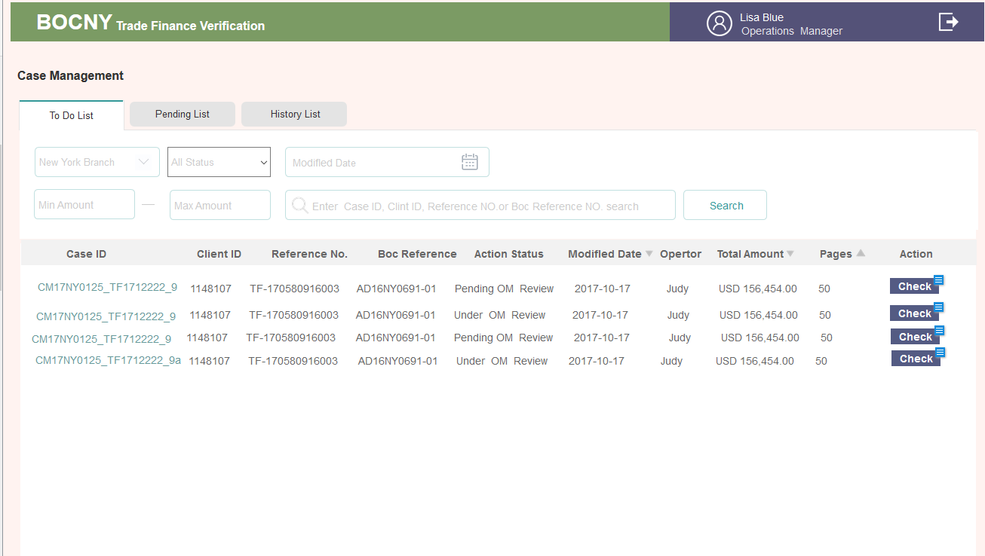

* Details

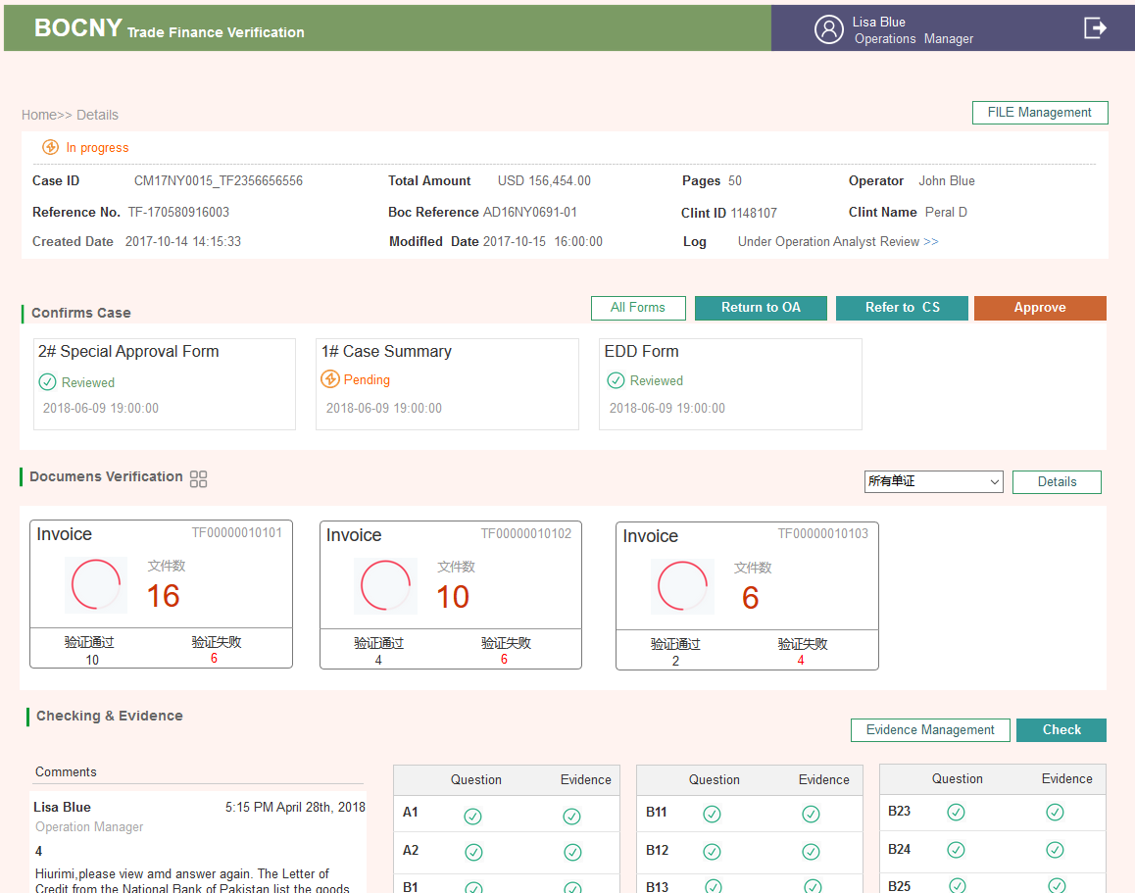

* ALL FORMS 第一次收到的回复页

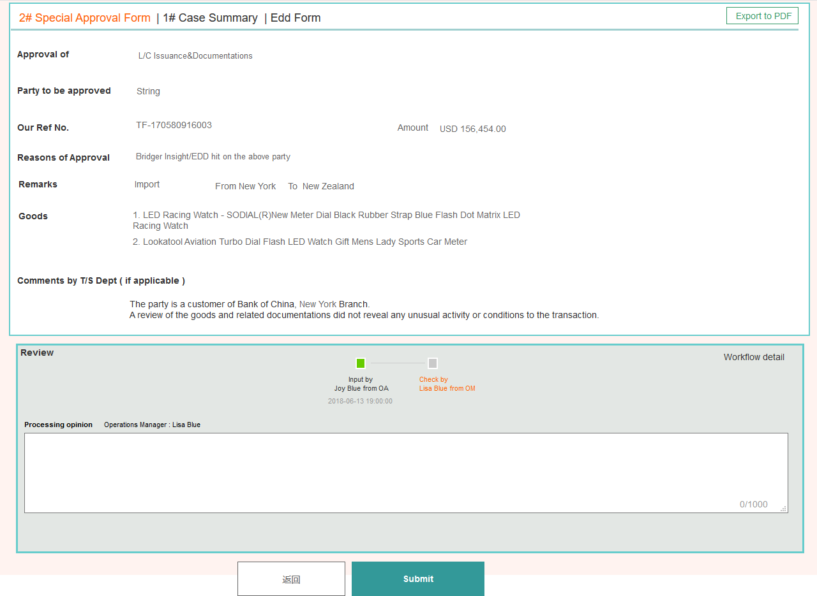

3.2.12 Compliance Supervisor

3.2.12.1. Brief introduction to function



3.2.12.2. Detailed description

* 列表

|  |  |  |
| --- | --- | --- |
| ***列表标签****t* | ***对应状态*** | ***备注*** |
| *TO DO LIST* | ***8A, 8B***  ***11,12***  ***15,16A,16B***  ***19,20***  ***30A,30B*** | * *OM第一次发给CS* * *CA处理完#2发给CS* * *CA增加完#3发给CS* * *CA增加完#4发给CS* * *BSA认为要补充资料，打回给CS* |
| Pending List | *9(含)之后的状态扣除以上&以下* | *详见状态表* |
| *History* List |  |  |

列表 时间字段，为最近更新时间

其它字段规则通OA，不再赘述

* 各状态控件变化

| **Step** | **动作** | **位置** | **类型** | **内容** |
| --- | --- | --- | --- | --- |
| 8A | OM第一次把case发给CS | To Do List列表 | 按钮 | Assign |
| Details>>客户信息 | 状态 | * Under Compliance Supervisor Assign |
| 内容 | 客户基本信息 |
| 按钮 | ~~无~~File Management |
| Details>>Confirms Case | 内容 | * 如果OA有填了EDD&1#&2#发过来的话，则在这里会显示   之后会随着后面角色的填写不断增加 |
| 按钮 | * All Forms ~~（有发表过来才有这个按钮，当前最多3张表，2#，EDD~~ * Assign |
| Details>> Checking & Evidence>> Comments | 内容 | OA那有，在这则有 |
| Details>> Checking & Evidence>>警告标识 | 内容 | 有 |
| 按钮 | * Evidence Management（可编辑页） * Check（可编辑页） |
| 8B后 | 将CASE分配给CA后 | Pending List列表 | 按钮 | Details |
| 详情页>>状态 | 内容 | * Pending Compliance Analyst Review * Under Compliance Analyst Review |
| 详情页>>Confirms Case | 按钮 | Assign按钮消失  All Forms不再允许编辑 |
| Checking & Evidence | 按钮 | * Evidence Management（不可编辑页）   Check（不可编辑） |
| 11 | CA处理完后发过来 | To Do List列表 | 按钮 | Check |
| 详情页>>状态 |  | * Under Compliance Supervisor Review |
| Confirms Case | 内容 | ~~最多3张表（#2&EDD可回复3张表均为待审阅）表单没有全变成已审阅，下按钮项，除ALL FORMS外其它往下走的按钮虽可见，但是置灰不可点击~~ 有 |
| 按钮 | * All Forms * Refer to LCD |
| 警告标识 | 按钮 | * Evidence Management（可编辑页）   Check（可编辑） |
| 12 | Refer to LCD后 | Pending List列表 | 按钮 | Details |
| 详情页>>状态 | 内容 | * Pending LCD Feedback * Under LCD Feedback |
| 详情页>>Confirms Case | 按钮 | * Refer to LCD按钮消失 * All Forms不再允许编辑 |
| Checking & Evidence | 按钮 | * Evidence Management（不可编辑页）   Check（不可编辑） |
| 15 | CA加了#3发过来 | To Do List列表 | 按钮 | Check |
| 详情页>>状态 | 内容 | Under Compliance Supervisor Review |
| 详情页>>Confirms Case | 内容 | 多了#3，可回复  3#为待审阅，其它为已审阅 |
| 按钮 | * All Forms(加了#3) * Return to CA * Approve |
| 警告标识 | 按钮 | * Evidence Management（可编辑页）   Check（可编辑页） |
| 16A | 详情页点击Approve 后 | Pending List 列表 | 按钮 | Details |
| 详情页>>状态 | 内容 | Close Approval |
| 详情页>>Confirms Case | 按钮 | 另2个按钮消失，All Forms不再允许编辑（多了#3） |
| Checking & Evidence | 按钮 | * Evidence Management（不可编辑页）   Check（不可编辑） |
| 16B | 详情页点击Return to CA后 | 详情页>>状态 | 内容 | * Pending Compliance Analyst Review * Under Compliance Analyst Review |
| 其它字段 | 通16A | 通16A |
| 19 | CA加了#4过来 | To Do List列表 | 按钮 | Check |
| 详情页>>状态 | 内容 | Under Compliance Supervisor Review |
| 详情页>>Confirms Case | 内容 | 多了#4，可回复  4#为待审阅，其它为已审阅 |
| 按钮 | * All Forms(加了#4) * Refer to BSA |
| 警告标识 | 按钮 | * Evidence Management（可编辑页）   Check（可编辑页） |
| 20 | 发给BSA后 | Pending List列表 | 按钮 | Details |
| 详情页>>状态 | 内容 | Pending BSA Officer Review  Under BSA Officer Review |
| 详情页>>Confirms Case | 按钮 | 另2个按钮消失，All Forms不再允许编辑（多了#4） |
| Checking & Evidence | 按钮 | * Evidence Management（不可编辑页）   Check（不可编辑） |
| 30A | 被BSA打回 | To Do List列表 | 按钮 | Assign |
| 详情页>>状态 | 内容 | Under Compliance Supervisor Assign |
| Details>>Confirms Case | 内容 | BSA有COMMENTS的状态变为待处理 |
| 按钮 | * All Forms * Assign |
| Details>> Checking & Evidence>> Comments | 内容 | OA那有，在这则有 |
| Details>> Checking & Evidence>>警告标识 | 内容 | 有 |
| Pending Compliance Supervisor Assign | 按钮 | * Evidence Management（可编辑页）   Check（可编辑页） |
| 30B | 分配给CA后 | Pending List列表 | 按钮 | Details |
| Details |  | Assign按钮消失，进入不可编辑状态 |

3.2.12.3. Interface requirements

* 列表页

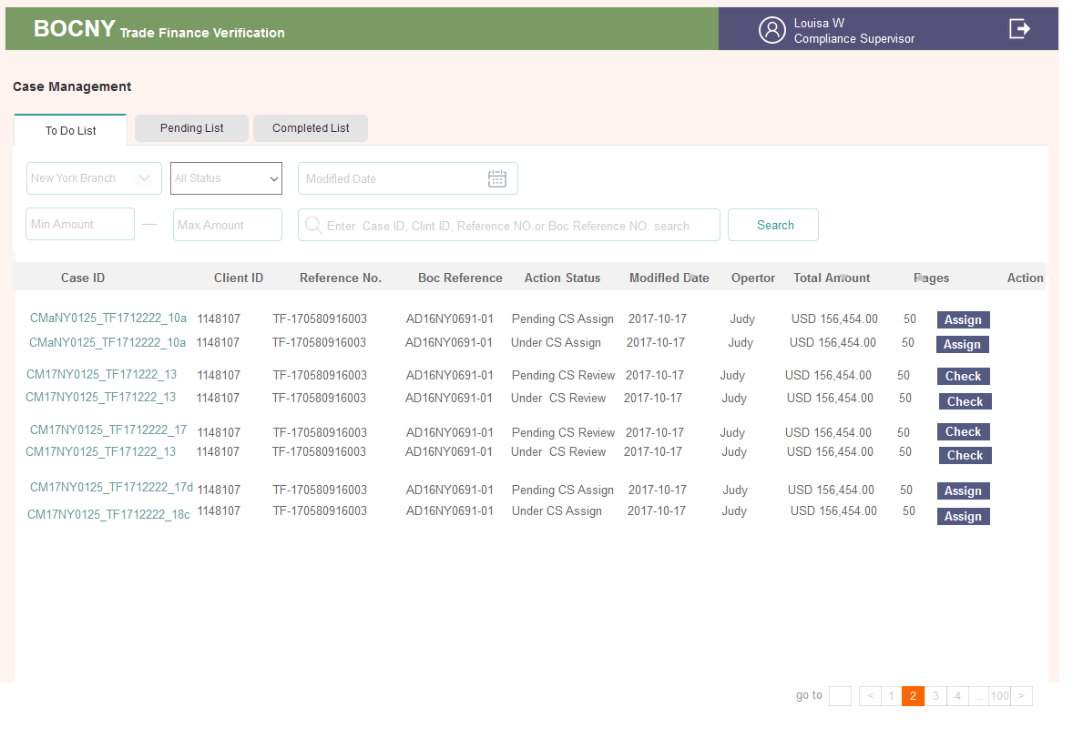

* 19流程 详情页

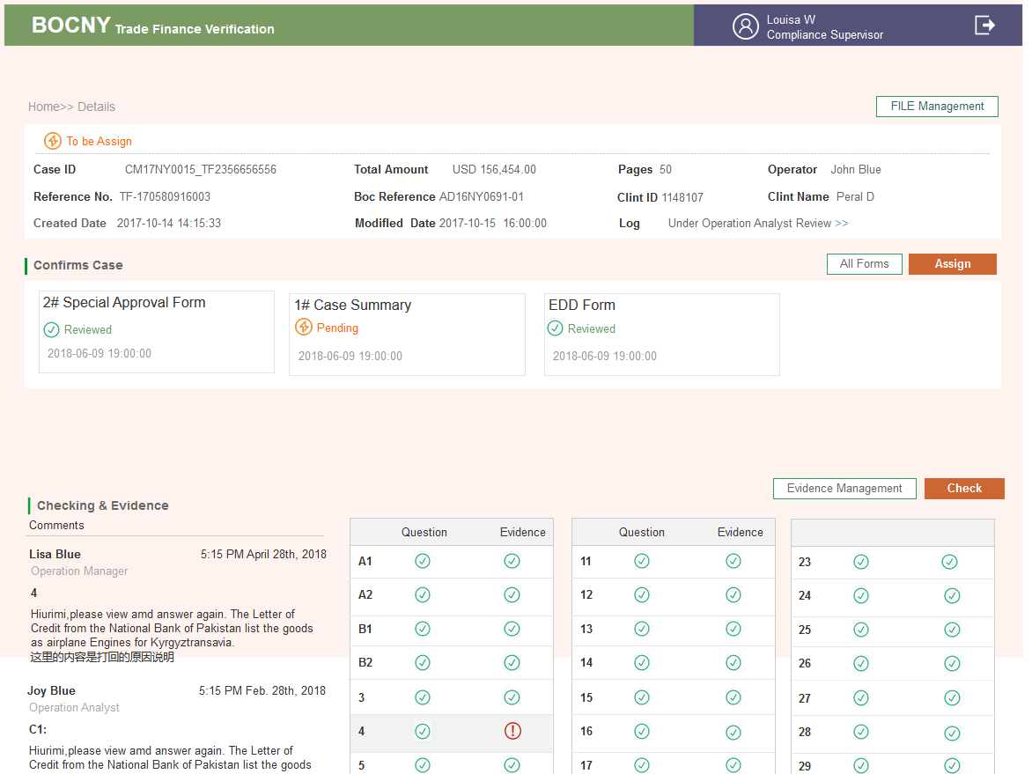

* #4 ALL Forms

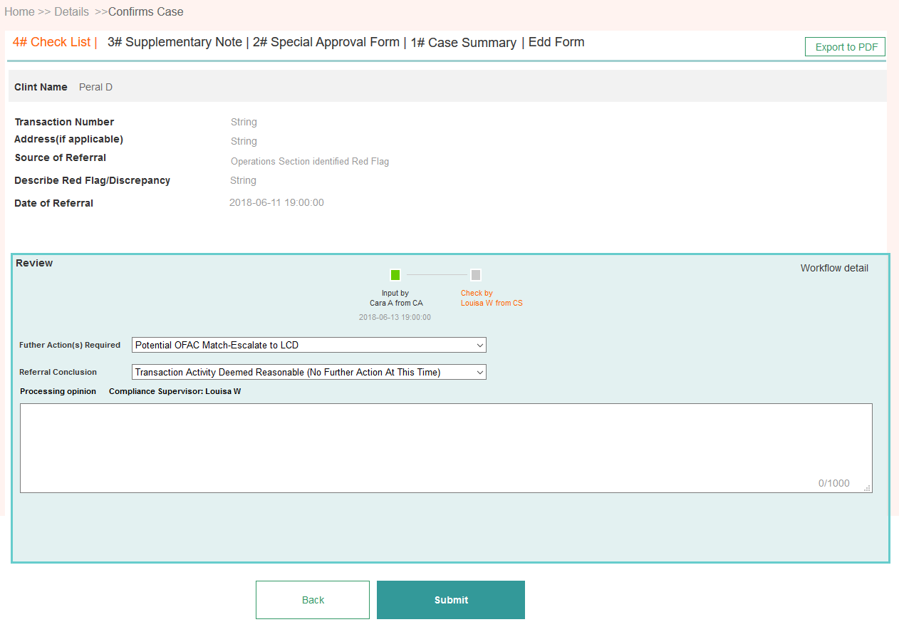

3.2.13 Compliance Analyst

3.2.13.1. Brief introduction to function



3.2.13.2. Detailed description

* 列表

|  |  |  |
| --- | --- | --- |
| ***列表标签****t* | ***对应状态*** | ***备注*** |
| *TO DO LIST* | ***9，10***  ***14A, 14B***  ***17, 18***  ***31A, 31B*** | *第一次收到CS分配来的*  *收到LCD发来的，添#3*  *被CS打回添#4*  *被BSA打给CS打回重处理* |
| Pending List | *11(含)之后的状态扣除以上&以下* | *详见状态表* |
| *History List* |  | *详见状态表* |

* 各状态控件变化

| **Step** | **动作** | **位置** | **类型** | **内容** |
| --- | --- | --- | --- | --- |
| 9 | CA第一次收到CS分配给的CASE | To Do List列表 | 按钮 | Check |
| Details>>客户信息 | 状态 | Under Compliance Analyst Review |
| 内容 | 客户基本信息 |
| 按钮 | ~~无~~File Management |
| Details>>Confirms Case | 内容 | ~~最多EDD&1#&2#，回复2#&EDD(3张表全是待处理)~~ 有 |
| 按钮 | * All Forms * Refer to CS |
| Details>> Checking & Evidence>> Comments | 内容 | 有则有 |
| Details>> Checking & Evidence>>警告标识 | 内容 | 有 |
| 按钮 | * Evidence Management（可编辑页） * Check（可编辑页） |
| 10 | Refer to CS | Pending List*列表* | 按钮 | Details |
| Details>>Confirms Case | 内容 | 不再允许修改 |
| 按钮 | * All Forms * Refer to CS消失 |
| Details>> Checking & Evidence>> Comments | 内容 | 有则有 |
| Details>> Checking & Evidence>>警告标识 | 内容 | 有 |
| Under Compliance Analyst Review | 按钮 | * Evidence Management（不可编辑） * Check（不可编辑） |
| 14A | LCD发给CA创建#3 | To Do List列表 | 按钮 | Check |
| Details>>客户信息 | 状态 | Under Compliance Analyst Review |
| 内容 | 客户基本信息 |
| 按钮 | ~~无~~File Management |
| Details>>Confirms Case | 内容 | * 自己添完#3后会增加#3 * 如果LCD有写了COMMENTS的表单，状态为待处理 |
| 按钮 | * All Forms * 3#Supplementary Notes * Refer to CS * OFAC Results看到LCD写的结果 |
| Details>> Checking & Evidence>> Comments | 内容 | 有则有 |
| Details>> Checking & Evidence>>警告标识 | 内容 | 有 |
| Under Compliance Analyst Review | 按钮 | * Evidence Management（可编辑页）   Check（可编辑页） |
| 14B | 建完#3 Refer to CS后 | Pending List*列表* | 按钮 | Details |
| Details>>Confirms Case | 内容 | 不再允许修改 |
| 按钮 | * All Forms |
| Details>> Checking & Evidence>> Comments | 内容 | 有则有 |
| Details>> Checking & Evidence>>警告标识 | 内容 | 有 |
| Under Compliance Analyst Review | 按钮 | * Evidence Management（不可编辑）   Check（不可编辑） |
| 17 | CS发过来要求再创建#4 | To Do List列表 | 按钮 | Check |
| Details>>客户信息 | 状态 | Under Compliance Analyst Review |
| 内容 | 客户基本信息 |
| 按钮 | ~~无~~File Management |
| Details>>Confirms Case | 内容 | * 自己添完#4后会增加#4   如果CS有写了COMMENTS的表单，状态为待处理 |
| 按钮 | * All Forms * 4#Check List * Refer to CS |
| Details>> Checking & Evidence>> Comments | 内容 | 有则有 |
| Details>> Checking & Evidence>>警告标识 | 内容 | 有 |
| Under Compliance Analyst Review | 按钮 | * Evidence Management（可编辑页）   Check（可编辑页） |
| 18/ 16B/20 | 创建#4并发给CS后 | Pending List*列表* | 按钮 | Details |
| Details>>Confirms Case | 内容 | 不再允许修改 |
| 按钮 | All Forms |
| Details>> Checking & Evidence>> Comments | 内容 | 有则有 |
| Details>> Checking & Evidence>>警告标识 | 内容 | 有 |
| Under Compliance Analyst Review | 按钮 | * Evidence Management（不可编辑） * Check（不可编辑） |
| 31A | BSA打回给CS分配给CA | 通9 | 通9 | 随着流程内容的增加有了增加 |
| 31B | CA发给CS后 | 通18 | 通18 | 有新增了COMMETNS 则会有增加变化 |

3.2.13.3. Interface requirements

* 列表页

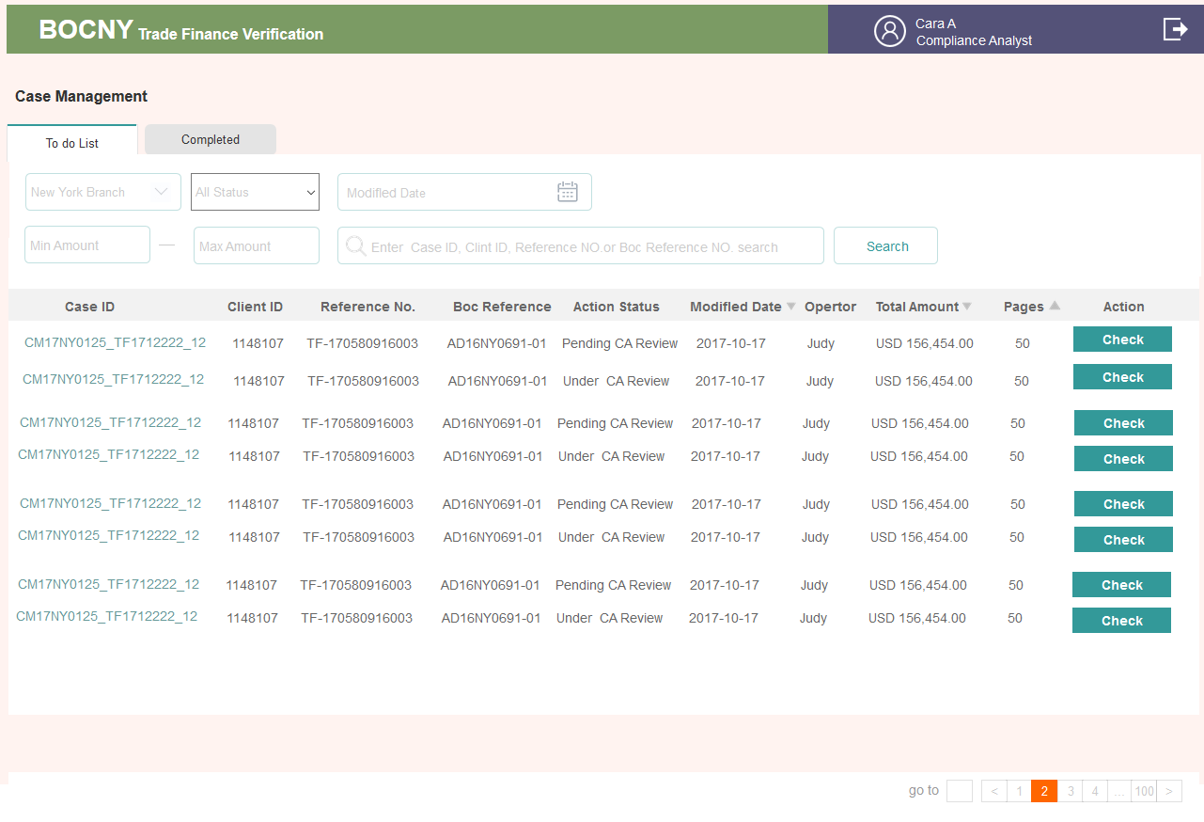

* 详情页

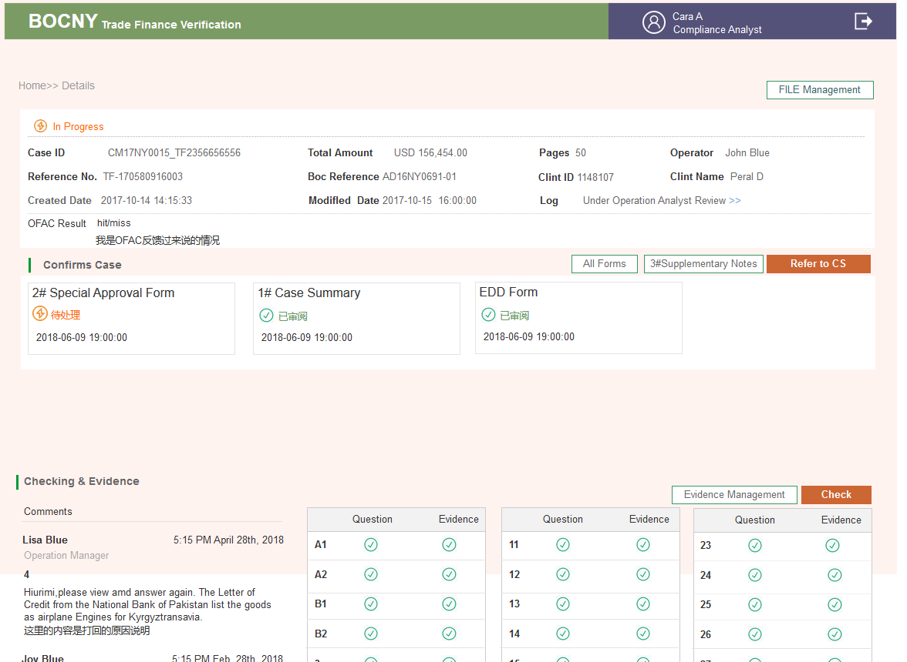

3.2.14 BSA Officer

3.2.14.1. Brief introduction to function



3.2.14.2. Detailed description

* 列表

|  |  |  |
| --- | --- | --- |
| ***列表标签****t* | ***对应状态*** | ***备注*** |
| *TO DO LIST* | ***21-27*** | * *第一次收到CS发来的CASE* * *打回CS后，再次收到发来的CASE* |
| Pending List | *28(含)之后的状态扣除以下* | *详见状态表* |
| *History List* |  | *详见状态表* |

* 各状态控件变化

24B

Step 1 BSA角色，在表4# 勾选Reject，点击Submit

Step2 **程序**发现勾选了Reject后，

1）状态变为close reject

2）在Details详情页出现#5填写的入口（修改了4# Reject改成其它了这个前往填写5#的入口便会消失）

Step 3 人工填写5#的内容后点击提交

Step 4 出现导出PDF按钮（提交了#5后才出现）

把之前填写的1#~5#，EDD,10#这几张表全部生成跟模板样式相同的PDF格式。导出到桌面上(走线下流程)

Step 5 但线上依然需要点击Send to LCD 状态从close reject变为Pending LCD SAR Process

CASE继续流转到LCD

Step 6 LCD收到CASE后，点击SAR按钮。然后现有设计也是在SAR弹窗中填写一些内容。然后点击submit，然后状态变为Close with SAR Control LOG#，这条CASE的所有流程就走完了。

| **Step** | **动作** | **位置** | **类型** | **内容** |
| --- | --- | --- | --- | --- |
| 21 | BSA复核 | To Do List列表 | 按钮 | Check |
| Details>>客户信息 | 状态 | Under BSA Officer Review |
| 内容 | 客户基本信息 |
| 按钮 | ~~无~~File Management |
| Details>>Confirms Case | 内容 | ~~#4~~  有 |
| 按钮 | * All Forms * Approve |
| Details>> Checking & Evidence>> Comments | 内容 | 有则有 |
| Details>> Checking & Evidence>>警告标识 | 内容 | 有 |
| 按钮 | * Evidence Management（可编辑页） * Check（可编辑页） |
| 24B | BSA #4选择了Reject | Details>>Confirms Case | 内容 | * 加了#5则有#5表 |
| 按钮 | * All Forms * Generate Reports（导出或打印ALL FORMS里所有的表） * 5# Referral Form of Unusual * Refer to LCD |
| 26D | BSA #4选择了继续处理 | Details>>Confirms Case | 内容 | #4 |
|  | 按钮 | * All Forms * Return to CS |

3.2.14.3. Interface requirements

* 列表页

* 详情页

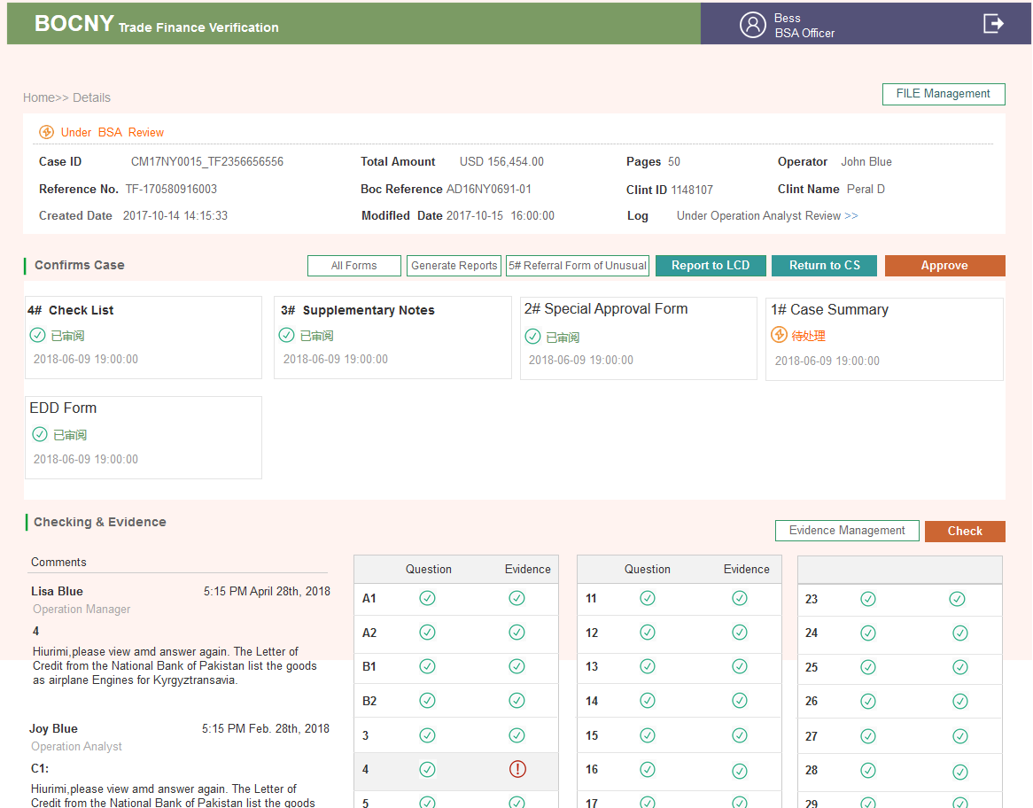

3.2.15 LCD Department

3.2.15.1. Brief introduction to function



3.2.15.2. Detailed description

* 列表

|  |  |  |
| --- | --- | --- |
| ***列表标签****t* | ***对应状态*** | ***备注*** |
| *TO DO LIST* | ***13A, 13B***  ***28, 29*** | * *第一次收到CS发来，主要是#2* * *最后一次收到BSA发来* |
| Pending List | *14A(含)之后的状态扣28，29扣以下* | *详见状态表* |
| *History List* |  | *详见状态表* |

* 各状态控件变化

| **Step** | **动作** | **位置** | **类型** | **内容** |
| --- | --- | --- | --- | --- |
| ***13A*** | LCD第一次收到 | To Do List列表 | 按钮 | Check |
| Details>>客户信息 | 状态 | Under LCD Department Review |
| 内容 | 客户基本信息 |
| 按钮 | ~~无~~File Management |
| Details>>Confirms Case | 内容 | #2 |
| 按钮 | * All Forms * OFAC(点击出一个弹窗，需要选择hit&miss点写内容非必填，Submit提交。CA及后面的角色会看的到。未提交，SEND TO CA按钮不能点) * Send to CA |
| Details>> Checking & Evidence>> Comments | 内容 | 有则有 |
| Details>> Checking & Evidence>>警告标识 | 内容 | 有 |
| 按钮 | * Evidence Management（不可编辑页） * Check |
| 13B | 发给CA后 | Pending List*列表* | 按钮 | Details |
| Details>>Confirms Case | 按钮 | * All Forms |
| 其它 | 内容&按钮 | 不可编辑 |
| 28 | 最后一次收到表单 | To Do List列表 | 按钮 | SAR |
| Details>>客户信息 | 状态 | * Reject |
| 内容 | * 客户基本信息 |
| 按钮 | ~~无~~File Management |
| Details>>Confirms Case | 内容 | * #5 |
| 按钮 | * Final Report（就是SAR最后导出的表PDF，所有的表可以导出或打印） * SAR LOG# （点击出一个弹窗，可以填写SAR结果，这些在状态日志中可见）Submit后该流程结束 |
| Details>> Checking & Evidence>> Comments | 内容 | * 有则有 |
| Details>> Checking & Evidence>>警告标识 | 内容 | * 有 |
| 按钮 | * Evidence Management（不可编辑页） * Check（不可编辑页） |
| 29 | SAR提交后 | Details>>Confirms Case | 按钮 | * Final Report |
| 其它字段 |  | 不可编辑 |

3.2.15.3. Interface requirements

* 列表页

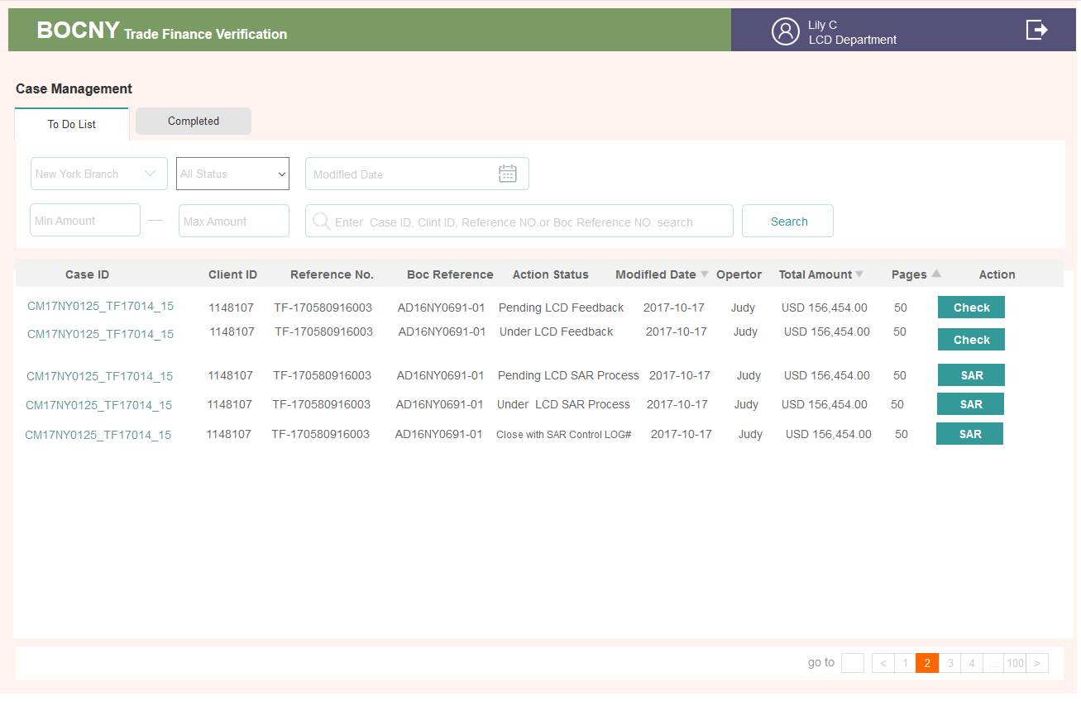

* 详情页

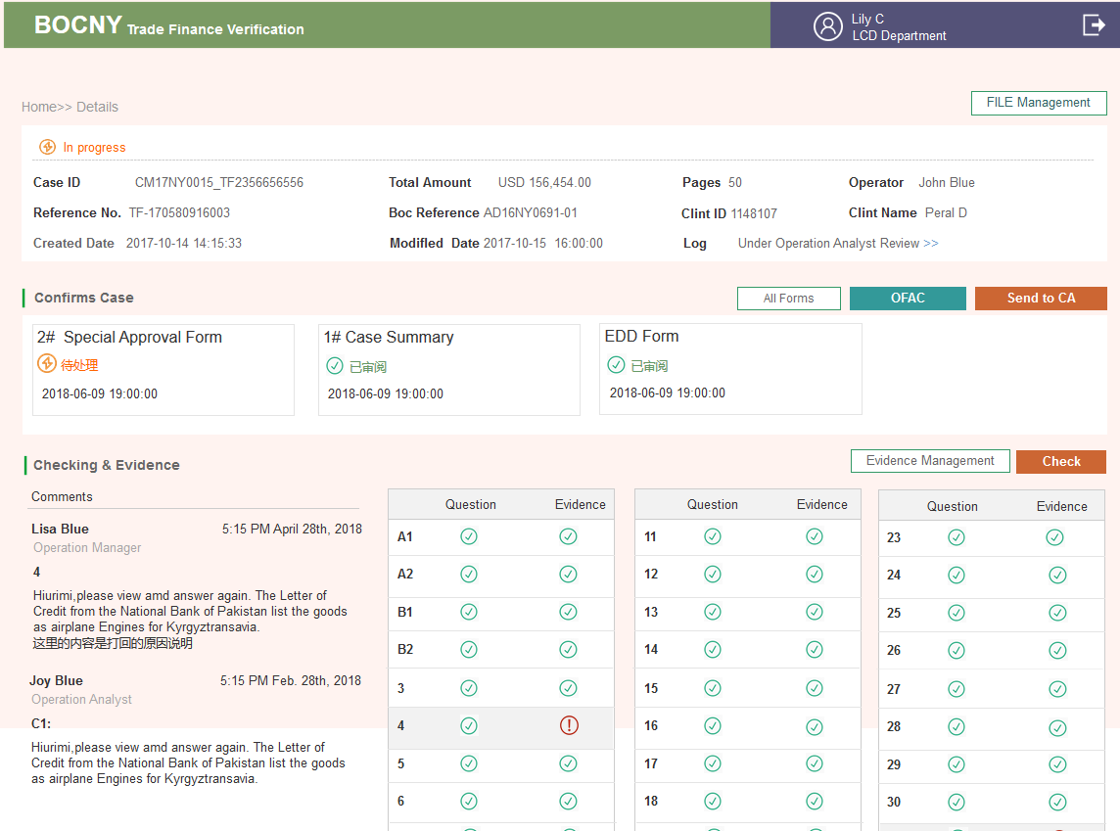

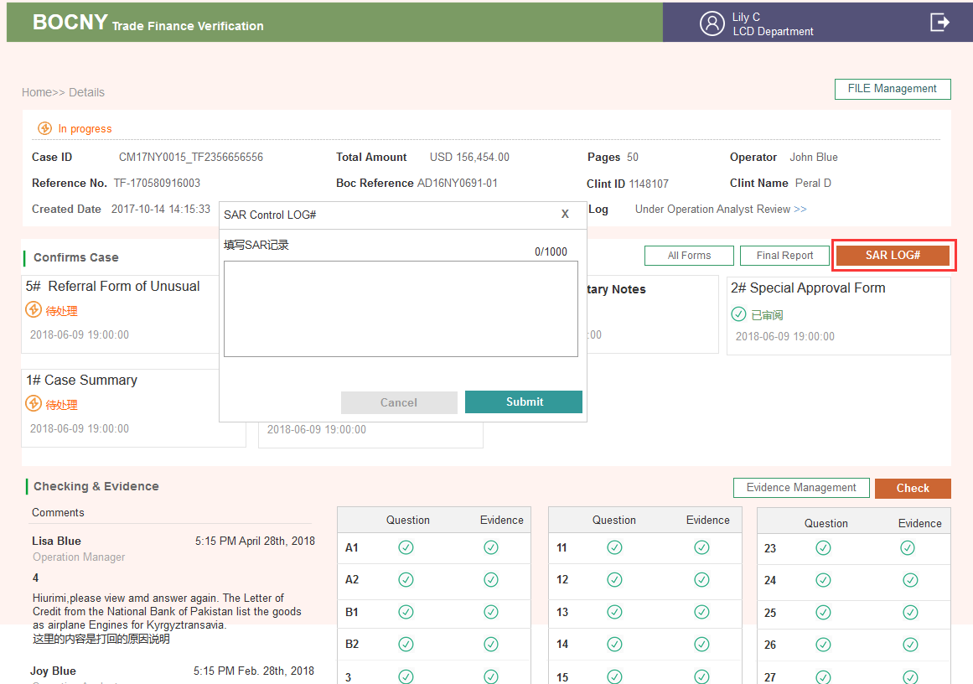

3.2.16 35Q logic

3.2.15.1. Brief introduction to function

这块是Check页面数据对接规则需求，会从T24&Graphen获取到数据，系统根据获取到 的数据进行内容展示



3.2.15.2. Detailed description

* Type

1. New LC Import issuance/amendment

2. New LC Import drawing

3. New LC Export documents/Transfer/AOP

4. New Inward Collections Documents

5. New Outward Collections Documents

6. Funded/Unfunded Risk Participation

7. Forfeiting

8. Factoring/Supply Chain Financing

9. Short Term Financing Transaction

* 35个问题逻辑说明

*A1. Has customer folder been created? (LC Issuance must create a customer folder before processing.)*

*Answer method: automatic*

*Logic: check if the client ID is in the "customer list" provided by TSD:*

* *If existed -> answer yes*
* *If not existed -> answer n/a and comment 'Case by Case'*
* *~~If not existed and transaction is related to an inward -> create a “case by case” form~~*

*Evidence: no evidence*

*逻辑：检查客户ID是否存在在customer list 里（TSD提供）：*

1. *如果存在 回答yes*
2. *不存在， 回答N/A，在comment里写上‘case by case’*
3. *去掉此条，在文档上传的地方添加一个‘case by case form’*

***A1. Has customer folder been created? (LC Issuance must create a customer folder before processing.)***

***客户文件夹是否已经创建（在申请信用证之前，必须要创建一个文件夹）***

* 35个问题答案

1） 在创建CASE时会输入一个客户的ID，Admin那里有一个客户列表管理Customer list of branches, 用客户的ID到那里面去对，如果能找到该客户ID，则说明客户文件夹已经创建。答案回答Y

2） 如果没有找到该客户ID，则答案回答N/A，*在comment里写上‘case by case’*

* 证据，A1没有系统获取的证据

*A2. If customer folder is created, is this transaction consistent with customer’s anticipated activity? (Transactions that are not consistent with customer’s anticipated activity require an investigation and potential updates to the customer folder before processing).*

*Answer method: semi-automatic*

*Logic: answer “blank”*

*Evidence:*

*1. An excel that contains the customer information:*

* *Anticipated activity of the client (Client ID) (from Customer List)*
* *Volume of the client (from Customer List)*

*2. An excel that contains the T24 results:*

* *If case type is "LC Export": Return Goods description, currency, amount, id, old lc number, Presenter_Cust_Name, Presenter_Cust_ID, applicant, applicant number, and country of origin for each transaction in T24. (see T24 matching table)*
* *If case type is “Factoring, Short Term Financing, Forfeiting/Riosk Participation, Unfunded Factoring & Unfunded Risk Participation”: Return BOC Ref No., Customer ID, Name of Borrower/Obligor/Limit Party, Goods Description, Currency, Transaction Amount and Country of Origin for each transaction in T24.*
* *Otherwise: Return Goods description, currency, amount, id, old lc number, beneficiary, beneficiary number, applicant, applicant number, and country of origin for each transaction in T24. (see T24 matching table)*

*The date range is 1 year (currentDate - caseDate=1 year).*

* + *If case type is “LC Export” or “LC Import Drawing” ,search multi_drawings and (caseDate=doc_receive_date)*
  + *Otherwise search multi_lc and (caseDate=issue_date) and for applicant/beneficiary, only the contexts before “]” are acquired*
* *T24.multi_lc.CON_CUS_LINK(Applicant Number) = Client ID*
* *~~Branch separate~~*
* *If case type is “Factoring, Short Term Financing, Forfeiting/Riosk Participation, Unfunded Factoring & Unfunded Risk Participation”: Search T24 “Supply Chain Finance Menu”.*

*证据：*

1. *Excel*

* *客户信息from T24*
* *Volume from TSD Customer List*

1. *Excel*

* *如果类型是‘LC Export’，返回字段…*
* *如果是‘Factoring…’，返回字段…*
* *否则返回字段… 这里查询T24从今天往回算起一年以内（20170801-20180801）的交易量加上今天的交易，与承诺的一年内的volume相比上下浮动不超过20%*
* *去掉branch separate，不分行*

***A2. If customer folder is created, is this transaction consistent with customer’s anticipated activity? (Transactions that are not consistent with customer’s anticipated activity require an investigation and potential updates to the customer folder before processing).***

***如果创建了客户文件夹，该交易是否与客户预期的一致？（与客户预期活动不一致的交易则要在处理前对客户文件夹进行调查和更新）。***

* 35个问题答案：程序不进行回答
* 证据

1. 有2张EXCEL表，字段详见EXCEL模板。

**表格1，放在Other下面《A2_Custimer Anticipated Activity》**

1. 客户信息，来自T24
2. Volume来自 TSD Customer List

**表格2，放在Other下面。 可能存在**

识别CASE的TYPE类型，

字段，来自T24

1）如果case 类型是LC EXPORT（对应创建CASE时TYPE类型3），返回字段见 **《A2_T24 Results_LC Export》**

2）如果case 类型是factoring, short-term finance, forfeiting, risk-participation.（对应TYPE类型6、7、8、9），返回字段见**《A2_T24 Results_Factoring and so on》**

3） 如果CASE类型是其它的，返回字段见B4_Country of Origin_input

**2. 查询范围**

用今天的时间-在T24中的时间。T24中的时间字段会根据单证类型取不同的时间字段

1）如果是“LC Export” or “LC Import Drawing” ,搜索multi_drawings （指的是T24里的一张表）里的doc_receive_date时间字段

2） 如果是其它类型，搜索T24>>表multi_lc里的issue_date时间字段

***B1. Are the goods/services consistent with the nature of the businesses of the seller and buyer (i.e., applicant and beneficiary)?***

*Answer method: semi-automatic*

*Logic: answer “blank”*

*Evidence:*

*1. Return results for all the corresponding fields.*

* *Search Method/Sequence: 1. Bloomberg, 2. US Google 3. Hong Kong Google*
* *If no results, return “Not Found”*
* *Searches should first be done in English and then by native language of the country of origin, which would be translated into English.*

*2. An excel that contains:*

* *The goods description from Invoice should be distinct (Not case-sensitive, always uppercase)*
* *The customer industry of the client from the Customer List*

*证据：*

1. *搜索结果*

* *搜索顺序*
* *无返回显示 not found*
* *显示结果优先选择英文，其他语言需进行翻译*

1. *Excel*

* *Invoice的商品描述（去重，全大写）*

*客户的行业*

**B1 Are the goods/services consistent with the nature of the businesses of the seller and buyer (i.e., applicant and beneficiary)?**

货物、服务是否符合卖方和买方（即申请人和受益人）的业务性质？

* 35个问题答案：程序不进行回答
* 证据

2个Excel表格

1. 表格1 放在bloomberg下面《B1_US Google》

对接graphen公司去搜索返回的数据（公司信息）。哪个渠道的就用哪个渠道的Excel表格

如果graphen公司返回的结果为空，则显示字段为“Not Found” 证据标红，置于GOOGLE/BLOOMBERG类下

如果手动上传了证据，标红去掉

2. 表格2，包含货物描述和客户行业字段《B1_Invoice&Industry Description》

货物描述字段，来源于本平台Input录入的Invoice发票里面的goods description。与API传过来的货物描述进行比对，相同的字段标红显示

相同的描述只显示一条，转化成全大写的，

客户的行业customer industry来源于T24客户列表和API 进行比对，如果比对不上，则进行标识

***B2. Is the size of the transaction and shipment consistent with the scale of the exporter or importer’s business activities and manufacturing capacity?***

*Answer method: semi-automatic*

*Logic: answer “blank”*

*Evidence:*

* *An excel that contains the T24 results (past transactions for the client)*
  + *Min transaction amount, id, old lc number*
  + *max transaction amount, id, old lc number*
  + *Average transaction amount, transaction count*
  + *If case type is “Factoring, Short Term Financing, Forfeiting/Riosk Participation, Unfunded Factoring & Unfunded Risk Participation”*

*An excel that contains the T24 results: BOC Ref No., Customer ID, Min transaction amount, Max transaction amount, Average transaction amount, transaction count.*

* *An excel that contains the case’s Transaction Amount (inputted when creating a case)*
* *The corresponding column in T24 database for transaction Max, Min, Average amount and currency unit*
  + *The date range is 1 year (currentDate - caseDate=1 year).*
    - *If case type is “LC Export” or “LC Import Drawing” ,search multi_drawings and (caseDate=doc_receive_date) and (Amount =DOC.AMT.LOCAL)*
    - *Otherwise search multi_lc and (caseDate=issue_date) and (amount = LC_AMT_LOCAL)*
* *~~Branch separate~~*
* *Search T24 Supply Chain Finance Menu when case type is factoring, short-term finance, forfaiting, risk-participation, Unfunded Factoring, Unfunded Risk Participation.*

*证据：*

1. *Excel： T24该客户历史数据*
2. *Excel：用户输入*
3. *T24 该客户一年交易数据整理*

**B2. Is the size of the transaction and shipment consistent with the scale of the exporter or importer’s business activities and manufacturing capacity?**

交易的规模和出货量是否符合出口商或进口商的经营活动规模和生产能力？

* 35个问题答案：程序不进行回答
* 证据 有2-3张EXCEL表格 放other下面

A. 第一张表包含最小最大&平均交易金额等信息《B2_Past Transactions for The Client》

见Excel 表格B2_Past Transactions for The Client

B. 第二张表 如果CASE类型属于“Factoring, Short Term Financing, Forfeiting/Riosk Participation, Unfunded Factoring & Unfunded Risk Participation”则获取BOC Ref No., Customer ID, Min transaction amount, Max transaction amount, Average transaction amount, transaction count.

这些字段，见Excel表格B2_Factoring, Short Term Financing, ForfeitingRiosk Participation, Unfunded Factoring & Unfunded Risk Participation《B2_Factoring and so on》

C. 第三张表，只有交易量一个字段，数据直接从本平台创建CASE时获取即可。

见Excel表格B2_ Case’s Transaction Amount Drawing《B2_ Case’s Transaction Amount Drawing》

搜索时间范围

获取一年的交易数据(currentDate - caseDate=1 year). 当前时间减去CASE时间

1. 如果case类型是“LC Export” 或“LC Import Drawing”，搜索multi_drawings类型下的字段(caseDate=**doc_receive_date**) and (Amount =**DOC.AMT.LOCAL**)

2. 否则，搜索multi_lc类型下的issue_date 和LC_AMT_LOCAL这2个字段

(caseDate=issue_date)、(amount = LC_AMT_LOCAL)

**B3. Are the delivery dates known and set to commence in the next 12 months?**

交货日期是否确定并在未来12个月内吗？

* 35个问题答案：程序回答
* 回答逻辑，

1. 先判断下这个case的类型，只有new lc import issuance/amendment& new lc import drawing（1、2）这2个类型才会要判断这个答案
2. 之后用shipment_date – application_date算是否大于1年，大于1年的话，回答N，小等于一年的话回答Y
3. 这里要注意shipment_date可能会有多个答案，假设有2个答案，有一个小于一年，一个大于一年，回答N
4. Shipment date字段来源于本系统INPUT里B/L单证的录入
5. application_date 字段来源于本系统INPUT里APPLICATION
6. 不是这2个类型的，直接回答N/A不需要，并且在commets表框 里备注“ Only applicable to import L/C

* 证据 不自动获取

***B4. Is the country of origin of the commodity or goods consistent with commodities or manufacturing capacity produced in that country?***

*Answer method: semi-automatic*

*Logic: answer ”blank”*

* *Get country of origin from “Certificate of Origin” or “Invoice”   
  (The country of origin can be more than one)*

*Evidence:*

* *An excel that contains” goods description” and “country of origin” from input should be distinct (Not case-sensitive, always uppercase)*
* *An excel that contains” goods description” and “country of origin” from T24/Data Mart*

*For each country of origin:*

*- An excel that contains the Top 10 common goods from T24/Data Mart for that country*

*> Note: Top 10 should be configurable by Compliance (e.g. Top 10 can be Top 20, Top 50, etc.)*

*> If cannot find this country. Alert: ” countries not found in T24:XXXX”*

*> The date range is 1 year (currentDate - caseDate=1 year).*

* *If case type is “LC Export” or “LC Import Drawing”, search multi_drawings and (caseDate=doc_receive_date)*
* *Otherwise search multi_lc and (caseDate=issue_date)*
* *If case type is “Factoring, Short Term Finance, Forfeiting & Risk Participation, Unfunded Factoring & Unfunded Risk-Participation”, search from T24 “Supply Chain Finance Menu: Factoring, Short Term Finance, Forfeiting/Risk Participtation, Unfunded Factoring, Unfunded Risk Participation”*
* *A Worlds Top Export website link for that country*
* *A Worlds Top Export website link、*

*证据：*

1. *Excel： 用户输入的goods desc 和 country of Origin （去重， 大写）*
2. *Excel：T24的 goods desc 和 country of Origin*

* *T24中该国家的前十位常见商品（或前二十… 参数可配置）*
* *如果没找到，alert*
* *搜索范围一年*

1. *Link*
2. *Link*

**B4. Is the country of origin of the commodity or goods consistent with commodities or manufacturing capacity produced in that country?**

B4. 货物的原产地国是否和货物的生产制造的国家一致？

* 35个问题答案 半自动 不回答
* 证据（2个EXCEL表，2个链接）

1. **EXCEL表1 《B4_Country of Origin_input》**

1）从本平台INPUT里面获取

2）字段 货物描述Goods Description &原产地国Country of Origin

3）从INVOICE获取到货物描述Goods Description &原产地国Country of Origin 字段，如果INVOICE里没有原产地国字段，则从CERTIFICATE OF ORIGIN 字段Origin里获取。注意原产地证书要归属于这个发票。

4）货物描述规则同上，去重，全大写

**2. EXCEL表2 《B4_Country of Origin_T24》**

1）API对接从T24中获取

2）搜索每个原产地国，及该国前10名的普通货物，**这个数量系统允许进行配置。**在问题右边加一个设置ICON，点击进行设置即可。设置后对该账号后面的所有Case生效

3） 如果某个原产地在T24中没有找到，则在EXCEL表下面备注警示 Alert: “Countries not found in T24: American、England” 放到证据的COMMENTS框里

4） 如果一条数据都没有，则不需要表2的EXCEL，直接显示警示字段

**搜索范围**

1）从今天往前推一年内数据(currentDate - caseDate=1 year)

2）如果case类型是“LC Export” or “LC Import Drawing”，搜索multi_drawings里的时间字段doc_receive_date

(caseDate=doc_receive_date)

3）如果case类型是 “Factoring, Short Term Finance, Forfeiting & Risk Participation, Unfunded Factoring & Unfunded Risk-Participation，搜索Supply Chain Finance Menu里的Factoring, Short Term Finance, Forfeiting/Risk Participtation, Unfunded Factoring, Unfunded Risk Participation”类型

3. 链接1 （从哪里来，是请求Graphen,还是固定的链接，地址是？）

* A Worlds Top Export website link for that country

4. 链接2

* A Worlds Top Export website link

***B5. Is the pricing of the goods/services reasonable compared to the fair market value?***

***a) What source was used to review the pricing?***

***b) Transaction Price:____ FMV:_____ Difference:_______***

Answer method: automatic

Logic:

* + - If there is no invoice document, comment: “no invoice in the transaction documents” and answer n/a.
    - If there is invoice document, the answer is either Case I or Case II (for single product)
  + Case I: answer yes (show up to three evidence), for multiple products case, answer yes only when each of the product is answered as yes.
    - If document states “LME” only search London Metal Exchange, otherwise search Alibaba
    - Price is a value:
      * Check: Alibaba/London Metal Exchange price is within the good price range [80%, 120%]
      * Check: Alibaba/London Metal Exchange price unit is same to good price unit
    - Price is a range:
      * Check: Alibaba/London Metal Exchange price range is within good price range [80%, 120%]
      * Check: Alibaba/London Metal Exchange price unit is same to good price unit
  + Case II: “Blank” (show up to three evidences, and alert: “system: result out of range”)
    - Check: good price (or price range) is within Alibaba/London Metal Exchange range
    - Check: good price unit is same to Alibaba/London Metal Exchange price unit
    - Sort: return the top-3 Alibaba/London Metal Exchange results that has the minimum range as the evidence
  + Others: “Blank” (alert:” system: unable to find result”)

Evidence:

For each product (has valid unit price and unit type):

* Show top three Alibaba search pages related to the product
* An excel that contains the min tolerance (80% of the unit price) and max tolerance (120% of the unit price)

逻辑：

改动 如果goods是commodity(即商品) 去Bloomberg查询，地址业务待提供

如果goods是钢铁去LME网站查询

其他情况去Alibaba查询

**B5. Is the pricing of the goods/services reasonable compared to the fair market value?**

**货物或者服务与市场的平均价值相比合理吗？**

* 35个问题回答，程序自动回答

1. 如果没有发票INVOICE这个文件，则回答N/A，在Comments表单中填写“no invoice found in the transaction documents”

2. 如果有发票的话，会有下面2种情况的回答

在INVOICE商品描述下面有一个LME字段，就是这个问题下用的，如果勾选 了，会去搜索伦敦金属交易所，如果勾选了commodity，则去Bloomberg查询，否则搜索阿里巴巴

1）回答是，

A. 从以上平台获取商品链接，如果有3条证据能够证明价格是合理的话，就勾Y。如果总共只有1条证据，而这条证据能证明是合理的话，亦勾Y

如果3条证据在范围内，3条证据在范围外，亦勾Y

B. 证据价格范围是在80%~120%之间，单位需要匹配

C. 比如一个商品价格是RMB 100块钱，然后能找到3条证据，他们的价格是在RMB 80~120（含）之间的话，那么这个商品的价格就是合理的

2) 不回答

找不到3条可匹配的价格证据，则不回答 alert: “&Goods Description: out of range”

API将阿里巴巴/伦敦金属交易所的排名前3位且有最小的范围的结果作为证明返回

3） 其它情况 ，不回答，显示 Alert:” &Goods Description: Not found”

Alert放在阿里巴巴项下

3. 如果发票INVOICE中没有某些产品的单价，comments表单中填写“&Goods description: no unit price found “

* 证据

1. 针对每个产品，展示与该产品相关的价格中最接近的阿里巴巴搜索页面

2. 显示离80%最近的一个价格的百分比和离120%最近的另一个价格百分比119%

***B6. Has the invoice number covering this shipment not been used for previous shipments?***

*Answer method: automatic*

*Logic:*

*search invoice number historically (limited to the current clientID and the related branch involved) from T-24 to determine if the invoice number has been used for previous shipments [tied to switching branches within the system]*

* + *If used: answer no; otherwise: answer yes.*
  + *If there is no invoice document, comment: “no invoice in the transaction documents” and answer n/a*

*Evidence:*

* + *An excel that contains the id, old drawing number, invoice number for the transactions that have the same invoice numbers in T24*
    - *For export lc drawing: Id -> id; old drawing number -> old_lc_number; invoice_number -> presentor_ref*
    - *For outward collection: use app_reference; for export_lc: use presentor_ref*
  + *An excel that contains the invoice number (from Invoice) for this case*

**B6. Has the invoice number covering this shipment not been used for previous shipments?**

**包含了该货物的发票号是否有被之前的货物的发票使用过？**

* 35个问题回答，程序自动回答

1. API T24中获取答案，如果被用过used，则回答N，否则回答Y

2. 如果没有发票INVOICE,，则回答N/A不需要.本系统INPUT

Comment里回答 “no invoice in the transaction documents”

3. 用发票号进行搜索

* 证据

2张EXCEL表

1. 表1 API对接T24

对于export lc drawing这个类型: Id -> id; old drawing number -> old_lc_number; invoice_number -> presentor_ref

对于outward collection这个类型 use app_reference; for export_lc: use presentor_ref

2. 表2 从本系统 input里面获取发票号码invoice number

多张发票，多个号码

* Input

异常的发票号会进行标红（已用过的）

***B7. Is the shipped quantity and quality of the goods consistent with the invoice?***

*Answer method: semi-automatic*

*Logic:*

*Withdraw commodity info (goods description, quantity weight, type of unit), quantity and gross weight from Invoice and transport documents. Withdraw gross weight and net weight from packing list. Sum up the quantity and weight according to the respective commodity name and type of unit.*

*Evidence:*

* + *An excel that contains quantity, weight, and type of unit and goods description from Invoice, transport documents and gross weight/net weight info from packing list.*
  + *No need to verify invoice/transport documents/packing list – the user does the verification.*
  + *In any situation, there is no need to check whether the goods are duplicates and remove duplicates.*

*只需要提供excel，不需要做sum up的操作，不需要做比对，人工做比对*

**B7. Is the shipped quantity and quality of the goods consistent with the invoice?**

**发货的数量是否和发票显示的数量一致？**

* 35个问题回答，半自动



* 逻辑

不回答

* 证据

从本系统Input中获取相关字段（quantity, weight, and type of unit and goods description，）发票INVOICE、装箱单PACKINGLIST（gross weight/net weight）运单（BILLOFLADING、AIRWAYBILL、TRUCKIN LAND BILL OF LADING）

具体字段，详见EXCEL表

商品名称可重复出现

**B8. Does the invoice clearly state the type or brand of goods, their value and unit or metric price?**

Answer method: automatic

Logic:

* + For each set of goods in Invoice:
    - If goods description, unit price, and value are all not None; continue check next goods
    - Else: answer “No”
  + If all set of goods have goods description, unit price, and value -> answer “Yes”

Evidence: no evidence

* + If there is no invoice document, comment: “no invoice in the transaction documents” and answer n/a. (same as b6,)

业务部门考虑去掉此条问题，在填写单据的时候这些项设计为必填

**B8. Does the invoice clearly state the type or brand of goods, their value and unit or metric price?**

**发票是否清楚地显示了货物的种类或品牌、价值、单价或公制价格？**

* 不需要程序回答35个问题
* 不需要程序提供证据证明

***B9. Is the transaction amount an installment payment for partial delivery or in non-round dollar amounts?***

*Answer method: automatic*

*Logic:*

* + *A) If the transaction amount is NOT a multiple of $10,000, system automatically answer yes.*
  + *B) If the transaction amount is a multiple of $10,000:*

*1. Transaction type is NOT a drawing under import LC or export LC, answer “No”.  
Comment:” round currency amount”*

*2. Transaction type is a drawing under import LC or export LC, display transaction amount and LC amount. Answer: blank. No alert and no comment.*

*Evidence:   
(Whether the transaction amount is a multiple of $10,000 or not, evidence is always needed)*

* + *Transaction amount (inputted when creating a case)*
  + *The transaction amount and currency in T24 (searched based on the TF number)*
    - *For LC import drawing and LC Export drawing, search Multi_lc table (value of LC_Amount). If not find in T24, alert:”not find LC_Amount in T24 by TF number”.*
    - *For Factoring, Short Term Financing, Forfeiting/Risk Participation, Unfunded Factoring & Unfunded Risk Participation, search Supply Chain Finance Menu in T24 (search based on SCF Number, Transaction amount & Currency).*
    - *Otherwise, no need to search T24.*
    - *\*\*extract T24 L/C amount: use “Reference no.” and take off last 2 digits to search in T-24. E.g. drawing ref. no. TF172446905003, use TF1724469050 search for L/C amount \*\**

**B9. Is the transaction amount an installment payment for partial delivery or in non-round dollar amounts?**

**交易金额是分批交货的分批付款的总额或是循环的金额吗？**

* 35个问题回答, 程序自动回答
* 逻辑

1. 在创建CASE时会输入一个金额Total Amount，如果这个金额不是1万美 元的倍数，则系统回答Y

2. 如果是1万美 元的倍数，并且交易类型不是drawing under import LC或export LC中的任一个，则回答N, Comment:” round currency amount”

3. 如果交易类型drawing under import LC or export LC，则不回答，

非以上情况 也不回答

* 证据

如果是 LC import drawing 或 LC Export drawing二种类型的CASE则会去搜索交易金额

用创建CASE 时的Reference no.去掉后两位数字搜索（例参考号TF172446905003,使用 TF1724469050搜索信用证金额）

如果搜索不到结果，则这里显示**alert:”*not find LC_Amount in T24 by TF number*”**

***B10. Does the transaction provide reasonable payment terms and schedules rather than offering terms that are “too good to be true” like advanced payments or terms unlikely to require payment (e.g., very delayed payment)?***

* + *Answering method – Manually answered by Operations*
  + *Supporting evidence - No evidence will be shown in this question*
  + *Remarks*

**B10. Does the transaction provide reasonable payment terms and schedules rather than offering terms that are “too good to be true” like advanced payments or terms unlikely to require payment (e.g., very delayed payment)?**

**这笔交易是否提供了合理的支付方式和交货时间，而不是出现类似太好得不真实的提前付款或不像需要付款（例如，已严重延迟的付款）？**

* 不需要程序回答35个问题
* 不需要程序提供证据证明

***B11. Is the documentation of the value, cost or weight of the goods consistent with customs declarations, invoices and transportation documents?***

*Answer method: semi-automatic*

*Logic:*

*Withdraw commodity info (goods description, quantity weight, type of unit) quantity and gross weight from Invoice and Transport Documents. Withdraw gross weight and net weight from packing list. Sum up the quantity and weight according to the respective commodity name and type of unit.*

*Evidence:*

* + *An excel that contains quantity, weight, and type of unit from Invoice, Transport Documents and gross weight/net weight info from packing list.*
  + *no need to verify invoice/Transport Documents/packing list*
  + *In any situation, there is no need to check whether the goods are duplicates and remove duplicates.*

**B11. Is the documentation of the value, cost or weight of the goods consistent with customs declarations, invoices and transportation documents?**

**货物的价值、成本或重量是否和报关单、发票和运输单据一致？**

* 35个问题 半自动
* 逻辑&证据通B7

***B12. Does the documentation appear authentic and consistent with commercial invoicing, bill of lading documents or documents previously received involving the seller?***

Answer method: Manually answered by Operations

Evidence: No evidence will be shown in this question

* Remarks

**B12. Does the documentation appear authentic and consistent with commercial invoicing, bill of lading documents or documents previously received involving the seller?**

**出现的文件是否真实，是否和之前收到的有关卖方的商业发票、提单等单据一致？**

* 不需要程序回答35个问题
* 不需要程序提供证据证明

***B13. If required, were original documents provided or did the customer provide a reasonable explanation as to waive the requirement for original documents?***

*Answer method: Manually answered by Operations*

*Evidence: No evidence will be shown in this question*

* *Remarks*

**B13. If required, were original documents provided or did the customer provide a reasonable explanation as to waive the requirement for original documents?**

**如果需要，是否需要提交正本文件还是客户提供了一个关于放弃对正本文件的需求的合理解释？**

* 不需要程序回答35个问题
* 不需要程序提供证据证明

***B14. If the Bill of Lading described containerized cargo, were the container numbers listed and non-sequential?***

*Answer method: Manually answered by Operations*

*Evidence: No evidence will be shown in this question*

* *Remarks*

**B14. If the Bill of Lading described containerized cargo, were the container numbers listed and non-sequential?**

**如果提单描述的是集装箱货物，那么柜号是否列明且无时序？**

* 不需要程序回答35个问题
* 不需要程序提供证据证明

**B15. Are the goods/services themselves not subject to export control restrictions, require an OFAC licenses to export or are U.S. made goods that may be of dual-use or involve parties in high-risk activities (e.g., equipment for military or police organizations, weapons, ammunition, nuclear materials, classified defense articles, chemical mixtures, sensitive technical equipment, precious gems, and certain natural resources, such as metals, ore, and crude oil).?**

Answer method: semi-automatic

Logic:

* + If the port of loading country (BL, airway bill, Truck BL) or origin country (Certificate of Origin, Invoice) is not from US, the question will answer to N/A.
  + Otherwise: answer “blank”

Evidence:

* + If the port of loading country or origin country is from US, display:
    - * https://www.bis.doc.gov/index.php/regulations/export-administration-regulations-ear
      * https://www.bis.doc.gov/index.php/forms-documents/regulations-docs/13-commerce-control-list-index/file

业务部门考虑提供一个 high risk list以及一个dual-use list 可维护，OFAC业务部门考虑删除（待最后确认）

**B15. Are the goods/services themselves not subject to export control restrictions, require an OFAC licenses to export or are U.S. made goods that may be of dual-use or involve parties in high-risk activities (e.g., equipment for military or police organizations, weapons, ammunition, nuclear materials, classified defense articles, chemical mixtures, sensitive technical equipment, precious gems, and certain natural resources, such as metals, ore, and crude oil).?**

**产品或服务是否符合出口控制禁令，需要一个OFAC证书出口或美国制造的货物可能过期使用或者参与方的行为为高风险的（例如，军事设备或警察组织、武器、装备、核材料、分类的防御物资、化学混合物、敏感的技术设备、贵重宝石和某种自然资源，例如金属、矿、原油）**

* 35个问题 半自动回答
* 回答逻辑

1.如果（字段：BL P/L Ccountry、Departure airport country、Departure Country）装运港的国家（单证：BILLOFLADING、AIRWAYBILL、TRUCKINLANDBILLOFLADING）或（字段：origin country）原产地国（单证：Certificate of Origin, Invoice）不是美国的话，问题的回答为N/A

1. 否则不回答

* 证据

如果装运港国家或原产地国来自美国，证据那显示如下2个链接

* + - * https://www.bis.doc.gov/index.php/regulations/export-administration-regulations-ear
      * https://www.bis.doc.gov/index.php/forms-documents/regulations-docs/13-commerce-control-list-index/file

***B16. Are there no legal or economic sanctions restrictions involved in the transaction?***

*Answer method: semi-automatic*

*Logic: answer “blank”, no need to pop up any alert.*

* + *For Import LC issuance, check LC PL country and LC PD country*
  + *For other types, check*
    - * *Country of Origin from Certificate of Origin or Invoice (CO first)*
      * *Check Port of Loading country, Port of Discharge country and transshipment country from Bill of Lading, Truck Bill of Lading and Airway bill.*
  + *If any of these countries are in the sanction country list, show corresponding comments.*

*Evidence:*

* + *Fircosoft results: The name of evidence doc: ”CaseID_CompanyName.PDF”*
  + *Dow Jones results :The name of evidence doc: ”CaseID_CompanyName.PDF”*
  + *Lloyds results*
  + *Sanction country list*
  + *Country List that shows the countries in this case*

*同B24，B25，或考虑合并此三条问题（待确认）*

**B16. Are there no legal or economic sanctions restrictions involved in the transaction?**

**该交易是否涉及法律或经济制裁限制?**

* 35个问题 不回答
* 逻辑
  + - 1. Import LC issuance类型 的CASE检查L/C ISSUANCE 信用证的LC P/L country、LC P/D country2个字段
      2. 其它类型的CASE，则在原产地证书CERTIFICATE OF ORIGIN和发票上INVOICE查看原产地Origin、Country of Origin ，首先查原产地证书

Check **Port of Loading country**, **Port of Discharge country** and **transshipment country** from **Bill of Lading, Truck Bill of Lading and Airway bill.**

从提单、卡车提单和空运单上检查 装运港国家、卸货港国家和转运国

这些国家跟Admin的制裁国家比对，有问题的，会出现在COMMENTS里

* 证据

1. 制裁国家清单，来源于Admin导入

2. 以上逻辑中获取的国家名单，见EXCEL

3. API来自Lloyds、Dow Jones或Fircosoft的证明文件。标题为CaseID_CompanyName.PDF（对方给什么我们就显示什么）

***B17. Is the buyer or a related third party responsible for payment to the seller?***

*Answer method: automatic*

*Logic: answer N/A*

* *Comments: “TSD does not accept any third-party payment”*

*Evidence: no evidence*

*业务部门考虑删除此条*

**~~B17. Is the buyer or a related third party responsible for payment to the seller?~~**

**~~买方和相关的第三方是否会对卖方付款？~~**

* ~~35个问题 自动~~
* ~~逻辑~~

~~回答N/A, Comments备注：“TSD does not accept any third-party payment”~~

* ~~证据~~

~~无~~

***B18. If the LC was amended or extended, was it done so with reasonable justification?***

*Answer method: semi-automatic*

*Logic:*

* + *If transaction is from LC drawing of Export Section, system will check T-24 if there was any amendment made to the L/C. When amendment exists, answer blank.*
    - * *Comment: “LC has amendments”.*
  + *When there is no amendment, it will show N/A and “No L/C amendment” in comment.*
  + *If transaction is from other sections, system will answer “N/A” and add “Not a L/C transaction” in comment.*

*Evidence: no evidence*

**B18. If the LC was amended or extended, was it done so with reasonable justification?**

**如果信用证被修改或延期，是否有合理的理由?**

* 不需要程序回答35个问题
* 不需要程序提供证据证明

***B19. Do the number of parties and countries involved in the transaction make economic sense?***

*Answer method: Manually answered by Operations*

*Evidence: No evidence will be shown in this question*

* *Remarks*

**B19. Do the number of parties and countries involved in the transaction make economic sense?**

**参与交易的各方和国家的数量是否具有经济意义?**

* 不需要程序回答35个问题
* 不需要程序提供证据证明

***B20. Are the origin of the goods, their final destination and all points of transshipment all non-high-risk jurisdictions?***

*Answer method: automatic*

*Logic:*

* + *For Import LC issuance, check LC PL country and LC PD country.*
  + *For other types, check*
    - * *Country of Origin from Certificate of Origin or Invoice (CO first)*
      * *Check Port of Loading country, Port of Discharge country and transshipment country from Bill of Lading, Truck Bill of Lading and Airway bill.*
  + *If any of these countries are in the high-risk country list (provided by TSD), show corresponding comments.*
    - * *Note: The high-risk country list should be provided and maintained by the LCD .*

*Evidence:*

* + *Lloyds results*
  + *Country List that shows the countries in this case*

**B20. Are the origin of the goods, their final destination and all points of transshipment all non-high-risk jurisdictions?**

货物的原产地、最终目的地和所有转运点是否都不是高风险地区?

* 35个问题：半自动
* 逻辑

1.如果是Import LC issuance类型，检查信用证*(L/C ISSUANCE*)的LC P/L country、LC P/D country字段，与Admin里的高危国家列表high-risk country list进行比对

2.如果是其它类型，从原产地证或发票上检查原产地Country of Origin，在提单、货车提单、空运单上检查装运港国家、卸货港国家和转运国家，与高危国家列表进行比对

3. 如果发现有国家出现在高危国家列表中，则在Comments中进行备注

4. 如果没有运输单据（海陆空）回答N/A

* 证据

1. API,来自Lloyds results的证据，给什么我们显示什么，一般是PDF

2. case里的国家清单

***B21. Is it correct that the transaction does not involve a shell company in a tax-evasion jurisdiction and the applicant, beneficiary and assignee are not using account with a bank in a tax-evasion jurisdiction?***

*Answer method: semi-automatic*

*Logic: answer “blank”*

*Evidence:*

* + *An excel that shows the tax heaven list stored on Shared Drive*
  + *Note: Compliance required to maintain tax heaven list under LCD’s guidance*

**B21. Is it correct that the transaction does not involve a shell company in a tax-evasion jurisdiction and the applicant, beneficiary and assignee are not using account with a bank in a tax-evasion jurisdiction?**

* 35个问题：不回答
* 证据

1张避税国家或地区表，从ADMIN获取

***B22. Were the goods transshipped only through jurisdictions previously disclosed on the LC and the vessel did not take a circuitous route?***

*Answer method: Manual*

*Logic: answer “blank”*

*Evidence:*

* + *Lloyds results*

**B22. Were the goods transshipped only through jurisdictions previously disclosed on the LC and the vessel did not take a circuitous route?**

* 35个问题：不回答
* 证据

Lloyds results

***B23. Was the type and size of the vessel appropriate for the type of cargo?***

*Answer method: semi-automatic*

*Logic: answer “blank”*

* + *Compare tonnage (DWT) vs weights (B/L)*
    - *In case of more than one B/L—Compare vessel names to correctly identify the weight from the same vessels*
    - *For all same vessel names—Sum up the total weights*

*Evidence:*

* + *Lloyds results*

**B23. Was the type and size of the vessel appropriate for the type of cargo?**

这艘船的类型和尺寸是否适合货物的类型?

* 35个问题：不回答

这条应该没什么要我们做的，只是传相应数据给API接口

* 证据

Lloyds results

***B24. Were OFAC screening and negative news search results negative for all parties to the transaction or otherwise non-material?***

*Answer method: semi-automatic*

*Logic: answer “blank”*

*Evidence:*

* + *Lloyds results*
  + *Fircosoft results*
  + *Dow Jones results*

**B24. Were OFAC screening and negative news search results negative for all parties to the transaction or otherwise non-material?**

* 35个问题：不回答
* 证据

Lloyds results, Fircosoft results, Dow Jones results

***B25. Were there no debarred parties or parties under export restrictions involved in the transaction (as listed by the U.S. State Department, U.S. Customs and Border Protection, or the Bureau of Industry and Security)?***

*Answer method: semi-automatic*

*Logic: answer “blank”*

*Evidence:*

* + *Fircosoft results*

**B25. Were there no debarred parties or parties under export restrictions involved in the transaction (as listed by the U.S. State Department, U.S. Customs and Border Protection, or the Bureau of Industry and Security)?**

* 35个问题：不回答
* 证据

Fircosoft results

***B26. Was the transaction free of any anti-boycott language?***

*Answer method: Manually answered by Operations*

*Logic:*

* + *No criteria logic as the question will be answered manually*

*Evidence:*

* + *No evidence will be shown in this question*

*Remarks:*

**B26. Was the transaction free of any anti-boycott language?**

* 不需要程序回答35个问题
* 不需要程序提供证据证明

***B27. Was the customer cooperative in providing information, delivering documents and did not make any unusual requests?***

*Answer method: Manually answered by Operations*

*Logic:*

* + *No criteria logic as the question will be answered manually*

*Evidence:*

* + *No evidence will be shown in this question*

*Remarks:*

**B27. Was the customer cooperative in providing information, delivering documents and did not make any unusual requests?**

* 不需要程序回答35个问题
* 不需要程序提供证据证明

***B28. Did the documentation for the import and export legs, LC, Bill of Lading conform to normal business practices?***

*Answer method: Manually answered by Operations*

*Logic:*

* + *No criteria logic as the question will be answered manually*

*Evidence:*

* + *No evidence will be shown in this question*

*Remarks:*

**B28. Did the documentation for the import and export legs, LC, Bill of Lading conform to normal business practices? 进出口业务的单据、信用证、提单是否符合正常的业务惯例？**

* 不需要程序回答35个问题
* 不需要程序提供证据证明

***B29. Was a form of collateral other than cash used to finance the transaction?***

*Answer method: semi-automatic*

*Logic:*

* + *If LC import, answer ' blank ‘*
  + *For other types: answer ' N/A ', comments 'Only applicable to Import L/C ‘*

*Evidence:*

* + *No evidence*

**B29. Was a form of collateral other than cash used to finance the transaction?除了现金外，还有其他形式的抵押品用来融资吗？**

* 35个问题：半自动
* 逻辑

1. 如果Case类型是LC import，不回答

2. 如果是其它类型，回答N/A，comments 里备注”Only applicable to Import L/C”

* 证据

无

***B30. Was the Operations Section’s review otherwise free of Red Flags?***

*Answer method: Manually answered by Operations*

*Logic:*

* + *No criteria logic as the question will be answered manually*

*Evidence:*

* + *No evidence will be shown in this question*

*Remarks:*

*此条考虑放入section D*

**B30. Was the Operations Section’s review otherwise free of Red Flags?**

* 不需要程序回答35个问题
* 不需要程序提供证据证明

***C1. Is the actual transaction consistent with the letter of credit? (e.g., shipment locations of the goods, shipping terms, or descriptions of the goods)? If not, summarize the discrepancy in the Remarks section.***

*Answer method: Manually answered by Operations*

*Logic:*

* + *No criteria logic as the question will be answered manually*

*Evidence:*

* + *No evidence will be shown in this question*

*Remarks:*

**C1. Is the actual transaction consistent with the letter of credit? (e.g., shipment locations of the goods, shipping terms, or descriptions of the goods)? If not, summarize the discrepancy in the Remarks section.**

* 不需要程序回答35个问题
* 不需要程序提供证据证明

***C2. Is there a reasonable justification for any amendments to a letter of credit?***

*Answer method: Semi-Automatic*

*Logic:*

* + *If B18 answer is N/A, then auto answer C2 as N/A.*
  + *Otherwise, the question will be answered manually.*

*Evidence:*

* + *No evidence will be shown in this question*

*Remarks:*

**C2. Is there a reasonable justification for any amendments to a letter of credit?**

* 35个问题：半自动
* 逻辑

1. 如果B18的答案是N/A,则这里的答案亦是N/A

2. 否则，不进行回答

* 证据

无

***D1. No other Red Flags involved in the transaction?***

*Answer method: Manually answered by Operations*

*Logic:*

* + *No criteria logic as the question will be answered manually*

*Evidence:*

* + *No evidence will be shown in this question*

*Remarks:*

**D1. No other Red Flags involved in the transaction?**

* 不需要程序回答35个问题
* 不需要程序提供证据证明
* 其它说明

1. 如果在Bridger项下 的证据数量超过80%，会进行警示，按条数算

放在comments框里。 Bridger Insight (“BI”) rationale is over 80%, Requiring a comment.

2. Invoice NO.发票号码在T24中搜索时，不识别大小写

3. 信用证L/C应检查完整的数据，而不受年份限制

4. ABR2.58 Subfolder function: all evidence should be categorized into different folders: Bridger Insight, Dow Jones, Lloyds, Customer Info, Price Check and so on. To be built after the code is moved from Python to Java.子文件夹功能:所有的证据都应该分类到不同的文件夹中:Bridger Insight，道琼斯，劳埃德，客户信息，价格检查等等。在代码从Python转移到Java之后构建。

5. ABR1.47 Lloyds Shipment Date – When shipment date is blank, there is no alert generated. The shipment date is necessary for a Lloyds search. Coding is needed to require a shipment date for Lloyds searches and to generate an alert if a shipment date is not included.

当请求Lloyds的接口数据时，是会需要shipment date这个字段的 （见INPUT表单）如果说没有这个字段，在请求后，显示在Lloyds证据类下 Alert:”shipment date not found”

* Store digital sample for transaction

|  |  |
| --- | --- |
| 35个问题 | 模板 |
| A2_Custimer Anticipated Activity |  |
| A2_T24 Results_Factoring and so on |  |
| A2_T24 Results_LC Export |  |
| A2_T24 Results_Others |  |
| B1_Invoice&Industry Description |  |
| B1_US Google |  |
| B2_ Case’s Transaction Amount Drawing |  |
| B2_Factoring and so on |  |
| B2_Past Transactions for The Client |  |
| B4_Country of Origin_input |  |
| B4_Country of Origin_T24 |  |
| B5_Whether the transaction price is reasonable |  |
| B6_Invoice Number |  |
| B6_T24 Result |  |
| B7_Invoice & Lading Quantity check |  |
| B9_The transaction amount and currency in T24 |  |
| B11_ Invoice & Lading Quantity check |  |
| B16_Country List For Import LC Issuance |  |
| B16_Country List For Other Case |  |
| B16_Sanction Country List |  |
| B20_Country List For Import LC Issuance |  |
| B20_Country List For Other Case |  |

## **3.2.17 Future Development**

### 1..2. Enhanced Due Diligence

* In a future development, Enhanced Due Diligence (“EDD”) will be applied to 4 types of products or commodities as follows:
  + Shipping
  + Service & Insurance
  + Metals
  + Oil & Gas
* After completing the review of the Transactions Risk Mitigation Checklist (“TRM Checklist”), the Operations Analyst will review the information to determine whether the facts of the transaction would trigger EDD. All transactions involving Shipping, Service & Insurance, Metals, and Oil & Gas will undergo EDD. The Operations Analyst will fill-in the appropriate form and determine whether a red flag is triggered by any of the answers in the form. If a red flag exists, the Operations Analyst will next review the Watch List to see if there is a match to the party involved in the transaction. If there is a match, the Operations Analyst will submit Special Approval Form #2 with the case and send it to the Operations Manager for review.
* When there is no Watch List match, the Operations Analyst sends the case to Operations Manager for review without the Special Approval Form #2. The Case then returns to the standard processing flow.

The EDD Forms (#6-9), are included in the Case Process section.

## **3.2.18 Case Process Enhancement**

After the introduction of Case Management, the system will add many kinds of user roles and their working interfaces to cooperate with workflow management to realize the flow and audit of Case. The content described in this section is this new interface. Note that in order for the review to be effective, there must be interface between the T24 data base and this Trade Finance Tool’s case management system.

### ~~Case List for Review Page~~

~~After the introduction of Case Management, in order to guide all kinds of roles to operate and process case quickly, a new Case List for Review page is defined for all kinds of users in case management workflow. It is easy to all operator of the to do list, and select a certain case for viewing and processing, can also be free to retrieve and view other cases in the system.~~

* **UI Diagram & illustration**

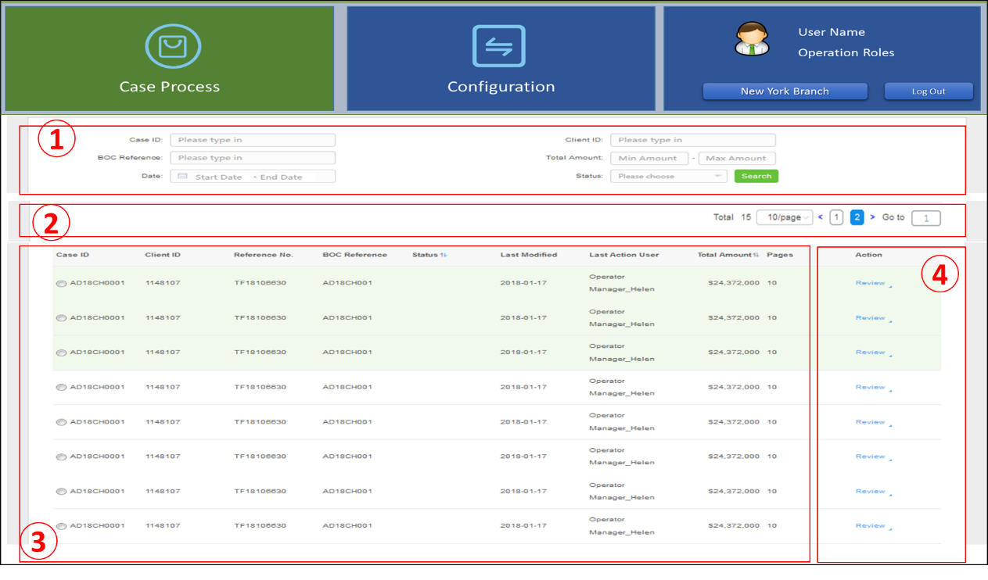

*Page description:*

* ~~Operations Analyst clicking the page link on its Case List page (see 4.3), then jumps to this page;~~
* ~~Operations Manager, Compliance Analyst, Compliance Supervisor, Compliance BSA Officer logs in, and select the "Case Process" module, this page will be displayed in the workspace;~~
* ~~This page is divided into four areas~~

|  |  |  |
| --- | --- | --- |
| # | AREA | DESCRIPTION |
| 1 | ~~Query Condition Area~~ | * ~~Sets search criteria / data items for list records.~~ * ~~Combined query according to the retrieval value of each data item entered~~ |
| ~~2~~ | ~~List Control Area~~ | * ~~Control the number of rows per page of the list, the current page number, the total number of pages, support for up and down pages and input page numbers for jump-in.~~ * ~~Support for searching within the list.~~ |
| ~~3~~ | ~~Case Record List Area~~ | * ~~Display the query results in a list (one row per Case record)~~ * ~~Click on column header to support ascending and downward sorting by column content, and all columns can support ascending and descending sorting.~~ * ~~If the query results contain case that needs to be processed by this role, it will be identified by background color.~~ * ~~When the first-time user enter this page, the query condition area is empty, and the list shows the to-do list for the current role by default.~~   ~~- Operations Analyst can be seen to return to its own Case from Operations Manager~~  ~~- Operations Manager Case waiting list for him to review~~  ~~- Compliance Analyst can see the case which currently assigned to him.~~  ~~- Compliance Supervisor can see all escalate by operations manager which pending on assessment, and those cases which has submitted by Compliance Analyst or returned by BSA officer~~  ~~- BSA Officer can see all the cases submitted to him by Supervisor.~~ |
| ~~4~~ | ~~Operations Function Area~~ | * ~~Display the action link / button for each case record, click on the case specified on the same line.~~ |

* **~~UI Elements~~**
* ~~Element of Query Condition Area:~~

|  |  |  |
| --- | --- | --- |
| ~~ITEM~~ | ~~TYPE~~ | ~~DESCRIPTION~~ |
| ~~CLIENT ID~~ | ~~String~~ | ~~Client ID number~~ |
| ~~REFERENCE NO~~ | ~~String~~ | ~~Trade finance Reference number~~ |
| ~~BOC REFERENCE NO~~ | ~~String~~ | ~~BOC business reference no~~ |
| ~~TOTAL AMOUNT~~ | ~~Decimal~~ | ~~Amount range (Min & Max)~~ |
| ~~CASE CREATE DATE~~ | ~~Date~~ | ~~Date range (Earliest & latest)~~ |
| ~~RED FLAG~~ | ~~Selection~~ | ~~Single choice (have red flag or not)~~ |
| ~~CASE STATUS~~ | ~~Selection~~ | ~~Drop down list to select~~ |
| ~~“Search”~~ | ~~Button~~ | ~~Click the search criteria entered and query the qualified case records and display it in the list area~~ |
| ~~“Clear”~~ | ~~Button~~ | ~~After clicking, empty the input query conditions.~~ |

* ~~Element of List Control Area:~~

|  |  |  |
| --- | --- | --- |
| ~~ITEM~~ | ~~TYPE~~ | ~~DESCRIPTION~~ |
| ~~SKIP TO PAGE NO~~ | ~~Numeric~~ | ~~Manually enter the number within the range of pages in the current list and jump to the specified page~~ |
| ~~Page UP/Page Down~~ | ~~Link~~ | ~~Click, jump to the previous page / next page~~ |
| ~~Restore~~ | ~~Link~~ | ~~Restore the list area content as the current role's to-do list~~ |

* ~~Element of Case Record List Area: (list Columns)~~

|  |  |  |
| --- | --- | --- |
| ~~ITEM~~ | ~~TYPE~~ | ~~DESCRIPTION~~ |
| ~~Client ID~~ | ~~String~~ | ~~Client ID Number~~ |
| ~~Client Name~~ | ~~String~~ | ~~Client full name~~ |
| ~~Reference No~~ | ~~String~~ | ~~Trade finance Reference number~~ |
| ~~BOC Reference No~~ | ~~String~~ | ~~BOC business reference no~~ |
| ~~Red Flag~~ | ~~String~~ | ~~Doses have red flag?~~ |
| ~~Status~~ | ~~String~~ | ~~Case currently status (with word description)~~ |
| ~~Create Date~~ | ~~String~~ | ~~Case created date and time~~ |
| ~~Last Modified~~ | ~~String~~ | ~~Last update datetime~~ |
| ~~Last Action User~~ | ~~String~~ | ~~Last user name~~ |
| ~~Total Amount~~ | ~~String~~ | ~~Transaction total amount.~~  ~~Format “currency + amount”, Amount shown in thousand places~~ |
| ~~Pages~~ | ~~Numeric~~ | ~~Pages number of case transaction documents~~ |

* ~~Element of Operations Function Area:~~

|  |  |  |
| --- | --- | --- |
| ~~ITEM~~ | ~~TYPE~~ | ~~DESCRIPTION~~ |
| ~~Edit~~ | ~~Link~~ | ~~Click refer to create case pages (ref 4.5)~~  ~~Display information for the current row Case record. (visible only for Operations Analyst)~~ |
| ~~Delete~~ | ~~Link~~ | ~~Click to prompt the user for the current row Case record to "confirm that you want to delete?" "and ask for reasons for deletion. After confirmation, physically delete and refresh the list of Case records (visible only to Operations Analyst)~~ |
| ~~Review~~ | ~~Button~~ | ~~Click to open the Review page (ref 0), and display the current row Case record~~ |

### ~~Case Review Page~~

~~This page helps the user to view the detailed information of a certain Case, in the Case Review page, according to the workflow flow control, shows its next operations processing requirements.~~

* **UI Diagram & illustration**

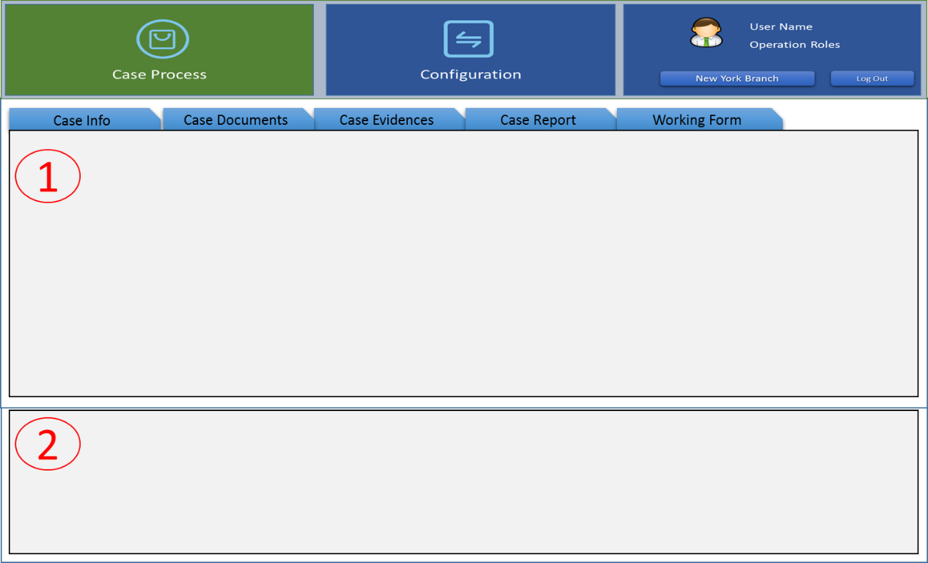

*~~Page description:~~*

* ~~Display this page while user clicked the review button of one case record on his case list for review page.~~
* ~~This page contains two areas:~~

|  |  |  |
| --- | --- | --- |
| ~~#~~ | ~~AREA~~ | ~~DESCRIPTION~~ |
| ~~1~~ | ~~Case Detail Information Area~~ | * ~~The classification method displays all kinds of information for the Case~~ * ~~Display different TAB tabs based on the current flow status of the Case~~ |
| ~~2~~ | ~~Case Operations Area~~ | * ~~Displays the information entry for the next action of the current user role~~ * ~~A feature button that displays the next action for the current user role~~   ~~(Different user roles and case workflow status display different content)~~ |

* **UI Elements**
* ~~Element of case detail information area:~~

|  |  |  |
| --- | --- | --- |
| ~~#~~ | ~~TAB ITEM~~ | ~~CONTENT~~ |
| ~~1~~ | ~~Case Info~~ | * ~~Case base information, Current Status~~ * ~~Case workflow chart~~ |
| ~~2~~ | ~~Case Documents~~ | * ~~The uploaded Transaction Documents(PDF)~~ * ~~Operations link for Transaction Documents.~~ |
| ~~3~~ | ~~Case Evidence~~ | * ~~Collected evidence list for this case (group by API source)~~ * ~~Click evidence link to review~~ |
| ~~4~~ | ~~Case Report~~ | * ~~The Transaction Risk Mitigation Check List report which submitted by Operations Analyst~~ |
| ~~5~~ | ~~Working Form~~ | * ~~Work forms for case review and refer~~ * ~~Render different Working forms in a secondary label (show existing ones only)~~ * ~~The styles of each Working Form see attached 7.1~~ |

* ~~Element of case operations area: (For different roles, the action area displays differently, as shown in the following table)~~

|  |  |  |  |
| --- | --- | --- | --- |
| ~~ROLE~~ | ~~ITEM~~ | ~~TYPE~~ | ~~DESCRIPTION~~ |
| ~~Operations Analyst~~ | ~~Upload Transaction Documents~~ | ~~button~~ | ~~Click to entry Case Verification page (ref 4.6). Upload Transaction Documents (PDF) and fields data input.~~ |
| ~~Upload Case Evidence~~ | ~~button~~ | ~~Click to entry Case Evidence Management Page (ref 4.10), upload evidence~~ |
| ~~Upload Question Evidence~~ | ~~button~~ | ~~Click to entry Case Question Checking page (ref 0). Upload Evidence for specific issues.~~ |
| ~~Operations Manager~~ | ~~Return to Operations Analyst~~ | ~~button~~ | ~~Click to entry Case Return page (ref 0).~~ |
| ~~Sign-Off~~ | ~~button~~ | ~~Click to display Case Sign-off page (ref 0)~~ |
| ~~Refer to Next~~ | ~~button~~ | ~~Click to display Case Refer to Next page (ref 4.11.6)~~ |
| ~~Evidence Manually Upload~~ | ~~button~~ | ~~Click to display Upload Evidence page. (ref 4.11.7)~~ |
| ~~Compliance Analyst~~ | ~~Refer to Next~~ | ~~button~~ | ~~Click to display Case Refer to Next Page. (ref 4.11.6)~~ |
| ~~Supplementary Notes (#3)~~ | ~~button~~ | ~~Click to entry Supplementary Notes form page. (ref 0)~~ |
| ~~Case Review Check List (#4)~~ | ~~button~~ | ~~Click to entry TSD Case Review Check List Form page. (ref 0)~~ |
| ~~Upload Case Evidence~~ | ~~button~~ | ~~Click to entry Case Evidence Management page (ref 4.10). upload Evidence~~ |
| ~~Evidence Manually Upload~~ | ~~button~~ | ~~Click to display Upload evidence page. (ref 4.11.7)~~ |
| ~~Compliance Supervisor~~ | ~~Assign~~ | ~~button~~ | ~~Click to display Case Assignment page.~~  ~~(ref 4.11.3)~~ |
| ~~Case Review Check List (#4)~~ | ~~button~~ | ~~Click to entry TSD Case Review Check List Form page (ref 0)~~ |
| ~~Sign-Off~~ | ~~button~~ | ~~Click to display Case Sign-Off page. (ref 0)~~ |
| ~~Refer to Next~~ | ~~button~~ | ~~Click to display Case Refer to Next page.~~  ~~(ref 4.11.6)~~ |
| ~~Evidence Manually Upload~~ | ~~button~~ | ~~Click to display Upload Evidence page~~  ~~(ref 4.11.7)~~ |
| ~~Compliance BSA Officer~~ | ~~Case Review Check List (#4)~~ | ~~button~~ | ~~Click to entry TSD Case Review Check List Form page (ref 0)~~ |
| ~~Return to Compliance Analyst~~ | ~~button~~ | ~~Click to display Case Return page. (ref 0)~~ |
| ~~Sign-Off~~ | ~~button~~ | ~~Click to display Case Sign-Off page (ref 0)~~ |
| ~~Refer to Next~~ | ~~button~~ | ~~Click to display Case Refer to Next page.~~  ~~(ref 4.11.6)~~ |
| ~~Evidence Manually Upload~~ | ~~button~~ | ~~Click to display Upload Evidence page.~~  ~~(ref 4.11.7)~~ |
| ~~（ALL）~~ | ~~Cancel Case~~ | ~~button~~ | ~~After clicking this button, system will notice user to input the reason, then discontinue the current case processing directly in the system (Set case status as ‘Cancelled’).~~  ~~Notice: If needs to abandon the current operations and close the window, click on the upper right corner of the window "X", or add a "Close" button~~ |
| ~~Return for Delete~~ | ~~button~~ | ~~Click to prompt the user whether to confirm the deletion. If user confirm, needs input the deleted reason.~~  ~~Close review page, return to Case List for review page. (System will return this case to original Operations Analyst for delete).~~ |

### ~~3.2.18.3. Case Assignment Page~~

~~This interface is only for cases where Compliance Supervisor assigns case to Compliance Analyst, and throughout the TSD process there are the following scenarios in which Compliance Supervisor needs to assign case to Compliance Analyst:~~

* 1. ~~Operations Manager escalated new case, need Compliance Supervisor to assign a Compliance Analyst to taking more review.~~
  2. ~~After Compliance Supervisor reviewed the productive case, need re-assign the Compliance Analyst to fill out the TSD Case Review Check List (#4) form first.~~
  3. ~~While Compliance BSA Officer’s review and request Compliance Supervisor to assign a Compliance Analyst to exec more additional due diligence check.~~
* **~~UI Diagram & illustration~~**

~~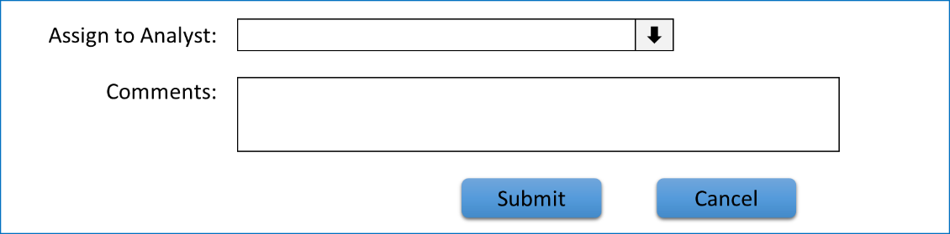~~

*~~Page description:~~*

* ~~Supervisor continues to display this subpage in the Case Review page after clicking on "Assign".~~
* **~~UI Elements~~**

|  |  |  |
| --- | --- | --- |
| ~~ITEM~~ | ~~TYPE~~ | ~~DESCRIPTION~~ |
| ~~Assign to Compliance Analyst~~ | ~~Selection~~ | ~~Mandatory, drop-down selection.~~  ~~List all Compliance Analyst user list of this company/branch.~~ |
| ~~Comments~~ | ~~String~~ | ~~Optional, Manual input, max length 1000 bytes.~~ |
| ~~“Submit”~~ | ~~button~~ | ~~Submit this Assign operations instruction, prompt after completion, and return to the Case List for Review page.~~ |
| ~~“Cancel”~~ | ~~button~~ | ~~Abort the Assign operations and return to the Case Review page~~ |

### ~~Case Sign-Off Page~~

~~Throughout the TSD workflow, Case can be sign-off by three types of user roles:~~

1. ~~Operations Manager：Only allow to sign-off those normal case which submitted by Operations Analyst (approve).~~
2. ~~Compliance Supervisor: Only allow to sign-off those non-productive case which submitted by Compliance Analyst (approve).~~
3. ~~Compliance BSA Officer: Can select approve or reject case while sign-off.~~

* **~~UI Diagram & illustration~~**

~~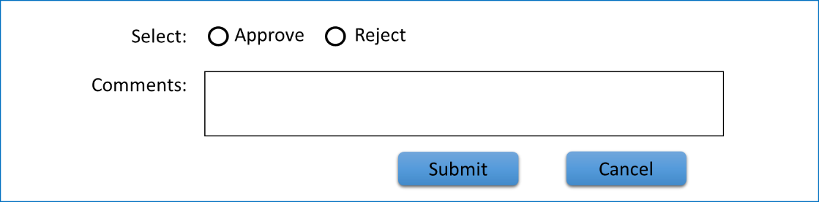~~

*~~Page description:~~*

* ~~After the user clicks "Sign-Off" on the Case review page, the child page continues to display in the case operations area of the Case Review page.~~
* **~~UI Elements~~**

|  |  |  |
| --- | --- | --- |
| ~~ITEM~~ | ~~TYPE~~ | ~~DESCRIPTION~~ |
| ~~Select(Sign-Off)~~ | ~~Selection~~ | ~~Mandatory,~~   * ~~For Operations Manager and Compliance Supervisor, Only Approve is allowed~~ |
| ~~Comments~~ | ~~String~~ | ~~Optional, Manual input, max length 500 bytes.~~ |
| ~~“Submit”~~ | ~~button~~ | ~~Click to confirm Sign-Off current case, prompt after completion, and return to the Case List for Review page.~~ |
| ~~“Cancel”~~ | ~~button~~ | ~~Abort the Sign-Off operations and return to the Case Review page~~ |

### ~~Case Return Page~~

~~Throughout the TSD workflow, the return back operations has the following scenarios:~~

1. ~~When Operations Manager reviews the Case submitted by Operations Analyst, he checks that Operations Analyst handles the Case correctly and adequately, such as whether the transaction information has been uploaded, whether the transaction information has been entered correctly and completely, and whether the answers to the various investigation questions are appropriate. Evidence is sufficient and so on. If there are deficiencies or deficiencies in Operations Manager, the Case can be returned to Operations Analyst for correction.  
   The reasons why Operations Manager returned Case to Operations Analyst for correction can be divided into two categories: 1) only need Operations Analyst to add more evidence, or to answer questions again. (2) The original information of the transaction is incorrectly entered or the original data is missing, and it needs to be re-checked.  
   The reason for the Operations Manager return should be stated.~~
2. ~~When Compliance Supervisor review case, If the case is productive, it will be returned to Compliance Analyst to fill in the TSD Case Review Check List form.~~
3. ~~When Compliance BSA Officer reviews case, it needs to return Case to supervisor to assign Compliance Analyst for further processing if it considers that more due diligence is required.~~

* **~~UI Diagram & illustration~~**

~~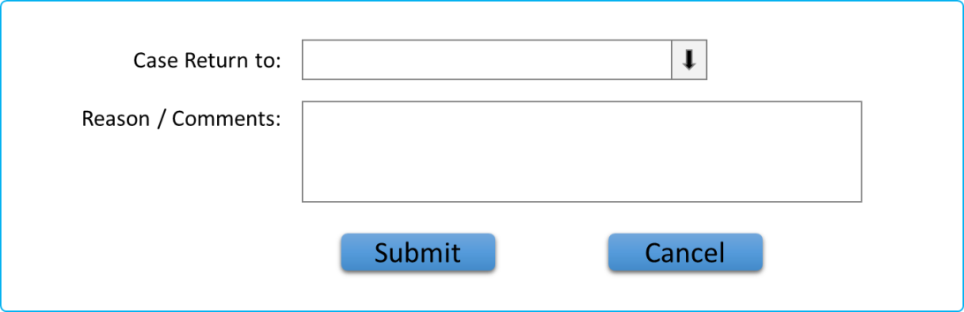~~

*~~Page description:~~*

* ~~After the user clicks the "Return" button on the Case review page, the child page continues to display in the case operations area of the Case Review page.~~
* **~~UI Elements~~**

|  |  |  |
| --- | --- | --- |
| ~~ITEM~~ | ~~TYPE~~ | ~~DESCRIPTION~~ |
| ~~Return to~~ | ~~Selection~~ | ~~Single option,~~  ~~When returned by Operations Manager, the drop-down list is the Operations Analyst list of the current business branch;~~  ~~When returned by Compliance Supervisor, the drop-down list is the Compliance Analyst list of the current business branch;~~  ~~When returned by BSA officer, the drop-down list is the Compliance Supervisor list of the current business branch.~~ |
| ~~Reason/Comments~~ | ~~String~~ | ~~Manual input, Max length is 500 bytes.~~ |
| ~~“Submit”~~ | ~~button~~ | ~~Submit the return instruction, prompt after completion, and return to the Case List for Review page.~~ |
| ~~“Cancel”~~ | ~~button~~ | ~~Abort the return back operations and return to the Case Review page.~~ |

### ~~Case Refer to Next Page~~

~~In the TSD workflow, there are the following scenarios for refer to next:~~

1. ~~Operations Analyst finished case checking, refer to operations manager to review.~~
2. ~~After Operations manager’s review, refer the case that has been identified as Red Flag to Compliance unit (supervisor) to review.~~
3. ~~When Compliance analyst receives cases and needs to report to LCD immediately. Will Refer to supervisor or BSA Officer is confirmed and forwarded to LCD.~~
4. ~~After Compliance analyst finished case checking and review, He needs refer the result to Supervisor to review.~~
5. ~~Compliance analyst completes the evidence supplement for a case and fills in Case Review Check List Form, He needs refer the result to supervisor to review.~~
6. ~~The Compliance supervisor check confirms that Compliance Analyst's application form for immediate submission is Special Approval form, and then reorders to LCD to process.~~
7. ~~The Compliance supervisor view confirms that Compliance Analyst appends the submitted TSD Case Review Check list and adds its own audit opinion to BSA Officer to review~~
8. ~~Compliance BSA Officer checks the Case application form from Compliance Analyst to submit a special Approval form immediately, and then reorders to LCD to process.~~

* **~~UI Diagram & illustration~~**

~~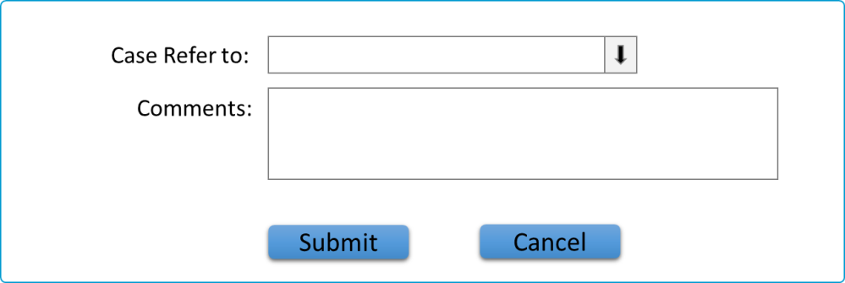~~

*~~Page Description:~~*

* ~~After the user clicks the "Refer to" button on the Case review page, the child page continues to display in the case operations area of the Case Review page.~~
* **~~UI Elements~~**

|  |  |  |
| --- | --- | --- |
| ~~ITEM~~ | ~~TYPE~~ | ~~DESCRIPTION~~ |
| ~~Refer to~~ | ~~Selection~~ | ~~Single Option~~  ~~For different roles or refer scenarios, see Note 1 for a description of the drop-down list items~~ |
| ~~Comments~~ | ~~String~~ | ~~Manual Input, Max Length is 500 bytes.~~ |
| ~~“Submit”~~ | ~~button~~ | ~~Submit the Refer to operations instruction, prompt after completion, and return to the Case List for Review page.~~ |
| ~~“Cancel”~~ | ~~button~~ | ~~Abort the refer to next operations and return to the Case Review interface~~ |

~~Remarks: Note 1~~

|  |  |
| --- | --- |
| ~~ROLE~~ | ~~DESCRIPTION~~ |
| ~~Operations Analyst~~ | ~~Drop-down list of Operations manager users for the current business branch~~ |
| ~~Operations Manager~~ | ~~Drop-down list of Compliance supervisor users for the current business branch~~ |
| ~~Compliance Analyst~~ | ~~List only the Compliance supervisor of the current business branch~~ |
| ~~Compliance Supervisor~~ | ~~If LCD escalate~~  ~~The drop-down list lists the LCD users configured for the system~~  ~~Otherwise~~  ~~Drop-down list of BSA Officer users for the current business branch~~ |
| ~~Compliance~~  ~~BSA Officer~~ | ~~The drop-down list lists the LCD users configured for the system~~ |

### ~~Upload Evidence Button~~

~~After the introduction of Case Management, all review roles (including Operations Manager and Compliance unit) must have the ability to manually upload Evidence for the case review process.~~

~~The Upload Evidence buttonis the same as currently selected by the Operations Analyst to upload evidence manually in the Check Questions page.~~

### ~~Operations Analyst: Special Approval Form Page~~

~~After Operations Analyst completes the investigation of a Case problem and generates the Summary Report (Transaction Risk Mitigation Check list, if the Case report exists with Red Flag and finds the client on Fircosoft watch list, which needs to fill in Special Approval form online.~~

* **~~UI Diagram & illustration~~**

~~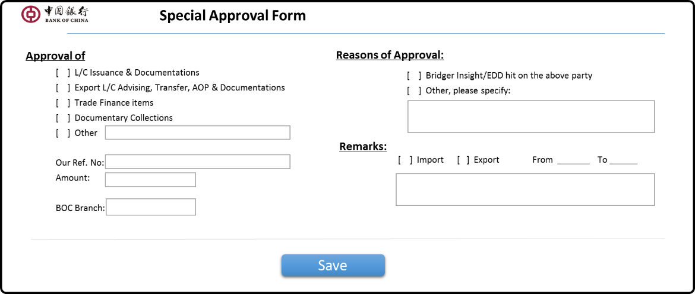~~

*~~Page description:~~*

* ~~When Operations Analyst submits the Case Summary Report, if the Case has Red Flag and the client is on the Fircosoft watch list, click the "Special Approval Form" button to display this page.~~
* ~~For this form page, see the form style provided by the customer, as shown in the attachment. Reference 7.1.2。~~
* **~~UI Elements~~**

|  |  |  |  |
| --- | --- | --- | --- |
| ~~#~~ | ~~ITEM~~ | ~~NAME~~ | ~~DESCRIPTION~~ |
| ~~1~~ | ~~Approval of~~ | ~~(group)~~ | ~~Mandatory, Manual input~~ |
| ~~2~~ | ~~Our Ref. No~~ | ~~BOC Reference no~~ | ~~Mandatory, Manual input~~  ~~From “Create case” input BOC reference & Reference No~~ |
| ~~3~~ | ~~Amount~~ | ~~Total Amount~~ | ~~Mandatory, format (currency + amount)~~ |
| ~~4~~ | ~~Import/Export~~ | ~~Flag~~ | ~~Mandatory, Manual input~~ |
| ~~5~~ | ~~From to~~ | ~~Start date~~ | ~~Mandatory, Manual input~~ |
| ~~6~~ | ~~Description of Goods~~ | ~~Goods Description~~ | ~~Mandatory, Manual input~~ |
| ~~7~~ | ~~BOC branch~~ | ~~Branch Name~~ | ~~Optional~~ |
| ~~4~~ | ~~”Save”~~ | ~~button~~ | ~~Save input information.~~ |

~~Note * see appendix for specific input elements 7.1.2~~

### ~~Compliance Analyst: Supplementary Notes Page~~

~~After Compliance Analyst finished all checking for case. Need to fill out the Supplementary Notes Form online for each case.~~

* **~~UI Diagram & illustration~~**

*~~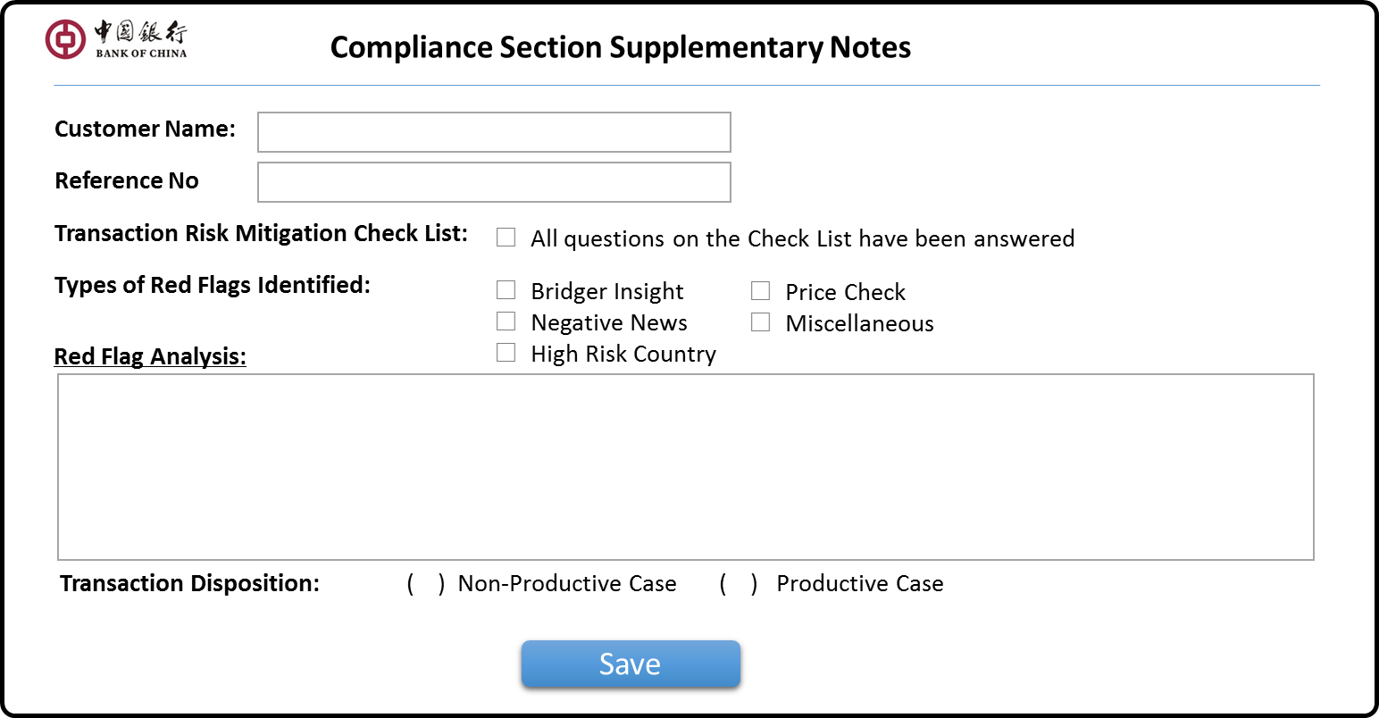~~*

*~~Page description:~~*

* ~~For Operations unit submission, if you don't need to report immediately to LCD Compliance Analyst to complete all kinds of audit surveys, click on the "Supplementary Notes" button on the Review interface, and this interface appears.~~
* ~~For Operations unit, if it has been reported to LCDs immediately, after Compliance Analyst has completed all kinds of audit investigations, and after receiving feedback from LCD, Analyst has clicked the "Supplementary Notes" button on the Review interface, and this interface appears.~~
* ~~The elements of this form page, ref 7.1.3。~~
* **~~UI Elements~~**

|  |  |  |  |
| --- | --- | --- | --- |
| ~~#~~ | ~~ITEM~~ | ~~NAME~~ | ~~DESCRIPTION~~ |
| ~~1~~ | ~~Customer Name~~ | ~~Client Name~~ | ~~Mandatory, come from “Create case” input client name~~ |
| ~~2~~ | ~~Reference No~~ | ~~BOC Business RefNo.~~ | ~~Mandatory, from “Create case” input BOC reference & Reference No~~ |
| ~~3~~ | ~~Transaction Risk Mitigation Check List~~ | ~~Have all the questions in the questionnaire been answered~~ | ~~Tick option， Yes/No~~ |
| ~~4~~ | ~~Types of Red Flags Identified~~ | ~~What kind of verification was reported~~ | ~~Multiple choice~~ |
| ~~5~~ | ~~Red Flag Analyst~~ | ~~Analyst Report~~ | ~~Manual data input~~ |
| ~~6~~ | ~~Transaction Disposition~~ | ~~if Productive?~~ | ~~Mandatory Yes/No~~ |
| ~~7~~ | ~~”Save”~~ | ~~button~~ | ~~Save input information after clicking~~ |

~~Note * see Appendix 5.1.3 for specific input elements~~

### ~~Compliance Analyst: TSD Case Review Check List Form Page~~

* **~~UI Diagram & illustration~~**

~~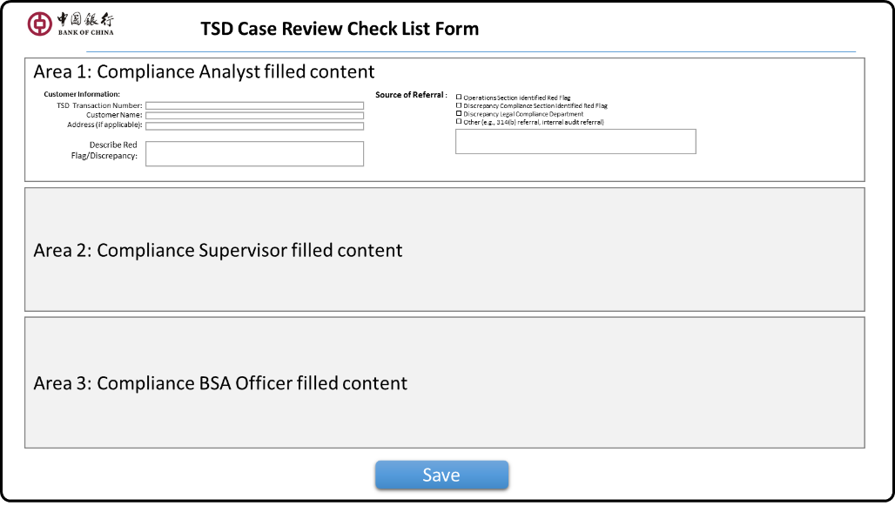~~

*~~Page description:~~*

* ~~Compliance Analyst receives the Case returned by Supervisor to fill out TSD Case Review Check List Form. On the Case review interface, select "TSD Case review check list Form" under Report tab to display this form page.~~
* ~~BOC provides the style of this form, see appendix 7.1.4.~~
* ~~Other roles worked as fill in the contents of Compliance Analyst can be viewed, but are not allowed to change. Compliance Analyst only needs to fill in the Area1 part.~~
* **~~UI Elements~~**

|  |  |  |  |
| --- | --- | --- | --- |
| ~~#~~ | ~~ITEM~~ | ~~NAME~~ | ~~DESCRIPTION~~ |
| ~~1~~ | ~~Customer Information~~ | ~~Client Info~~ | ~~TSD Transaction Number: from “Create case” input BOC reference & Reference No~~  ~~Client Name: from “Create case” input client name~~  ~~Address: manual input~~ |
| ~~2~~ | ~~Source of Referral~~ | ~~Escalate Reason~~ | ~~manual input~~ |
| ~~3~~ | ~~Compliance Section Reviewer~~ | ~~reviewer ID~~ | ~~name of Compliance Analyst~~ |
| ~~4~~ | ~~”Save”~~ | ~~button~~ | ~~Save input information after clicking~~ |

~~Note * see appendix 7.1.4 for specific input elements~~

### ~~Compliance Supervisor: TSD Case Review Check List Form Page~~

* **~~UI Diagram & illustration~~**

~~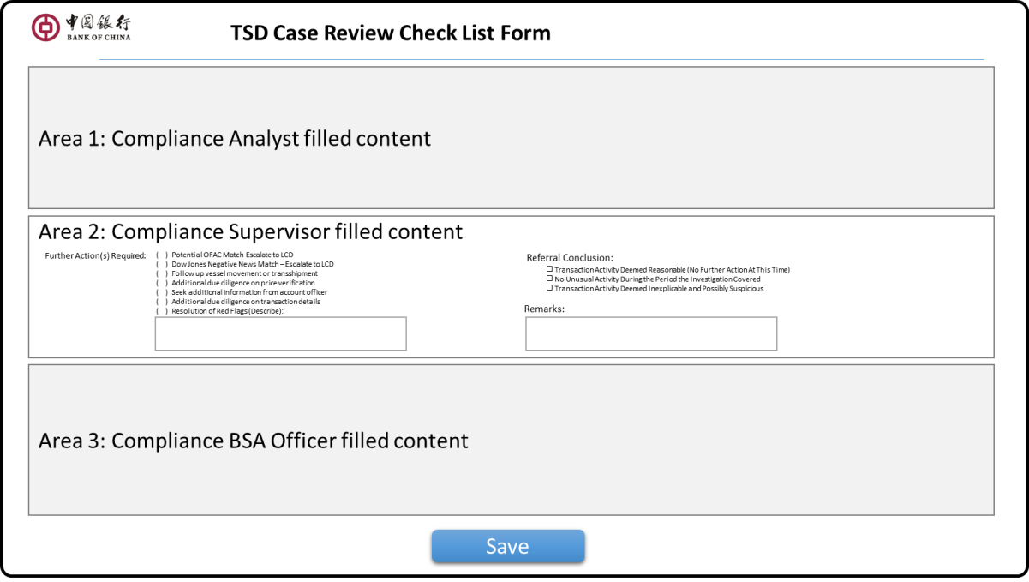~~

*~~Page Description:~~*

* ~~Supervisor on the Case review page, select "TSD Case review check list Form" under the Report tag to display this form page.~~
* ~~BOC provides the style of this form, see appendix 7.1.4.~~
* ~~Other roles worked as fill in the contents of Compliance Supervisor can be viewed, but are not allowed to change. Compliance Supervisor only needs to fill in the Area2 part.~~
* **~~UI Elements~~**

|  |  |  |  |
| --- | --- | --- | --- |
| ~~#~~ | ~~ITEM~~ | ~~NAME~~ | ~~DESCRIPTION~~ |
| ~~1~~ | ~~Further Actions Required~~ | ~~Next Action~~ | ~~Multi-selection~~ |
| ~~2~~ | ~~Assigned to~~ | ~~Reviewer and comments~~ | ~~Name and date filled by system automatically.~~  ~~Supervisor input ‘remarks’ manually~~ |
| ~~3~~ | ~~Referral Conclusion~~ | ~~Refer comments~~ | ~~Manual input~~ |
| ~~4~~ | ~~”Save”~~ | ~~Button~~ | ~~Save input information after clicking~~ |

~~Notes*: for detail input elements, refer appendix 7.1.4.~~

### ~~BSA Officer: TSD Case Review Check List Form Page~~

* **~~UI Diagram & illustration~~**

~~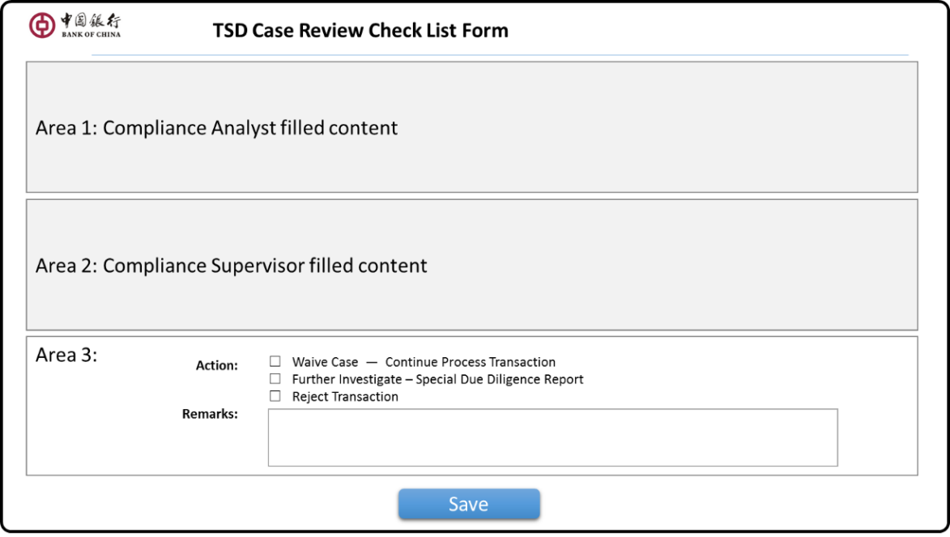~~

*~~Page description:~~*

* ~~BSA Officer on the Case review page, select "TSD Case review check list Form" under the Report tag to display this form page.~~
* ~~BOC provides the style of this form, see appendix 7.1.4.~~
* ~~Other roles worked as fill in the contents of BSA Officer can be viewed, but are not allowed to change. BSA Officer only needs to fill in the Area3 part.~~
* **~~UI Elements~~**

|  |  |  |  |
| --- | --- | --- | --- |
| ~~#~~ | ~~ITEM~~ | ~~NAME~~ | ~~DESCRIPTION~~ |
| ~~1~~ | ~~Action~~ | ~~Next action~~ | ~~1.Waive - Continue Process Transaction~~  ~~2.needs more due diligence~~  ~~3.Reject~~ |
| ~~2~~ | ~~Remarks~~ | ~~comments~~ | ~~Manual input~~ |
| ~~3~~ | ~~“Save”~~ | ~~button~~ | ~~Save input information after clicking~~ |

~~Notes*: for detail input elements, refer appendix 7.1.4.~~

### ~~BSA Officer: Unusual /Suspicious Activities Form Page~~

~~When BSA Officer Sign-off a case, if the final review results is rejection the transaction, and BSA Officer believes that the transaction should be reported to LCD for SAR filing, the system will display the report form online for BSA to fill in according to BSA's choice.~~

* **~~UI Diagram & illustration~~**

~~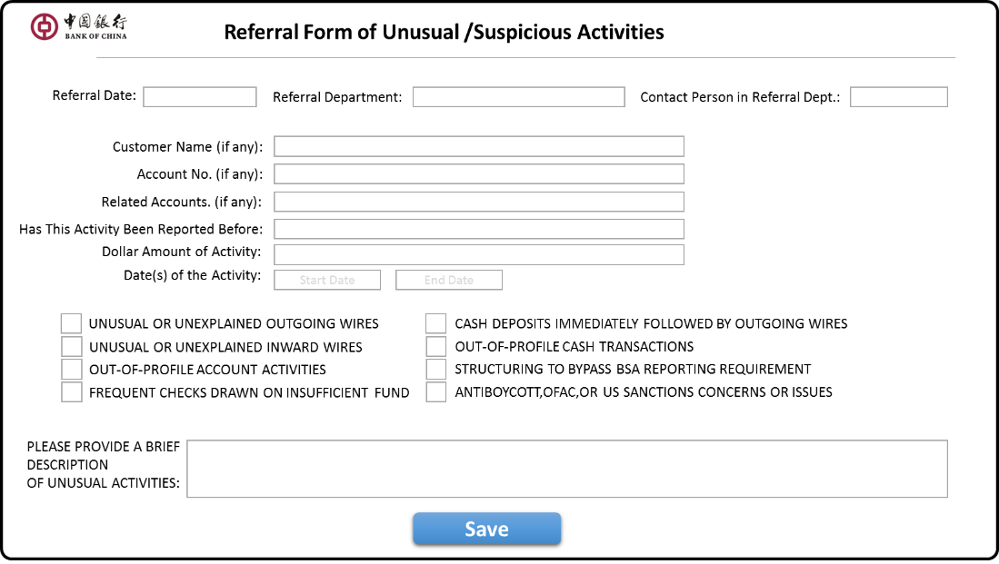~~

*~~Page description:~~*

* ~~After BSA Officer Sign-Off Case, if the selected audit result is a rejection of the transaction, the system prompts BSA "do you need to report to LCD for SAR reporting?" ", if BSA answers YES, this form page is displayed.~~
* ~~BOC provides the style of this form, see appendix 7.1.5.~~
* ~~All the elements will be filled manually.~~
* ~~When BSA is completed, click the "Print" button to print out the form for offline circulation.~~
* **~~UI Elements~~**

|  |  |  |  |
| --- | --- | --- | --- |
| ~~#~~ | ~~ITEM~~ | ~~NAME~~ | ~~DESCRIPTION~~ |
| ~~1~~ | ~~Referral Date~~ | ~~Escalate date~~ | ~~Default to current date~~ |
| ~~2~~ | ~~Referral Dept.~~ | ~~Departments applying~~ |  |
| ~~3~~ | ~~Contact Person~~ | ~~contact person~~ |  |
| ~~4~~ | ~~Info group~~ | ~~Case related information~~ |  |
| ~~5~~ | ~~Unusual Brief~~ | ~~Event brief description~~ | ~~manual input~~ |
| ~~6~~ | ~~”Print”~~ | ~~button~~ | ~~When clicked, save the information and print the paper form~~ |

~~Notes*: for detail input elements, refer appendix 7.1.5.~~

### ~~LCD Officer: Review & Feedback Page~~

~~In the whole TSD processing, the LCD needs to support the audit of the TSD, there are several support scenarios as follows:~~

1. ~~When TSD Compliance Analyst confirms the existence of "Special Approval Form #2" in a case, it is necessary to report the Case to LCD immediately and wait for feedback from LCD.~~
2. ~~When TSD BSA Officer Reject a case, which is considered as an unusual and suspicious transaction, will also choose to report it to LCD for SAR filing.~~

~~For the first scenario of reporting and feedback, the system will configure a user role for LCD, allowing LCD users to log in directly to the system and view Case and application forms within the system.~~

~~For the second scenario, it will be handled offline (same as the current manual method, which is, after the TSD user completes the Sign-Off in the system, the system provides the form to be completed online and prints it, and then submits it to LCD offline for processing.~~

* **~~Case List for Review Page~~**
* ~~LCD User Login~~
* ~~When LCD has completed its own investigation and processing work, it is necessary to input / feedback the survey opinions and processing results of the case in the system.~~

~~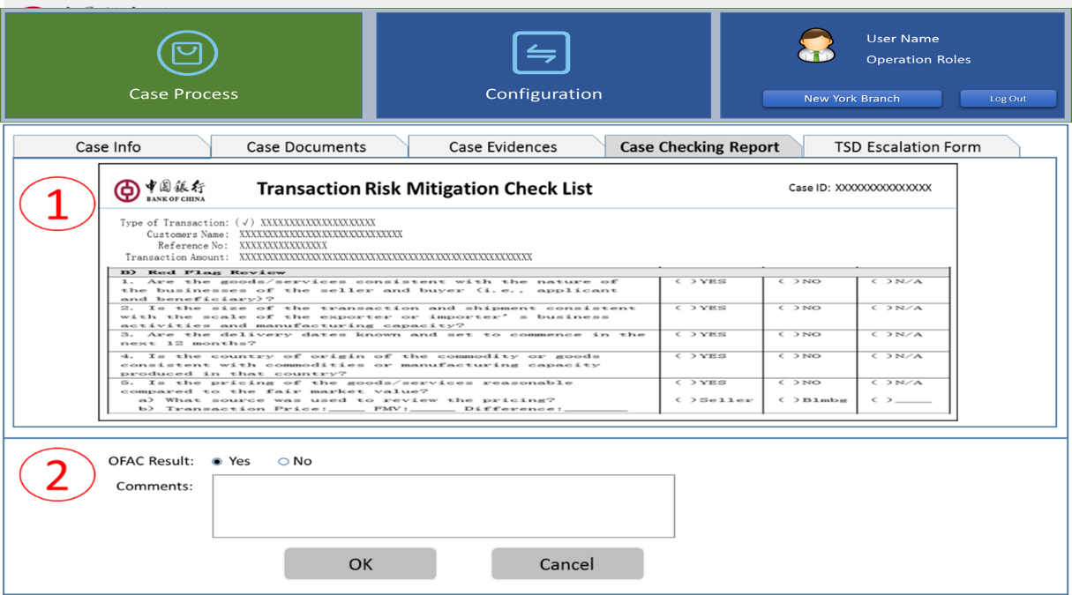~~

*~~Page description:~~*

* ~~LCD user choose a case in List Page, click on "Review & Feedback" button appears on this page.~~
* ~~This page is divided into two regions: 1: case information area, 2: feedback area~~
* ~~Elements of case information area:~~

|  |  |  |  |
| --- | --- | --- | --- |
| ~~#~~ | ~~GROUP(TAB)~~ | ~~INFORMATION~~ | ~~DESCRIPTION~~ |
| ~~1~~ | ~~Case Info~~ | ~~Case information~~ | ~~Only viewable, not modifiable~~ |
| ~~2~~ | ~~Case Documents~~ | ~~Case transaction documents~~ | ~~Only viewable, not modifiable.~~  ~~Display the upload PDF file contents~~ |
| ~~3~~ | ~~Evidence Info~~ | ~~Case Evidence~~ | ~~Only viewable, not modifiable~~ |
| ~~4~~ | ~~Checking Report~~ | ~~Case report~~ | ~~Display Transaction Risk Mitigation Check List Summary Report, not modifiable~~ |
| ~~5~~ | ~~Escalation Form~~ | ~~TSD Application Form~~ | ~~According to different scenarios, display one of the following forms:~~   * ~~Special Approval Form (from Compliance Analyst)~~ * ~~Unusual /Suspicious Activities Form (from BSA Officer)~~ |
| ~~Note: LCD users can use TAB tags to switch to display / view the above information~~ | | | |

* ~~Element of feedback area:~~

~~If this report is a case of applying for an OFAC investigation:~~

|  |  |  |  |
| --- | --- | --- | --- |
| ~~#~~ | ~~ITEM~~ | ~~NAME~~ | ~~DESCRIPTION~~ |
| ~~1~~ | ~~OFAC Result~~ |  | ~~Mandatory, YES or No~~ |
| ~~2~~ | ~~Comments~~ |  | ~~Optional, Manual input~~ |

~~If this report belongs to the scenario reported by SAR:~~

|  |  |  |  |
| --- | --- | --- | --- |
| ~~#~~ | ~~ITEM~~ | ~~NAME~~ | ~~DESCRIPTION~~ |
| ~~1~~ | ~~SAR Result~~ |  | ~~Mandatory, Manual Input~~  ~~INVESTIGATION CONTROL LOG#~~ |
| ~~2~~ | ~~Comments~~ |  | ~~Optional, Manual input~~ |

* ~~Link and button~~

|  |  |  |
| --- | --- | --- |
| ~~#~~ | ~~ITEM~~ | ~~DESCRIPTION~~ |
| ~~1~~ | ~~"OK" button~~ | ~~Click to save the result of LCD user input, prompt the operations to succeed, and return LCD Case Lis page.~~ |
| ~~2~~ | ~~"Cancel" button~~ | ~~Give up Review and feedback, click and return directly to LCD Case Lis page.~~ |

### ~~Administrator: Exception Process Page~~

~~During workflow control, when a Case has been assigned to a role user, other users do not have permission to operate on the case. To avoid the situation that the current case dispatch user cannot continue processing and other users cannot operate, the system allows the process manager to return an assigned case to the pending status within the system so that other users can take over the case.~~

* **~~UI Diagram & illustration~~**

~~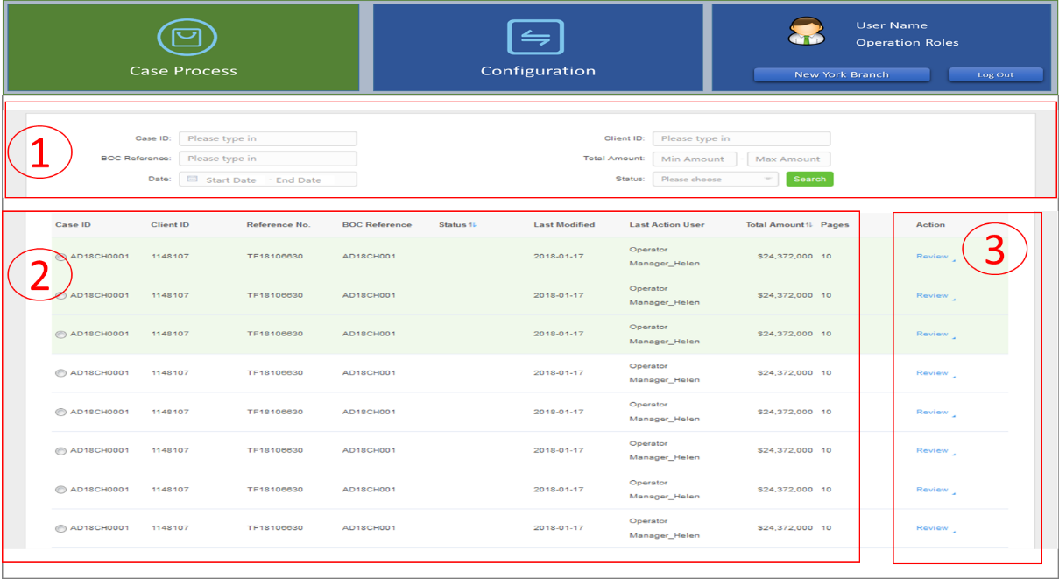~~

*~~Page description:~~*

* ~~After the administrator logs in to the system, and selecting the "Case Process" module on the Home Page, this page will be displayed in the workspace;~~
* ~~This page is divided into three areas:~~

|  |  |  |
| --- | --- | --- |
| ~~#~~ | ~~AREA~~ | ~~DESCRIPTION~~ |
| ~~1~~ | ~~Query condition area~~ | * ~~Sets search criteria / data items for list records.~~ * ~~Combined query according to the retrieval value of each data item entered~~ |
| ~~2~~ | ~~Case record list area~~ | * ~~Display the retrieved query results in a list (one row per Case record.~~ * ~~Click on column header to support ascending and downward sorting by column content, and all columns can support ascending and descending sorting.~~ |
| ~~3~~ | ~~Operations area~~ | * ~~Operational function links for each record~~ |

* ~~Elements of Query condition area:~~

|  |  |  |
| --- | --- | --- |
| ~~ITEM~~ | ~~TYPE~~ | ~~DESCRIPTION~~ |
| ~~TF Reference No.~~ | ~~String~~ | ~~Trade finance reference number~~ |
| ~~BOC Reference No.~~ | ~~String~~ | ~~BOC business reference number~~ |
| ~~Client ID~~ | ~~String~~ | ~~Client ID~~ |
| ~~Case Status~~ | ~~Selection~~ | ~~Drop-down selection~~ |
| ~~Holder User~~ | ~~String~~ | ~~Currently case holder (user name)~~ |

* ~~Elements of Case record list area (same as case list for review column):~~

|  |  |  |
| --- | --- | --- |
| ~~ITEM~~ | ~~TYPE~~ | ~~DESCRIPTION~~ |
| ~~Client ID~~ | ~~String~~ | ~~Client ID Number~~ |
| ~~Client Name~~ | ~~String~~ | ~~Client name~~ |
| ~~Reference No~~ | ~~String~~ | ~~Trade finance reference number~~ |
| ~~BOC Reference No~~ | ~~String~~ | ~~BOC business reference number~~ |
| ~~Red Flag~~ | ~~String~~ | ~~if Red Flag~~ |
| ~~Status~~ | ~~String~~ | ~~Case status (with word description)~~ |
| ~~Last Modified~~ | ~~String~~ | ~~Last update date & time~~ |
| ~~Last Action User~~ | ~~String~~ | ~~Last operator user name~~ |
| ~~Total Amount~~ | ~~String~~ | ~~Transaction Total Amount~~  ~~Format: Currency Code + Amount~~  ~~Amount shown in thousand places~~ |
| ~~Pages~~ | ~~Numeric~~ | ~~Case transaction documents pages number.~~ |

* ~~Elements of Operations area:~~

|  |  |  |
| --- | --- | --- |
| ~~ITEM~~ | ~~TYPE~~ | ~~DESCRIPTION~~ |
| ~~Reassign~~ | ~~button~~ | ~~Click on the pop-up Refer to page (see below)~~    ~~In the Refer to drop-down box, reassign the Case back to its previous assigned staff for re-assignment.~~ |

## **3.2.19 Operations Analyst: Case Summary Report Page**

### 1..1. AS-IS

~~After clicking the “Summary” button, the popup window “Case Summary” will summary the overview answer of the entire 35 questions.~~

~~Basically, the window will summarize the following editable information~~

1. Client ID
2. Client Name
3. Reference No
4. BOC Reference
5. Type
6. Total Amount
7. Remark which is editable

Summarization of answer and comments in each question where the comments are editable and will show in the final report

~~Each question’s comments will keep 85 bytes length for user key in.~~

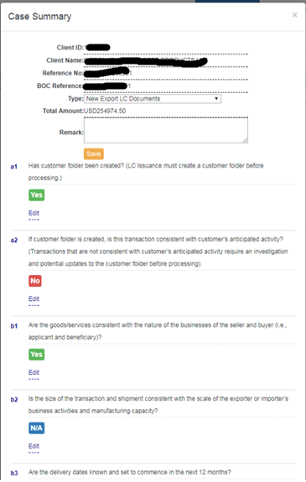

After the Operations Analyst reviews all the questions, he\she could click the “Export to PDF” button to export the final report. Without go to the summary page, the Operations Analyst could also click “Export to PDF” button in any question answer page to generate the report any time.” Export to PDF” is available after ALL questions are answered. An alert will note Operations Analyst which questions have not been answered yet in a pop up window.

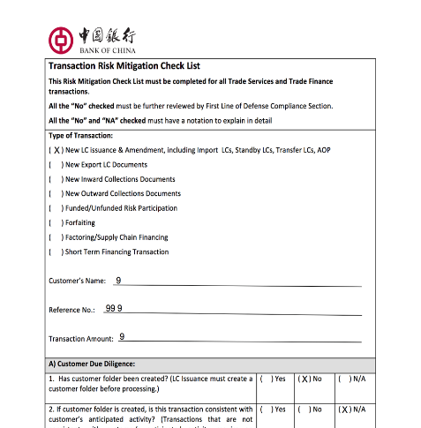

### 1..2. Enhancement

* Alert before quit summary page without saving content.
* In the interface of Case Summary, information of the case (such as client ID, client name, reference no. and so on) can be modified and the system doesn't start or ask the Operations Analyst to recheck the case using new information.
* For stringency of the whole due diligence process, such information should ONLY be allowed to modify before checking begins, and once such information modified, re-checking of the whole case should automatically start.
* Show user name (*name*) and action date for Operations Analyst & Operations Manager. Operations Analyst *name* once form #1 is submitted, operations manager *name*  click “**approve”** for no red flag section，click “**refer to”** for red flag section）











































































































* 1. Requirements for customer information

blank

3.4. Requirements for channel

blank

3.5. Requirements related to the core system

3.5.1 Technical Enhancement

3.5.1.1. Workflow Control

1. TF AML should be able to generate email message alerting the relevant parties of the pending actions required (“Pending actions” refers to every time a case is sent/returned to another role in the flow chart). For e.g. an email will be sent to the assigned parties when the Operations Manager escalated new case, the Compliance Supervisor assigned a case to a Compliance Analyst, or when the Compliance Supervisor escalated a case to the BSA Officer, etc.

3.5.1.2. Add Audit Trail

5、If changes are made to any of the thresholds in the system, record the threshold changes, user id and date of change.

3.5.1.3. File Management

3.5.2 Interface Requirements

3.5.2.1. Hardware

The following are components of hardware that are necessary for this Trade Finance Tool:

* Server with GPU
* PC
* Network

3.5.2.2. Access

3.6. Requirements for report and accounting

**Enhanced Due Diligence Forms (Future Development)**

### Form 1: Service & Insurance (#6)

To： Compliance Dept.

From: Trade Services Dept.

TSD Reference_______________ Date: ________________ Recorded by: ____________

ENHANCED DUE DILIGENCE(EDD) FOR CUSTOMERS

Underwriting services, Insurance or Reinsurance Sector

*(This Enhance Due Diligence Form is developed to cover account opening, trade settlements, loans transactions and credit facilities. The officer in charge is only required to complete those topics of search relevant and applicable to the underlying business activities.)*

|  |  |  |
| --- | --- | --- |
| Topics of Search | Information obtained | Remarks (if any) |
| EDD Party NAME and ADDRESS |  |  |
| EDD Party’s Affiliated Group of Companies (if any) |  |  |
| Country of Domicile of EDD Party’s Head Office (if any) |  |  |
| Types of the transaction (e.g. Account Opening; Trade Finance; Trade Services; Loans / Credit facility) |  |  |
| Purpose of the transaction |  |  |
| Does the Transaction involve Underwriting services, Insurance or Reinsurance Sector related to Iranian entities? |  |  |
| Amount of the transaction (e.g. Amount of Deposits, Loan Amount, Trade Settlement Amount etc.) |  |  |
| Description of Goods |  |  |

|  |  |  |
| --- | --- | --- |
| Country of Origin | Information obtained | Remarks(if any) |
| Port and Country of Loading |  |  |
| Port and Country of discharge |  |  |
| Final destination (Please also show county name) |  |  |
| Buyer / Seller Name & Country Location (you may circle either Buyer or Seller and put in info) |  |  |
| Supplier or Manufacturer & Location (if different than “Seller” above) |  |  |
| Name of End User & Country Location |  |  |
| Identify (through public information, e.g. Google, annual reports, news media etc,) if Customer or its affiliated group companies invest in or does business with the Iranian Shipbuilding Industry? |  |  |
| Identify if Customer or its affiliate group of companies conduct business activities with companies or financial institutions on the Sanction List |  |  |
| Other additional topics of search |  |  |

Prepared by: ___________________ Ext. ___________________ Date: _________

Reviewed by: ___________________ Ext. ___________________ Date: _________

Approved by: ___________________ Ext. ___________________ Date: _________

Approved by: Compliance: ____________ Ext.___________________ Date:________ _

### Form 2: Metal (#7)

To： Compliance Dept.

From: Trade Services Dept.

TSD Reference____________________ Date: ___________ Recorded by: _____________

ENHANCED DUE DILIGENCE(EDD) FOR CUSTOMERS

Commodities such as precious metals, graphite, raw or semi-finished metals (e.g., aluminum and steel)

*(This Enhance Due Diligence Form is developed to cover account opening, trade settlements, loans transactions and credit facilities. The officer in charge is only required to complete those topics of search relevant and applicable to the underlying business activities.)*

|  |  |  |
| --- | --- | --- |
| Topics of Search | Information obtained | Remarks (if any) |
| EDD Party NAME and ADDRESS |  |  |
| EDD Party’s Affiliated Group of Companies (if any) |  |  |
| Country of Domicile of EDD Party’s Head Office (if any) |  |  |
| Types of the transaction (e.g. Account Opening; Trade Finance; Trade Services; Loans / Credit facility) |  |  |
| Purpose of the transaction |  |  |
| Does the Transaction involve the investment in customers dealing in Commodities such as precious metals, graphite, raw or semi-finished metals (e.g., aluminum and steel), coal with Iranian entities? |  |  |
| Does the Transaction support the sale or purchase of Commodities such as precious metals, graphite, raw or semi-finished metals (e.g., aluminum and steel), coal with Iranian entities? |  |  |
| Amount of the transaction (e.g. Amount of Deposits, Loan Amount, Trade Settlement Amount etc.) |  |  |

|  |  |  |
| --- | --- | --- |
| Description of Goods |  | Remarks(if any) |
| Country of Origin |  |  |
| Port and Country of Loading |  |  |
| Port and Country of discharge |  |  |
| Final destination (Please also show country name) |  |  |
| Buyer / Seller Name & Country Location (you may circle either Buyer or Seller and put in info.) |  |  |
| Supplier or Manufacturer & Location (if different than “Seller” above) |  |  |
| Name of End User & Country Location |  |  |
| Identify (through public information, e.g. Google, annual reports, news media etc,) if Customer or its affiliated group companies dealing in Commodities such as precious metals, graphite, raw or semi-finished metals (e.g., aluminum and steel), coal with Iranian entities? |  |  |
| Identify if Customer or its affiliate group of companies conduct business activities with companies or financial institutions on the Sanction List |  |  |
| Other additional topics of search |  |  |

Prepared by: _____________________ Ext. ______________ Date: ________________

Reviewed by: _____________________ Ext. ______________ Date: ________________

Approved by: Compliance: ___________ Ext. ______________ Date: ________________

### Form 3: Oil & Petro (#8)

To： Compliance Dept.

From: Trade Services Dept.

TSD Reference________________ Area of Business: ___________ Recorded by: ___________

ENHANCED DUE DILIGENCE(EDD) FOR CUSTOMERR OF OIL, GAS AND PETROLEUM SECTORS

*(Some of the information may be duplicated or does not apply. Please just fill in the blanks that fit your area of business.)*

| Topics of Search | Information obtained | Remarks (if any) |
| --- | --- | --- |
| EDD Party NAME and ADDRESS |  |  |
| EDD Party’s Affiliated Group of Companies (if any) |  |  |
|  |  |  |
| Country of Domicile of EDD Party’s Head Office (if any) |  |  |
| Types of the transaction  This is to describe what kind of the transaction that belongs with.  Some examples: Import/Export |  |  |
| Purpose of the transaction |  |  |
| Does the Transaction involve the investment in the Iranian Petroleum Industry? |  |  |
| Does the Transaction support the development of Iranian Refined Petroleum Industry? |  |  |
| Does the Transaction involve the sale of Refined Petroleum Products to Iran |  |  |
| Amount of the transaction |  |  |
| Description of Goods |  |  |
| Country of Origin |  |  |
| Port of Loading (Please also show country name) |  |  |
| Port of discharge (Please also show country name) |  |  |
| Final destination (Please also show country name) |  |  |

|  |  |  |
| --- | --- | --- |
| Buyer / Seller Name & Country Location (you may circle either Buyer or Seller and put in info.) |  |  |
| Supplier or Manufacturer & Location (if different than “Seller” above) |  |  |
| Name of End User & Country Location |  |  |
| Number of transactions for the past one year |  |  |
| Volume of transactions for the past one year |  |  |
| Identify (through public information, e.g. Google, annual reports, news media etc,) if Customer or its affiliated group companies invest in Iran Petroleum Industry, provides support to the Refined Petroleum Industry, or sells Refined Petroleum to Iran? |  |  |
| Identify if Customer or its affiliate group of companies conduct business activities with companies or financial institutions on the Sanction List |  |  |
| Other additional topics of search |  |  |
| Note: This Enhance Due Diligence Form is developed to cover wire transfer activities, trade settlements, loan transactions and credit facilities. The officer in charge is only required to complete those topics of search relevant and applicable to the underlying business activities. | | |

Prepared by: _____________________ Ext. ______________ Date: ________________

Reviewed by: _____________________ Ext. ______________ Date: ________________

Approved by: Compliance: ___________ Ext. ______________ Date: ________________

### Form 4: Shipping & Ship Building (#9)

To： Compliance Dept.

From: Trade Services Dept.

TSD Reference________________ Area of Business: ___________ Recorded by: ___________

ENHANCED DUE DILIGENCE(EDD) FOR CUSTOMERR IN SHIPPING & SHIPBUILDING SECTORS

*(This Enhance Due Diligence Form is developed to cover wire transfer activities, trade settlements, loan transactions and credit facilities. The officer in charge is only required to complete those topics of search relevant and applicable to the underlying business activities..)*

|  |  |  |
| --- | --- | --- |
| Topics of Search | Information obtained | Remarks(if any) |
| EDD Party NAME and ADDRESS |  |  |
| EDD Party’s Affiliated Group of Companies (if any) |  |  |
| Country of Domicile of EDD Party’s Head Office (if any) |  |  |
|  |  |  |
| Types of the transaction （e.g. Account Opening; Trade Finance; Trade Services; Loans / Credit facility） |  |  |
| Purpose of the transaction |  |  |
| Does the Transaction involve the investment in the Iranian Shipping and Shipbuilding Industry? |  |  |
| Does the Transaction support the development of Iranian Shipping and Shipbuilding Industry? |  |  |
| Does the Transaction involve the sale of Shipping Services and/or Shipbuilding Services to Iran? |  |  |
| Amount of the transaction (e.g. Amount of Deposits, Loan Amount, Trade Settlement Amount etc.) |  |  |
| Description of Goods |  |  |

|  |  |  |
| --- | --- | --- |
| Country of Origin |  |  |
| Port and Country of Loading |  |  |
| Port and Country of discharge |  |  |
| Final destination (Please also show country name) |  |  |
| Buyer / Seller Name & Country Location (you may circle either Buyer or Seller and put in info.) |  |  |
| Supplier or Manufacture & Location (if different than “Seller” above) |  |  |
| Identify (through public information, e.g. Google, annual reports, news media etc, ) if Customer or its affiliate group companies invest in or does business with the Iranian Shipping or Shipbuilding Industry? |  |  |
| Identify if Customer or its affiliated group of companies conduct business activities with companies or financial institution on the Sanction List |  |  |
| Other additional topics of search |  |  |

Prepared by: _____________________ Ext. ______________ Date: ________________

Reviewed by: _____________________ Ext. ______________ Date: ________________

Approved by: Compliance: ___________ Ext. ______________ Date: ________________

3.7. Regulatory requirements

* N/A

3.8. Requirements for data downloading

* N/A

**Static Data Management**

### 1..1. AS-IS

On the current system, some static data / parameter lists exist in the form of Excel files or text files for use by Crawler and Logic, including:

|  |  |  |
| --- | --- | --- |
| # | File Name | File Format (Sample) |
| 1 | Sanctioned Countries List | Two fields:  1. Country Name  2. Abbreviation (two characters) |
| 2 | Common Tax Havens | One field:  1. Country Name/Region Name |
| 3 | Country Risk Classification and  Country Risk Rating | Three fields:  1. Country Name  2. Abbreviation (2 characters)  3. Link |
| 4 | Common Company Suffixes | Five fields:  1. Common company suffix  2. maximum four variations for each common company suffix |
| 5 | Top 10 Exports | Three fields:  1. Country Name  2. Abbreviation (2 characters)  3. Link |
| 6 | Branch Customer list | One file for per branch  Two fields:  1. Client ID  2. Client Name |
| 7 | Third party WEB URL list | text file format  Use for Crawler process. |

### 1..2. Enhancement

System will provide data configuration maintenance web page for TSD Compliance Analyst to input data of Sanction country, suffix, tax haven, third part website, customer List, As for high risk data, it will be updated by batch.

#### 1..2.1. Batch Import Excel File

In AS-IS system, there are seven types of parameter files. In the future, six types of parameter data will be pre-imported into the SQL Server database in batch mode. The 6 types of files are:

1. List of sanctions countries (Excel File)
2. National list of tax avoidance countries (Excel File)
3. Company name suffix list (Excel File)
4. List of TOP10 websites for countries exporting goods (Excel File)
5. Customer list of branches (Excel File)
6. List of third-party websites (Txt File)

When these data files are imported into the system in batch mode, the system will provide an online maintenance function for system administrator. Please ref to 4.14.2.2.

Upload Excel File Page

The "high risk country list" is provided by LCD department. In the future, LCD will provide full data when it is time to update. The system will provide file import function through front-end interface.

* **UI Diagram & illustration**

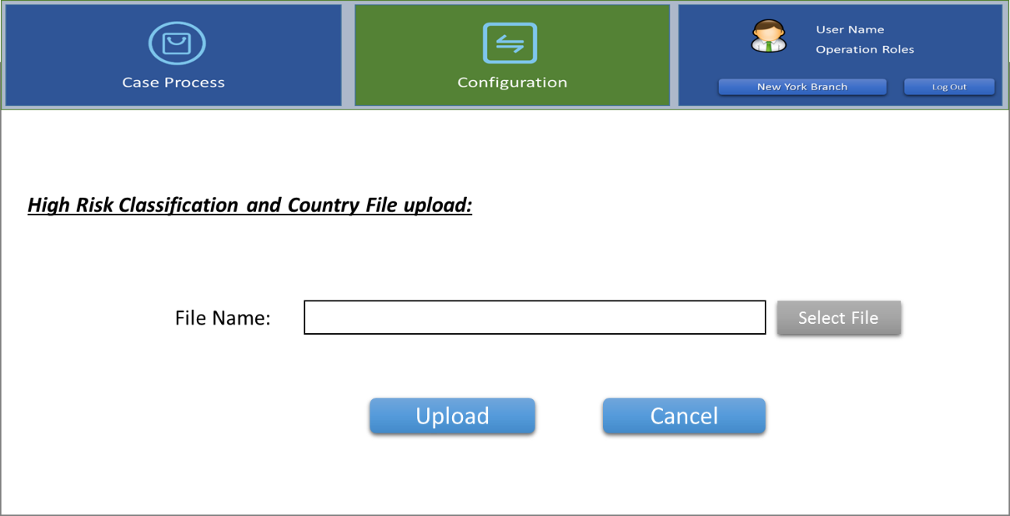

*~~Page description:~~*

* ~~When user selects the "Configuration" component on the Home Page, click the "High Risk Classification and Country File Upload" link in the workspace to enter the page.~~
* ~~When the user selects a file on this page and clicks Upload, the entire contents of the data file (.xlsx) can be directly parsed and imported into the system with full coverage.~~
* **UI Elements**

|  |  |  |  |
| --- | --- | --- | --- |
| # | ITEM | NAME | DESCRIPTION |
| 1 | File Name | Excel file name | This information is echoed by the system and cannot be edited by the user, |
| 2 | Select File | Link/Button | Click to open the file selection dialog box, after the user selects the file (limited to excel file), the selected file name is automatically echoed in the "File Name" field |
| 3 | Upload | Button | Click to import the selected “High risk country list” file into the system.  When finished, prompt the user of the import results and return to the previous work page. |

#### ~~1..2.2. Manually Data Maintenance Page~~

~~About the 6 types of pre-imported data provided in 3.12.2.1, the system provides an online manual maintenance interface for single records, as follows:~~

* **UI Diagram & illustration**

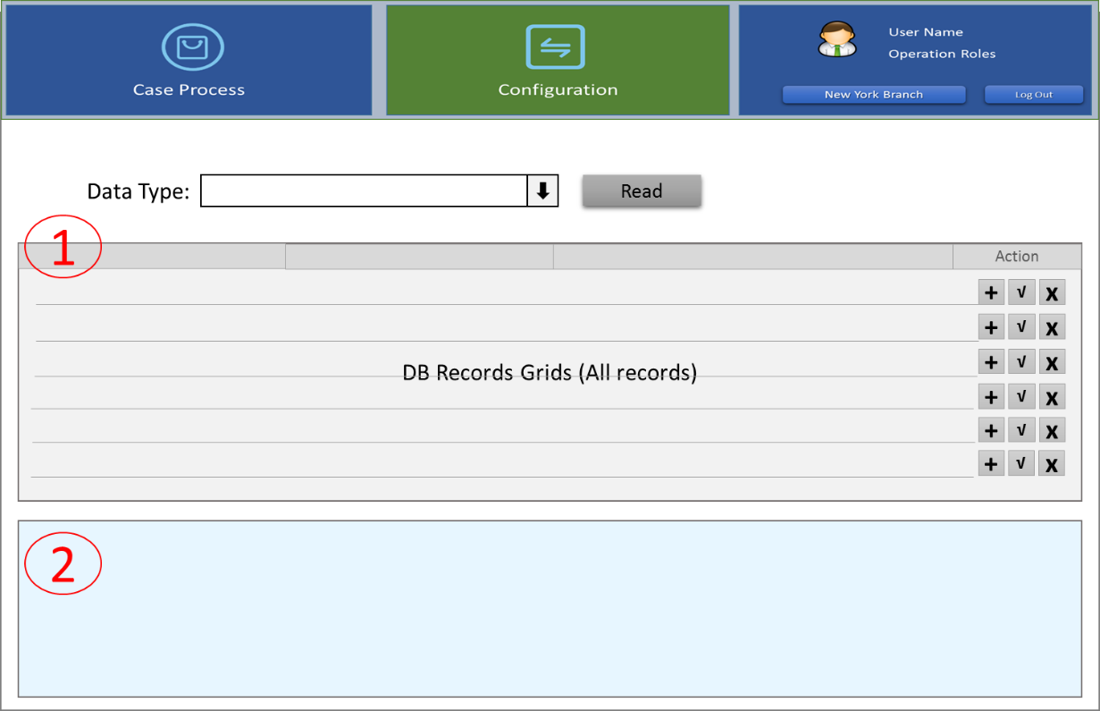

*~~Page description:~~*

* ~~users choose the "Configuration" module in the Home Page, click on the Static Data in the work area Maintenance "link to access this page~~
* ~~This page is divided into two areas: 1, database record list, 2, information editing area.~~
* ~~The database record list area for displaying the specified data type all records in database.~~
* ~~The Information editing area worked as input fields show a record of the content for users to edit~~
* ~~The operations process of user maintenance data is: 1) the user specifies the data type 2) the system lists the existing data record 3) the user adds, modifies or deletes a record one by one.~~
* **~~UI Elements~~**

|  |  |  |
| --- | --- | --- |
| ~~#~~ | ~~AREA~~ | ~~DESCRIPTION~~ |
| ~~1~~ | ~~database record list~~ | * ~~According to user selected Data Type, list database records.~~ |
| ~~2~~ | ~~information editing area~~ | * ~~User maintains a record in this area (new, modified)~~ |

|  |  |  |
| --- | --- | --- |
| ~~#~~ | ~~ITEM~~ | ~~DESCRIPTION~~ |
| ~~1~~ | ~~Date Type~~ | ~~Drop-Down selection~~  ~~6 data type except “High risk country”~~ |
| ~~2~~ | ~~List~~ | ~~Displays the full contents of each record in database~~ |
| ~~3~~ | ~~Action~~ | ~~New. Edit, Delete~~ |
| ~~information editing area~~ | | |
| ~~4~~ | ~~Record Fields~~ | ~~Display edit field by specified data type and data table structure~~ |
| ~~5~~ | ~~“Save” button~~ | ~~Click to maintenance (add or update) a record.~~ |

3.9. Relevant computing methods and calculation formulas *If there are special or complicated computing methods or calculation formulas in terms of transaction processing, please describe in details, and the background knowledge of computing methods or calculation formulas shall also be explained in details.*

# Chapter 4. Other Requirements

4.1. Post evaluation

4.1.1 Post evaluation

* *Post evaluation ″ The project involved include: XXX, XXX, XXX;*

4.1.2 Post evaluation data acquisition

* *If the post evaluation data of this project cannot be directly obtained, please propose a data application of post evaluation, in terms of identity, report, or other means.*
* *such as: XXX: XX taken in the field plus XX logo;*

*XXX: XX reports*

*XXX: ......* 如:XXX:XX领域+ XX标志;XXX:XX XXX报道:

4.2. Data quality requirements

* *The new system should be clearly aware of the measurement standard and data quality requirements, including data indicators definition, measurement specifications, data integrity and consistency check rules, etc.* 
  1. Business indicators

|  |  |  |  |
| --- | --- | --- | --- |
| **Project type** | **Data item** | | **Description** |
| New system[1] | Number of system users (estimated quantity) | Business coverage | □Global □Domestic only □overseas only  □Affiliated institutions  *Please specify which domestic or oversea branches* |
| Volume of active customers |  |
| Forecast about the system for the next 3 years对未来3年系统进行预测 | Number of customers |  |
| Number of accounts |  |
| Volume of transactions |  |
| Requirements for service time of application system应用系统使用时间的要求 | Requirements for system runtime | *For example: 5*8, 7*8, 7*12 and 7*24, etc. Please describe respectively if it has daily runtime* |
| Start time and end time of business operation | *For example: 9:00-17:00 every day* |
| Online business rush hour | *For example: 9:00-11:00 and 15:00-17:00 every day* |
| Time for batch processing | *For example: 22:00-1:00 the next day* |
| Requirements for business data backup业务数据备份的需求 | Online retention period for business data(which determines data cleaning method) | Describe retention period in terms of data type, for example: for account data, in which active accounts must be stored permanently, and closed accounts will be retained for 1 year; transaction records data should be retained for 3 years. |
| Offline retention of business data in key time interval | *For example: Permanent retention of data at the end of month and on the interest accrual date.* |
| Available enquiry period for daily backup data. | *For example: Enquiry about data of all dates within a month* |
| Requirement for business recovery time业务恢复时间的需求 | The maximum tolerated recovery time considering business importance or regulatory requirements | 1. *For example: X days, X hours* |
| Private line requirement专线的要求 | Whether need to connect to third party through private line |  |
| Whether need to connect offsite disaster recovery center(Shanghai) to keep business alive in case of disaster(communicate with third party first) |  |
| Requirements for client deployment客户端部署要求 | Counter-based terminals   * + 1. Whether it is necessary to deploy counter-based terminals?     2. BL terminals or non-BL terminals？     3. Number of counter-based terminals |  |
| Backstage management terminals   * + 1. Whether it is necessary to deploy backstage management terminals     2. Number of backstage management terminals |  |
| Requirements for application system transaction response time应用系统事务响应时间的需求 | | *For example: Transaction response time shall be kept within 0.5s.* |
| In the case of breakdown of the application system, what system functions are allowed to be closed temporarily to enhance system recovery speed and reduce correlative influence? | | *For example: Temporary closing of enquiry transactions or temporary disconnection with the e-banking system, etc.* |
| Optimization and modification of existing system对现有系统进行优化和修改 | Business functions that need to be manually operated by operation & maintenance personnel of the information center due to defects of the current system (for branch) | |  |

4.4. Security indicator (for branch)

**

4.5. Suggestions on development mode

* *Make suggestions on purchase, outsourcing or independent research and development of product components, and indicate the reasons.*
* *Analyze corresponding risks.*

4.6. Requirements for time and resources

* *N/A*
  1. Other requirements _Non-Functional Requirements
* *N/A*

4.7.1 Availability

4.7.2 Maintanance, Back-up and Recovery

* There should be a “Document Management System” which can manage archived data (refer to 7.2. File Management Structure Design).
  + The system should be able to support the continuous upload of additional documents into the appropriate folders throughout the lifecycle of a transaction.
* Provides daily data backup mechanisms and recover data rapidly during abnormal conditions as part of the department’s BCP.
* Supports recovery and query capabilities of archived data.
* The system must have regular data backup, archive and recovery functions and be able to recover data from backup quickly.
* Utilizes standard BoC Stand-By Architecture rather than regular database backup and recovery to insure availability requirements are met
* Provide data and documents storage and management functions for uploaded transactions documents and forms, case verification evidences, all business workflows forms, etc.
* The system’s capacity must be able to support archive and retrievability of full set of trade finance documents, including invoice, B/L, P/L, C/O, various certificates, LC copies, correspondences, SWIFT messages, accounting entries, compliance evidences, replacement documentations, and etc.

4.7.3 Capacity Planning

* The system shall be able to handle up to 300 concurrent users.
* Average business cases processed per hour: 50 cases
* 1 year estimated business volume：
  + Operations Unit processing volume is 20,000
  + Compliance Unit processing volume (red flag) is 10,000
* 3 year estimated business volume：
  + Operations Unit processing volume is 60,000
  + Compliance Unit processing volume (red flag) is 30,000
* Average processing time per case：30-60 minutes
* Estimated operating time, from scanning transaction documents to the generation of the Transaction Risk Mitigation Check List: 1 minute
* Maximum tolerance of response time: 1-2 minutes
* System user interface interaction time lag < 3 seconds
* Query Operations response time < 6 seconds
* Input saving response time < 3 seconds
* Statistic Operations response time < 10 seconds
* API average processing time per entity 5 seconds
* Training time required for normal/advanced users: 1 day

4.7.4 Data Retention

* 8 years - Historical case data and related evidences in the system.
* Archive records (Historical case data and related evidences) after 8 years.
  + Archived records must be retrievable quickly.
* The system must have historical document search and recovery functions.

4.7.5 Disaster Recovery

* Incorporates BoC Disaster Recovery Plan specifications *(Need Details from BoC)
* Includes standard ETL database disaster recovery plan

4.7.6 Reliability and Stability

* No ETL failure shall result in irrecoverable data loss
* Reprocessing/restart capabilities are categorized as either System, Data Integrity, or Data Quality and handled accordingly.

4.7.7 Regulatory Compliance

* All regulatory compliance components from each of the upstream data sources will be maintained

4.7.8 Security Requirements

* The system should enforce users to change their passwords the first time they login.
* Any passwords stored in the system (including database) should be encrypted.
* Login Time out is configurable.
* User administration such as disabling, modifying, enabling, creating, deleting and etc. requires authorization from another user administrator.
* Users are not allowed to change their email address information by themselves, only user administrator can change that.
* The system should lock the user account after 3 failed login attempts, and the number of failed attempts is configurable.
* The system should be able to generate an Excel which enables the user to export user list. The Excel should include at least the following information: First Name, Last Name, Department, Status, Last Logon, Role, Creation Date, Password Expiration, Last Modified, Permission
* User is not allowed to login on two or more different computers at the same time
* The system should support https and ssl to ensure the data communication security.
* The system should grant different accessibilities to different user roles to ensure the segregation of data and authorities. The accessibilities to different data and modules should be configurable by the user administrators. The roles are configured through functions.
* The system must keep a record log of user activities, such as login, logout and etc. The information should include IP address, time stamp, Operations, and etc.
* The system must keep a record of all system and application logs. These logs must provide enough information for the application and system maintenance personals to conduct analysis, monitoring, and malfunction remediation and etc.
* Password history - Last 5 passwords cannot be used in application system. Last 24 passwords cannot be used in Windows system.
* Passwords must be changed no greater than every 90 days. The system should notify the user his/her password expiration date every day starting from 10 days before the expiration date.
* *Password Rules:*
* Be at least 8 characters in length
* Contain at least 3 of the 4 following password complexity requirements:
  + Lowercase letters (e.g., a – z)
  + Uppercase letters (e.g., A – Z)
  + Numbers (e.g., 1 – 9)
  + Special Characters (e.g., (!@#$%^&*)

4.7.9 System Management Requirements

* During Implementation and testing DEVELOPMENT TEAM will monitor servers and applications to determine if they are up and running based on standard service model
* Version control must use the BoC standard configuration management tools

4.7.10 User Management Requirements

* The User Group will be the TSD Operations & Compliance Units and the LCD (Legal and Compliance Department)
* Configurable Company organizational structure and structure map, including add/modify/delete “company-department-team-user” and etc.
* Configurable user information management, including adding, modifying, deleting user information, changing password, getting forgot password, reset password, sending email and etc. Configurable relations between the users and the company-department-team that the users belong to. Configurable different company/department/team’s data access permission and default data access permission of each company/department/team.
* The user management should work as the unified user management, authority management and function permission management platform, it need to provide API Interfaces to support unified login authorization and API Interfaces for “managed systems” to get “permitted function list” (e.g. the interface return json containing the function permission list and the company/department/team the user belongs to and “company/department/team” default permission and etc.) according to different user roles and different “managed systems”, so as to centrally configure and control the accessibility of each different roles to each different functions in the “managed systems”.
* Configurable Role management, including adding/modifying/deleting roles. Configurable “function permission” of each roles。Roles can be grouped and the group “function permission” is configurable. Roles can have sub-roles, the “function permission list” of the role should automatically include all the “function permission” of its sub-roles.
* Configurable “managed system” and system functions, including adding/modifying/deleting “managed system” and the functions that the “managed system” contains.
* Complete audit log, recording and support the query of all the users’ action of login, logout, Operations, and Operations in all “managed systems” and etc. Provide the API interface for “managed systems” to record all users Operations of all “managed systems” into the user management platform.
* Configurable Time-out mechanism, automatically log-out when time-out. The time-out limit is configurable.
* Refer to security requirements for User password complexity and password management requirements.

4.7.11 Coding Standards

* Below is a sample of general BoC Coding Standards. Please see appendix 5.4 BoC Development Coding Standards
* The code should be readable, with clear comments, standardized naming and formatting, and general-purpose encapsulation
* The code should have maintainability, modular development, configurable parameters, clear interface definition between modules, module reusability, high cohesion, low coupling
* The code should be changeable, apply common design patterns, and the relevant documentation is in place
* The code should have good error handling, take full account of error data input, network delay, slow database access, slow association system calls and other exception handling mechanisms and friendly information prompts.
* The attached document details the BoC Coding Standards:

4.7.12 Monitoring

Description needed from Bank of China ADC department

# References

* Approval and signed reports of superior institutions
* Business-related rules & regulations or operation procedure.
* Original of business-related voucher
* Available report forms
* Market analysis & research report or feasibility analysis report
* Proposals on new product development
* Materials quoted in the document

Appendices

## **4.8. Business Workflow Forms**

### 4.8.1. #1 Transaction Risk Mitigation Check List

|  |  |  |  |
| --- | --- | --- | --- |
|  | | | |
| **Transaction Risk Mitigation Check List** | | | |
| **This Risk Mitigation Check List must be completed for all Trade Services and Trade Finance transactions.**  **All the “NO” checked** must be further reviewed by First Line of Defense Compliance Section.  **All the “NO” and “NA” checked** must have a notation to explain in detail. | | | |
| **Type of Transaction:**  ( ) New LC Import issuance/amendment  ( ) New LC Import drawing  ( ) New LC Export documents/Transfer/AOP  ( ) New Inward Collections Documents  ( ) New Outward Collections Documents  ( ) Funded/Unfunded Risk Participation  ( ) Forfeiting  ( ) Factoring/Supply Chain Financing  ( ) Short Term Financing Transaction  Customers Name: ______________________________________________________________________  Reference No: ________________________________________________________________________  Transaction Amount: __________________________________________________________________  Type of Transaction是单选，以上内容中来源于创建Case的信息 single choice, the content above is derived from the information to creating a case | | | |
| **A) Customer Due Diligence** | | | |
| 1. Has customer folder been created? (LC Issuance must create a customer folder before processing.) | ( )YES | ( )NO | ( )N/A |
| 2. If customer folder is created, is this transaction consistent with customer’s anticipated activity? (Transactions that are not consistent with customer’s anticipated activity require an investigation and potential updates to the customer folder before processing). | ( )YES | ( )NO | ( )N/A |
| **B) Red Flag Review** | | | |
| 1. Are the goods/services consistent with the nature of the businesses of the seller and buyer (i.e., applicant and beneficiary)? | ( )YES | ( )NO | ( )N/A |
| 2. Is the size of the transaction and shipment consistent with the scale of the exporter or importer’s business activities and manufacturing capacity? | ( )YES | ( )NO | ( )N/A |
| 3. Are the delivery dates known and set to commence in the next 12 months? | ( )YES | ( )NO | ( )N/A |
| 4. Is the country of origin of the commodity or goods consistent with commodities or manufacturing capacity produced in that country? | ( )YES | ( )NO | ( )N/A |
| 5. Is the pricing of the goods/services reasonable compared to the fair market value?  a) What source was used to review the pricing?  b) Transaction Price:____ FMV:_____ Difference:_______ | ( )YES  ( )Seller | ( )NO  ( )Blmbg | ( )N/A  ( )____ |
| 6. Has the invoice number covering this shipment not been used for previous shipments? | ( )YES | ( )NO | ( )N/A |
| 7. Is the shipped quantity and quality of the goods consistent with the invoice? | ( )YES | ( )NO | ( )N/A |
| 8. Does the invoice clearly state the type or brand of goods, their value and unit or metric price? | ( )YES | ( )NO | ( )N/A |
| 9. Is the transaction amount an installment payment for partial delivery or in non-round dollar amounts? | ( )YES | ( )NO | ( )N/A |
| 10. Does the transaction provide reasonable payment terms and schedules rather than offering terms that are “too good to be true” like advanced payments or terms unlikely to require payment (e.g., very delayed payment)? | ( )YES | ( )NO | ( )N/A |
| 11. Is the documentation of the value, cost or weight of the goods consistent with customs declarations, invoices and transportation documents? | ( )YES | ( )NO | ( )N/A |
| 12. Does the documentation appear authentic and consistent with commercial invoicing, bill of lading documents or documents previously received involving the seller? | ( )YES | ( )NO | ( )N/A |
| 13. If required, were original documents provided or did the customer provide a reasonable explanation as to waive the requirement for original documents? | ( )YES | ( )NO | ( )N/A |
| 14. If the Bill of Lading described containerized cargo, were the container numbers listed and non-sequential? | ( )YES | ( )NO | ( )N/A |
| 15. Are the goods/services themselves not subject to export control restrictions, require an OFAC licenses to export or are U.S. made goods that may be of dual-use or involve parties in high-risk activities (e.g., equipment for military or police organizations, weapons, ammunition, nuclear materials, classified defense articles, chemical mixtures, sensitive technical equipment, precious gems, and certain natural resources, such as metals, ore, and crude oil).? | ( )YES | ( )NO | ( )N/A |
| 16. Are there no legal or economic sanctions restrictions involved in the transaction? | ( )YES | ( )NO | ( )N/A |
| 17. Is the buyer or a related third party responsible for payment to the seller? | ( )YES | ( )NO | ( )N/A |
| 18. If the LC was amended or extended, was it done so with reasonable justification? | ( )YES | ( )NO | ( )N/A |
| 19. Do the number of parties and countries involved in the transaction make economic sense? | ( )YES | ( )NO | ( )N/A |
| 20. Are the origin of the goods, their final destination and all points of transshipment all non-high-risk jurisdictions? | ( )YES | ( )NO | ( )N/A |
| 21. Is it correct that the transaction does not involve a shell company in a tax-evasion jurisdiction and the applicant, beneficiary and assignee are not using account with a bank in a tax-evasion jurisdiction? | ( )YES | ( )NO | ( )N/A |
| 22. Were the goods transshipped only through jurisdictions previously disclosed on the LC and the vessel did not take a circuitous route? | ( )YES | ( )NO | ( )N/A |
| 23. Was the type and size of the vessel appropriate for the type of cargo? | ( )YES | ( )NO | ( )N/A |
| 24. Were OFAC screening and negative news search results negative for all parties to the transaction or otherwise non-material? | ( )YES | ( )NO | ( )N/A |
| 25. Were there no debarred parties or parties under export restrictions involved in the transaction (as listed by the U.S. State Department, U.S. Customs and Border Protection, or the Bureau of Industry and Security)? | ( )YES | ( )NO | ( )N/A |
| 26. Was the transaction free of any anti-boycott language? | ( )YES | ( )NO | ( )N/A |
| 27. Was the customer cooperative in providing information, delivering documents and did not make any unusual requests? | ( )YES | ( )NO | ( )N/A |
| 28. Did the documentation for the import and export legs, LC, Bill of Lading conform to normal business practices? | ( )YES | ( )NO | ( )N/A |
| 29. Was a form of collateral other than cash used to finance the transaction? | ( )YES | ( )NO | ( )N/A |
| 30. Was the Operations Section’s review otherwise free of Red Flags? | ( )YES | ( )NO | ( )N/A |
| **C) Letter of Credit Specific Risks:** | | | |
| 1. Is the actual transaction consistent with the letter of credit? (e.g., shipment locations of the goods, shipping terms, or descriptions of the goods)? If not, summarize the discrepancy in the Remarks section. | ( )YES | ( )NO | ( )N/A |
| 2. Is there a reasonable justification for any amendments to a letter of credit?  The comments by Operations Analyst about this question is shown here XXXXXXXX | ( )YES | ( )NO | ( )N/A |
| **D) Other Red Flags:** | | | |
| 1. No other Red Flags involved in the transaction?  If other Red Flag involved – Please describe:  < Manually entered here by Operations Analyst > | | ( )YES | ( )NO |
| **E) Remarks:** | | | |
| < Manually entered by Operations Analyst, this is the main input of Operations Analyst > | | | |
| **NYB TSD Operations Section**  Handled by (Signature): <name of Opr Analyst> Date: <data submit to Operations Manager> | | | |
| **If red flags identified, Operations Manager Review and Concur by Signing below. Then pass to Compliance Section for Investigation.**  <Signing when Operations Manager Refer to Supervisor>  Reviewed by: name of Operations Manager Date: | | | |
| **If no red flags identified, Operations Manager / Officer Review and Sign off here and Process the Transaction.**  <Operations Manager Sign-Off>  Reviewed by: name of Operations Manager Date: | | | |

### 4.8.2. #2 Special Approval Form

|  |
| --- |
| Bank of China USA |
| **Special Approval Form** |
| TO: Legal & Compliance Dept.  From: Trade Services Department Date: ______________ |
| Approval of single choice  [ ] L/C Issuance & Documentations  [ ] Export L/C Advising, Transfer, AOP & Documentations  [ ] Trade Finance items  [ ] Documentary Collections  [ ] Other ______________________________  Party to be approved：_______________________  **Our Ref No:** ________________________________ Amount: ____________________ |
| **Reasons of Approval:** Multiple choice  [ ] Bridger Insight/EDD hit on the above party  [ ] Other, please specify: ___________________________________________________ |
| **Remarks:** Single choice  [ ] Import [ ] Export From ________________ To _________________  Description of Goods: _________________________________________________________ |
| **Comments by T/S Dept:(if applicable):**  The party is a customer of Bank of China, ______________________ Branch.  A review of the goods and related documentations did not reveal any unusual activity or conditions to the transaction.  <The above content is pre-filled by Operations Analyst.> |
| **Handled by: ________ Ext. ____ Date: _______**  name of Operations Analyst， Date of submission date |
| **Reviewed by TSD Compliance Section: __________ Date: ___________**  **__________ Date: ___________**  < Compliance Analyst & Supervisor’s Signature >  name of Compliance Analyst, Date is submission date  name of Compliance Supervisor, Date is submission date |
| **Legal & Compliance Dept. Remarks:** |
| **Approved by: ___________________ Legal & Compliance Dept.**  <The above area marked yellow is filled by LCD> ， name of LCD name，Date is submission date |

### 4.8.3. #3 Compliance Section Supplementary Notes

|  |
| --- |
| **Compliance Section Supplementary Notes** |
| **Customer Name:**  **Reference No.:** |
| **Transaction Risk Mitigation Check List:  All questions on the Check List have been answered**  **Types of Red Flags Identified:  Bridger Insight  Negative News**  **High Risk Country  Price Check**  **Miscellaneous** multiple choice |
| **Red Flag Analysis:**  <There will be a lot of text description here> |
| **Transaction Disposition: (** ) Non-Productive Case ( ) Productive Case  The above content is filled by Compliance Analyst. |
| **NYB TSD Compliance Section**  Reviewed by: ____ Compliance Analyst ____ Date: __________________  ____ Compliance Supervisor ____ Date: __________________  name of Compliance Analyst， Date is submission date  name of Compliance Supervisor， Date is submission date |

### 4.8.4. #4 TSD Case Review Check List

|  |  |
| --- | --- |
| **TSD Case Review Check List** | |
| **Customer**  **Information** | TSD Transaction Number: ___________  Customer Name: _____________________________________________________  Address (if applicable): ________________________________________________ |
| **Source of**  **Referral** | □ Operations Section identified Red Flag  □ Discrepancy Compliance Section identified Red Flag  □ Discrepancy Legal Compliance Department  □ Other (e.g., 314(b) referral, internal audit referral) Describe: _________________ multiple choice  Describe Red Flag/Discrepancy: _________________________________________  ___________________________________________________________________  ___________________________________________________________________  ___________________________________________________________________  ___________________________________________________________________  Date of Referral: ___________________ |
| **Compliance Section Reviewer** | Staff Name: __________________  Date: _________________  < The above three white areas are filled in by Compliance Analyst>  name of Compliance Analyst  Date is submission date |
| **Further Action(s) Required**  (*Complete by Head of Compliance section) | ( )Potential OFAC Match-Escalate to LCD  ( )Dow Jones Negative News Match – Escalate to LCD  ( )Follow up vessel movement or transshipment  ( )Additional due diligence on price verification  ( )Seek additional information from account officer  ( )Additional due diligence on transaction details  ( )Resolution of Red Flags (Describe): <multiple choice>，Other ______________  ____________________________________________________________________  ____________________________________________________________________  ____________________________________________________________________  ____________________________________________________________________ |
| **Assigned to**  (*Complete by Head of Compliance Section) | **Remarks: ____________________________________________________________**  **Staff Name: _________________**  **Date: _________________**  name of Compliance Supervisor  Date is submission date |
| **Referral Conclusion**  (*Complete by Head of Compliance Section) | □ Transaction Activity Deemed Reasonable (No Further Action At This Time)  □ No Unusual Activity During the Period the Investigation Covered  □ Transaction Activity Deemed Inexplicable and Possibly Suspicious  <Single choice>  **Remarks: _____________________________________________________________**  **Head of Compliance Section Signature: __________________**  **Date: ___________________**  <The above three blue areas are filled in by Compliance Supervisor>  name of Compliance Supervisor  Date is submission date |
| **Approval of Case Disposition**  (*Complete by NYB TSD BSA Officer or Tier II Branch BSA Officer) | **Action:**  □ Waive Case – Continue Process Transaction  □ Further Investigate – Special Due Diligence Report  □ Reject Transaction  Single choice  Remarks:  ________________________________________________________________  ________________________________________________________________  ________________________________________________________________  NYB TSD BSA Officer or Tier II Branch BSA Officer:  Date: ______________________  <The yellow area is filled in by BSA Officer>  name of BSA officer  Date is submission date |

### 4.8.5. #5 Referral Form of Unusual /Suspicious Activities (offline)

|  |  |  |  |  |
| --- | --- | --- | --- | --- |
| A | REFERRAL DATE { } | | REFERRAL  DEPARTMENT { } | CONTACT PERSON IN REFERRAL  DEPT. { } |
| B | CUSTOMER NAME (IF ANY): | |  | |
| C | ACCOUNT NO. (IF ANY): | |  | |
| D | RELATED ACCOUNTS (IF ANY): | |  | |
| E | HAS THIS ACTIVITY BEEN REPORTED BEFORE | |  | |
| F | DOLLAR AMOUNT OF ACTIVITY | |  | |
| G | DATE(S) OF THE ACTIVITY | | STATE DATE { } END DATE { } | |
| □ UNUSUAL OR UNEXPLAINED OUTGOING WIRES  □ UNUSUAL OR UNEXPLAINED INWARD WIRES  □ OUT-OF-PROFILE ACCOUNT ACTIVITIES  □ FREQUENT CHECKS DRAWN ON INSUFFICIENT  FUND  □ SUSPICIOUS FRAUDULENT TRANSACTION  OR SCHEMES  □ VIOLATION OG THE DAILY OR ANNUAL  $LIMIT FOR REMITTANCES  □ INSIDER ACTIVITY CONCERNS  □ COUNTERFEIT OR FORGED ITEMS  □ CUSTOMER IDENTIFICATION ISSUES  <Multiple choice> | | | □ CASH DEPOSITS IMMEDIATELY FOLLOWED BY  OUTGOING WIRES  □ OUT-OF-PROFILE CASH TRANSACTIONS  □ STRUCTURING TO BYPASS BSA REPORTING  REQUIREMENT  □ ANTIBOYCOTT,OFAC,OR US SANCTIONS CONCERNS OR  ISSUES  □ SUSPICIOUS CASH EXCHANGE(SMALL BILLS  FOR LARGE BILLS ETC…)  □ SUSPICIOUS SCAM E-MAIL/LETTER  □ UNEXPLAINED OR SUSPICIOUS ACTIVITY BETWEEN  RELATED PARTIES  □ TRAVELER’S CHECKS IN SEQUENTIAL ORDER  □ OTHERS (PLEASE SPECIFY BELOW):  ___________________________________ | |
| PLEASE PROVIDE A BRIEF DESCRIPTION  OF UNUSUAL ACTIVITIES: | | <The above areas are filled in by BSA Officer> | | |
| INVESTIGATION CONTROL LOG #: | | <add> comment and INVESTIGATION CONTROL LOG #:  For LCD  [Number is Assigned by Compliance Office] | | |

### 4.8.6. #10 Case-by-case transaction worksheet (online for inward collection & offline for export L/C collection)



## **4.9. Transaction Documents Fields**

1、AS-IS Fields:



2、To-be Documents Fields Requirement:



3、Fircosoft Screening Fields:



## **4.10. File Management Structure Design**



## **4.11.** **New Function & Enhancement List**

| **No.** | **Function Category** | **Function Description** | **New or Enhancement?** |
| --- | --- | --- | --- |
| 1 | Case Process | Case list for Review | New |
| 2 | Case Process | Case review | New |
| 3 | Case Process | Case Assignment | New |
| 4 | Case Process | Case Sign-off | New |
| 5 | Case Process | Case Return | New |
| 6 | Case Process | Case Refer to Next Role | New |
| 7 | Case Process | Upload Evidence | New |
| 8 | Case Process | Operations Analyst: Special Approval Form | New |
| 9 | Case Process | Compliance Analyst: Supplementary Notes | New |
| 10 | Case Process | Compliance Analyst: TSD Case Review Check List Form | New |
| 11 | Case Process | Compliance Supervisor: TSD Case Revie Check List Form | New |
| 12 | Case Process | BSA Officer: TSD Case Review Check List Form | New |
| 13 | Case Process | BSA Officer: Unusual/Suspicious Activities Form | New |
| 14 | Case Process | LCD Officer: Review & Feedback | New |
| 15 | Case Process | Administrator: Exception Process | New |
| 16 | Logic Check | 8 issues, reference to 3.11.2 | Enhancement |
| 17 | Login | Password wordings should be improved：Delete wording "Already have login and password?" | Enhancement |
| 18 | Login | User could Change Branch with a drop-down option for Company selection when user logins in system. Only 3 branches included in this phase: New York Branch, Chicago branch, and Los Angeles branch. NYB user will handle NYB and Chicago branch business data，LAB user will handle LA branch business data. No user id should be created in Chicago branch. | Enhancement |
| 19 | Login | User could also switch difference branches without logout. Click “Change Branch” and select company. | Enhancement |
| 20 | Login | The activities of user login/logout should be tracking, | Enhancement |
| 21 | Home Page | Increase user Home page | Enhancement |
| 22 | Home Page | Provide function components in Home Page | Enhancement |
| 23 | Home Page | Adding “Change Branch” Function | Enhancement |
| 24 | Operations Analyst: ID Configuration | IF ANY ID CONFIGURATION FAILED, IT SHOULD BE BIG ALERT TO DRAW OUR ATTENTION | Enhancement |
| 25 | Operations Analyst: Create Case | Price input should include 2 sections:  - Currency section, default value is USD, Currency list: USD;CNY;EUR,JPY,GBP,KRW,CHF - All the amount numbers should be verified and add thousands of separators in amount. For example, if I manually input 250000, it should be adjusted as 250,000.00 automatically (or there could be more digit after the decimal). | Enhancement |
| 26 | Operations Analyst: Create Case | For cases with the same reference number, Reference number will be unique code, system could block out and alert users once case create. | Enhancement |
| 27 | Operations Analyst: Case Verification | When 'shipment date' in blank, no alert, the shipment date is necessary for Lloyds search. | Enhancement |
| 28 | Operations Analyst: Case Verification | Operations Analyst could select type template which template have created. | Enhancement |
| 29 | Operations Analyst: Case Verification | Once one page added, the new page will be default marked “others”. Operations Analyst could correct type for this page if needed, and input template after adjustment. | Enhancement |
| 30 | Operations Analyst: Case Verification | New API to the new Lloyds website. | Enhancement |
| 31 | Operations Analyst: Case Verification | Adjust Verify Page: split PDF edit function (add page, delete page, change page sequence, rotate page， Operations Analyst could zoom-in or zoom-out or rotate for view) from original page and add new page for these edit functions; keep PDF view function (Operations Analyst could zoom-in, zoom-out, page up, page down, page restore) in original page | Enhancement |
| 32 | Operations Analyst: Case Verification | Split screen (A) to two screens. (Left side separate to screen B). Screen (B) focuses on PDF modifications. Screen (A) focuses on Data input and left side keeping PDF view function. Switch to screen-B from screen-A if needs | Enhancement |
| 33 | Operations Analyst: Case Summary Report | Alert before quit summary page without saving content. | Enhancement |
| 34 | Operations Analyst: Case Summary Report | In the interface of Case Summary, information of the case (such as client ID, client name, reference no. and so on) can be modified and the system doesn't start or ask the Operations Analyst to recheck the case using new information. | Enhancement |
| 35 | Operations Analyst: Case Summary Report | For stringency of the whole due diligence process, such information should ONLY be allowed to modify before checking begins, and once such information modified, re-checking of the whole case should automatically start. | Enhancement |
| 36 | Operations Analyst: Case Summary Report | Show user name (*name*) and action date for Operations Analyst & operations manager. （operations analysis *name* once submit #1 report，operations manager *name* click “**approve”** for no red flag section，click “**refer to”** for red flag section） | Enhancement |
| 37 | Operations Analyst: Evidence Management | Evidence management-not organize and categorize 1) Name standard of file which download is Reference No. (e.g. TFxxxxxxxxxx.zip) 2) There are 6 sub-folders under this zip file. (5 API evidence + 1 logic) | Enhancement |
| 38 | Operations Analyst: Evidence Management | Evidence file should have naming standard which can contain ownership, movement and vessel information. | Enhancement |
| 39 | Operations Analyst: Evidence Management | All evidence should be internally linked: once an evidence is deleted under certain question, the same evidence will automatically disappear under other questions at the same time. | Enhancement |
| 40 | Operations Analyst: Evidence Management | If BI rationale is over 80%, Operations Analyst should input comments, otherwise system should alert. | Enhancement |
| 41 | Operations Analyst: Evidence Management | Establish database for commodity and unit price，establish database for invoice no. | Enhancement |
| 42 | Operations Analyst: Evidence Management | If Dow Jones RATIONALE OVER 80% (manually judge). Operations Analyst could select an evidence, and it will trigger and pop out a window for comment input. Once Operations Analyst complete comments input and save, the highlighted comments will appear in left PDF. The input comment will be added at the end of the PDF. And a PDF could be created which is including original DJ result and input comments. The PDF name should be original name+ identified stamp. The PDF file could upload as evidence via manually. | Enhancement |
| 43 | Operations Analyst: Evidence Management | Operations Analyst could select an evidence in Bloomberg/Google, and it will trigger and pop out a window for comment input. Once Operations Analyst complete comments input and save, the highlighted comments will appear in left PDF. The input comment will be added at the end of the PDF. And a PDF could be created which is including original result and input comments. The PDF name should be original name+ identified stamp. The PDF file could upload as evidence via manually. | Enhancement |
| 44 | Static Data Management | provide data configuration maintenance page for TSD Compliance Analyst input: Sanction country, suffix, tax haven, third part website, custom List. For high risk will be updated by batch which data from LCD | New |
| 45 | Workflow Control | Workflow Control | New |
| 46 | Audit Trail | User log in and log out activity. | New |
| 47 | Audit Trail | The activity caused TF case processing workflow status change. | New |
| 48 | Audit Trail | The activity caused TF case data change (create/delete/content modify), meanwhile need to store previous data in history table. | New |
| 49 | Audit Trail | If signature is needed for action owner， just record user id and date once approve or signature button. | New |
| 50 | File Management | The directory structure in server | Enhancement |
| 51 | File Management | Improve the standardization of file name for search easily | Enhancement |
| 52 | File Management | Case related file backup & restore | New |

## 4.13. Trade Finance User Requirements Specifications

1. Besides the New system, the form is also applicable to new E-banking business or function.